

《高级计算机图形学》期末论文

题 目： 关于真实感图形展示
专 业： 计算机应用技术
年 级： 研 一
学 号： 12019100800
姓 名： Joseph Tomasulo

2019年 12 月 20 日

Abstract
This project runs on WebGL2, a rasterization engine written in GLSL. In this project, we describe the basics of WebGL and some of the fundamentals of graphics programming. In particular, we discuss two dimensional linear transformations, 3D perspective, lighting, and finally shadows. Most of the content was learned from freely available tutorials online. The source code is available at github.com/j-toma/webgl-explorations.

Keywords*
vertex shader – the rasterizer
fragment shader – the colorizer
buffer – arrays of binary data that the GPU can process
attribute – a function that feeds binary data to the vertex shader
program – a combination of a vertex shader and a fragment shader
canvas – this is where the drawing takes place
slider – a control for the user to interact with different aspects of the drawing
CULL_FACE – a function that prevents WebGL from drawing backward facing shapes
DEPTH_BUFFER – a function that prevents WebGL from drawing shapes on top of one another
frustrum – the portion of a pyramid that remains after its upper part has been cut off by a plane parallel to its base
camera – an origin point of view in front of which drawn objects move
specular highlight – the bright spot of light that appears on shiny objects when illuminated
shadow acne – erroneous self-shadowing caused by simply comparing depth value to the shadow map

*Defined as used in this article

Content
1. Background
WebGL runs on the GPU and, as such, the programmer must provide two functions to successfully execute WebGL code. The first is a vertex shader to compute vertex positions for rasterizing primitives like points, lines, and triangles. The second is a fragment shader. The fragment shader computes the color of each pixel of the primitives provided by the vertex shader.

There are 4 ways a shader can receive data. 1) Buffers are arrays of binary data and are coupled with attributes to provide them to the vertex shader; 2) Uniforms are global variable executed before the shader; 3) Textures are arrays of data that can be accessed freely in the shader; 4) Varyings are ways for vertex shaders to pass data to the fragment shader. In this project, we mostly work with buffers and attributes.

WebGL works in clip space, a coordinate system from -1 to 1 no matter what size the canvas is.

2. Two Dimensions
Before looking at three dimensional figures, it is worth taking a look at how to implement two dimensional figures to get a feel for the WebGL framework. In the following example, sliders are available on the top right to translate, rotate and scale a figure (in this case, a capital “F”).

Image 1 (“2d-lin-trans.html”):
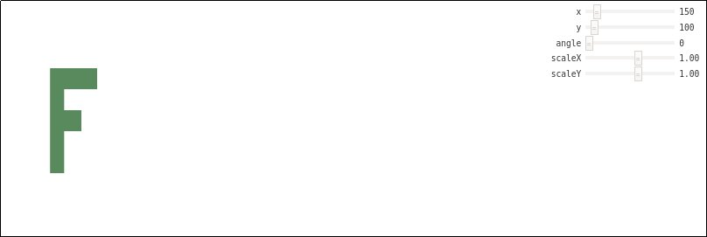
And here is an example of those slides in action:

Image 2 (“2d-lin-trans.html”)
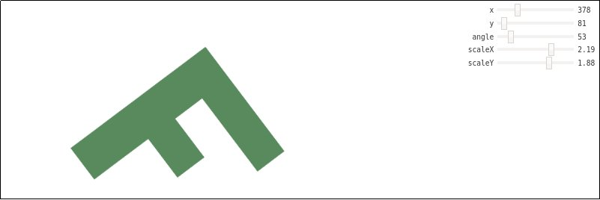
By comparing the slider positions and the figures, it should be evident that the program is working properly.

Now, there are three main things going on here. The first is that our vertex shader is using 3x3 transformation matrices to calculate position. The second is that, in the main method, the shaders are linked together into a program with a position buffer and a vertex array. In the main method, you can also find the update functions for position, angle, and scale, corresponding to the sliders. The final part of the main method is a “draw scene” function that links the program to a canvas, calculates the desired configuration, and draws to the canvas. Third, there is a final section where the geometry of the letter “F” is described, the linear transformations are defined, and the required matrix operations are specified.

3. Three Dimensions
Now that we understand the basics, lets make it three dimensional. Initially, the obvious difference is that our transformation matrices will need to be in four dimensions, but they follow the same patterns, so this isn’t a big deal. The only notable difference is that, as would be expected, there are more directions of rotation. Another thing we need to deal with is that the geometry will need to be updated, which is simply of matter of specifying the corners of our shape (still the capital letter “F”) in three dimensional space. The difficult part is that in WebGL, there are forward and backward facing shapes, depending on the order the vertices are drawn. Forward facing shapes are drawn in a counterclockwise fashion. We need to “cull” the backward facing shapes. Further, we define a depth buffer that allows our fragment shader to only draw top level pixels. With these changes, we can see the following development.

Image 3 (“3d-perspect.html”)
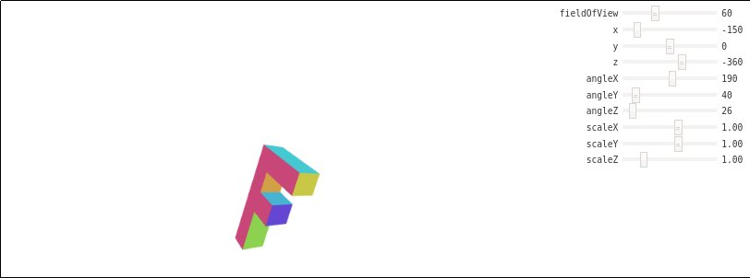
Here you can see that the image does, in fact, appear three dimensional.

Image 4 (“3d-perspect.html”)
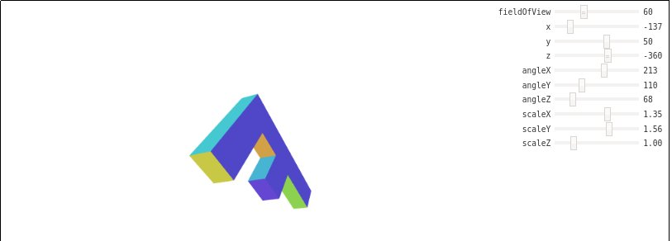
By moving the sliders, we can drastically change the appearance of our shape.

Finally, there is another new slider at the top that controls the field of view:

Image 5 (“3d-perspect.html”)
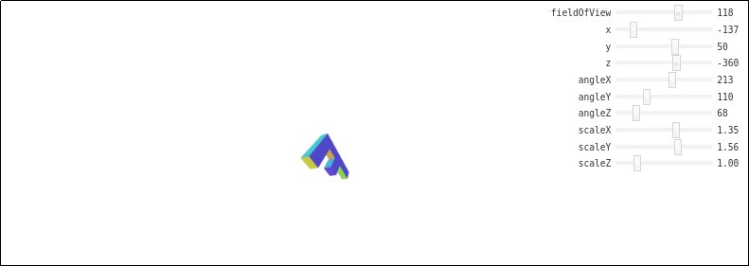
This last addition that makes the “F” look far away is implemented in a perspective function that maps a frustrum to clip space. It assumes there is a camera at the origin and it receives a near and a far z value to calculate a scale.

After perspective, the next step to making a realistic image is to allow the user to control the camera angle. In order to accomplish this effect, first, a circle of “F’s” are drawn using a for-loop in the drawScene function. Next, a camera matrix is generated and a view matrix takes its inverse. Then the projection matrix effectively moves the world so that the camera stays at the origin. Let’s see it in action:

Image 6 (“F-circle-cam.html”)
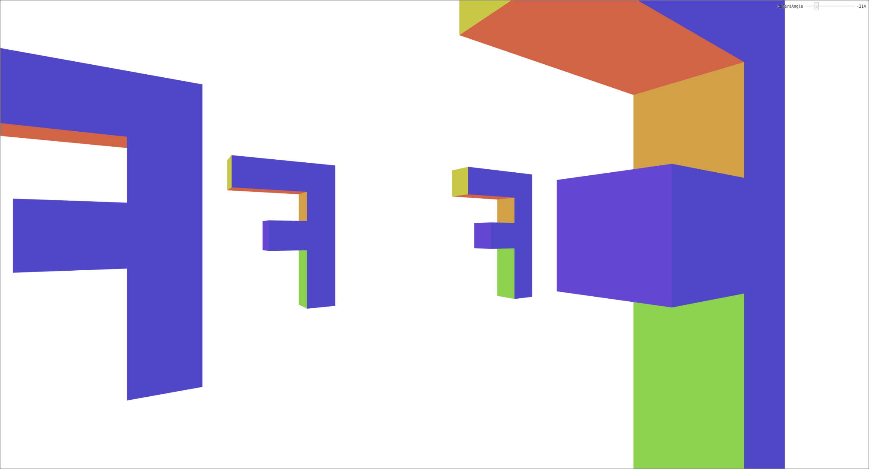
Image 7 (“F-circle-cam.html”)
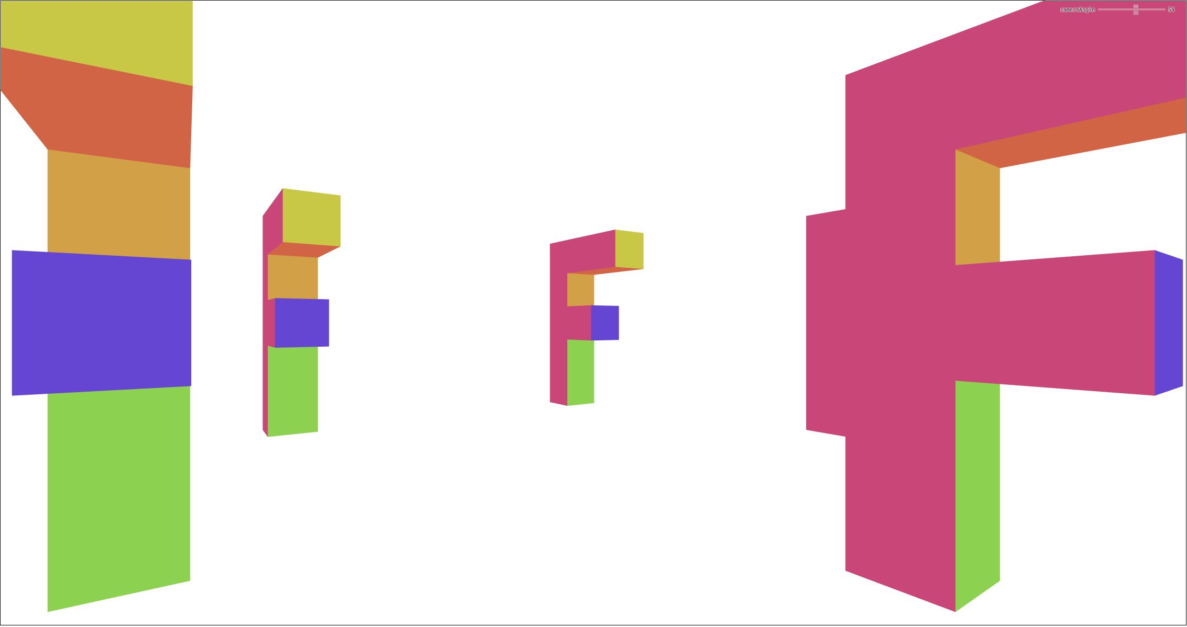
In the above, the scaling is a bit different than previous demonstrations. A slider is still present for interaction, but it is a bit small this time around.

4. Lighting
In the following demonstration we explore point lighting. The crucial calculation here is the dot product of the surface normal and each surface to light vector. To achieve this the vertex shader needs the light position, the position of the surface (calculated using the u_world matrix in the code), a vector from every point on the surface to the light source, as well as the surface normal.

Another effect that we add in the following demonstration is called specular highlighting. Specular light is perfectly reflected in a mirror-like way from the light source to the viewer. Specular reflection is only visible where the surface normal is oriented precisely halfway between the direction of incoming light and the direction of the viewer; this is called the half-angle direction (“halfVector” in the code) because it bisects the two angles. Since most surfaces are not perfectly reflective mirror-like objects, they show a blurred specular highlight. In the code, to control the different levels of shininess of objects, we raise the dot product of the surface normal and the halfVector to a power.

Image 8 (“point-light.html”)
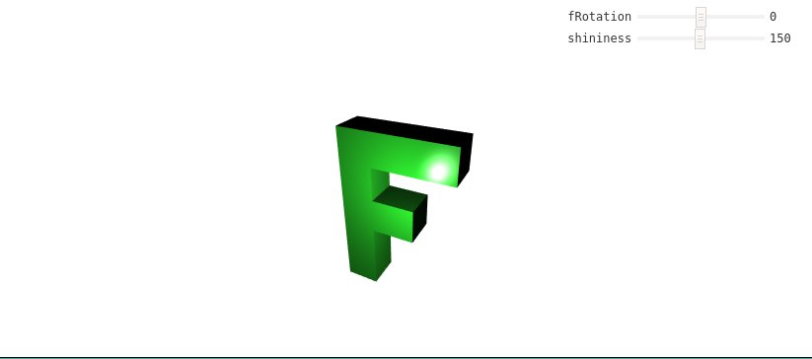
Image 9 (“point-light.html”)
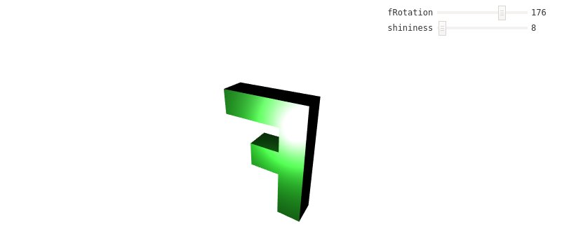
In the second image you can see that reducing the shininess of the surface has increased the blurriness of the highlighting. From this image, we can also see how point lighting lights up different surfaces on our object depending on their relative location.

5. Shadows
This section takes advantage of textures. We do not draw textures on top of surfaces. Instead, as the object is render, for each pixel, we check whether the projected texture is in range. If so, we sample the texture, otherwise we sample a different color. To create a shadow, we just use a projected texture that contains depth data from the point of view of a light. In the code, this depth texture gets attached to the framebuffer as the DEPTH_ATTACHMENT.

If implemented as above, there will be patterns around the shadows called shadow acne. Shadow acne happens because shadow maps are discrete whereas surfaces are continuous, so there are spots on the surface whose depth is lower than the that of the corresponding position in the shadow map, and consequently get shaded. To avoid this, we add a regular depth bias to prevent this from happening so often. It is just a constant added to the projected texture coordinate.

Another new bit in this section is spot lighting. It is actually very similar to point lighting from the last section. The difference is that instead of light emanating in every direction from a point, we take the dot product of a chosen direction and the direction of the light vector. If the cosine of this dot product, or the dot limit, is in a certain range, then there is light. Using this kind of lighting, we only need half the field of view.

You can see the results of these additions to the code in the following scene:

Image 10 (“shadow.html”)
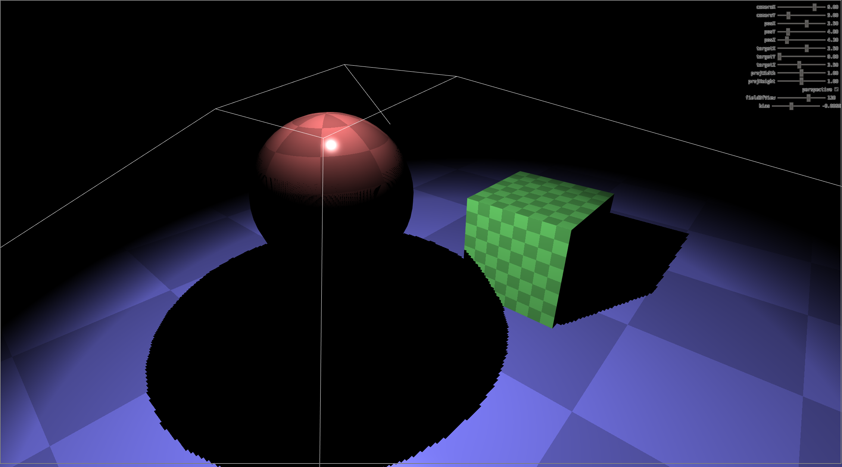
Image 11 (“shadow.html”)
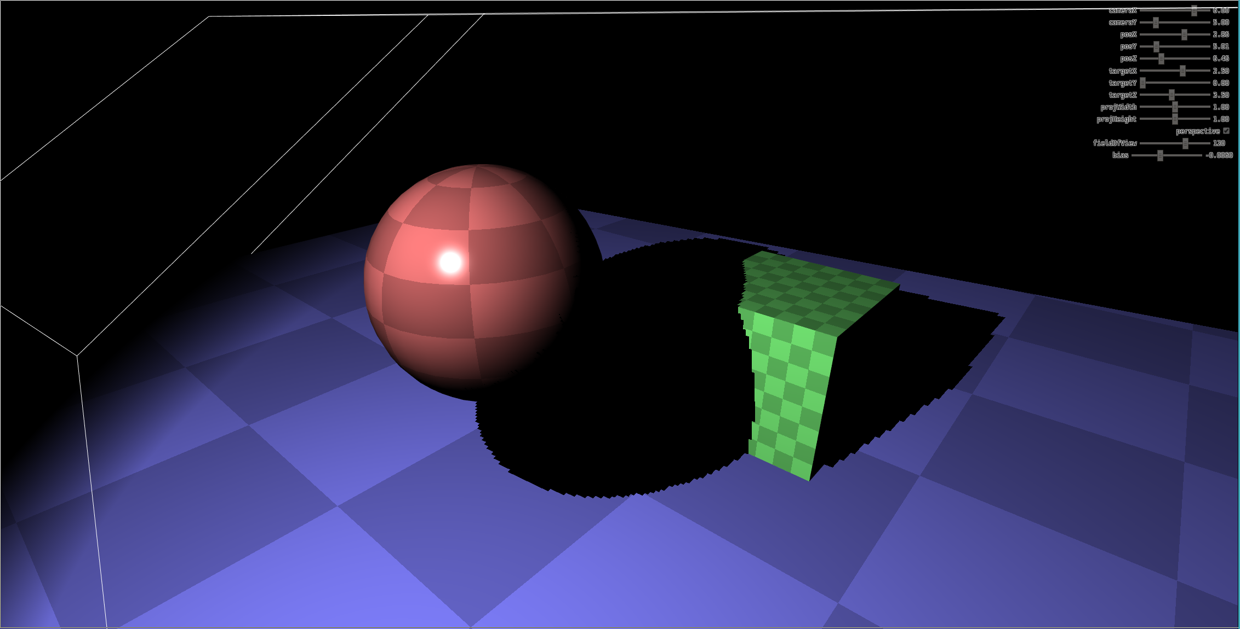
Conclusion
In this project, we learned some of the fundamentals of WebGL that are necessary for creating realistic looking images. They include 2D and 3D linear transformations such as scaling, translation, and rotations. Also featured is a brief exposition of point lighting. Finally we looked at an example of a scene that uses shadows and discussed the added complexity of shadow acne.

Sources
https://webgl2fundamentals.org/
https://github.com/gfxfundamentals/webgl2-fundamentals

Code
Here we note that all the code is available at github.com/j-toma/webgl-explorations. Here we provide the code for the point lighting demonstration.

