Test 1
Assignment
- G signifies students that take this class for Graduate Credit; they must do all the items
- UG students are not required to do the G work, but they may do it for bonus points
- Problems solved beyond the minimum requirements will be given bonus points.
- Challenge problems are optional; they will earn bonus points.

NOTES:
- Show your work to obtain partial credit if appropriate
- Always display input data!
- Partial credit might be given based on work done and MATLAB codes if they are attached; without them, no partial credit can be given.
- Display numerical results to three significant digits (four if the first digit is 1).
- Use SI system of measurement
https://en.wikipedia.org/wiki/International_System_of_Units
- Scale units using appropriate prefixes (e.g., nano, micro, milli, kilo, mega, giga…)
https://en.wikipedia.org/wiki/Metric_prefix
- Problems solved beyond the minimum requirements will be given bonus points.
- Challenge problems are optional. They may be solved for extra credit
- Normalized plots are plots with the y-axis scaled between
–1 and +1. A plotted variable is normalized by dividing it by its maximum absolute value

Notations and abbreviations:
- BVP = boundary value problem
- EOM = equation of motion
- FBD = free body diagram
- FRF = frequency response function
- IVP = initial value problem
- LHS = left hand side
- NLM = Newton’s law of motion
- ODE = ordinary differential equation
- PDE = partial differential equation
- RHS = right hand side

TABLE OF CONTENTS
A. Pendulum 4
A.1 Analyze pendulum 4
A.2 Calculate pendulum response to initial displacement 5
A.3 Calculate pendulum response to impact 7
B. Spring-mass-damper vibrating systems 8
B.1 Analyze spring-mass vibrating system 8
B.2 Analyze spring-mass-damper vibrating system 9
B.3 Calculate spring-mass-damper response to initial displacement 10
B.4 Calculate truck suspension response 11
B.5 Overdamped spring-mass-damper systems 13
B.6 Analyze spring-mass-damper forced vibration 14
B.7 Calculate flex-beam response to slightly unbalanced electric motor excitation 15
B.8 Graduate work: calculate horizontal flex-beam response to impact 17
C. Extra Credit Challenge Problems 19
C.1 Analyze vertical spring-mass vibration system 19
C.2 Analyze vertical flex-beam vibration 20
C.3 Analyze horizontal flex-beam vibration 21
C.4 Calculate horizontal flex-beam response to initial displacement 22
C.5 Analyze spring-mass forced vibration 23
C.6 Calculate cantilever response to suddenly applied weight 24
C.7 Analyze flex-beam pendulum 25
C.8 Calculate flex-beam pendulum response to impact 26
C.9 Complex exponentials and trigonometric functions 28

Pendulum

Analyze pendulum

NOTHING HERE

Calculate pendulum response to initial displacement

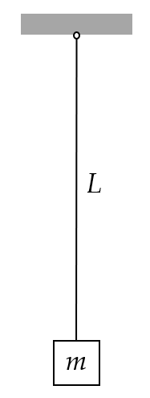
Figure 1: pendulum of length L and mass m
Take g=9.81 m/s² as the generally accepted value of gravitational acceleration. Consider a pendulum of nominal length L_{nominal}=500mm and mass m=45kg as shown in Figure 1. When manufactured in series production, the pendulum length values are not exact due to manufacturing tolerance. The mm length values for ten pendulum sets are:
L = [502.013, 499.337, 500.472, 502.949, 502.216, 496.635, 500.416, 498.255, 498.350, 499.358] mm
Do the following:
- For the ten pendulum sets, calculate
  - rad/sec natural frequency ω_{n}
  - Hz natural frequency f_{n}
  - period of oscillation τ
  - display in table format L, ω_{n}, f_{n}, τ
- Mean values: calculate and display the mean values of ω_{n}, f_{n}, τ

- Initial value problem (IVP): assume initial displacement u₀=4mm and zero initial velocity. Use the mean values of ω_{n}, f_{n}, τ to do the following:
  - Calculate and display the position of the mass u(t₁) after t₁=18 sec
  - Calculate and display the duration t_{Nosc} of N_{osc} oscillations and the corresponding position of the mass u_{Nosc} for N_{osc}=15
  - Plot the response of the system for N_{osc} oscillations and use a datatip on the plot to find the value u(t₁) at t₁ on the plot
- Discuss your results

Calculate pendulum response to impact
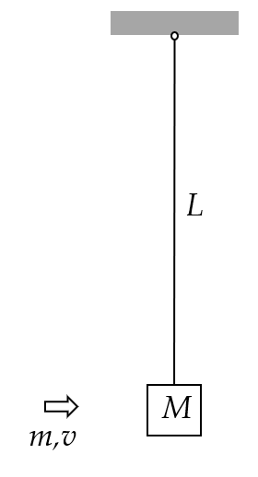
Figure 2: impact excitation of a pendulum system
Take g=9.81 m/s² as the generally accepted value of gravitational acceleration. Consider a pendulum of nominal length L=500 mm and mass M=45kg as shown in Figure 2. The pendulum is initially at rest hanging vertically. A small projectile of mass m=11 grams and velocity v=850 m/s hits the mass M and remains embedded into it. This impact imparts an initial velocity to the system that starts to oscillate. Do the following:
- display input data
- Calculate the initial velocity of the system as a result of the interaction between the projectile and the mass.
- Calculate the rad/sec natural frequency ω_{n} and period of oscillation τ of the pendulum with projectile embedded into it
- Calculate the response u(t₁) after t₁=18 sec
- Plot the response of the system for N_{osc}=15 oscillations and find on the plot:
  - the largest response
  - the response value calculated at item (4)
- Discuss your results

Spring-mass-damper vibrating systems

Analyze spring-mass vibrating system

NOTHING HERE

Analyze spring-mass-damper vibrating system

NOTHING HERE

Calculate spring-mass-damper response to initial displacement
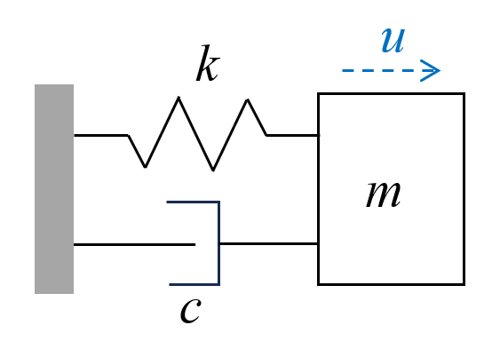

Figure 3: spring-mass-damper vibrating system
Consider a spring-mass vibrating system with m=5.3 kg, k=530 N/m, c=22 N/(m/s) as shown in Figure 3. The vibrating system is given an initial displacement u₀=4 mm with zero initial velocity. Do the following:
- Display input data
- Calculate the natural frequency in rad/sec ω_{n} and in Hz f_{n}
- Calculate the critical damping c_{cr}
- Calculate the damping ratio ζ
- Calculate the damped frequency in rad/sec ω_{d} and in Hz f_{d}
- Calculate the damped period of oscillation τ_{d}
- Calculate the characteristic-equation roots s₁, s₂ and the constants C₁, C₂
- Calculate the constants A, B and then the constants C, ϕ
- Calculate the duration t₁ of one oscillation and the corresponding position u₁=u(t₁)
- Calculate the value u_{0.02} representing 2% of the initial displacement
- Plot the response of the system for N_{osc}=12 oscillations and use datatips on the plot to find the following:
  - the largest response
  - the response value calculated at item (9)
  - the time when the response magnitude has decreased permanently below u_{0.02} calculated at item (10)
- Discuss your results

Calculate truck suspension response
Consider a pickup truck wheel suspension consisting of a leaf spring and an oil damper. The truck and its suspension can be modeled, in first approximation, as a k-m-c spring-mass-damper system as shown in Figure 4.
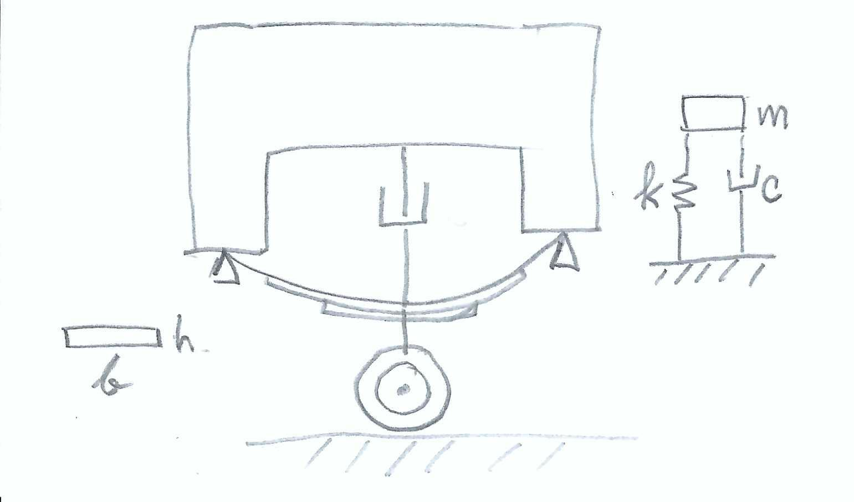
Figure 4 Truck suspension consisting of a leaf spring and an oil damper
The leaf spring can be approximated by a uniform beam of length L=1200 mm and cross-section dimensions h=4mm, b=40mm made of steel with E=200GPa. The truck mass apportioned to the wheel can be estimated as m=520kg. Assume initial displacement u₀=105mm and zero initial velocity . Do the following:
- Display input data
- Calculate the second moment of area I of the beam cross-section
- Calculate the flexural stiffness EI of the beam
- Calculate the spring constant k of the system
- Calculate the natural frequency in rad/sec ω_{n} and in Hz f_{n}
- Calculate the critical damping c_{cr}
- Assume 25% damping ratio, i.e., ζ=0.25, and calculate the physical damping c. Print ζ and c
- Calculate the damped frequency in rad/sec ω_{d} and in Hz f_{d}
- Calculate the damped period of oscillation τ_{d}
- Calculate the characteristic-equation roots s₁, s₂ and the constants C₁, C₂
- Calculate the constants A, B and then the constants C, ϕ
- Calculate the duration t₁ of one oscillation and the corresponding position u₁=u(t₁)
- Calculate the value u_{0.02} representing 2% of the initial displacement
- Plot the response of the system for N_{osc}=17 oscillations and use datatips on the plot to find the following:
  - the largest response
  - the response value calculated at item (12)
  - the time when the response magnitude has decreased permanently below u_{0.02} calculated at item (13)
- Discuss your results
- Graduate work: assume the damper is worn out such that ζ is reduced to ζ=10%.
  - Repeat items (6) through (15)
  - Compare and discuss the two results

Overdamped spring-mass-damper systems
Consider a spring-mass-damper system with natural frequency f_{n}=5Hz and various values of the damping ratio ζ. The system is given an initial displacement u₀ = 3 mm with zero initial velocity. Do the following:
- display input data
- calculate the rad/s frequency ω_{n}
- Assume overdamped conditions ζ > 1 and develop the solution as follows:
  - write the expressions of the roots s₁, s₂ in terms of ω_{n} and ζ
  - write the solution u(t) in terms of s₁, s₂ and constants C₁, C₂
  - write the expression of the constants C₁, C₂ in terms of initial displacement u₀ and initial velocity
  - take ζ=2.5 and calculate the numerical values of s₁, s₂ and C₁, C₂
  - plot the response u(t) for t=0,…,3 seconds
- Assume critically damped conditions ζ =1 and do the following:
  - write the expressions of the two partial solutions u₁(t), u₂(t) in terms of ω_{n}
  - write the expression of the complete solution in terms of ω_{n} and C₁, C₂
  - write the expressions of the constants C₁, C₂ in terms of initial displacement u₀ and initial velocity
  - calculate the numerical values of C₁, C₂
  - plot the response u(t) for t=0,…,3 seconds
- Graduate Work: nothing here
- Graduate Work: some race-car manufacturers design for critical damping whereas others use overdamped design. Discuss the pros and cons of the two options

Analyze spring-mass-damper forced vibration

NOTHING HERE

Calculate flex-beam response to slightly unbalanced electric motor excitation
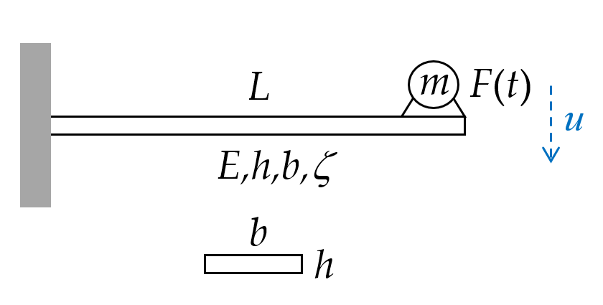
Figure 5 damped cantilever beam excited by force F(t) from slightly unbalanced electric motor
Consider a cantilever beam of length L=520 mm, elastic modulus E=200 GPa, cross-section properties h=4 mm, b=30 mm and damping ratio ζ=15%. (The damping is achieved through a proprietary damping treatment applied on the beam surface.) An electric motor of mass m=0.7 kg operating at 3,100 RPM is attached at the beam tip as shown in Figure 5. The electric motor is slightly unbalanced producing a slight vibratory excitation with $\hat{F}=12 mN$. The excitation frequency ω depends on the electric motor RPM. Do the following:
- Display input data
- Calculate
  - cross-section second moment of area I, flexural stiffness EI, and spring constant k
  - natural frequency ω_{n} rad/s, critical damping c_{cr}, physical damping c
  - quasi-static deflection u_{qst} corresponding to ω_{n}→0
- Calculate the values of
  - resonant frequency ω_{r} and damped frequency ω_{d}
  - peak magnification M_{r}
  - magnification at phase resonance M₉₀
  - physical response magnitude || at phase resonance
  - calculate the Hz frequencies f_{r}, f_{n} and the corresponding RPM values
- assume excitation at phase resonance:
  - calculate the excitation frequency ω in rad/s and f in Hz
  - calculate period of oscillation τ
  - Plot the time response for N_{osc}=13 oscillations. Hint: plot the real part of the complex displacement u(t)
- Graduate work:
  - plot the magnitude and phase of the frequency response function FRF vs. excitation f Hz from quasi-static to 12 times the phase resonance frequency
  - calculate the FRF magnitude at phase-resonance RPM and at double the phase resonance RPM
  - calculate the vibration magnitude when the electric motor runs at its operational RPM
  - comment on what vibration would be observed as the motor is started and accelerated to reach its operational RPM

Graduate work: calculate
horizontal flex-beam response to impact
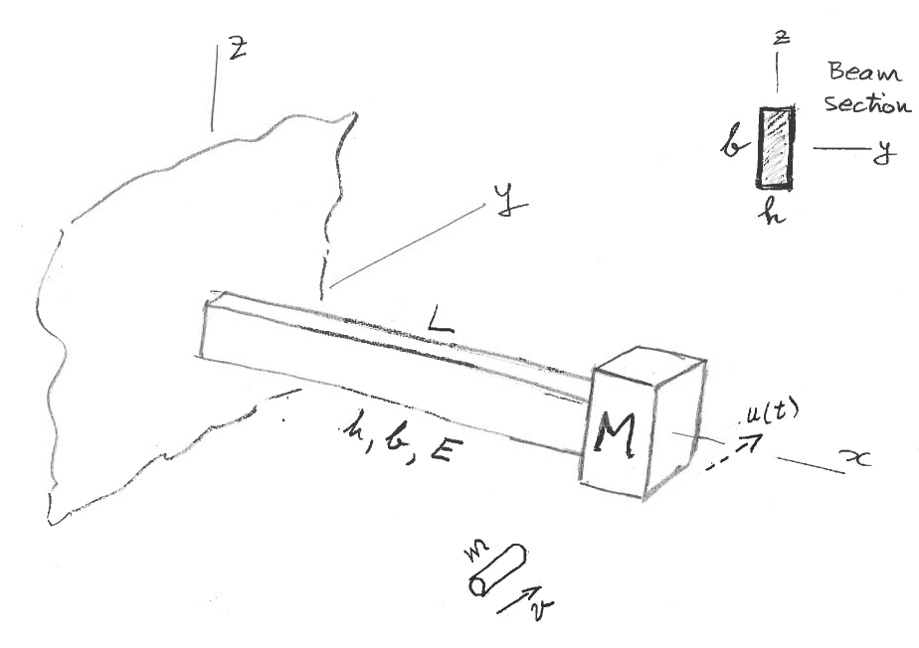
Figure 6: impact excitation of a horizontal flex-beam vibration system
Consider a cantilever beam of length L=525 mm with a mass M=62kg attached at its tip as shown in Figure 6. The beam material is steel with E=200 GPa. The beam cross-section dimensions are h=4 mm, b=30 mm. The beam is initially at rest.
A small projectile of mass m=13 grams and velocity v=1020 m/s hits the mass and remains embedded in it. This impact imparts an initial velocity to the system that starts to oscillate with motion u(t) contained in the horizontal plane. Do the following:
- Display input data
- Calculate the second moment of area I for flexing consistent with the direction of motion u(t)
- Calculate the cross-sectional stiffness EI of the beam
- Calculate the flex-beam spring constant k
- Calculate the initial velocity of the system as a result of the interaction between the projectile and the mass
- Calculate the rad/sec natural frequency ω_{n} and period of oscillation τ
- Calculate the position of the mass u(t₁) after t₁=17 sec
- Plot the response of the system for N_{osc}=13 oscillations and find on the plot:
  - the largest response
  - the response calculated at item (7)
- Discuss your results

Extra Credit Challenge Problems
Challenge problems are optional.

Analyze vertical spring-mass vibration system

NOTHING HERE

Analyze vertical flex-beam vibration

NOTHING HERE

Analyze horizontal flex-beam vibration

NOTHING HERE

Calculate horizontal flex-beam response to initial displacement

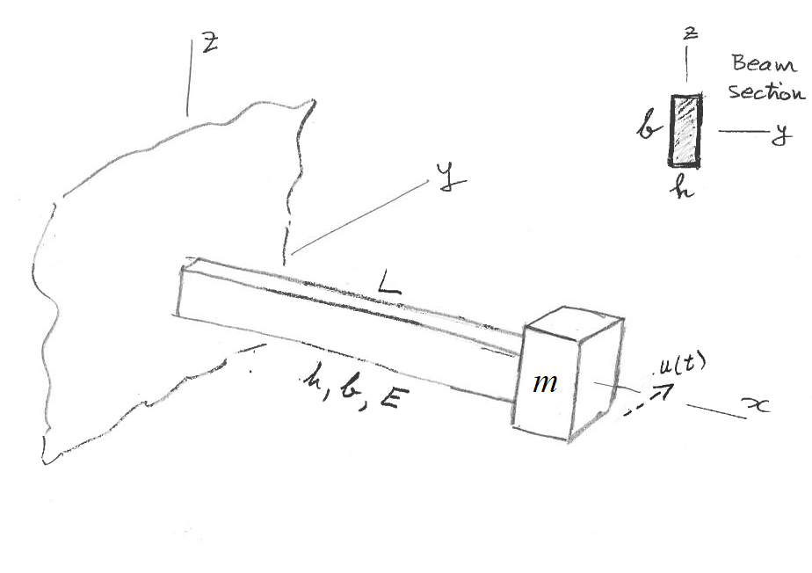
Figure 7: flex-beam vibrating system
Consider a cantilever beam of length L=525 mm with a mass m=62kg attached at its tip as shown in Figure 7. The beam material is steel with E=200 GPa. The beam cross-section dimensions are h=4 mm, b=30 mm. The tip mass is given an initial displacement u₀=3mm with zero initial velocity. Do the following:
- Display input data
- Calculate the second moment of area I for flexing consistent with the direction of motion u(t)
- Calculate the cross-sectional stiffness EI of the beam
- Calculate the spring constant k of the system
- Calculate the natural frequency in rad/sec ω_{n}
- Calculate the natural frequency in Hz f_{n}
- Calculate the period of oscillation in sec τ
- Calculate the position of the mass u(t₁) after t₁=18 sec
- Plot the response of the system for N_{osc}=13 oscillations and use a data tip on the plot to find the value u(t₁) at t₁ on the plot
- Discuss your results

Analyze spring-mass forced vibration

NOTHING HERE

Calculate cantilever response to suddenly applied weight
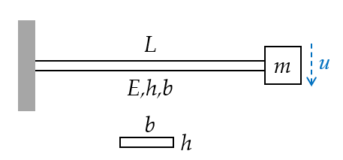
Figure 8: cantilever beam with tip mass
Take g=9.81 m/s² as the generally accepted value of gravitational acceleration. Consider a cantilever beam of length L=525 mm and a mass m=3 kg that has to be attached to its tip as shown in Figure 8. The beam is made of steel with elastic modulus E=200 GPa and yield stress Y=710 MPa cross-section properties h=4 mm, b=30mm. Do the following:
- Display input data
- Calculate the cross-section second moment of area I, the flexural stiffness EI, the spring constant k, the natural frequency ω_{n} rad/s, f_{n} Hz, and period of oscillation τ of the system
- Calculate the weight F₀ of the mass m
- Static case: assume the mass is attached onto the undeformed beam and the let go gradually without inducing any vibration and calculate the static displacement u_{st}
- Dynamic case: assume the mass is attached onto the undeformed beam and then let go suddenly inducing a state of vibration:
  - calculate the maximum dynamic displacement u_{dyn}
  - Plot the response u(t) measured from the undeformed position for N_{osc}=13 oscillations
  - Put a datatip on the plot to identify the maximum displacement and compare with result of item (5)(a)
- Graduate work: calculate the maximum stress at the root of the beam and the safety factor SF=Y/σ and comment on your results for the above two cases:
  - σ_{st} for the static case
  - σ_{dyn} for the dynamic case
- Discuss your results

Analyze flex-beam pendulum

NOTHING HERE

Calculate flex-beam pendulum response to impact
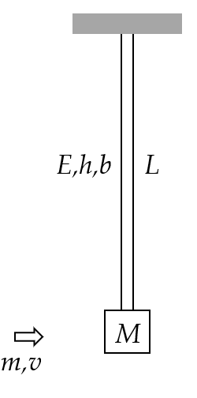
Figure 9: impact excitation of a vertical flex-beam pendulum
Take g=9.81 m/s² as the generally accepted value of gravitational acceleration. Consider a vertical flex-beam pendulum of length L=440 mm with a mass M=62 kg attached at its end as shown in Figure 9. The beam material is steel with E=200 GPa. The beam cross-section dimensions are h=4 mm, b=30 mm. The beam is initially at rest.
A projectile of mass m=11 grams and velocity v=1020 m/s hits the mass and remains embedded into it. The azimuthal orientation of the projectile motion is such that the beam flexes about its minor cross-sectional stiffness. This impact imparts an initial velocity to the system that starts to oscillate. Do the following:
- Display input data
- Calculate the minor second moment of area I of the beam
- Calculate the minor cross-sectional stiffness EI
- Calculate the flex-beam spring constant k
- Calculate the initial velocity of the system as resulting from the interaction between the projectile and the large mass
- Calculate the rad/s natural frequency ω_{nFBP} and period of oscillation τ_{FBP} of the flex-beam pendulum with projectile embedded into it
- Calculate the response u(t₁) after t₁=18 sec
- Plot the response of the system for N_{osc}=23 oscillations and find on the plot:
  - the largest response
  - the response value calculated at item (7)
- Discuss your results in comparison with results of Problem A.3

Complex exponentials and trigonometric functions

NOTHING HERE

