Lab 1 – Euler Buckling

Jacob Vaught
Michael Barger

EMCH 362 – Mechanical Laboratory 2
Mobli Mostafa
Mario Villegas
08-26-2024
Abstract
This lab examined the Euler buckling of columns under four boundary conditions: Fixed-Free, Pinned-Pinned, Fixed-Pinned, and Fixed-Fixed. Using the WP 121 Demonstration Unit, critical buckling loads were measured for metal strips, and these measurements were used to calculate the modulus of elasticity (E) of the material, with the known value being approximately 200 GPa. The results showed that the Pinned-Pinned, Fixed-Pinned, and Fixed-Fixed cases produced confidence intervals that included the real modulus, indicating reasonable accuracy, while the Fixed-Free case yielded a significantly higher modulus, suggesting inaccuracies. Despite demonstrating the principles of Euler buckling, the high variability in the data points to the need for improved precision and consistency in future experiments.

Introduction
Buckling is a critical failure mode in structural engineering, where slender columns under compressive load can suddenly bend, leading to catastrophic failure. Understanding and predicting buckling behavior is essential for designing safe and efficient structures. Euler's theory identifies four primary boundary conditions—Fixed-Free, Pinned-Pinned, Fixed-Pinned, and Fixed-Fixed—each affecting the column's buckling behavior differently. These modes represent varying levels of constraint at the column ends, influencing the effective length and the load required to cause buckling. By studying these four conditions, engineers can better predict and mitigate the risk of buckling in real-world structures, ensuring their stability and safety.
Methods
The experiment involved the use of the WP 121 Demonstration Unit to test the buckling behavior of metal strips under different boundary conditions: Fixed-Free, Pinned-Pinned, Fixed-Pinned, and Fixed-Fixed. The setup for each boundary condition was carefully configured according to the instructions in the WP 121 online manual, ensuring proper alignment and constraint. Weights were incrementally added to the top of each metal strip until buckling occurred, with the critical buckling load $P_{\text{cr}}$ recorded for each trial. The precise dimensions of each strip, including height $h$, width $b$, and length $L$, were measured using a caliper to calculate the moment of inertia $I$, which is given by the equation:
$$\begin{aligned}I=\frac{h⋅b^{3}}{12}\#(1)\end{aligned}$$
The modulus of elasticity$E$ was calculated using Euler's buckling equation, which relates the critical buckling load to the moment of inertia and effective length of the column:
$$\begin{aligned}E=\frac{P_{\text{cr}}⋅{\left(KL\right)}^{2}}{n^{2}π^{2}I}\#(2)\end{aligned}$$
Here, $K$ is the effective length factor, and $n$ is the buckling mode, both of which depend on the boundary conditions. The statistical analysis of the collected data was conducted in Excel, where the average AVERAGE and standard deviation STDEV.S were computed for each set of trials. Confidence intervals at 75% were determined using critical values from a t-table, providing a measure of the uncertainty in the modulus of elasticity calculations for each boundary condition.

Results and Discussion
The results of this experiment, summarized in Tables 1 through 4, provide measurements for the critical parameters needed to calculate the modulus of elasticity E under different boundary conditions: Fixed-Free, Pinned-Pinned, Fixed-Pinned, and Fixed-Fixed. The modulus of elasticity was derived using Euler’s buckling equation. Any errors in measuring $P_{\text{cr}}$ and I propagate to E according to the following relationships and combined using the root-sum-square (RSS) method:
$$\begin{aligned}\frac{ΔE}{E}=\frac{ΔP_{\text{cr}}}{P_{\text{cr}}}\#\left(3\right)\end{aligned}$$
$$\begin{aligned}\frac{ΔE}{E}=-\frac{ΔI}{I}\#\left(4\right)\end{aligned}$$
$$\begin{aligned}\frac{ΔE}{E}=\sqrt{{\left(\frac{ΔP_{\text{cr}}}{P_{\text{cr}}}\right)}^{2}+{\left(\frac{ΔI}{I}\right)}^{2}}\#\left(5\right)\end{aligned}$$
This comprehensive error analysis shows that even small uncertainties in $P_{\text{cr}}$ and I can lead to significant variability in the calculated E, as reflected in the high standard deviations and broad confidence intervals seen in Table 5. The Fixed-Free case yielded a particularly wide confidence interval [323.716, 666.367] GPa, indicating a large potential error in the measurement process, likely due to inaccuracies in setup or measurement technique.

Comparing the experimental results with the ideal values in Table 6, we see that the modulus of elasticity for the Pinned-Pinned, Fixed-Pinned, and Fixed-Fixed cases fell within ranges that included the known material property of 200 GPa. However, the Fixed-Free condition produced significantly higher values, suggesting possible errors in this configuration.
Conclusion
This lab effectively demonstrated Euler buckling for various boundary conditions, with most calculated moduli of elasticity aligning closely with the known value of 200 GPa, except for the Fixed-Free case, which exhibited higher values indicating potential inaccuracies. The error analysis revealed that even minor errors in the critical buckling load $P_{\text{cr}}$ and I can significantly affect results, with factors such as vibrations, friction, uncalibrated weights, and pre-existing column defects contributing to variability.

To improve future experiments, more precise measurement tools like calibrated calipers should be used, along with calibrated weights and measures to minimize vibrations and friction. Additionally, statistical analysis that accounts for operator error, measurement tool error, and other sources of error could produce more accurate confidence intervals.

References
- GUNT WP 121 Product Page, “https://www.gunt.de/en/products/engineering-mechanics-and-engineering-design/strength-of-materials/buckling-and-stability/demonstration-of-euler-buckling/020.12100/wp121/glct-1:pa-148:ca-11:pr-1530”
- Amazon online shop, “https://www.amazon.com/Digital-Caliper-Adoric-Calipers-Measuring/dp/B07DFFYCXS?th=1”

Appendix

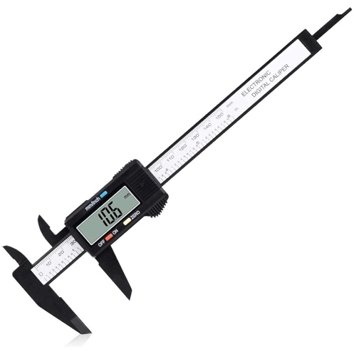
Figure 1- A picture of a caliper [2]
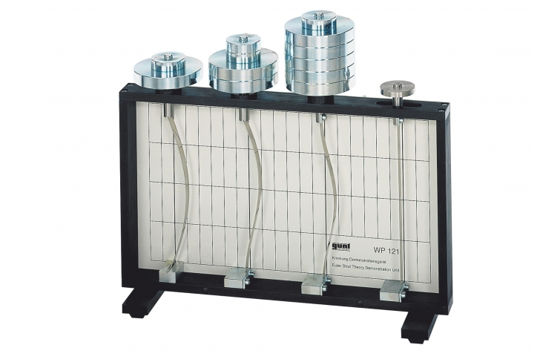
Figure 2- A picture of the buckling setup[1]

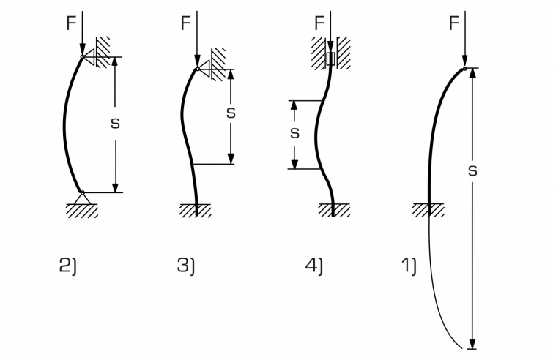
Figure 3-Effective Column Lengths [1]

Table 1- Table used for the buckling labs data recording
Symbol | Unit | Free-Fixed
 |  | 1 | 2 | 3 | 4 | 5 | AVG | St. Dev
L | mm | 181 | 180 | 181 | 179 | 180 | 180.2 | 0.83666
b | mm | 0.4 | 0.6 | 0.4 | 0.6 | 0.5 | 0.5 | 0.1
h | mm | 11.9 | 12 | 11.8 | 11.9 | 12.1 | 11.94 | 0.114018
Iy | mm4 | 0.063467 | 0.216 | 0.062933 | 0.2142 | 0.126042 | 0.124375 | 0.076179
Fcrit | N | 4 | 5 | 5 | 4 | 5.3924 | 4.67848 | 0.639746
E | GPa | 836.8193 | 303.9636 | 1054.889 | 242.4973 | 561.789 | 495.0414 | 346.3788

Table 2- Table used for the buckling labs data recording
Symbol | Unit | Pinned-Pinned
 |  | 1 | 2 | 3 | 4 | 5 | AVG | St. Dev
L | mm | 181 | 180 | 181 | 179 | 180 | 180.2 | 0.83666
b | mm | 0.4 | 0.6 | 0.4 | 0.6 | 0.5 | 0.5 | 0.1
h | mm | 11.9 | 12 | 11.8 | 11.9 | 12.1 | 11.94 | 0.114018
Iy | mm4 | 0.063467 | 0.216 | 0.062933 | 0.2142 | 0.126042 | 0.124375 | 0.076179
Fcrit | N | 7 | 7 | 7 | 7 | 7 | 7 | 0
E | GPa | 366.1085 | 106.3872 | 369.2111 | 106.0926 | 182.3178 | 185.1718 | 132.9783

Table 3- Table used for the buckling labs data recording
Symbol | Unit | Fixed-Pinned
 |  | 1 | 2 | 3 | 4 | 5 | AVG | St. Dev
L | mm | 181 | 180 | 181 | 179 | 180 | 180.2 | 0.83666
b | mm | 0.4 | 0.6 | 0.4 | 0.6 | 0.5 | 0.5 | 0.1
h | mm | 11.9 | 12 | 11.8 | 11.9 | 12.1 | 11.94 | 0.114018
Iy | mm4 | 0.063467 | 0.216 | 0.062933 | 0.2142 | 0.126042 | 0.124375 | 0.076179
Fcrit | N | 16 | 14 | 15 | 16 | 15 | 15.2 | 0.83666
E | GPa | 418.4097 | 106.3872 | 395.5833 | 121.2486 | 195.3405 | 201.0436 | 149.7594

Table 4- Table used for the buckling labs data recording
Symbol | Unit | Fixed-Fixed
 |  | 1 | 2 | 3 | 4 | 5 | AVG | St. Dev
L | mm | 181 | 180 | 181 | 179 | 180 | 180.2 | 0.83666
b | mm | 0.4 | 0.6 | 0.4 | 0.6 | 0.5 | 0.5 | 0.1
h | mm | 11.9 | 12 | 11.8 | 11.9 | 12.1 | 11.94 | 0.114018
Iy | mm4 | 0.063467 | 0.216 | 0.062933 | 0.2142 | 0.126042 | 0.124375 | 0.076179
Fcrit | N | 32 | 33 | 33 | 32 | 31 | 32.2 | 0.83666
E | GPa | 418.4097 | 125.385 | 435.1416 | 121.2486 | 201.8519 | 212.9475 | 155.3397

Table 5- Confidence Interval
Case | Mean (GPa) | St. Dev (Gpa) | Size | Critical Value | Margin of Error | Lower Bound | Upper Bound
Free-Fixed | 495.0414 | 346.3788 | 5 | 1.106 | 171.3252713 | 323.7161287 | 666.3666713
Pinned-Pinned | 185.1718 | 132.9783 | 5 | 1.106 | 65.77349226 | 119.3983077 | 250.9452923
Fixed-Pinned | 201.0436 | 149.7594 | 5 | 1.106 | 74.07373035 | 126.9698697 | 275.1173303
Fixed-Fixed | 212.9475 | 155.3397 | 5 | 1.106 | 76.83384849 | 136.1136515 | 289.7813485

Table 6- Ideal Results for the 4 Euler Cases
 | Fixed-Fixed | Pinned-Fixed | Pinned-Pinned | Fixed-Free
Length (mm) | 180 | 180 | 180 | 180
Width b (mm) | 0.5 | 0.5 | 0.5 | 0.5
Height h (mm) | 12 | 12 | 12 | 12
I_y (m^4) | 1.25E-13 | 1.25E-13 | 1.25E-13 | 1.25E-13
E (Pa) | 2E+11 | 2E+11 | 2E+11 | 2E+11
K | 0.5 | 0.707106781 | 1 | 2
P_cr (N) | 30.46174198 | 15.23087099 | 7.615435495 | 1.903858874

