Lab 2 – Heat Transfer

Jacob Vaught
Michael Barger
Athena Shier

EMCH 362 – Mechanical Laboratory 2
Mobli Mostafa
Mario Villegas
08-26-2024
Abstract
This heat transfer lab aims to explore thermal conductivity and heat transfer phenomena using various methods. The objectives include determining the thermal conductivity of brass using the Armfield conduction apparatus, examining steady-state and transient conduction, and investigating heat transfer coefficients under forced and free convection conditions. Experiments involve measuring the conductivity of brass samples, analyzing steady-state temperature distributions, and comparing results with known literature values. The lab also employs a C-Therm device for transient heat conduction measurements on non-metallic samples, requiring repeated testing and statistical analysis. Additionally, the experiment evaluates heat transfer coefficients and Biot numbers for natural and forced convection of a copper block, validating the lumped capacitance model assumptions.

Introduction
Heat transfer is crucial in engineering because it directly impacts the efficiency, safety, and performance of systems such as engines, electronics, and thermal insulation. Understanding heat transfer mechanisms—conduction, convection, and radiation—allows engineers to design effective thermal management strategies, prevent overheating, and optimize energy use. Studying heat transfer helps predict how materials and structures will behave under thermal stress, guiding the development of more reliable and efficient technologies. This lab investigates heat transfer principles to deepen our understanding of these critical processes and their practical applications.

Methods
Experiment #1 aimed to determine the thermal conductivity of a brass sample using steady-state heat transfer. A brass specimen was placed between a heat source and a heat sink. Thermocouples were positioned to measure temperature gradients. Temperature readings were monitored using DAQami software until steady-state conditions were achieved. Under the assumptions of steady-state conditions, one-dimensional heat conduction, and constant thermal conductivity, Fourier's law simplifies to:
$$\begin{aligned}V*I=Q=-kA\frac{ΔT}{Δy}\#(1)\end{aligned}$$
Experiment #2 involved measuring the thermal conductivity of Pyroceram 9606 using the C-Therm device. The device utilizes transient heat conduction principles and requires frequent recalibration, which may affect measurement accuracy. The procedure was straightforward: the C-Therm device was powered on, the TCi software was launched, and the sample was tested. A total of 19 measurements were taken to enable statistical analysis.

Experiment #3 determined the heat transfer coefficient for natural and forced convection. A cube with a thermocouple attached at its center, was heated to 80°C. After reaching the temperature, the block was allowed to cool down to 50°C under two conditions: by natural convection in still air, and by forced convection using a blower. The raw temperature data collected are presented in Table 5.
$$\begin{aligned}\frac{θ}{θ_{i}}=\frac{T-T_{∞}}{T_{i}-T_{∞}}=\exp\left[-\left(\frac{hA}{p∀c}\right)t\right]\#(2)\end{aligned}$$

Results and Discussion
The results of Experiment #1, summarized in Figures 1–3 and Tables 1–3, indicate that the average thermal conductivity of the brass sample was calculated to be 121.06 W/m·°C with a ST Deviation of 12.41 W/m·°C which aligns with the conductivity range (110-128 W/m·°C). Deviations from linearity were observed. These discrepancies can be attributed to experimental errors such as imperfect thermal contact between the sample and the thermocouples, heat losses due to inadequate insulation, and possible inaccuracies in the thermocouple calibrations.
The results of Experiment #2, the measured thermal conductivity values, are presented in Table 4. The average thermal conductivity was found to be 3.968 W/m·K with a standard deviation of 0.019 W/m·K. Compared to the literature value of approximately 3.638 W/m·K for Pyroceram 9606, the discrepancy can be attributed to calibration issues with the C-Therm device.
For Experiment #3, The cooling of the copper block followed an exponential decay, consistent with the lumped capacitance model. Plotting ln(θ) against time produced linear relationships, indicating negligible gradients within the block. From these plots, we calculated heat transfer coefficients of 13.12 W/m²·K for natural convection and 56.15 W/m²·K for forced convection. The Biot numbers were 0.0001363 for natural convection and 0.0005835 for forced convection, both less than 0.1. This confirms that the lumped capacitance model is valid for our system. The data in Tables 5 and 6 support these findings, demonstrating consistent measurements that align with theoretical expectations.
Conclusion
This lab effectively explored heat transfer principles through experiments measuring thermal conductivity and heat transfer coefficients. Experiment 1 determined the thermal conductivity of brass using steady-state conduction, aligning with known values but showing deviations due to imperfect thermal contact, inadequate insulation, and potential thermocouple inaccuracies. Experiment 2 used the C-Therm device to measure Pyroceram 9606, revealing discrepancies likely caused by calibration issues and device variability, highlighting the challenges in transient measurements. Experiment 3 validated the lumped capacitance model by assessing heat transfer coefficients under natural and forced convection, though controlling airflow conditions more precisely could improve consistency.

To enhance these experiments, better thermal contact methods, improved insulation, and rigorous calibration protocols would reduce measurement errors. Controlling environmental conditions, especially during convection tests, would minimize variability. Increasing trials and using statistical analysis would further clarify uncertainties. These improvements would strengthen the accuracy and reliability of the experiments, providing deeper insights into heat transfer mechanisms essential for engineering applications.

References
- Incropera, F. P., & DeWitt, D. P. (2002). Fundamentals of Heat and Mass Transfer (5th ed.). John Wiley & Sons.
- Cengel, Y. A. (2003). Heat Transfer: A Practical Approach (2nd ed.). McGraw-Hill.
- Holman, J. P. (2010). Heat Transfer (10th ed.). McGraw-Hill.

Appendix

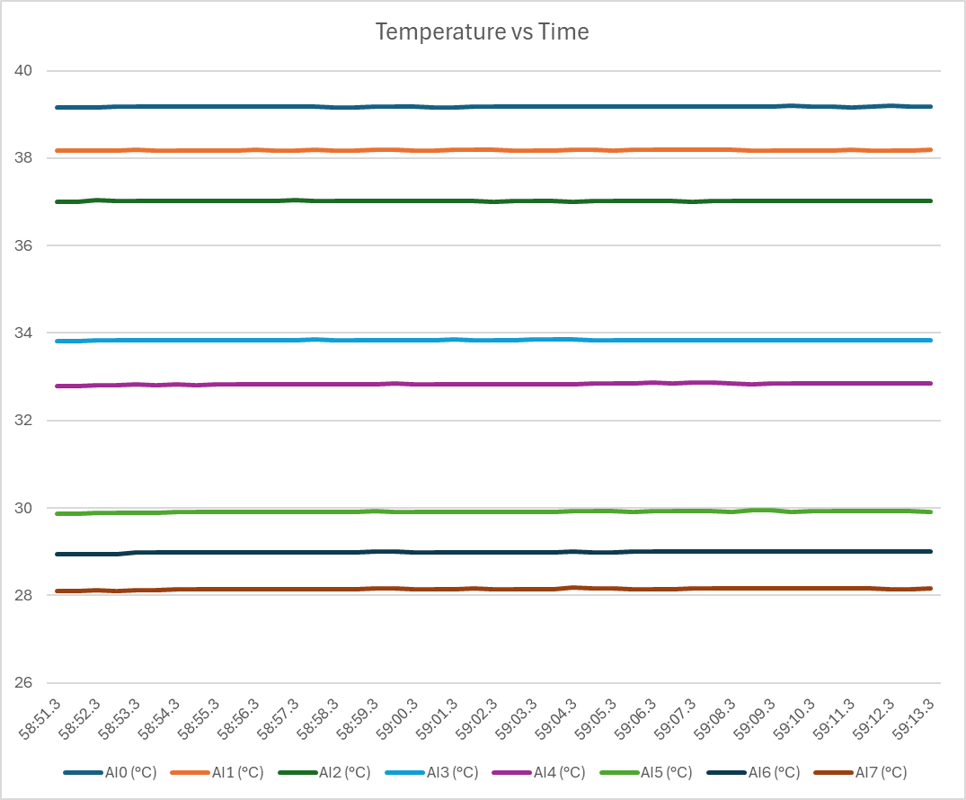
Figure 1- Variation of thermocouple reading T, as a function of time
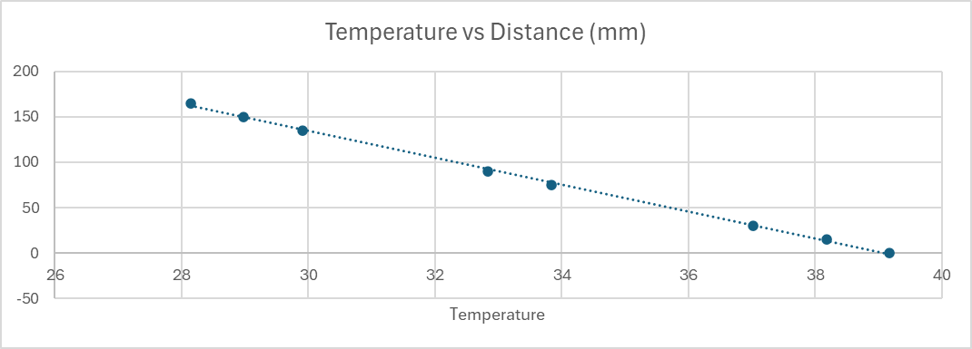
Figure 2- Average thermocouple measure at different locations
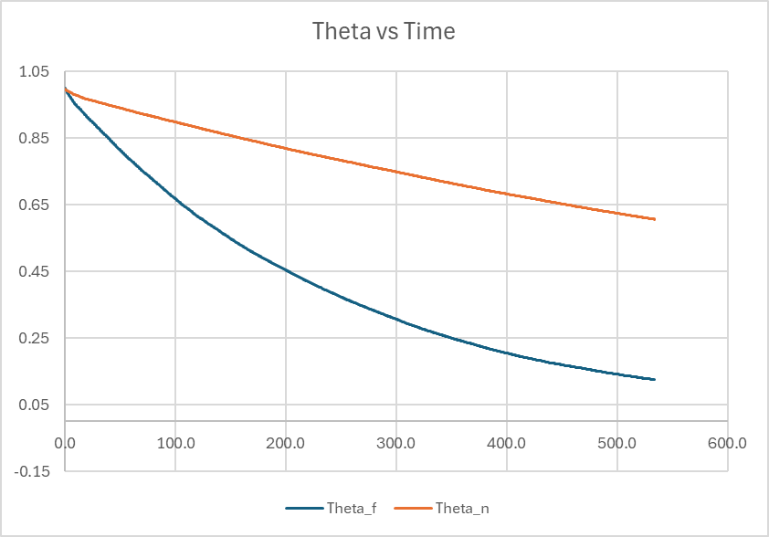
Figure 3-Temperature Difference vs. Time
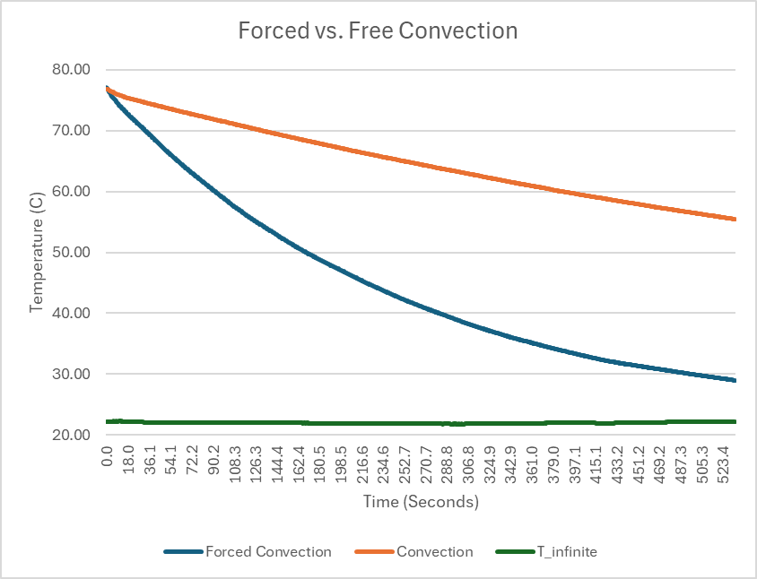
Figure 4-Temperature vs. Time

Table 1- Average Temperatures at Thermocouples
Thermocouple | Distance (mm) | Temperature (°C)
AI0 | 0 | 39.17
AI1 | 15 | 38.18
AI2 | 30 | 37.02
AI3 | 75 | 33.84
AI4 | 90 | 32.83
AI5 | 135 | 29.91
AI6 | 150 | 28.99
AI7 | 165 | 28.15

Table 2- Thermal Conductivity Calculations
Segment | Δy (m) | ΔT (°C) | k (W/m·°C)
AI0 - AI1 | 0.015 | 0.99 | 120.22
AI1 - AI2 | 0.015 | 1.16 | 102.75
AI2 - AI3 | 0.045 | 3.18 | 112.44
AI3 - AI4 | 0.015 | 1.01 | 118.01
AI4 - AI5 | 0.045 | 2.92 | 122.6
AI5 - AI6 | 0.015 | 0.92 | 129.52
AI6 - AI7 | 0.015 | 0.84 | 141.86

Table 3- Experimental Parameters
Property | Value
Diameter, D | 25 mm
Length, L | 30 mm
Area, A | 2.9087*10^-4 m^2
Voltage, V | 5 V
Current, I | 0.78 A
Q =V*I | 3.9 W

Table 4- Data from Experiment #2
Effusivity | K (W/mK) | 1/m | R2 | Vo (mV) | Vmax (mV) | ΔV (mV) | Ambient (°C) | ΔT (C)
2966.9 | 4.025 | 66.96 | 0.9999 | 5113.8 | 5126.3 | 12.5 | 21.1 | 0.7
2947.2 | 3.980 | 66.55 | 0.9999 | 5112.0 | 5124.6 | 12.6 | 20.9 | 0.7
2945.2 | 3.975 | 66.50 | 0.9999 | 5111.6 | 5124.1 | 12.6 | 20.9 | 0.7
2943.9 | 3.972 | 66.47 | 0.9999 | 5111.5 | 5124.1 | 12.6 | 20.8 | 0.7
2927.1 | 3.934 | 66.12 | 0.9999 | 5111.3 | 5123.9 | 12.6 | 20.8 | 0.7
2934.2 | 3.950 | 66.27 | 0.9999 | 5111.1 | 5123.7 | 12.6 | 20.8 | 0.7
2944.6 | 3.974 | 66.49 | 0.9999 | 5111.4 | 5123.9 | 12.6 | 20.8 | 0.7
2940.0 | 3.964 | 66.39 | 0.9999 | 5111.1 | 5123.6 | 12.5 | 20.8 | 0.7
2940.6 | 3.965 | 66.41 | 0.9999 | 5110.9 | 5123.4 | 12.6 | 20.8 | 0.7
2948.1 | 3.982 | 66.56 | 0.9999 | 5110.8 | 5123.4 | 12.6 | 20.8 | 0.7
2944.5 | 3.974 | 66.49 | 0.9999 | 5111.2 | 5123.7 | 12.6 | 20.8 | 0.7
2933.6 | 3.949 | 66.26 | 0.9999 | 5111.1 | 5123.7 | 12.6 | 20.8 | 0.7
2941.7 | 3.967 | 66.43 | 0.9999 | 5110.9 | 5123.5 | 12.5 | 20.8 | 0.7
2932.1 | 3.946 | 66.23 | 0.9999 | 5111.0 | 5123.6 | 12.6 | 20.8 | 0.7
2932.2 | 3.946 | 66.23 | 0.9999 | 5111.2 | 5123.8 | 12.6 | 20.9 | 0.7
2947.6 | 3.981 | 66.55 | 0.9999 | 5111.4 | 5124.0 | 12.6 | 20.8 | 0.7
2942.6 | 3.969 | 66.45 | 0.9999 | 5111.0 | 5123.6 | 12.6 | 20.9 | 0.7
2940.5 | 3.965 | 66.41 | 0.9999 | 5111.1 | 5123.7 | 12.6 | 20.9 | 0.7
2944.4 | 3.973 | 66.48 | 0.9999 | 5111.3 | 5123.9 | 12.6 | 20.8 | 0.7

Table 5- Data from Experiment #3
Time | F Conv | Conv | T_inf | Theta_f | ln(Th_f) | Theta_n | ln(Th_n)
0.0 | 77.10 | 76.87 | 22.22 | 1.00 | 0.00 | 1.00 | 0.00
55.3 | 65.90 | 73.53 | 22.02 | 0.80 | -0.23 | 0.94 | -0.07
111.7 | 57.10 | 70.94 | 22.02 | 0.64 | -0.45 | 0.89 | -0.12
168.1 | 50.14 | 68.44 | 21.94 | 0.51 | -0.67 | 0.84 | -0.17
224.5 | 44.64 | 66.08 | 21.88 | 0.41 | -0.89 | 0.80 | -0.22
280.9 | 40.10 | 63.90 | 21.81 | 0.33 | -1.11 | 0.76 | -0.27
337.3 | 36.41 | 61.79 | 21.88 | 0.26 | -1.34 | 0.72 | -0.32
393.7 | 33.54 | 59.78 | 21.97 | 0.21 | -1.56 | 0.69 | -0.38
450.1 | 31.38 | 57.95 | 22.02 | 0.17 | -1.77 | 0.65 | -0.43
506.5 | 29.71 | 56.25 | 22.13 | 0.14 | -1.98 | 0.62 | -0.48

Table 6- Final Results for the Experiment #3
Name | Slope
ln(Theta_f) | -0.0039068
ln(Theta_n) | -0.0009126
E | F
T_i_f | 77.095186
T_i_n | 76.866399
Name | Value
ρ | 8960
c | 385
k_s | 401
L_side | 0.025
A | 0.00375
V | 1.5625E-05
C L | 0.0041667
h_f | 56.1532704
Bi_f | 0.0005835
h_n | 13.1164516
Bi_n | 0.0001363

