Lab 3 – Vibrations

Jacob Vaught
Michael Barger
Athena Shier

EMCH 362 – Mechanical Laboratory 2
Mobli Mostafa
Mario Villegas
09-16-2024
Abstract
This experiment investigates the vibration characteristics of an aluminum beam in both free-free and cantilever configurations. The primary objectives are to determine the first five natural resonant frequencies and corresponding node positions of the beam, compare these to theoretical values, and calculate the damping ratio for the cantilever configuration. A LabView program was developed to acquire and analyze data from the vibrating beam. Results demonstrated a close correlation between experimental and theoretical values, validating the predictive models used. The damping ratio was also successfully determined, highlighting the beam's energy dissipation characteristics.

Introduction
Vibration analysis of beams is a critical area of study in structural dynamics, with applications ranging from mechanical systems to civil engineering. Understanding the natural frequencies and mode shapes of a beam allows for better design and control of structures, reducing the risk of resonant failure. This experiment aims to analyze the vibration characteristics of an aluminum beam, focusing on two configurations: free-free and cantilever. The objectives include determining the natural frequencies and node positions and comparing them with theoretical predictions. Additionally, the experiment aims to calculate the damping ratio, which provides insight into the material's inherent energy dissipation properties. The theoretical foundation relies on beam theory, where natural frequencies are functions of material properties and geometry.

Methods
Both experiments utilized an aluminum beam in two configurations: free-free and cantilever. The beam's dimensions were measured using a caliper and measuring tape. The setup included a shaker to induce vibrations, a signal generator to control frequency and amplitude, and a power amplifier to drive the shaker. The natural frequencies were identified by varying the frequency of the signal generator and observing maximum amplitude responses. A thin, light object similar to a pencil was run across the beam to locate the nodes, which were identified as the points with the least vibration amplitude. To determine the natural frequencies, Equation 1 was used. Equation 2 was used to determine the moment of inertia.
(1) $f=\frac{{\left(β_{n}L\right)}^{2}}{2πL^{2}}⋅\sqrt{\frac{E⋅I}{ρ⋅A}}$
(2) $Ι=\frac{h⋅b^{3}}{12}$

For Experiment #2, a LabView program was designed to continuously record the beam's vibrational data through a data acquisition system. The program used a While Loop to acquire strain data, displaying real-time graphs of the vibration signal and saving the data to a text file for further analysis. The damping ratio ζ was calculated from the logarithmic decrement method:
(3) $ζ=\frac{δ}{2π}$
(4) $δ=\frac{1}{n}\ln\left(\frac{X_{o}}{X_{n}}\right)$
where δ is the logarithmic decrement calculated from the ratio of successive peak amplitudes x_{o}​ and x_{n}​.
Results and Discussion
The experimental results for the natural frequencies and node positions of the aluminum beam in both free-free and cantilever configurations are summarized in Table 1. The errors between the measured and theoretical values were calculated for both setups. The free-free configuration consistently showed smaller errors compared to the cantilever setup, with the most significant deviation being 0.33699 for the second node position in the second mode. This suggests that the free-free model more accurately simulates the beam’s behavior.
In the cantilever configuration, there were frequent discrepancies in the node positions, particularly in higher modes. The cantilever model struggled with accurately predicting the number and position of nodes, possibly due to less ideal clamping conditions or variations in the beam's effective length.
The second experiment aimed to determine the damping characteristics of the cantilever beam. The average logarithmic decrement was found to be 0.1772, and the corresponding damping ratio ζ was calculated to be 0.0282, indicating an underdamped system. These results are illustrated in Figures 1 and 2.
A MATLAB program was used to identify the peaks of the beam’s oscillations, and a statistical analysis was conducted based on the decrement between successive peaks. The low damping ratio (ζ<<1) confirms that the beam oscillates freely with minimal energy loss, characteristic of an underdamped system. This behavior is visualized in Figure 2, where the system exhibits sustained oscillations with gradual amplitude reduction.
Conclusion
This lab effectively investigated the vibration characteristics of an aluminum beam in both free-free and cantilever configurations, achieving the primary objectives of identifying the first five natural resonant frequencies, corresponding node positions, and calculating the damping ratio for the cantilever setup. The experimental results showed that the free-free model was more accurate in predicting the beam’s behavior, as evidenced by smaller errors in node positions compared to the cantilever configuration. The cantilever model often missed the number of nodes and exhibited inconsistencies, likely due to non-ideal clamping conditions and measurement inaccuracies.
To improve the accuracy and reliability of future experiments, several enhancements are recommended. For the node position measurements, employing more precise techniques, such as laser displacement sensors, could reduce subjective errors. Ensuring a rigid and stable clamping mechanism would mitigate inaccuracies in the cantilever model. Additionally, incorporating a more sensitive data acquisition system could improve the precision of frequency measurements, especially for higher modes. By implementing these improvements, future studies could achieve a more accurate representation of beam vibration characteristics and further validate the theoretical models used in this lab.

References
http://www.varg.unsw.edu.au/Assets/link%20pdfs/Beam_vibration.pdf
https://rtlabs.nitk.ac.in/?q=article/free-vibration-cantilever-beam
https://www.vibrationdata.com/tutorials2/beam.pdf
https://ocw.mit.edu/courses/2-002-mechanics-and-materials-ii-spring-2004/bc25a56b5a91ad29ca5c7419616686f7_lec2.pdf

Appendix

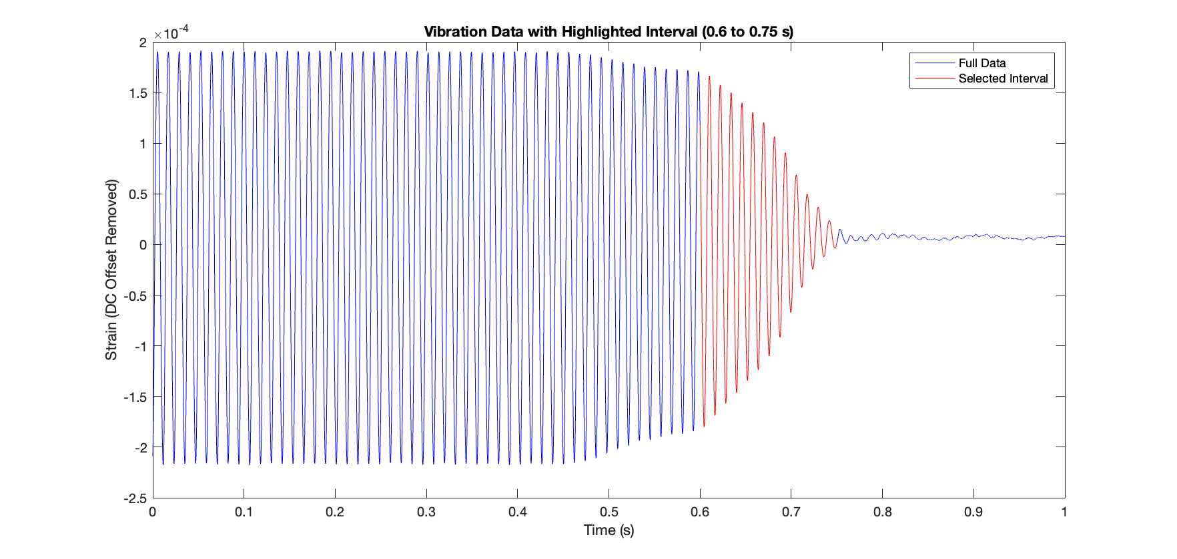
Figure 1- Collected data of vibrating bar coming to rest.
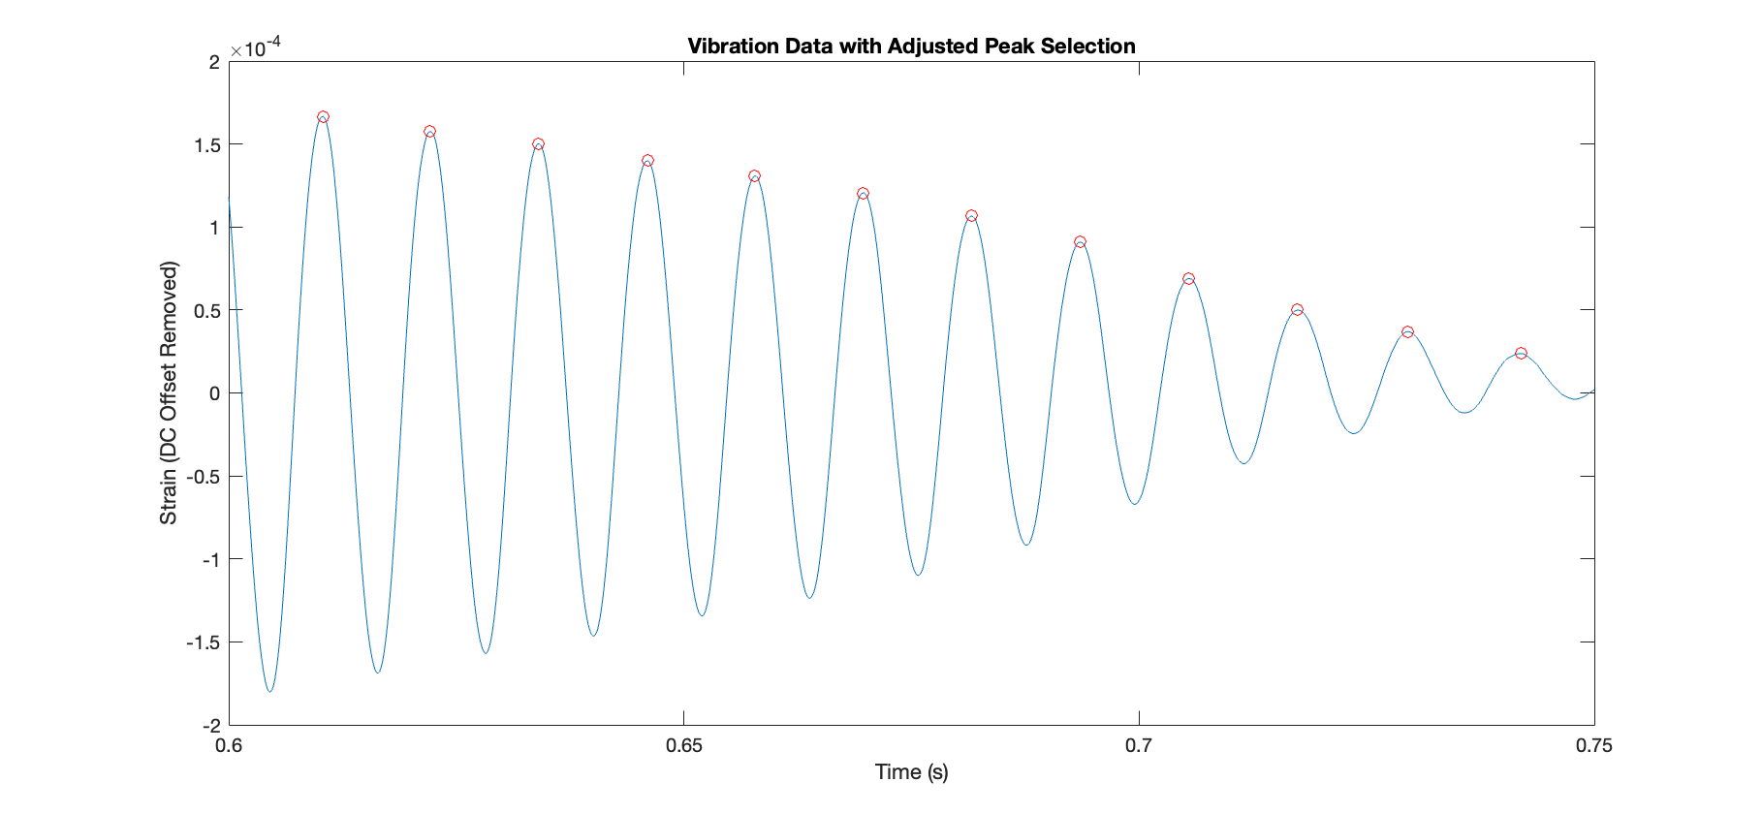
Figure 2- Data used to determine damping ratio.
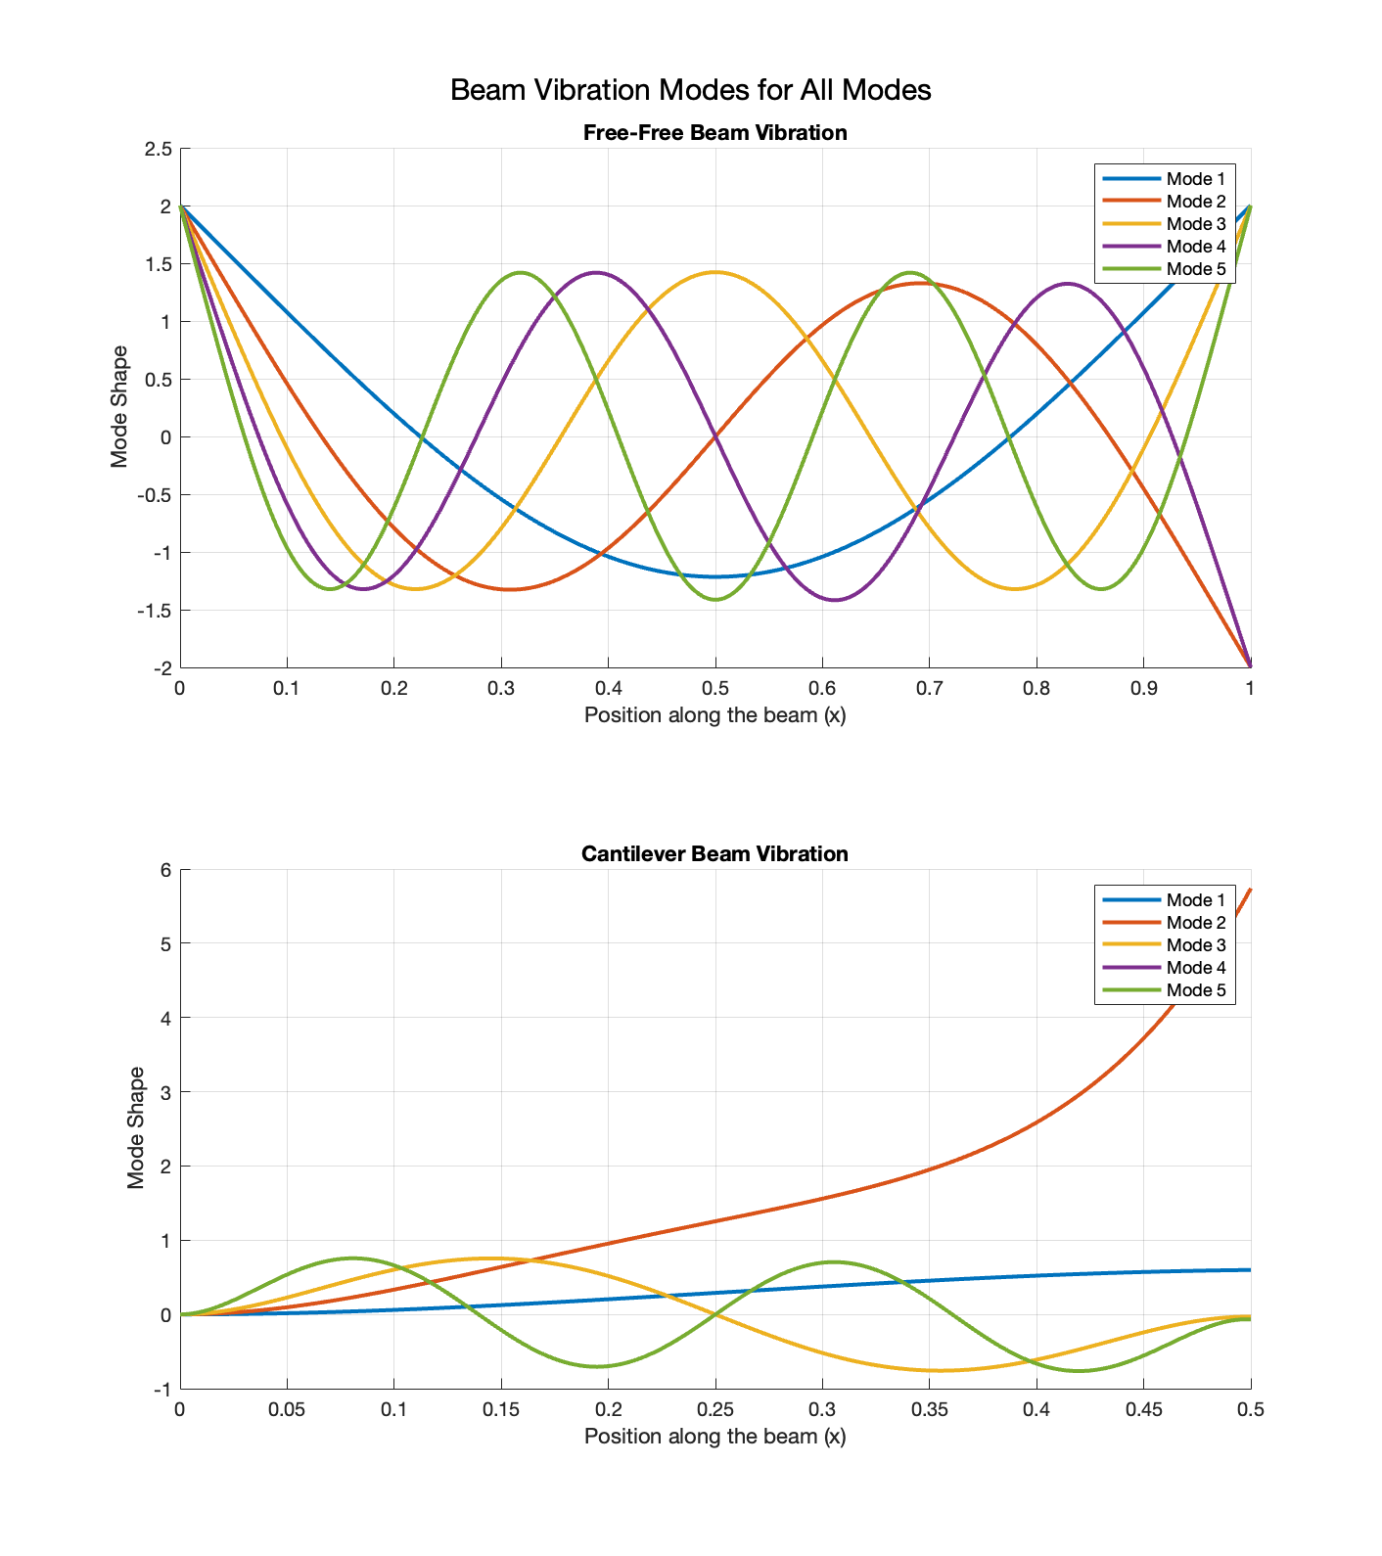
Figure 3-Mode shapes for Cantilever and Free-free beams

Table 1- Measured data vs calculated data and error.
Mode | Node | Measured | Free-Free | FF Error | Cantilever1 | C1 Error | Cantilever2 | C2 Error
1 | 1 | 0.225 | 0.22416 | 0.00084 | 0 | 0.225 | 0 | 0.225
 | 2 | 0.721 | 0.77585 | 0.05485 | N/A | N/A | N/A | N/A
2 | 1 | 0.112 | 0.13211 | 0.02011 | 0.07 | 0.042 | 0.099 | 0.043
 | 2 | 0.837 | 0.50001 | 0.33699 | 0.386 | 0.451 | 0.423 | 0.414
3 | 1 | 0.097 | 0.09444 | 0.00256 | 0.217 | 0.12 | 0.24 | 0.143
 | 2 | 0.381 | 0.35579 | 0.02521 | 0.402 | 0.021 | 0.424 | 0.043
4 | 1 | 0.065 | 0.07345 | 0.00845 | 0.144 | 0.079 | 0.164 | 0.099
 | 2 | 0.25 | 0.27678 | 0.02678 | 0.285 | 0.035 | 0.308 | 0.058
 | 3 | 0.707 | 0.50001 | 0.20699 | N/A | N/A | 0.308 | 0.399
 | 4 | 0.891 | 0.72323 | 0.16777 | N/A | N/A | 0.447 | 0.444
5 | 1 | 0.064 | 0.0601 | 0.0039 | 0.102 | 0.038 | 0.126 | 0.062
 | 2 | 0.228 | 0.22645 | 0.00155 | 0.213 | 0.015 | 0.239 | 0.011
 | 3 | 0.428 | 0.40912 | 0.01888 | 0.329 | 0.099 | 0.355 | 0.073
 | 4 | 0.54 | 0.59086 | 0.05086 | 0.43 | 0.11 | 0.455 | 0.085
 | 5 | 0.731 | 0.77353 | 0.04253 | N/A | N/A | N/A | N/A
 | 6 | 0.899 | 0.93989 | 0.04089 | N/A | N/A | N/A | N/A

