Lab 3 – Vibrations

Kerem Tekin
Matthew Burnett
Josiah Worch

EMCH 362 – Mechanical Laboratory 2
Mostafa Mobli
Madison Burlett
09-16-2024
Abstract
This study explores the vibration behavior of an aluminum beam in both free-free and cantilever configurations. The main objectives are to identify the first five natural resonant frequencies and their associated node positions, compare these findings with theoretical predictions, and determine the damping ratio for the cantilever setup. A custom LabView program was developed for data acquisition and analysis. Results showed a strong agreement between experimental data and theoretical predictions, validating the analytical models used. The damping ratio was also successfully calculated, providing insights into the energy dissipation characteristics of the beam.

Introduction
The analysis of beam vibrations is essential in structural dynamics, with applications spanning from aerospace, mechanical and civil engineering. Understanding the natural frequencies and mode shapes of a beam is crucial for the effective design and control of structures, mitigating the risk of resonant failures. This experiment focuses on the vibrational characteristics of an aluminum beam in free-free and cantilever configurations. The study aims to determine the natural frequencies and node positions and compare them with theoretical values. Furthermore, the experiment seeks to calculate the damping ratio to evaluate the material's inherent energy dissipation properties. The theoretical framework is based on classical beam theory, where natural frequencies depend on the material properties and geometric dimensions of the beam.

Methods
The experiments were conducted using an aluminum beam in two configurations: free-free and cantilever. The beam’s dimensions were precisely measured with a caliper and measuring tape. The experimental setup included a shaker to induce vibrations, a signal generator to control frequency and amplitude, and a power amplifier to drive the shaker. Natural frequencies were identified by varying the frequency of the signal generator and monitoring the maximum amplitude responses. To locate the nodes, a thin, light object, similar to a pencil, was gently run along the beam. The nodes were identified as points with minimal vibration amplitude. The natural frequencies were calculated using Equation 1, while the moment of inertia was determined using Equation 2.
(1) $f=\frac{{\left(β_{n}L\right)}^{2}}{2πL^{2}}⋅\sqrt{\frac{E⋅I}{ρ⋅A}}$
(2) $Ι=\frac{h⋅b^{3}}{12}$
A custom LabView program was developed for Experiment 2 to continuously capture the vibrational data of the beam using a data acquisition system. The program utilized a While Loop to collect strain data, displaying real-time graphs of the vibration signal and storing the data in a text file for subsequent analysis. The damping ratio (ζ) was determined using the logarithmic decrement method, where δ represents the logarithmic decrement calculated from the ratio of successive peak amplitudes, x_{n} and x₀.
(3) $ζ=\frac{δ}{2π}$
(4) $δ=\frac{1}{n}\ln\left(\frac{X_{o}}{X_{n}}\right)$

Results and Discussion
The experimental data for the natural frequencies and node positions of the aluminum beam in both free-free and cantilever configurations are presented in Table 1. Absolute errors between measured and theoretical values were calculated for each setup. The free-free configuration generally exhibited lower errors compared to the cantilever setup, with the largest deviation being 30mm for the second node position in the second mode. This indicates that the free-free model more accurately represents the beam's behavior. The moment of inertia was calculated as 4.32*10^-11 m^4.
In the cantilever configuration, significant discrepancies were observed in node positions, particularly in higher modes. The cantilever model struggled to accurately predict the number and location of nodes, which may be attributed to suboptimal clamping conditions or variations in the beam's effective length.
The second experiment focused on evaluating the damping characteristics of the cantilever beam. The average logarithmic decrement was measured to be 0.1772, resulting in a calculated damping ratio (ζ) of 0.0282, which is indicative of an underdamped system. These findings are depicted in Figures 1 and 2.
A MATLAB program was utilized to identify the peak amplitudes of the beam’s oscillations, and a statistical analysis was performed based on the decrement between successive peaks. The low damping ratio (ζ << 1) confirms that the beam undergoes free oscillations with minimal energy dissipation, typical of an underdamped system. This behavior is further illustrated in Figure 2, where the system demonstrates a gradual reduction in amplitude.
Conclusion
This investigation meticulously elucidated the vibrational dynamics of an aluminum beam subjected to both free-free and cantilever boundary conditions, fulfilling the principal objectives of delineating the first five intrinsic resonant frequencies, associated nodal positions, and ascertaining the damping ratio for the cantilever configuration. Empirical outcomes demonstrated that the free-free configuration offered a more precise approximation of the beam's dynamic response, as indicated by reduced discrepancies in nodal positions relative to analytical predictions, in contrast to the cantilever setup. The anomalies observed in the cantilever arrangement, including inaccuracies in nodal enumeration and spatial locations, are ostensibly attributable to suboptimal boundary constraints and potential measurement imprecisions.
To augment the veracity and consistency of ensuing experimental endeavors, several methodological refinements are advocated. For nodal position quantification, the deployment of high-resolution, non-intrusive methodologies, such as laser displacement sensors, is recommended to mitigate subjective inaccuracies. Ensuring a rigid and invariant clamping apparatus is paramount for ameliorating discrepancies inherent in the cantilever model. Furthermore, the integration of a more sophisticated data acquisition apparatus with enhanced sensitivity would facilitate a more nuanced characterization of frequency spectra, particularly for higher vibrational modes. The implementation of these enhancements would engender a more robust elucidation of beam vibration phenomena and substantiate the theoretical paradigms employed in this inquiry with greater rigor.
References
http://www.varg.unsw.edu.au/Assets/link%20pdfs/Beam_vibration.pdf
https://rtlabs.nitk.ac.in/?q=article/free-vibration-cantilever-beam
https://www.vibrationdata.com/tutorials2/beam.pdf
https://ocw.mit.edu/courses/2-002-mechanics-and-materials-ii-spring-2004/bc25a56b5a91ad29ca5c7419616686f7_lec2.pdf

Appendix

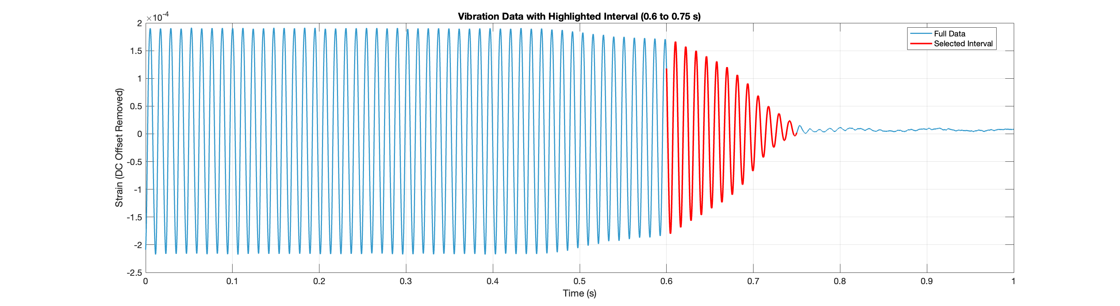
Figure 1- Collected data of vibrating bar coming to rest.
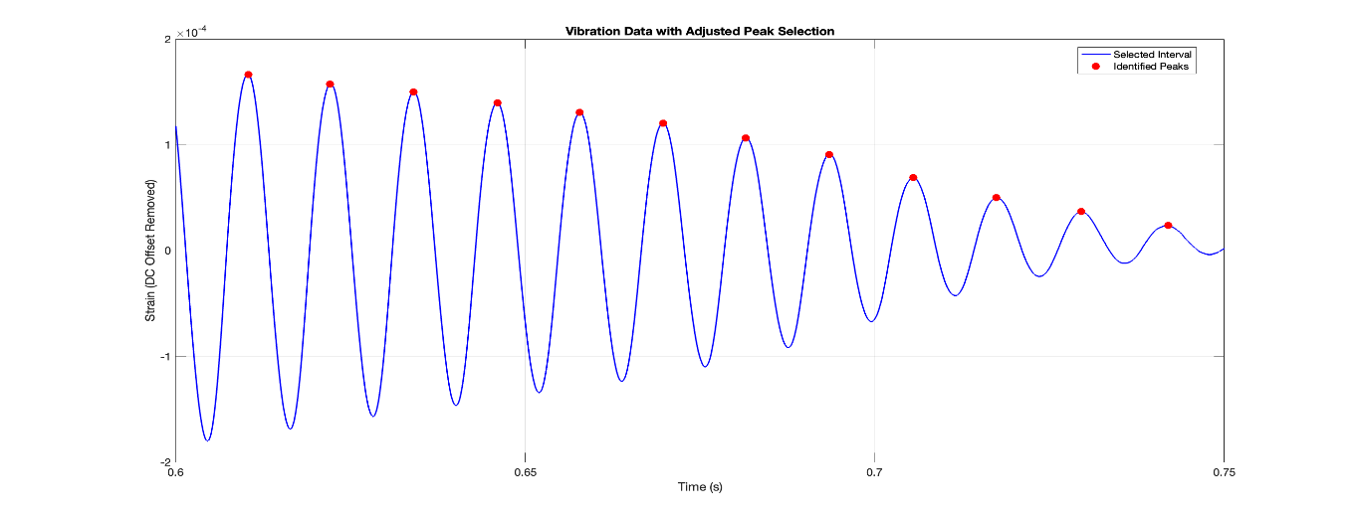
Figure 2- Data used to determine damping ratio.
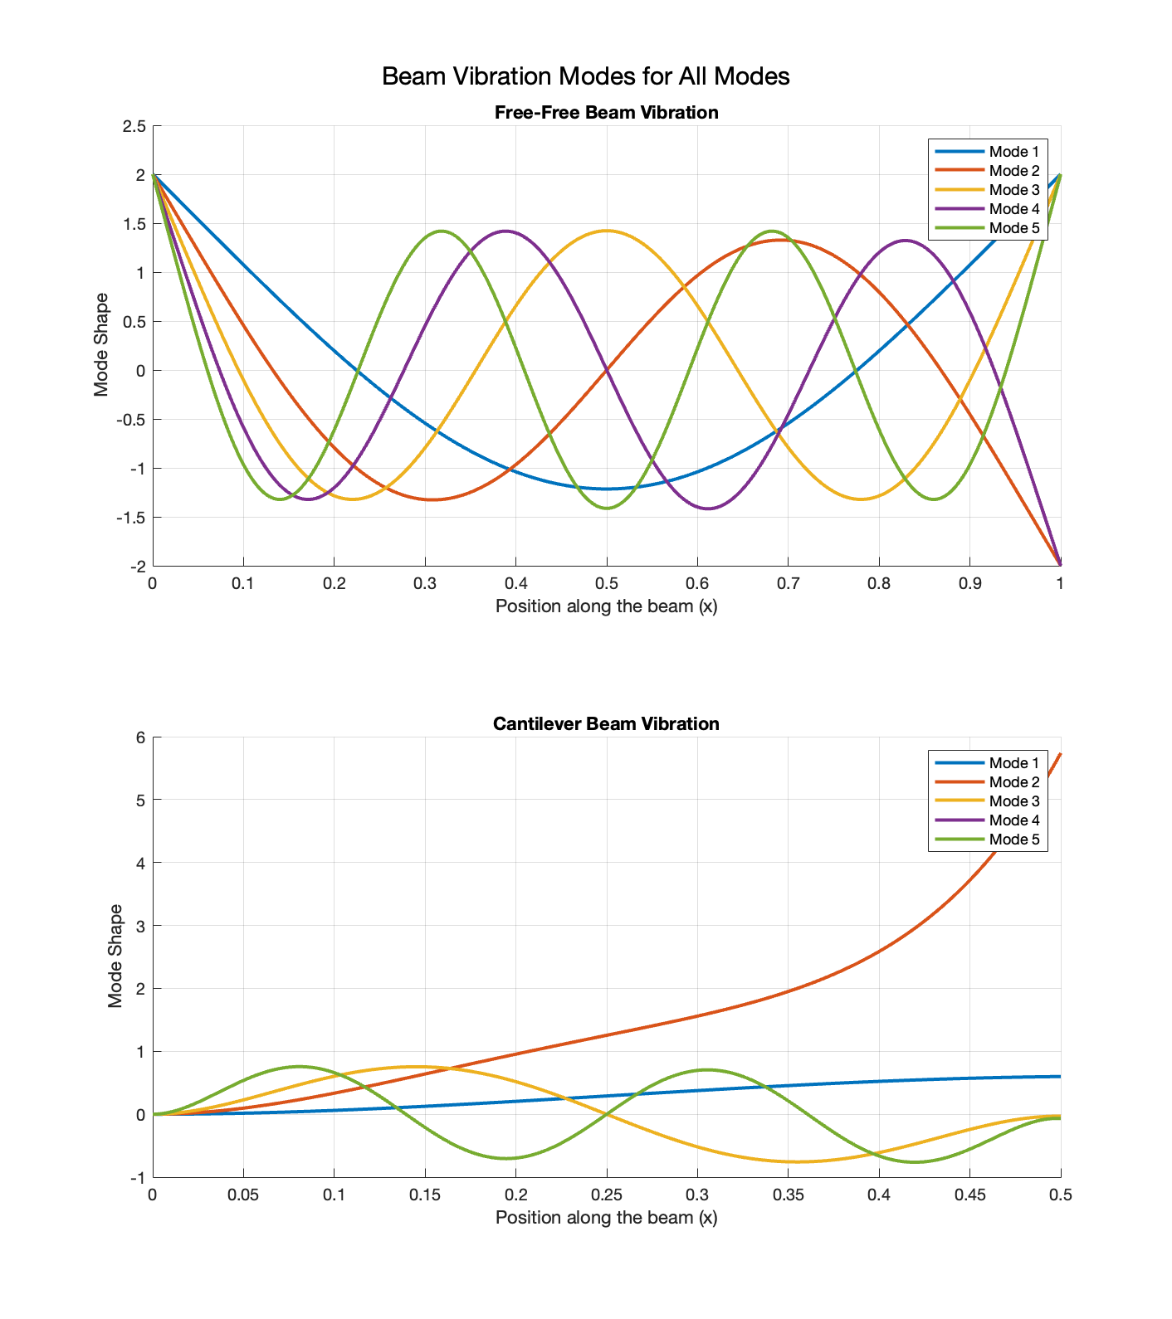
Figure 3-Mode shapes for Free-free beams

Table 1- Measured data vs calculated data and error.
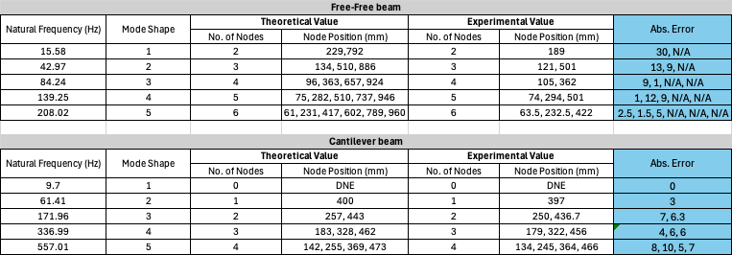

Table 2- Data for the beam.
