Lab 07 – CFD

Jacob Vaught
Michael Barger
Athena Shier

EMCH 362 – Mechanical Laboratory 2
Mobli Mostafa
Mario Villegas
10-21-2024
Abstract
This experiment investigates fluid flow characteristics around a square obstacle using Computational Fluid Dynamics (CFD) in ANSYS Workbench. The primary objective is to analyze wake formation, flow separation, and vortex generation at two inlet velocities: 0.01 m/s and 0.1 m/s. A structured mesh was used to ensure accurate resolution of boundary layer effects, with special focus on refining the mesh near the obstacle. Results show that increasing velocity leads to more pronounced wake regions and vortex formation, consistent with higher Reynolds number flows. Pressure distribution and velocity fields were visualized to illustrate stagnation and recirculation behavior. The study demonstrates the importance of mesh quality for accurate simulation results, with suggestions for further refinement and future exploration of turbulence models to improve accuracy.
Introduction
Fluid dynamics around obstacles, such as square bodies, is a significant area of study due to its relevance in various engineering applications, including aerodynamics, civil engineering, and heat exchangers. Understanding how fluid behaves when encountering obstacles is critical for designing systems to minimize drag, analyze loading, optimize flow, or predict vortex shedding behavior. This experiment aims to simulate and analyze the flow of air around a square obstacle using ANSYS Fluent, a tool in the Workbench package. The objectives include investigating wake formation, vortex shedding, and pressure distribution at multiple velocities. By employing a structured mesh, the simulation captures boundary layer effects and flow separation with precision. The study explores how increasing the inlet velocity affects flow behavior, with results expected to align with theoretical predictions for laminar bluff-body flows.
Methods
We created a 1m x 1m rectangular control volume with a centered 0.2m x 0.2m square obstacle using ANSYS DesignModeler. This configuration is a simplified representation of bluff-body flow, where the fluid encounters a sudden change in geometry, causing flow separation and the development of wake regions.
The geometry was discretized into smaller cells using a structured mesh to ensure that regions near the obstacle were accurately resolved. Special care was taken to refine the mesh around the square, ensuring precise calculation of flow features such as vortices and boundary layer behavior. Mesh quality metrics such as skewness and aspect ratio were checked to confirm the mesh was suitable for simulation, as poor mesh quality can negatively affect accuracy.
A 2D solver was used, and laminar flow was selected, as the Reynolds numbers for the given velocities fall well within the laminar range. Air was used as the working fluid with standard properties. Simulations were conducted for two velocities: 0.01 m/s and 0.1 m/s. A pressure outlet was set to 0 gauge pressure. No-slip boundary conditions were applied to the control volume walls and the surface of the square obstacle. The flow field was initialized from the inlet velocity, and the simulation was run for 1000 iterations, ensuring convergence by monitoring scaled residuals. Eq. 1 ensures mass conservation within the control volume and Eq. 2 describes how the velocity field evolves under the influence of pressure and viscous forces.
$$\begin{aligned}\frac{∂ρ}{∂t}+∇⋅ρv=0 \#1 \end{aligned}$$
$$\begin{aligned}ρ\left( \frac{∂ρ}{∂t}+v⋅∇v\right)=-∇ p+μ∇^{2}v \#2 \end{aligned}$$

Results and Discussion
The pathlines from the simulation provide insights into wake formation behind the square obstacle. At both velocities, fluid flows smoothly along the front face of the square, but separation occurs at the rear. At 0.01 m/s, the flow is stable, with a narrow wake region and minimal vortex shedding. As shown in Figure 1, at 0.1 m/s, the wake becomes larger, with visible vortex formation, indicating greater instability due to higher Reynolds number effects.
The pressure distribution highlights both stagnation and low-pressure regions around the square. As fluid hits the front face, it stagnates, creating a high-pressure zone, as expected when the velocity drops to zero. This follows Bernoulli’s principle. As fluid flows past the sides, it accelerates, causing a pressure drop. In Figure 2, at 0.1 m/s, the wake expands, forming a broader low-pressure zone due to increased separation.
The velocity vectors illustrate how the fluid speeds up along the square’s edges and slows in the wake. At 0.01 m/s, fluid accelerates moderately along the edges, staying attached to the surface with little separation. The wake shows low velocity, indicating limited recirculation. As shown in Figure 3, at 0.1 m/s, fluid accelerates more rapidly along the edges, with higher velocity magnitudes. The flow separates earlier at the square’s rear edges, creating larger recirculation zones typical of bluff-body flows at higher Reynolds numbers, where inertia prevents smooth reattachment.
Mesh quality was crucial for accurate results. The structured mesh captured boundary layer effects and vortex formation well. A finer mesh could improve the resolution of small vortices, while future simulations might benefit from testing unstructured or adaptive meshes.
Conclusion
This CFD simulation successfully demonstrated the effects of fluid flow around a square obstacle at two different inlet velocities. The results showed how wake regions, vortex formation, and flow separation develop behind the obstacle as the fluid flows around it. Increasing the velocity from 0.01 m/s to 0.1 m/s led to a larger wake region and more prominent vortex formation, aligning with theoretical expectations for bluff-body flows at higher Reynolds numbers.
The study highlighted the importance of mesh quality in CFD simulations. A well-refined mesh allowed for accurate resolution of the boundary layer and wake regions, ensuring reliable results. However, further improvements in mesh refinement could enhance the accuracy of the simulation, particularly at higher velocities.
In future studies, additional turbulence models (such as k-ω or k-ε) could be incorporated to simulate flow behavior more accurately at higher velocities where turbulence becomes significant.
References
- White, F. M., “Fluid Mechanics,” 7th Edition, McGraw-Hill, 2011.
- ANSYS Fluent User Guide, ANSYS Inc., 2024.

Appendix
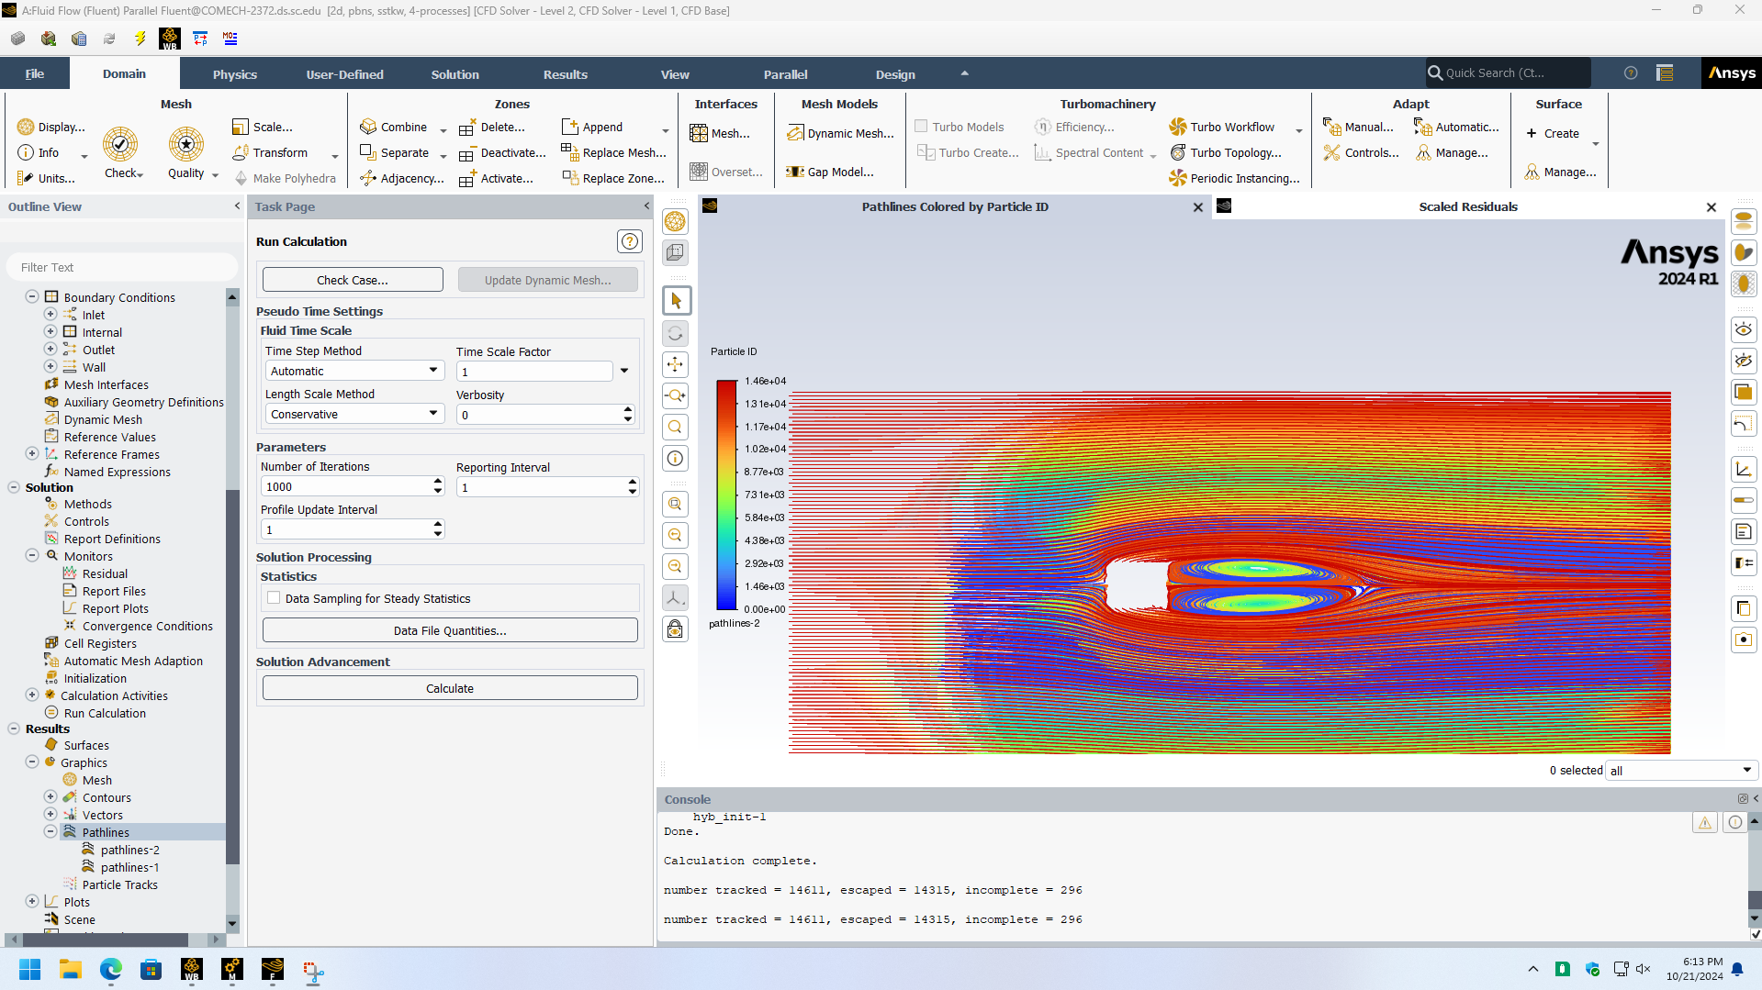
Figure 1- Pathlines Colored by Particle ID for 0.1
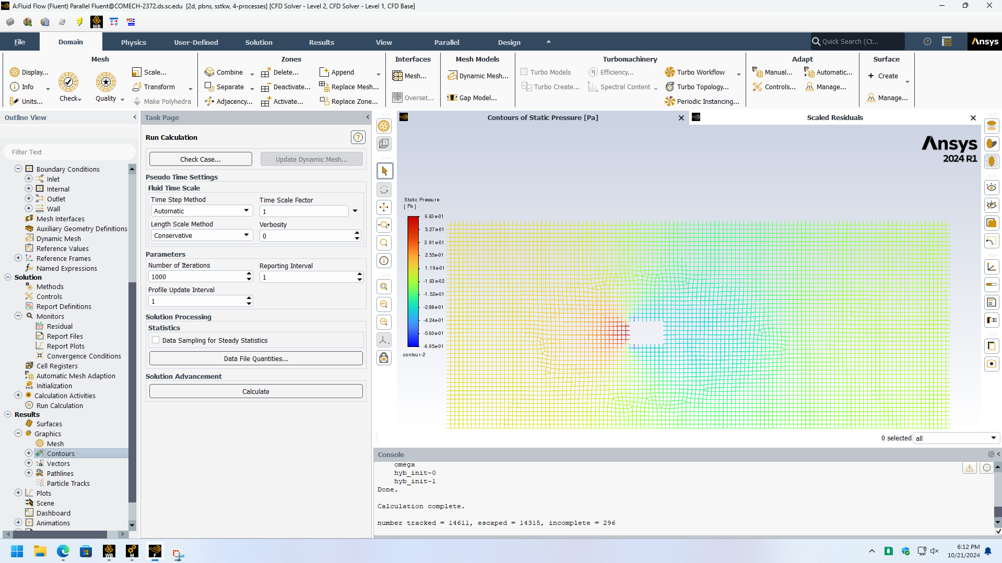
Figure 2- Pressure distribution contours for 0.1

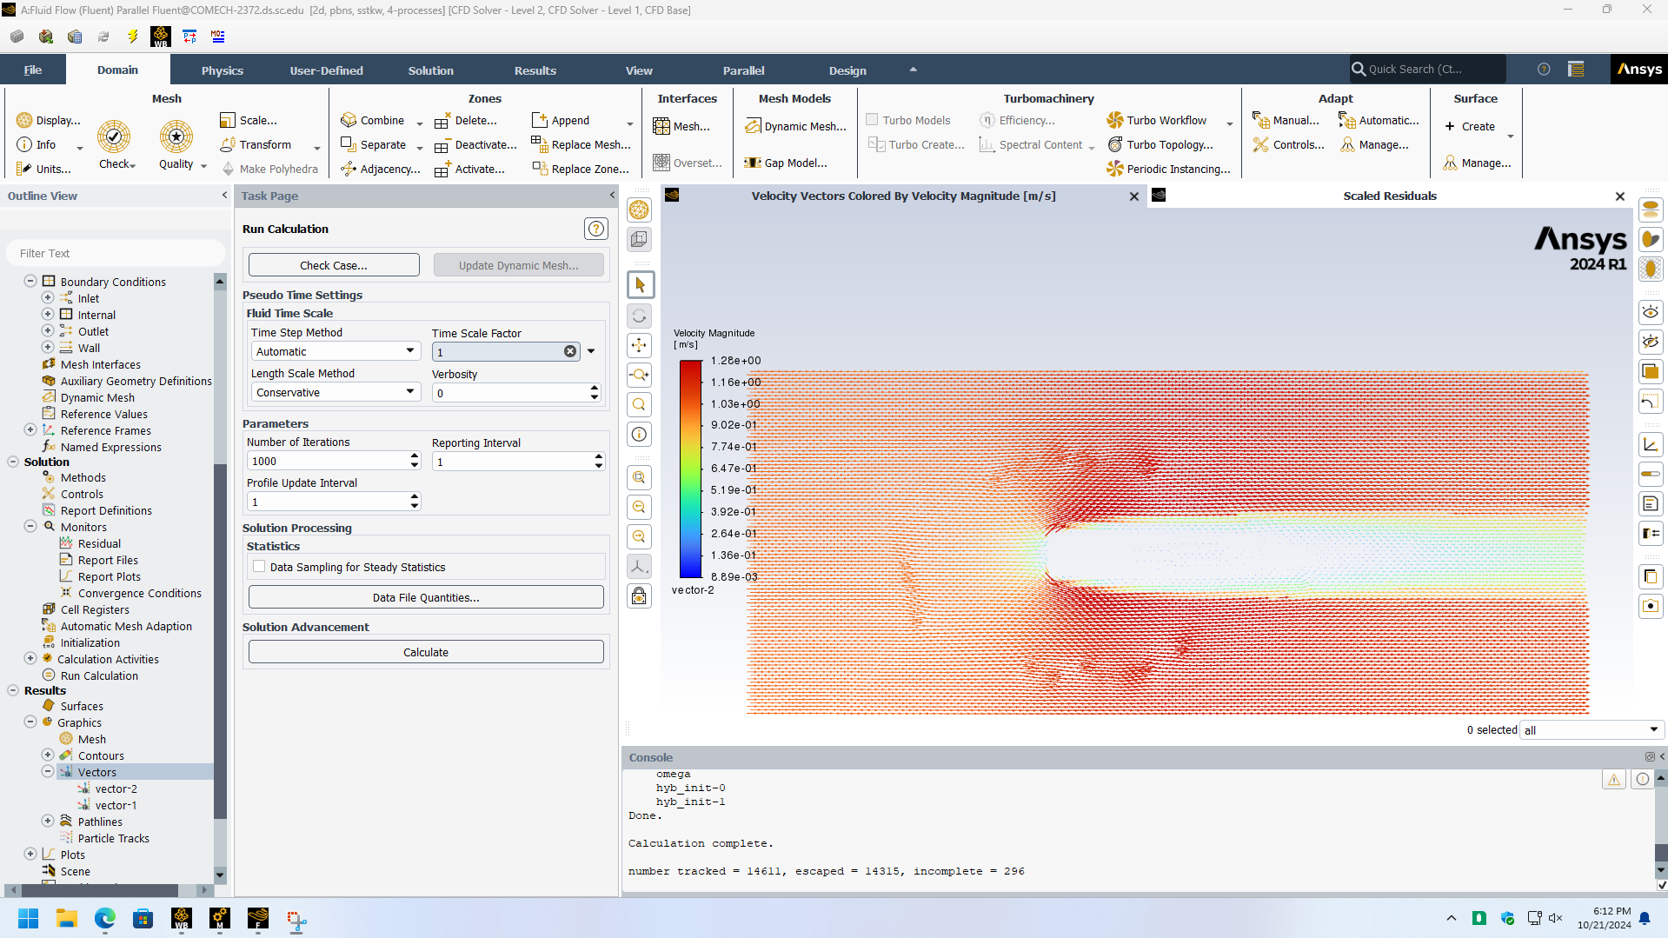
Figure 3- Velocity Vectors Colored by Magnitude for 0.1

