Lab 07 – CFD

Matthew Burnett
Josiah Worch
Kerem Tekin

EMCH 362 – Mechanical Laboratory 2
Mobli Mostafa
Madison Burlett
10-21-2024
Abstract
This study examines fluid flow characteristics around a square obstacle using Computational Fluid Dynamics (CFD) within ANSYS Workbench. The primary objectives are to analyze wake formation, flow separation, and vortex generation at inlet velocities of 0.01, 0.1 and 1 m/s. A structured mesh was employed to accurately resolve boundary layer effects, with particular emphasis on mesh refinement near the obstacle. Results indicate that higher inlet velocities lead to more pronounced wake regions and enhanced vortex formation, consistent with increased Reynolds numbers. Visualizations of pressure distribution and velocity fields elucidate stagnation and recirculation behaviors. The findings underscore the critical role of mesh quality in obtaining accurate simulations and suggest avenues for further mesh refinement and the exploration of advanced turbulence models to enhance accuracy.
Introduction
The study of fluid dynamics is pivotal in various engineering disciplines, including aerodynamics and thermal management systems. A comprehensive understanding of fluid behavior in the presence of obstacles is essential for designing systems that minimize drag, assess loading, optimize flow characteristics, and predict vortex shedding phenomena. This experiment utilizes ANSYS Fluent, part of the ANSYS Workbench suite, to simulate and analyze airflow around a square obstacle. The objectives encompass the investigation of wake formation, vortex shedding, and pressure distribution across multiple inlet velocities. By employing a structured mesh, the simulation accurately captures boundary layer effects and flow separation. Additionally, the study examines the impact of increased inlet velocities on flow behavior, with anticipated results aligning with theoretical models of laminar flows.
Methods
A rectangular control volume measuring 1 m × 1 m, containing a centrally positioned square obstacle of 0.2 m × 0.2 m, was created using ANSYS DesignModeler. This configuration serves as a simplified model of bluff-body flow, wherein the fluid encounters an abrupt geometric change, leading to flow separation and the formation of wake regions.
The geometry was discretized into smaller cells through a structured mesh to ensure accurate resolution of regions near the obstacle. Particular attention was given to mesh refinement around the square to facilitate precise computation of flow features such as vortices and boundary layer behavior. Mesh quality metrics, including skewness and aspect ratio, were evaluated to confirm the suitability of the mesh for simulation, as poor mesh quality can adversely affect accuracy.
A two-dimensional solver was employed, and laminar flow was selected, as the Reynolds numbers corresponding to the inlet velocities of 0.01 m/s, 0.1 m/s, and 1 m/s remained within the laminar regime. Air was utilized as the working fluid, adopting standard properties. A pressure outlet was established at 0 gauge pressure. No-slip boundary conditions were imposed on both the control volume walls and the surface of the square obstacle. The flow field was initialized based on the inlet velocity, and the simulation was executed for 1000 iterations, ensuring convergence by monitoring scaled residuals. Equation (1) ensures mass conservation within the control volume, while Equation (2) describes the evolution of the velocity field under the influence of pressure and viscous forces. $\begin{aligned}\frac{∂ρ}{∂t}+∇⋅ρv=0 \#1 \end{aligned}$
$$\begin{aligned}ρ\left( \frac{∂ρ}{∂t}+v⋅∇v\right)=-∇ p+μ∇^{2}v \#2 \end{aligned}$$
Results and Discussion
The simulation pathlines provide insights into wake formation behind the square obstacle at inlet velocities of 0.01 m/s, 0.1 m/s, and 1 m/s. At all velocities, fluid flows smoothly along the front face of the square; however, flow separation occurs at the rear. At 0.01 m/s, the flow remains stable, exhibiting a narrow wake region with minimal vortex shedding. At 0.1 m/s, as illustrated in Figure 1, the wake expands, and visible vortices emerge, indicating increased instability associated with higher Reynolds numbers.
The pressure distribution reveals both stagnation and low-pressure regions surrounding the square obstacle. Upon impact with the front face, fluid stagnates, resulting in a high-pressure zone, consistent with Bernoulli’s principle as velocity approaches zero. As fluid flows past the sides, acceleration occurs, leading to a pressure drop. In Figure 2, at 0.1 m/s, the wake expands, forming a broader low-pressure zone due to increased flow separation.
As shown in Figure 3, fluid accelerates more rapidly along the edges, resulting in higher velocity magnitudes. Flow separation initiates earlier at the rear edges, creating larger recirculation zones typical of bluff-body flows at elevated Reynolds numbers, where inertial forces inhibit smooth reattachment. At 1 m/s, fluid acceleration along the edges is pronounced.
Mesh quality was essential for accurate simulation results. The structured mesh effectively captured boundary layer effects and vortex formation. A finer mesh could enhance the resolution of smaller vortices, while future simulations may benefit from employing unstructured or adaptive meshes to further improve accuracy.

Conclusion
This CFD simulation successfully demonstrated the effects of fluid flow around a square obstacle at three distinct inlet velocities: 0.01 m/s, 0.1 m/s, and 1 m/s. The results elucidated the development of wake regions, vortex formation, and flow separation behind the obstacle as the fluid navigated around it. An increase in inlet velocity from 0.01 m/s to 0.1 m/s resulted in a larger wake region and more pronounced vortex formation, consistent with theoretical predictions for bluff-body flows at elevated Reynolds numbers. Further increasing the velocity to 1 m/s led to an even more extensive wake and intensified vortex structures, reflecting heightened flow instability associated with higher Reynolds numbers.
The study underscored the critical role of mesh quality in CFD simulations. A well-refined structured mesh facilitated accurate resolution of boundary layer effects and wake regions, thereby ensuring reliable results across all tested velocities. Nevertheless, enhanced mesh refinement could further improve simulation accuracy, particularly at the highest velocity of 1 m/s, where finer flow details become increasingly significant.
Future studies may incorporate additional turbulence models to more accurately capture flow behavior at higher velocities where turbulence effects become more prominent.
References
- White, F. M., “Fluid Mechanics,” 7th Edition, McGraw-Hill, 2011.
- ANSYS Fluent User Guide, ANSYS Inc., 2024.

Appendix
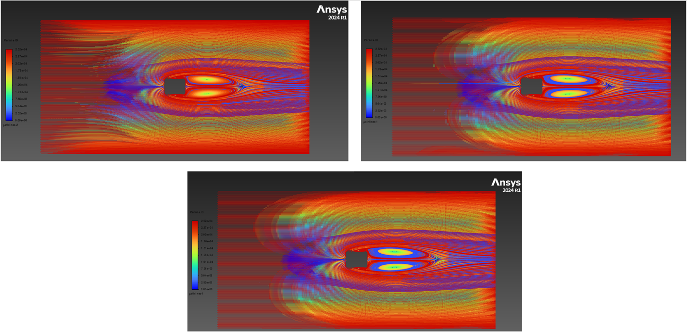
Figure 1- Pathlines Colored by Particle ID for 0.1
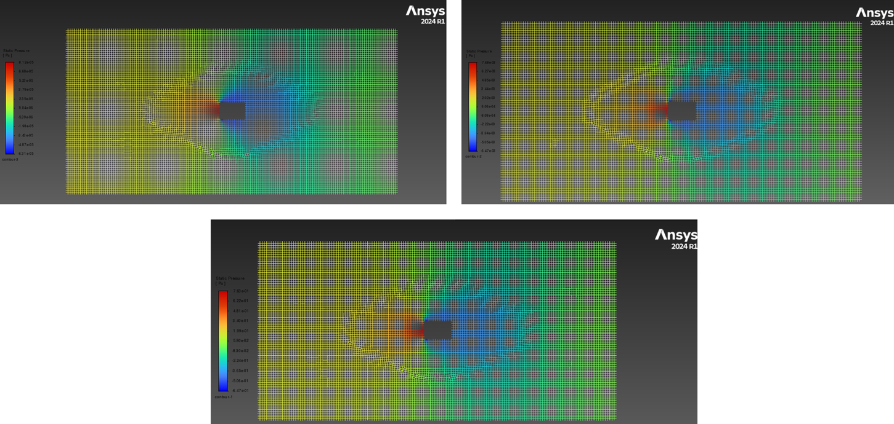
Figure 2- Pressure distribution contours for 0.1

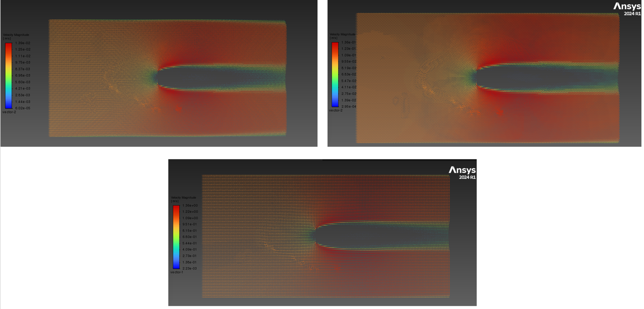
Figure 3- Velocity Vectors Colored by Magnitude

