Lab 08 – CM

Jacob Vaught
Michael Barger
Athena Shier

EMCH 362 – Mechanical Laboratory 2
Mobli Mostafa
Mario Villegas
10-28-2024
Abstract
This experiment explores the deformation of a circular object under fluid forces by integrating CFD results from ANSYS Fluent into a static-structural analysis in ANSYS Workbench. The objectives were to analyze stress, strain, and deformation using Multiphysics simulation. The study utilized a structured mesh tailored for structural analysis and imported pressure distribution data from CFD simulations as boundary conditions. Results revealed that deformation was concentrated in regions exposed to higher fluid forces, while stress concentrated near fixed supports. The findings emphasize the significance of coupling CFD and structural analysis for accurate simulation of real-world engineering scenarios.

Introduction
Understanding the interaction between fluid forces and structural deformation is critical in fields such as aerospace, civil engineering, and biomechanics. Multiphysics simulations, which couple CFD and structural analysis, allow engineers to study the effects of fluid pressure on materials. This lab aimed to investigate the deformation of a circular object subjected to fluid forces by integrating CFD results from ANSYS Fluent into a static-structural analysis. The analysis focused on understanding stress distribution, strain behavior, and deformation patterns under a defined load. A structured mesh was used to enhance the accuracy of the structural analysis, and results were validated through post-processing tools.

Methods
We created a 2D circular object with a diameter of 1 m using ANSYS DesignModeler. This configuration represents a simplified structural model subjected to fluid forces, enabling the analysis of deformation caused by pressure distribution obtained from a CFD simulation.
The geometry was discretized using a structured mesh tailored specifically for structural analysis. Special attention was given to mesh refinement near the edges of the object, where higher stress and strain were expected. Mesh quality metrics such as element size, skewness, and aspect ratio were checked to ensure the mesh was suitable for the simulation. Proper mesh refinement was crucial for accurate complex force distributions.
The material properties of the circular object were defined as structural steel, with isotropic and linear behavior assumed for the analysis. Fixed supports were applied to constrain two opposing sides of the object, simulating a realistic loading scenario. Fluid pressure results from a previous CFD simulation in ANSYS Fluent were imported as boundary conditions through a data transfer link between the Fluent and Static-Structural modules.
The CFD simulation was conducted with air as the working fluid, and the pressure distribution generated on the circular object was used as input for the structural analysis. The pressure load was applied to the surface of the object in the Static-Structural module, and the simulation was run to calculate the deformation, stress, and strain. The governing equations for the structural analysis include Eq. 1 and Eq. 2 for stress-strain relationships:
$$\begin{aligned}∑F=0\#1 \end{aligned}$$
$$\begin{aligned}σ=E⋅ϵ\#2 \end{aligned}$$

Results and Discussion
The simulation results provide detailed insights into the deformation of the circular object under fluid pressure, focusing on equivalent elastic strain, equivalent stress, and total deformation. These parameters were visualized using contour plots, which highlight the deformation behavior and load distribution across the object.
As shown in Figure 1, the strain contours reveal a radial gradient, with deformation increasing progressively from the center toward the free edges. This behavior aligns with theoretical expectations for isotropic materials under uniformly distributed pressure forces.
As shown in Figure 2, the stress contours highlight critical areas near the fixed boundaries, where the majority of the force is absorbed. The smooth transition of stress toward the free edges further validates the mesh quality and material property settings.
As shown in Figure 3, the deformation contours indicate a symmetric displacement pattern, with the highest movement occurring at the free edges. The uniform deformation pattern demonstrates a realistic response to the applied boundary conditions.
The simulation results emphasize the need for careful consideration of stress and strain concentrations when designing structures subjected to fluid forces. Identifying regions prone to high stress can help engineers reinforce critical areas, improving durability and preventing failure.

Conclusion
This simulation successfully demonstrated the structural response of a circular object under fluid forces, integrating CFD and static-structural analysis in ANSYS Workbench. The results showed how equivalent elastic strain, von Mises stress, and total deformation were distributed across the object, with strain and deformation concentrated in fluid-exposed regions and stress peaking near the fixed supports. These outcomes align with theoretical expectations for isotropic materials under uniform pressure loads.
The study emphasized the importance of mesh quality in structural simulations. A well-defined and refined mesh ensured accurate resolution of stress and strain gradients, leading to reliable results. Further improvements in mesh refinement, especially near areas of high deformation or stress concentration, could enhance the accuracy of the analysis.
In future studies, the use of non-linear materials, dynamic loading scenarios, or alternative boundary conditions could provide a more comprehensive understanding of fluid-structure interaction. Additionally, incorporating adaptive meshing or more advanced coupling techniques may improve the resolution and efficiency of similar simulations.
References
- White, F. M., “Fluid Mechanics,” 7th Edition, McGraw-Hill, 2011.
- ANSYS Fluent User Guide, ANSYS Inc., 2024.

Appendix
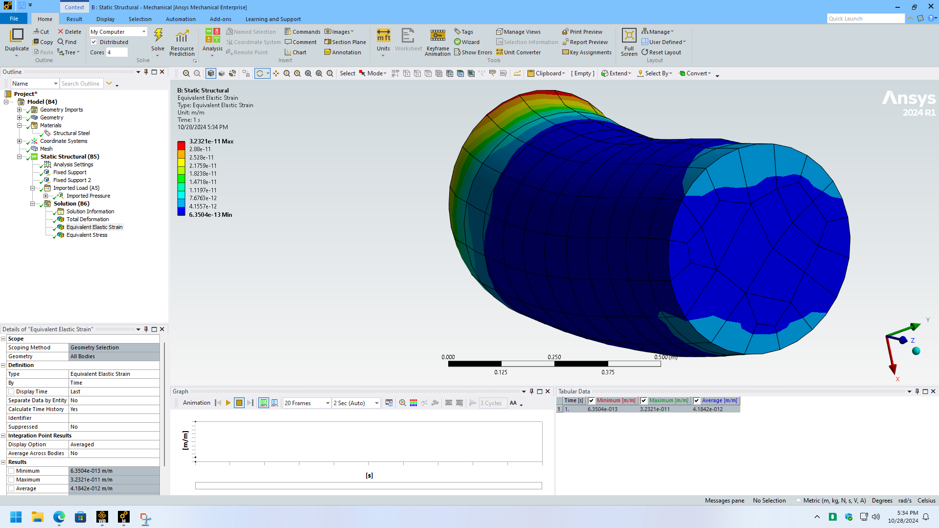
Figure 1- Elastic Strain
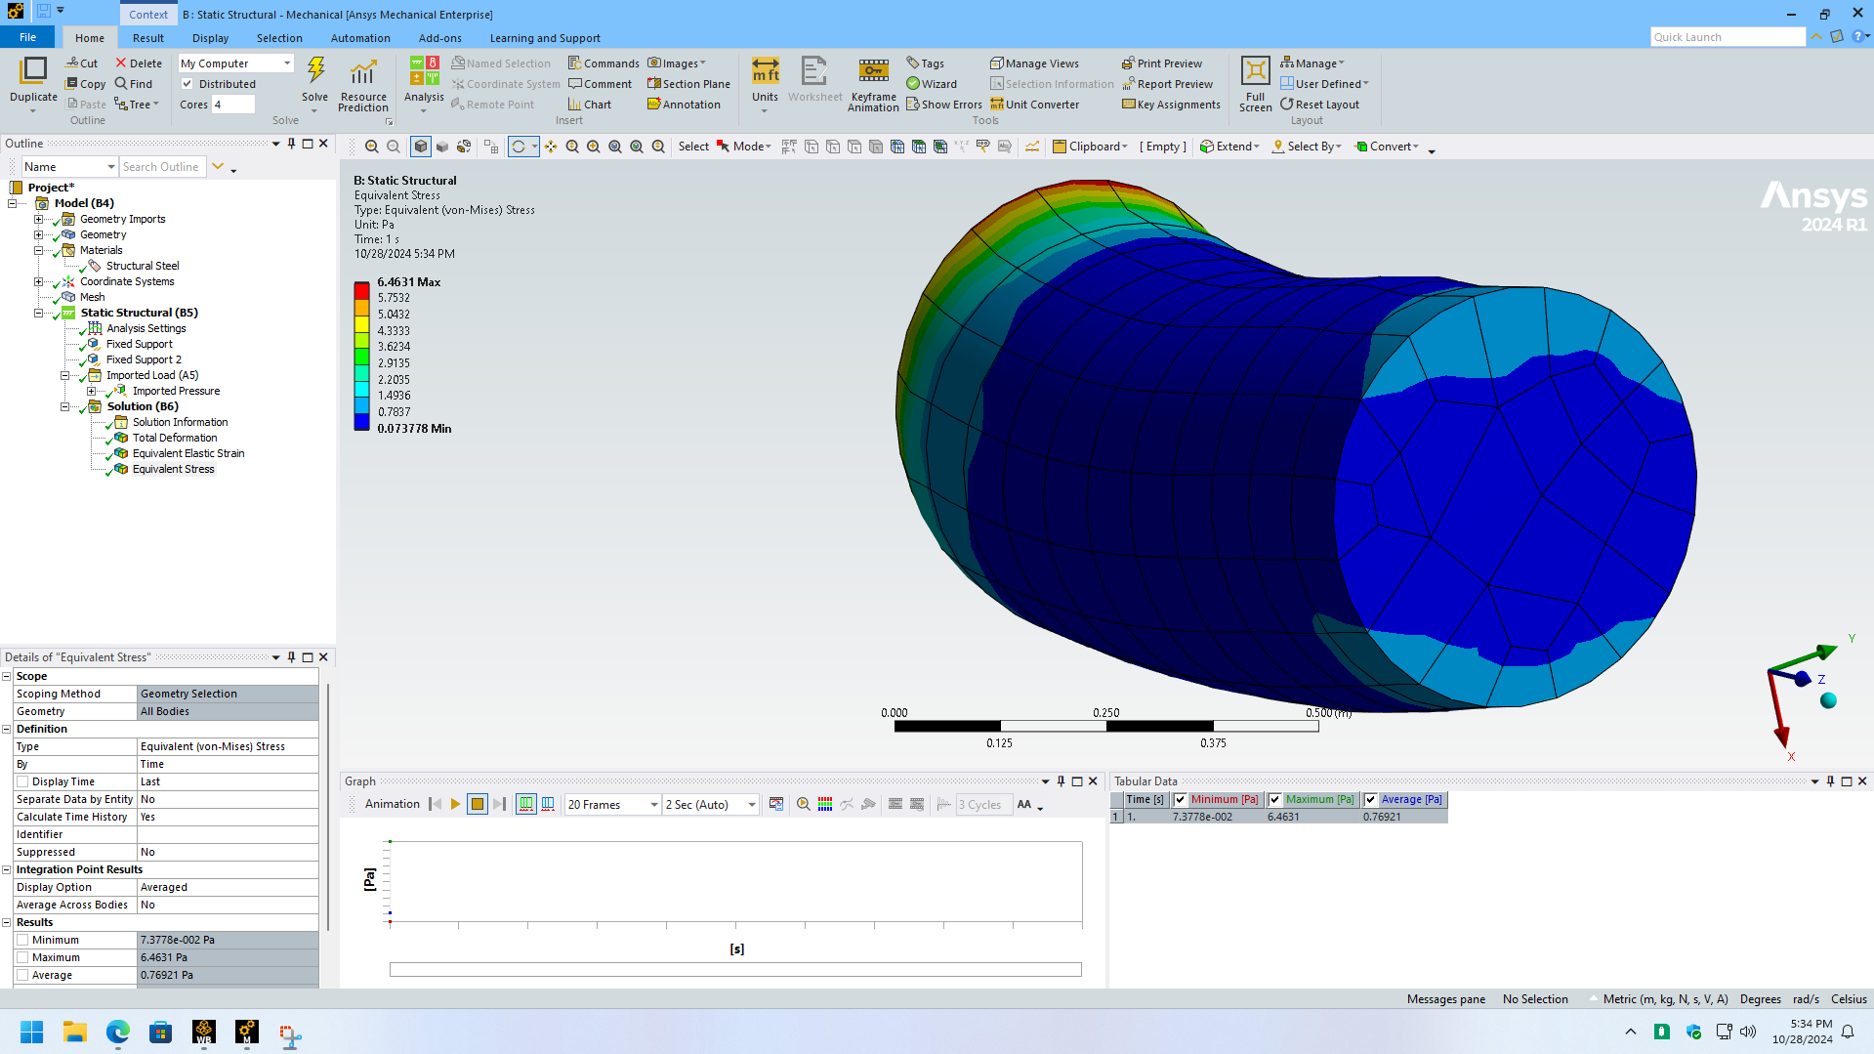
Figure 2- Equivalent Stress

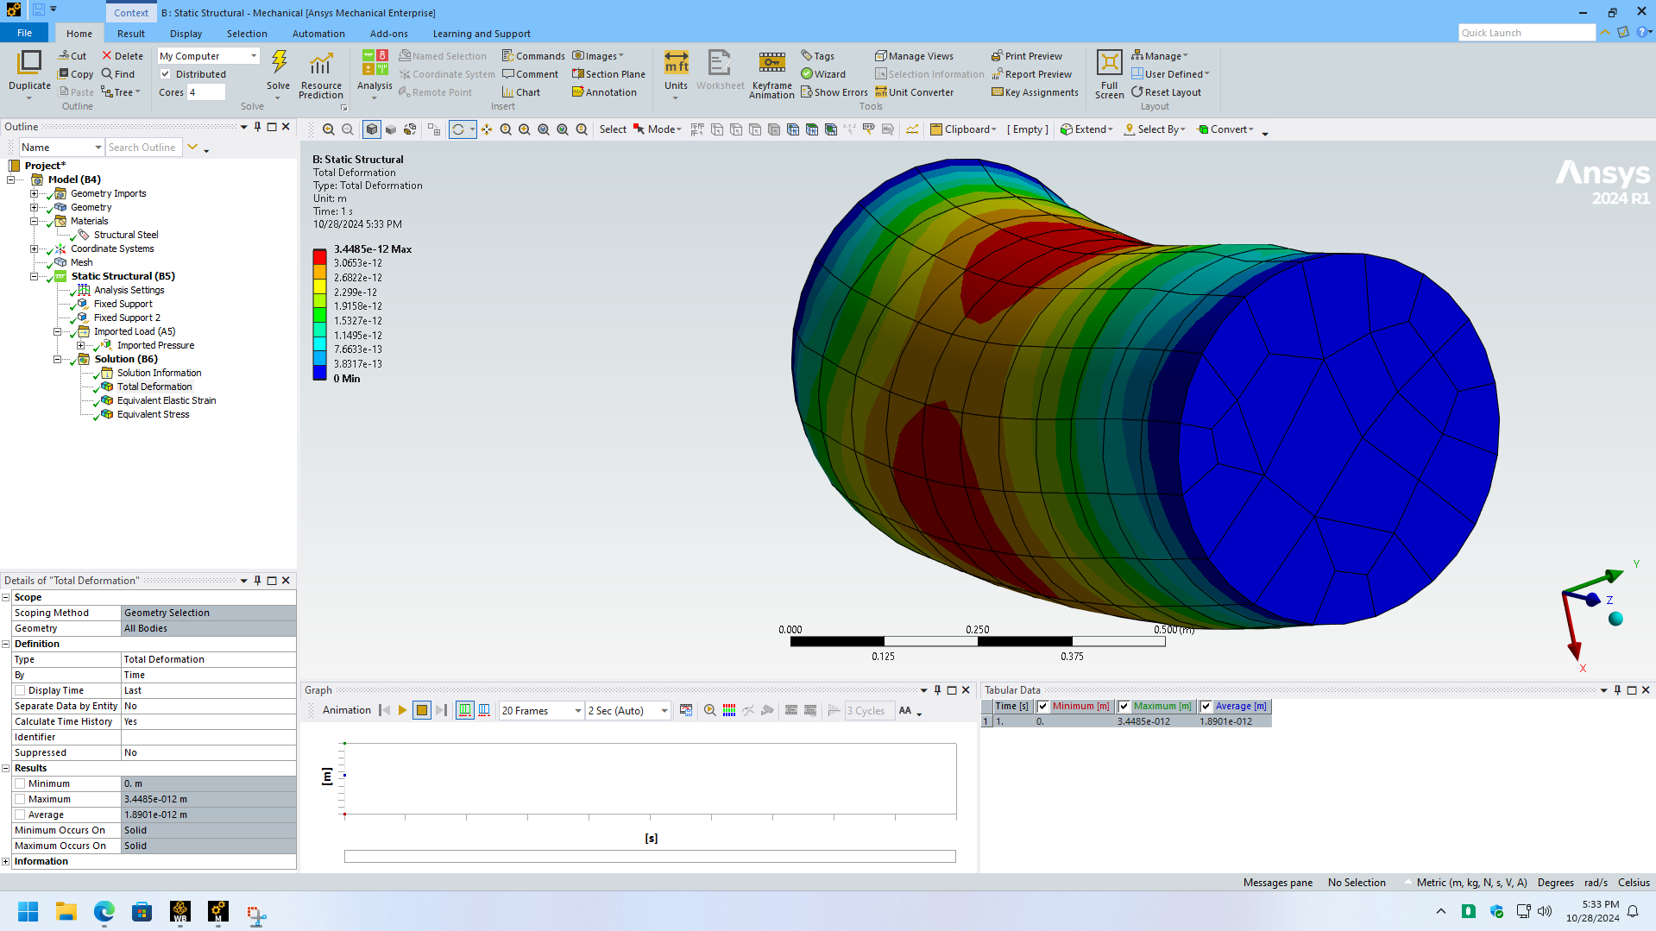
Figure 3- Total Deformation

