Control Methodologies for Tailless Aircraft: Analysis and Testing
Authored by Jacob C. Vaught
University of South Carolina
ELCT 331 Control Systems Fundamentals

Background
The exploration of optimal control strategies for tailless aircraft represents a significant area of interest within the realms of both civilian and military aviation. Tailless aircraft, distinguished by their lack of conventional vertical tails, present a unique set of aerodynamic challenges. This configuration leads to advantages such as reduced radar visibility and enhanced weight efficiency, making them particularly valuable for stealth operations and energy conservation. However, these benefits are counterbalanced by intrinsic issues related to stability and control complexities.
Historically, control methods for tailless aircraft have often depended on a combination of aerodynamic shaping and the use of active control surfaces. These traditional approaches, while somewhat effective, typically result in increased weight and mechanical complexity. Such increases can detrimentally affect the aircraft's overall efficiency and reliability, posing significant challenges in their design and operational use.
Recent technological advancements have paved the way for more sophisticated control solutions, such as the implementation of nonlinear dynamic inversion (NDI) control laws. This approach is grounded in the principle of time scale separation, which allows for the categorization of control variables into 'fast' and 'slow' groups. This separation facilitates the independent development of specific control laws for each group. Typically, these control laws are integrated into a dual-loop flight control system. This system, often featuring a modular architecture, streamlines the coordination of redundant control surfaces, thereby simplifying the control system design process.
Despite these advancements, tailless aircraft continue to face formidable challenges rooted in their inherent aerodynamic instability. This instability is primarily a consequence of the absence of a vertical tail, a feature traditionally responsible for providing yaw stability. As a result, tailless aircraft necessitate more complex and sophisticated control mechanisms to ensure stable and responsive maneuvering.
Advanced control systems, such as the nonlinear dynamic inversion method, aim to tackle these challenges. However, they introduce additional layers of complexity. These systems are tasked with managing the complex interplay of multiple control surfaces and their nonlinear impact on the aircraft's flight dynamics. Furthermore, the design and practical implementation of these advanced systems necessitate a meticulous consideration of the aircraft's dynamic behavior across varying flight conditions, including scenarios involving potential structural damages or system failures.
The critical role of tailless aircraft in both civilian and military sectors, coupled with the unique challenges posed by their design, highlights the imperative for ongoing research and development in this specialized field. The pursuit of ensuring the safe, efficient, and reliable operation of these aircraft remains a paramount objective for aerospace engineers and researchers, demanding continual innovation and adaptation in control system design and aerodynamic optimization.

Theory
In the realm of control engineering, various control strategies are carefully engineered to tackle specific system characteristics and challenges. These strategies employ distinct mathematical formulations to achieve desired outcomes, and they play a crucial role in shaping the behavior of complex systems. This section discusses six prominent control strategies, exploring their mathematical foundations and practical applications.
Nonlinear Dynamic Inversion is an advanced control method primarily applied to systems with nonlinear dynamics. Its fundamental premise involves inverting the system's nonlinear dynamics to control it as if it were linear. This process hinges on constructing a nonlinear model of the system and then inverting this model to determine the control input. Mathematically, NDI is represented as:
$$u=f^{-1}\left(x,\dot{x},y_{des}\right)$$
Here, $u$ signifies the control input, $f^{-1}$ stands for the inversion of the nonlinear model, while $x$, $\dot{x}$, and $y_{des}$ denote the state, its derivative, and the desired output, respectively. This approach empowers engineers to exert precise control over systems characterized by intricate nonlinear behaviors. However, NDI's effectiveness is contingent on the accuracy of the model used, making it less reliable for systems where precise modeling is challenging or infeasible.
Continuous Sliding Mode Control is particularly effective when dealing with systems riddled with uncertainties or nonlinearities. It functions by establishing a sliding surface, typically a function of the system state, and then designing a control law that compels the system state to reach and remain on this surface. The general form of the control law in SMC is expressed as:
$$u=-k⋅\text{sign}\left(s\left(x\right)\right)$$
In this equation, $s(x)$ signifies the sliding surface function, and $k$ represents a positive gain. The sign function ensures that the control action propels the system state toward the sliding surface, bestowing robustness against disturbances and uncertainties. This robustness, however, comes with a potential downside of high-frequency oscillations or "chattering," which can be detrimental to the system's actuators and overall stability.
The Linear Quadratic Regulator is a cornerstone of linear control theory, particularly in systems where striking a balance between control effort and state accuracy is paramount. The primary goal of LQR is to minimize a cost function typically comprising terms for state error and control effort. The cost function assumes the form:
$$J=\int_{0}^{∞}{\left(x^{T}Qx+u^{T}Ru\right)dt}$$
In this equation, $Q$ and $R$ serve as weighting matrices that define the relative significance of state error and control effort, respectively. This approach is highly efficient in systems requiring precise control while minimizing energy or effort expenditure. While efficient for linear systems, LQR's performance can degrade in the presence of nonlinearity or model uncertainties. Additionally, the selection of weight matrices in the cost function is often subjective, requiring expert knowledge and trial-and-error tuning.
The Proportional-Integral-Derivative (PID) controller stands as one of the most widely used control strategies, renowned for its simplicity and effectiveness. It computes control actions based on the current error, its accumulation over time, and its rate of change. The control action in a PID controller is expressed as:
$$u\left(t\right)=K_{p}e\left(t\right)+K_{i}\int{e\left(t\right)dt}+K_{d}\frac{de\left(t\right)}{dt}$$
In this equation, $K_{p}$, $K_{i}$, and $K_{d}$ represent the proportional, integral, and derivative gains, respectively, while $e(t)$ denotes the error at time $t$. This method shines in systems characterized by relatively straightforward dynamics. While effective for many systems, PID controllers can struggle with non-linear systems or systems with significant time delays. They also require careful tuning of their gain parameters, which can be non-trivial in complex systems.
Model Predictive Control is a control strategy harnessing a system model to predict future states and optimize control actions over a future time horizon. The objective function in MPC is typically formulated as:
$$\min_{U}{\sum_{k=0}^{N-1}{\left(x_{k}^{T}Qx_{k}+u_{k}^{T}Ru_{k}\right)}}$$
Subject to the constraint $x_{k+1}=Ax_{k}+Bu_{k}$, with $N$ representing the prediction horizon and $A$ and $B$ denoting the system matrices. MPC proves especially valuable in intricate systems where forecasting future states and managing constraints are pivotal for control. However, MPC requires significant computational resources due to its predictive nature, and its performance is heavily reliant on the accuracy of the system model used.
This modern approach leverages neural networks to model and control complex, nonlinear systems. Here, the control input is derived from the neural network's output, which is a function of its inputs and learned weights. The control input can be formulated as:
$$u=NN\left(x,θ\right)$$
In this equation, $NN$ signifies the neural network function, $x$ represents the input to the network, and $θ$ denotes the network's weights. This approach excels in learning and adapting to a system's dynamics but demands substantial data and computational resources for training. While powerful in learning and adapting to system dynamics, this approach demands substantial computational resources and extensive data for training the network. Additionally this type of system is currently still an active research area, resulting in a less understood control system leading to potential issues.
Each of these control strategies serves as a tailored tool for managing specific types of systems and addressing unique challenges. From mitigating nonlinear behaviors to optimizing control actions based on future predictions, these methodologies exemplify the depth and adaptability of modern control theory in the field of engineering.

Challenges and Objectives
The objective of this project entails the creation of a controller tasked with guiding the system to achieve a target angle of attack (α) of 0.5 radians and a sideslip angle (β) of 0.2 radians, all while maintaining zero steady-state error. The system experiences a sudden shift in dynamics at the 5-second mark, further complicated by the presence of five control variables. Consequently, this project presents a highly intricate control system design challenge. The system State Space equation as provided from the report paper is shown below.

$$\begin{matrix} & \left[\begin{matrix}\overset{˙}{α} \\ \overset{˙}{β} \\ \overset{˙}{p} \\ \overset{˙}{q} \\ \overset{˙}{r}\end{matrix}\right]=\left[\begin{matrix}-0.6344 & 0.0027 & 0 & 0.9871 & 0 \\ 0 & -0.0038 & 0.1540 & 0 & -0.9876 \\ 0 & -8.2125 & -0.7849 & 0 & 0.1171 \\ -0.5971 & 0 & 0 & -0.5099 & 0 \\ 0 & -0.8887 & -0.0299 & 0 & -0.0156\end{matrix}\right]*\left[\begin{matrix}α \\ β \\ p \\ q \\ r\end{matrix}\right] \\ & +\left[\begin{matrix}b_{11} & -0.0459 & b_{13} & -0.0133 & -0.0133 \\ b_{21} & 0.0047 & 0 & 0.0031 & -0.0031 \\ b_{31} & -3.7830 & 0 & 1.8255 & -1.8255 \\ b_{41} & -2.5115 & b_{43} & -0.9494 & -0.9494 \\ b_{51} & -0.0453 & 0 & -0.2081 & 0.2081\end{matrix}\right]*\left[\begin{matrix}δ_{el} \\ δ_{er} \\ δ_{pflap} \\ δ_{amtl} \\ δ_{amtr}\end{matrix}\right] \\ & \left[\begin{matrix}{\overset{˙}{δ}}_{el} \\ {\overset{˙}{δ}}_{er} \\ {\overset{˙}{δ}}_{\text{plap }} \\ {\overset{˙}{δ}}_{amtl} \\ {\overset{˙}{δ}}_{\text{amtr }}\end{matrix}\right]=-\left[\begin{matrix}20 & 0 & 0 & 0 & 0 \\ 0 & 20 & 0 & 0 & 0 \\ 0 & 0 & 20 & 0 & 0 \\ 0 & 0 & 0 & 20 & 0 \\ 0 & 0 & 0 & 0 & 20\end{matrix}\right]*\left(\left[\begin{matrix}δ_{el} \\ δ_{er} \\ δ_{pflap} \\ δ_{amtl} \\ δ_{amtr}\end{matrix}\right]-\left[\begin{matrix}u_{1} \\ u_{2} \\ u_{3} \\ u_{4} \\ u_{5}\end{matrix}\right]\right) \\ & \end{matrix}$$
$$\begin{matrix} & b_{11}=\left\{\begin{matrix}-0.0459, & t<5.0 s \\ -0.03213, & t≥5.0 s\end{matrix}\right. \\ & b_{21}=\left\{\begin{matrix}-0.0047, & t<5.0 s \\ -0.00329, & t≥5.0 s\end{matrix}\right. \\ & b_{31}=\left\{\begin{matrix}3.783, & t<5.0 s \\ 2.648, & t≥5.0 s,\end{matrix}\right. \\ & b_{41}=\left\{\begin{matrix}-2.5114, & t<5.0 s \\ -1.7580, & t≥5.0 s\end{matrix}\right. \\ & b_{51}=\left\{\begin{matrix}-0.0453, & t<5.0 s \\ -0.03171, & t≥5.0 s\end{matrix}\right. \\ & b_{13}=\left\{\begin{matrix}-0.0395, & t<5.0 s \\ -0.01975, & t≥5.0 s\end{matrix}\right. \\ & b_{43}=\left\{\begin{matrix}-1.9042, & t<5.0 s \\ -0.9521, & t≥5.0 s.\end{matrix}\right.\end{matrix}$$

One challenge arises from the system's inherent nonlinearity, which results in a non-linear relationship between the inputs and outputs. This nonlinearity poses a substantial obstacle to devising a controller that can effectively operate across the system's entire range of operation. A second formidable challenge stems from the time-varying nature of the system. As the system dynamics evolve over time, crafting a controller capable of delivering consistent performance throughout the mission duration becomes a daunting task. Lastly, the presence of five (5) control variables introduces a multitude of control strategies, making it arduous to determine the optimal approach.
The Linear Quadratic Regulator (LQR) controller emerges as a favored option for managing nonlinear and time-varying systems. Operating as a state-feedback controller, it employs a quadratic cost function to minimize the disparity between the actual system state and the desired state. The LQR controller's design hinges on solving a Riccati equation, a nonlinear equation amenable to numerical methods. Once this equation is successfully solved, the LQR controller's gains can be computed.
This controller boasts several advantages over alternative types. Firstly, it harnesses the full system state to compute the control signal, rendering it more resilient in the face of disturbances and system uncertainties. Secondly, the LQR controller revolves around the minimization of a quadratic cost function, allowing for the fine-tuning of controller performance. For instance, the cost function can be weighted to prioritize specific system states.
The Proportional-Integral-Derivative (PID) controller stands as another popular choice for handling nonlinear and time-varying systems. It embodies a straightforward design and implementation. Comprising three parameters - proportional gain (Kp), integral gain (Ki), and derivative gain (Kd) - the PID controller governs the system's response to error, steady-state error, and the rate of error change, respectively.
PID controller tuning entails adjusting these three gains, a process that can be executed through trial and error or a systematic tuning methodology. The PID controller boasts several merits. Firstly, its simplicity in implementation renders it accessible. Secondly, it exhibits resilience to system disturbances and uncertainties. Thirdly, it offers ease in tuning.
Both the LQR controller and the PID controller present viable options for the control of the specified system. While the LQR controller offers enhanced performance, it demands a more intricate design and implementation process. In contrast, the PID controller boasts simplicity but may not achieve the same performance levels as the LQR controller. The optimal controller choice hinges on the application's specific requirements. If performance takes precedence, the LQR controller offers a superior choice. Conversely, if simplicity and ease of implementation are paramount, the PID controller proves more suitable.
In the context of the given system, the LQR controller appears to be the superior choice. The system's nonlinear, time-varying nature, and five control variables pose substantial challenges that a simplistic controller like the PID may struggle to handle. The LQR controller, although more complex to design and implement, can effectively address the intricacies of the system and deliver superior performance. Nevertheless, it is worth noting that the LQR controller's design may be demanding, particularly for a system with five state variables and control variables.

Methodology
This study explored three distinct control strategies to address the outlined objectives. The methods evaluated include a conventional dual-PID controller, a Linear-Quadratic Regulator (LQR) Controller, and a State-Space Control system enhanced by Integral Action and Gain Scheduling. Each of these approaches was implemented and rigorously tested against the project's defined requirements.
Given the system's high complexity, automated tuning tools were developed for both the LQR and PID controllers. These tools leverage MATLAB's Optimization Toolbox, employing genetic optimization techniques. A detailed description of these tools and their implementation is provided in the subsequent sections of this document. This automated approach was instrumental in efficiently fine-tuning the controller parameters, ensuring optimal performance in the complex control environment addressed by this project.

PID Implementation
The simulation of a control system incorporating a Proportional-Integral-Derivative (PID) controller is achieved using MATLAB code. This system is primarily tailored for the control of angular positions, focusing on the angle of attack (alpha) and the sideslip angle (beta), which is indicative of its potential application in aircraft control systems.
The PID controller is a staple in feedback control mechanisms within the field of engineering. It operates by calculating an error value, which is the discrepancy between a desired setpoint and a measured process variable, and endeavors to minimize this error through process control adjustments.
- Proportional Control (P): Generates an output proportional to the current error value, with the proportional gain (Kp) defining the response ratio to the error magnitude.
- Integral Control (I): Addresses accumulated errors over time, where the integral gain (Ki) modulates the response rate to these cumulative errors, aiding in the eradication of steady-state errors.
- Derivative Control (D): Focuses on the error's rate of change, aiming to mitigate overshooting and oscillations. The derivative gain (Kd) dictates the degree of this response.
The system is depicted in a state-space format, where the state matrix (A) and the input matrix (B) vary based on time (t). The state vector (x) represents the system's current state, encompassing angles and possibly their rates. The implemented code simulates the system's temporal response. It computes errors in the angle of attack and sideslip angle, applies PID control, updates the system state, and logs data for subsequent plotting. The simulation progresses over a predefined time frame, with a specific time step (dt), updating the system state at each interval and recording angles, control inputs, and errors for analysis.
These controllers exhibit adaptability, crucial for dynamic systems, as they can adjust to evolving system dynamics indicated by the dynamic B matrix, ensuring consistent performance. Furthermore, PID controllers excel in error minimization, with the integral component reducing steady-state error and the derivative component curbing overshoot, bolstering stability. Lastly, their versatility allows code and control strategies developed for one system to be adapted for various others needing precise angular control, establishing PID controllers as invaluable tools in control systems engineering.
The MATLAB code initiates by clearing the workspace and setting up initial conditions and simulation parameters. The state-space matrices (A) and PID gains for alpha (angle of attack) and beta (sideslip angle) are defined, along with the desired angles for tracking. The simulation loop iterates over the defined time span, at each step obtaining the appropriate B matrix, calculating errors in alpha and beta, and applying PID control. The control input vector is constructed, and the system state is updated accordingly. This loop also stores values for subsequent plotting, and updates the previous errors for the next iteration.
Subplots are generated to visualize the Angle of Attack, Sideslip Angle, Combined Control Inputs, and System Errors over time. Additionally, a function (`get_B_matrix`) is defined to return the correct B matrix based on the time variable. This simulation provides a comprehensive framework for understanding and implementing PID control in systems where precise angular control is imperative, demonstrating its efficacy and versatility in dynamic control environments.

LQR Implementation
In the LQR implementation, an advanced control system utilizing Linear Quadratic Regulator (LQR) is implemented for a tailless plane. LQR is a method used in control theory to design a feedback controller that regulates the behavior of a dynamic system to be both stable and efficient. This portion delves into the nuances of this implementation, highlighting how LQR addresses specific challenges in control systems.
The essence of LQR lies in its ability to find an optimal control law that minimizes a cost function, typically a quadratic function of the state variables and control inputs. The cost function represents a trade-off between system performance (e.g., maintaining desired trajectories) and the effort required (e.g., control energy). In the context of the given code, the LQR approach is used to control the angle of attack (alpha) and the sideslip angle (beta) of a plane, crucial parameters for maintaining stability and desired flight dynamics.
The state-space representation, a hallmark of modern control theory, is utilized here. The system's dynamics are represented by matrix A, while matrix C is used for output equations. The LQR controller is designed based on an augmented system (A_aug), which includes the original state-space representation and additional states to track the desired angles. This augmentation is essential for implementing tracking control, a common requirement in aerospace applications.
The heart of the LQR design is the selection of weighting matrices Q and R. These matrices define the relative importance of minimizing state errors versus minimizing control effort. The delicate balance between these two aspects is crucial; too much emphasis on reducing state errors might result in aggressive control actions, while overly penalizing control effort can lead to sluggish system response. The choice of these matrices often involves a fair amount of tuning, typically based on system requirements and performance goals.
In the simulation setup, a differential equation solver (ode45) is used to simulate the system's response over time, starting from initial conditions. The simulation iteratively computes the state of the system and the corresponding control inputs based on the LQR control law. The control inputs are calculated to minimize the cost function defined by Q and R, effectively regulating the plane's angles to track the desired trajectories. The LQR control method addresses several challenges in control system design:
- Optimality: By minimizing a cost function, LQR ensures that the control actions are not just stabilizing but also optimal in terms of a predefined criterion. This is particularly important in systems like aircraft, where efficiency and performance are paramount.
- Robustness: LQR controllers are known for their robustness, especially in systems with well-modeled dynamics. They can maintain performance even in the presence of small disturbances or model uncertainties, a common scenario in aerospace applications.
- Flexibility: The LQR framework is versatile and can be adapted to various systems simply by modifying the state-space representation and tuning the weighting matrices. This flexibility makes it a popular choice in engineering applications beyond just aerospace.
- Simplicity and Effectiveness: Despite its mathematical sophistication, an LQR controller can be relatively straightforward to implement and can offer significant improvements over simpler control methods, especially in systems with complex dynamics.
The LQR control system implemented exemplifies a sophisticated approach to managing the dynamics of a tailless plane. By optimizing a cost function that balances state error and control effort, LQR provides a powerful tool for designing efficient, robust, and adaptable control systems. This method is particularly well-suited for applications like aerospace, where precise control over system dynamics is critical for performance and safety.

Novel Control System
The core of the custom system is anchored in a state-space model, encapsulating the B22 Stealth plane's dynamics through matrices A, B, C, and D. This model offers a comprehensive representation of the plane's behavior, setting the stage for precise control. To enhance tracking accuracy, the system is augmented by integrating desired angles of attack and sideslip into the state-space model. This augmentation is pivotal in mitigating steady-state errors, a common shortfall in traditional control systems. The cornerstone of this design is the application of the pole placement technique. Unlike PID, which requires iterative gain tuning, or LQR, which balances state error and control effort, pole placement directly influences system dynamics. This technique permits precise specification of system response characteristics, including stability and response speed. This also requires less intensive tuning for the system, with overshoot an unlikely issue.
Utilizing the ode45 differential equation solver, the control algorithm simulates the system's behavior over time. This iterative process dynamically computes control inputs, ensuring adherence to predefined trajectories. The control inputs and error metrics are evaluated at each time step, underlining the system's robustness in maintaining desired angular positions. The simulation results, depicted in the next section, exhibit the system's efficacy in maintaining the angle of attack and sideslip angle with minimal error. The control inputs are adeptly modulated, reflecting the system's responsive nature. The contrast with PID and LQR systems is marked. The state feedback approach, through pole placement, allows for a more bespoke response to the aircraft's unique dynamics. This methodology not only simplifies the control design but also enhances the system's overall stability and responsiveness.
The implementation of this state feedback control system marks a stride in aircraft control technology. By focusing on direct control over the aircraft's dynamics and simplifying the design process, this approach outperforms traditional PID and LQR methods. This research contributes a novel perspective to aerospace control systems, offering a path to more efficient and accurate control strategies in complex dynamic environments.

Tuning Functions
There were 2 developed tuning functions, one for the PID and one for the LQR control system. Both solutions utilized a genetic algorithm, a form of evolutionary computing. This was employed to optimize the LQR's weight matrices. This algorithm mimics the process of natural selection, where the fittest individuals are selected for reproduction in order to produce offspring of the next generation.
The optimization begins with initial guesses for the Q and R matrices, represented as a vector of weights. The algorithm iteratively adjusts these weights within specified bounds to minimize a cost function. This function is defined by the sum of squared errors between the actual and desired flight parameters.
The time span of the simulation, set from 0 to 20 seconds, is chosen to adequately capture the system's dynamic response to control inputs over a significant period. This duration is sufficient to observe the transient and steady-state behaviors of the aircraft under the LQR control.
The optimization algorithm, `fmincon`, is configured with specific options to balance computational efficiency and solution accuracy. The maximum number of function evaluations and iterations are set to ensure thorough exploration of the solution space while maintaining computational feasibility.
Genetic algorithms operate on the principle of survival of the fittest. Mathematically, this can be expressed as:
$$\text{minimize }f\left(x\right)$$
$$\text{subject to }x∈$$
where $f\left(x\right)$ is the cost function to be minimized and $Φ$ represents the feasible set of solutions (in this case, the range of possible weights for Q and R matrices). The algorithm generates a population of possible solutions, evaluates their fitness based on the cost function, and then applies genetic operators such as selection, crossover, and mutation to evolve the solutions over generations.
This approach enables precise adjustment of the controller parameters, ensuring optimal performance in terms of system stability and response accuracy. The selection of the time span and simulation steps further contributes to the effectiveness of the system, allowing for a comprehensive evaluation of the controller's performance over a relevant operational timeframe.
The PID tuning function operated extremely similarly, instead of tuning the Q and R Matrices, the PID values were adjusted.

Results and Discussion
In a comprehensive assessment, the custom control system exhibited superior performance compared to the standard systems implemented. However, a notable limitation of this custom system is its real-time updating of control parameters as more information about the system is acquired. This aspect results in considerable computational demands, potentially limiting its applicability in various real-world scenarios due to resource constraints. In terms of response tests, all systems were evaluated using a step response initiated at time zero. While each system eventually stabilized, the Linear Quadratic Regulator (LQR) demonstrated a quicker attainment of steady state compared to the Proportional-Integral-Derivative (PID) system, highlighting a difference in their response times and efficiency in reaching equilibrium.
The PID Controller had the worst performance in the steady state response when applying a ramp test. The LQR had the best, maintaining a constant steady state error, while the custom controller performed worse with a high frequency oscillation. During the Exponential test, the LQR performed best, while the PID performed worst. The Custom controller performed middle of the pack, having a linear error, but with a high frequency oscillation.

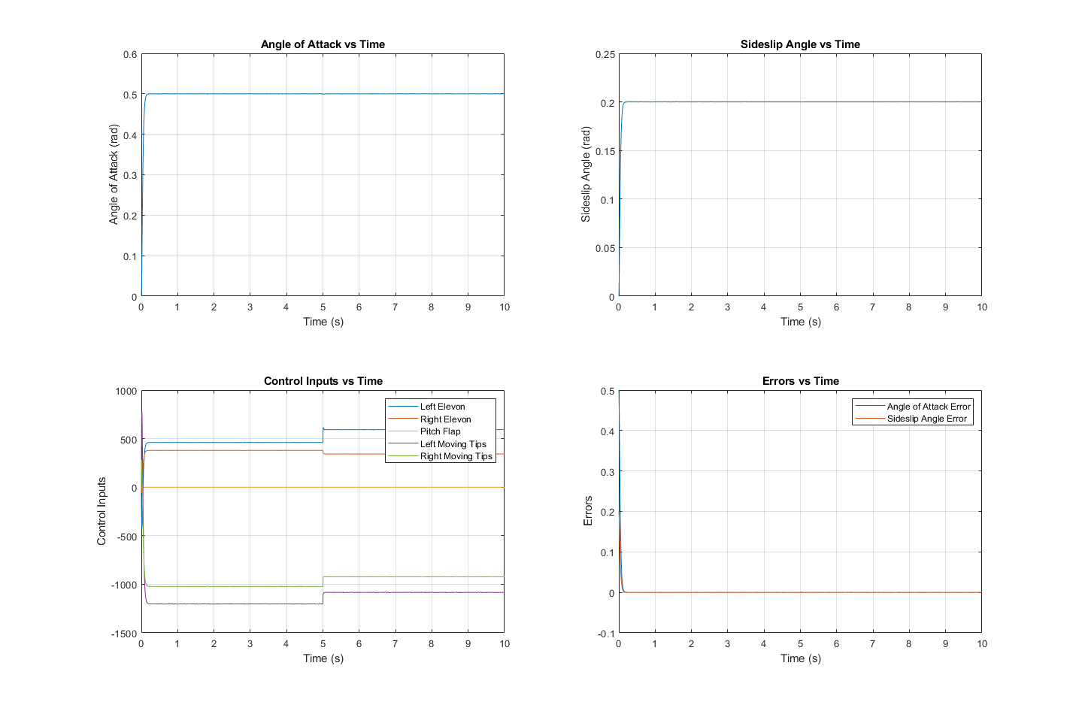
Figure 1: Custom Controller Step Response
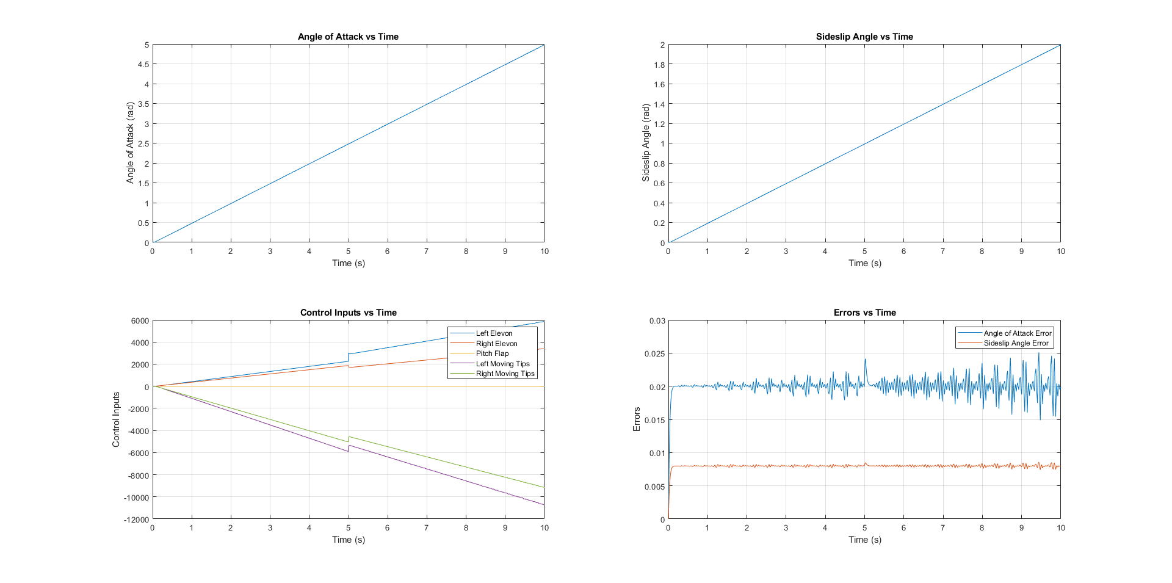
Figure 2: Custom Controller Linear Response
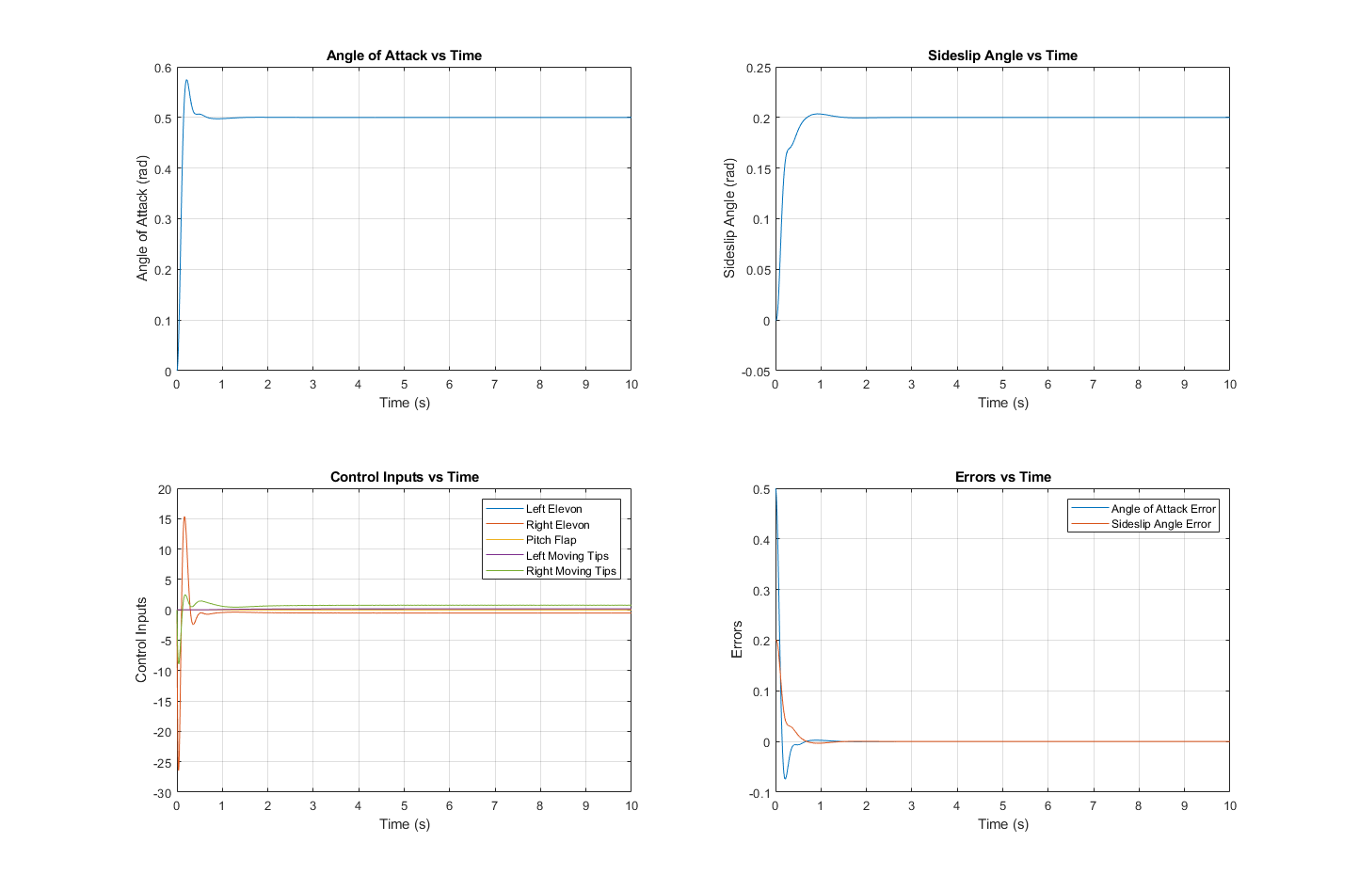
Figure 3: LQR Controller Step Response
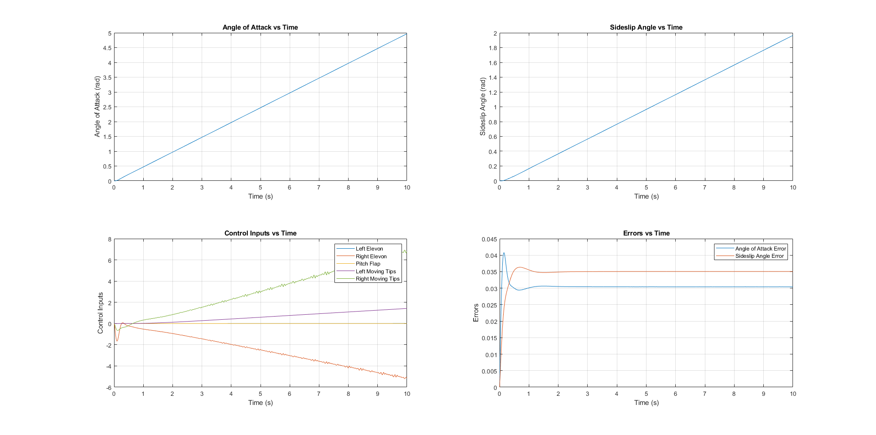
Figure 4: LQR Controller Linear Response
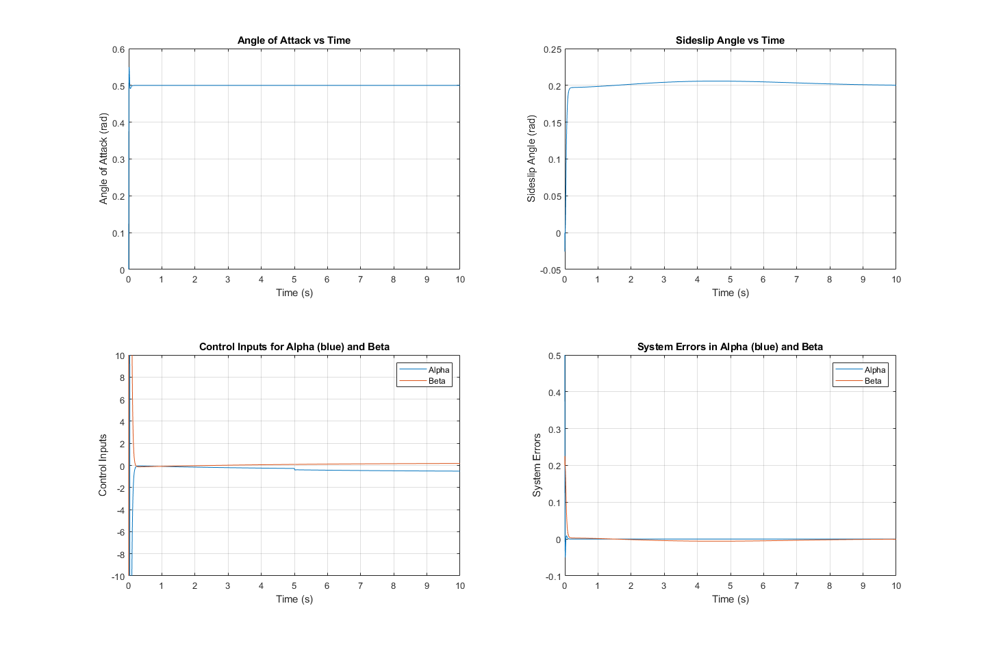
Figure 5: PID Controller Step Response
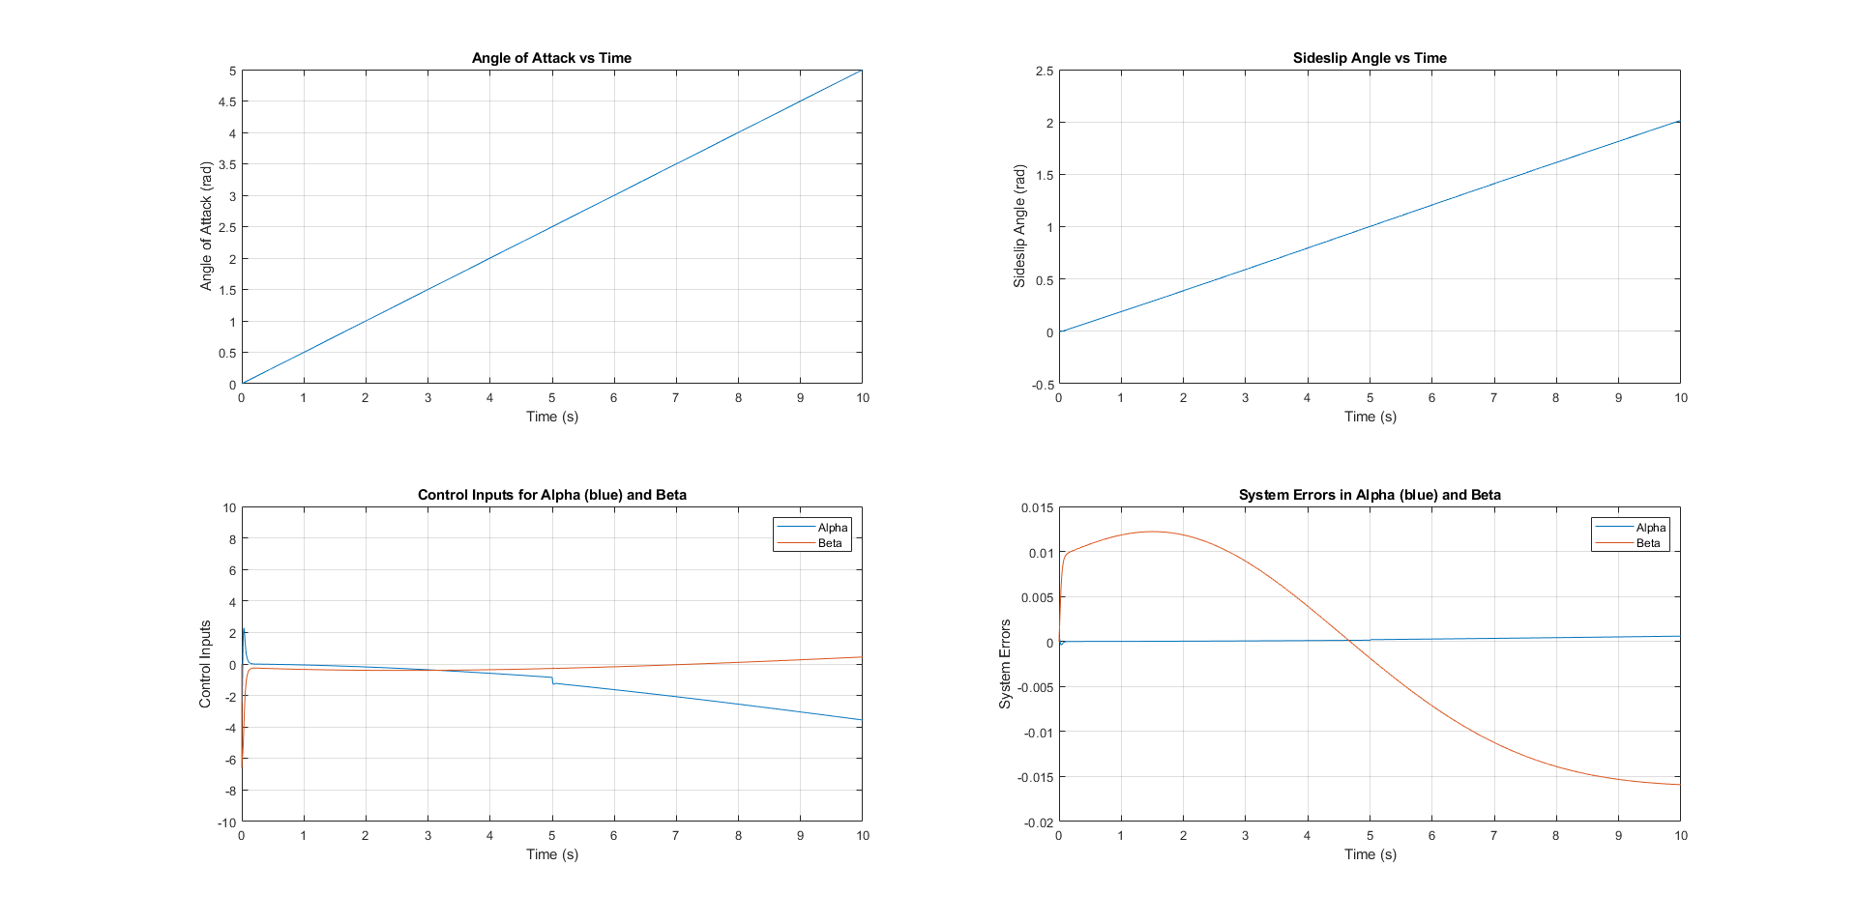
Figure 6: PID Controller Linear Response
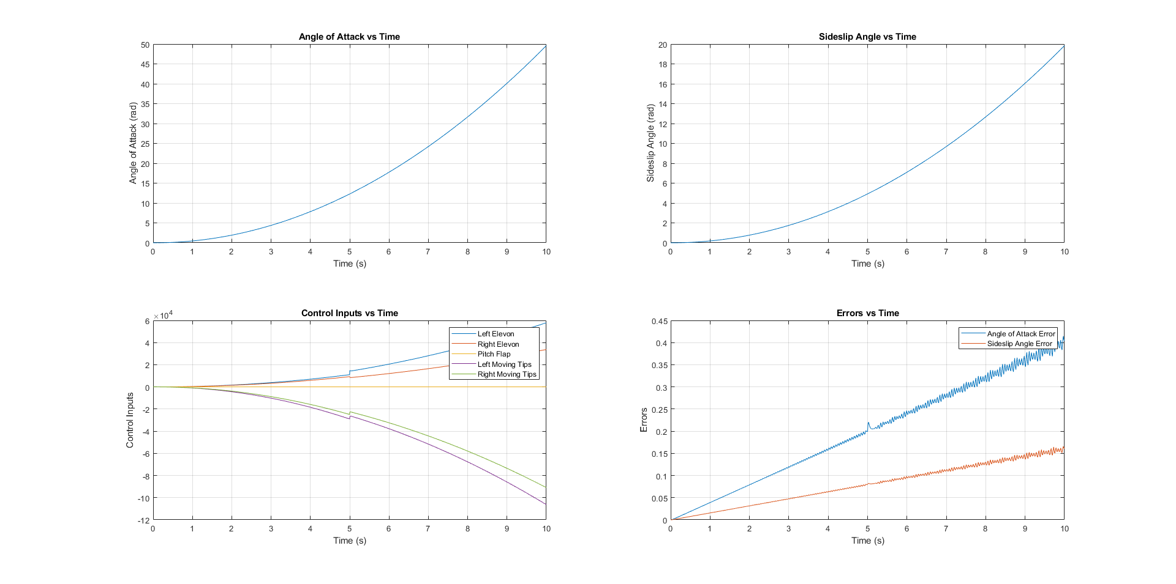
Figure 7: Exponential Response Custom Controller
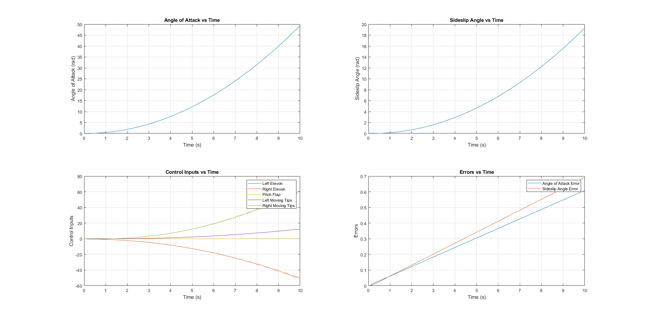
Figure 8: Exponential Response LQR Controller
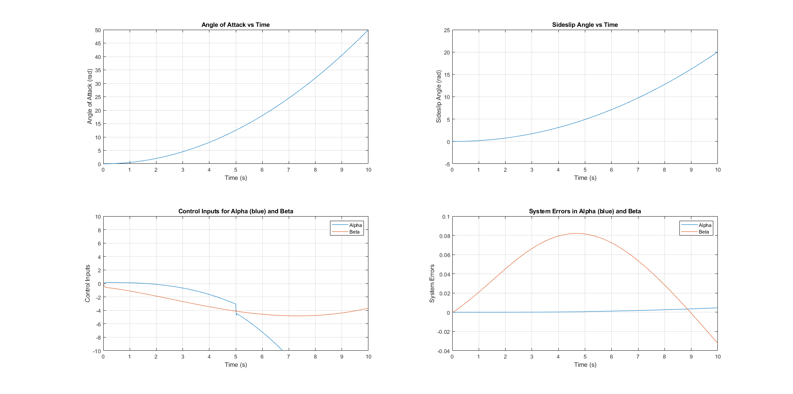
Figure 9: Exponential Response PID Controller

MATLAB Code
Custom Controller Code:
% Clears the Command Window, deletes all variables, and closes all figures.
clc;
clear;
close all;
% Defines the state-space model of a B22 Stealth plane.
% A: State matrix representing the plane's dynamics.
A = [-0.6344 0.0027 0 0.9871 0;
0 -0.0038 0.1540 0 -0.9876;
0 -8.2125 -0.7849 0 0.1171;
-0.5971 0 0 -0.5099 0;
0 -0.8887 -0.0299 0 -0.0156];
% C: Matrix mapping the state variables to outputs.
C = eye(5);
% D: Matrix for direct input to output mapping (not used here).
D = zeros(5, 5);
% B_init: Initial input matrix, influencing the system's response.
B_init = [-0.0459 -0.0459 0 -0.0133 -0.0133;
-0.0047 0.0047 0 0.0031 -0.0031;
3.783 -3.7830 0 1.8255 -1.8255;
-2.5114 -2.5115 0 -0.9494 -0.9494;
-0.0453 -0.0453 0 -0.2081 0.2081];
% Defines constant desired angles for control.
alpha_d = @(t) 0.5 * sin(t); % Desired angle of attack.
beta_d = @(t) 0.2 * cos(t); % Desired sideslip angle.
% Augments the system to reduce steady-state error.
A_aug = [A, zeros(size(A, 1), 2); -C(1:2,:), zeros(2, 2)];
% Sets the desired pole locations for system response.
poles = [-50, -50.1, -50.2, -50.3, -50.4, -50.5, -50.6];
% Simulation time settings.
t_span = [0 10]; % From 0 to 0.5 seconds.
x0 = zeros(length(A_aug), 1); % Initial state.
% Defines how the state changes over time.
ode_func = @(t, x) dynamics(t, x, A_aug, poles, alpha_d, beta_d);
% Runs the simulation.
[t, x] = ode45(ode_func, t_span, x0);
% Extracts angle of attack and sideslip angle from the simulation.
alpha = x(:,1);
beta = x(:,2);
% Calculates control inputs and errors.
control_inputs = zeros(length(t), size(B_init, 2));
errors = zeros(length(t), 2);
for i = 1:length(t)
[B_aug, K_aug] = get_B_aug_and_K(t(i), A_aug, poles);
control_inputs(i, :) = -K_aug * x(i, :)';
errors(i, :) = [alpha_d(t(i)) - x(i, 1), beta_d(t(i)) - x(i, 2)];
end
% Plots the simulation results.
figure;
subplot(2,2,1);
plot(t, alpha);
xlabel('Time (s)');
ylabel('Angle of Attack (rad)');
title('Angle of Attack vs Time');
grid on;
subplot(2,2,2);
plot(t, beta);
xlabel('Time (s)');
ylabel('Sideslip Angle (rad)');
title('Sideslip Angle vs Time');
grid on;
subplot(2,2,3);
plot(t, control_inputs);
xlabel('Time (s)');
ylabel('Control Inputs');
title('Control Inputs vs Time');
legend('Left Elevon', 'Right Elevon', 'Pitch Flap', 'Left Moving Tips', 'Right Moving Tips');
grid on;
subplot(2,2,4);
plot(t, errors);
xlabel('Time (s)');
ylabel('Errors');
title('Errors vs Time');
legend('Angle of Attack Error', 'Sideslip Angle Error');
grid on;
% Computes the B matrix and gain matrix K at each time step.
function [B_aug, K_aug] = get_B_aug_and_K(t, A_aug, poles)
if t < 5
B = [-0.0459 -0.0459 0 -0.0133 -0.0133;
-0.0047 0.0047 0 0.0031 -0.0031;
3.783 -3.7830 0 1.8255 -1.8255;
-2.5114 -2.5115 0 -0.9494 -0.9494;
-0.0453 -0.0453 0 -0.2081 0.2081];
else
B = [-0.03213 -0.0459 0 -0.0133 -0.0133;
-0.00329 0.0047 0 0.0031 -0.0031;
2.648 -3.7830 0 1.8255 -1.8255;
-1.7580 -2.5115 0 -0.9494 -0.9494;
-0.03171 -0.0453 0 -0.2081 0.2081];
end
B_aug_base = [B; zeros(2, size(B, 2))];
K_aug = place(A_aug, B_aug_base, poles); % Compute state feedback gain matrix
B_aug = B_aug_base;
end
% Defines the system's behavior.
function dx = dynamics(t, x, A_aug, poles, alpha_d, beta_d)
[B_aug, K_aug] = get_B_aug_and_K(t, A_aug, poles);
desired_alpha = alpha_d(t);
desired_beta = beta_d(t);
dx = A_aug*x - B_aug*K_aug*x + [zeros(size(A_aug, 1) - 2, 1); desired_alpha; desired_beta];
end

LQR Code:
%clc;
clear;
close all;
% Define the state-space model of a tailless plane.
A = [-0.6344 0.0027 0 0.9871 0;
0 -0.0038 0.1540 0 -0.9876;
0 -8.2125 -0.7849 0 0.1171;
-0.5971 0 0 -0.5099 0;
0 -0.8887 -0.0299 0 -0.0156];
C = eye(5);
D = zeros(5, 5);
% Augment the system to include tracking of desired angles
A_aug = [A, zeros(size(A, 1), 2); -C(1:2,:), zeros(2, 2)];
% LQR weights
Q = diag([6.85914e-05 0.00141472 2.3427e-07 5.755e-07 0.098731 9.88064 29.2109]); % Tune these weights
R = diag([3.116 9.51765e-07 3.88178 0.0121297 2.65035e-06]);
% Desired angles
alpha_d = @(t) 0.5 * sin(t);
beta_d = @(t) 0.2 * cos(t);
% Simulation setup
t_span = [0 10];
x0 = zeros(length(A_aug), 1);
% Run the simulation
[t, x] = ode45(@(t, x) dynamics_lqr(t, x, A_aug, Q, R, alpha_d, beta_d), t_span, x0);
% Extract states
alpha = x(:,1);
beta = x(:,2);
% Calculate control inputs and errors
control_inputs = zeros(length(t), 5); % The size is 5 as per your B matrix
errors = zeros(length(t), 2);
for i = 1:length(t)
[B_aug, K_aug] = get_B_aug_and_K_lqr(t(i), A_aug, Q, R);
control_inputs(i, :) = -K_aug * x(i, :)';
errors(i, :) = [alpha_d(t(i)) - x(i, 1), beta_d(t(i)) - x(i, 2)];
end
% Plot results
subplot(2, 2, 1);
plot(t, alpha);
xlabel('Time (s)');
ylabel('Angle of Attack (rad)');
title('Angle of Attack vs Time');
grid on;
subplot(2, 2, 2);
plot(t, beta);
xlabel('Time (s)');
ylabel('Sideslip Angle (rad)');
title('Sideslip Angle vs Time');
grid on;
subplot(2, 2, 3);
plot(t, control_inputs);
xlabel('Time (s)');
ylabel('Control Inputs');
title('Control Inputs vs Time');
legend('Left Elevon', 'Right Elevon', 'Pitch Flap', 'Left Moving Tips', 'Right Moving Tips');
grid on;
subplot(2, 2, 4);
plot(t, errors);
xlabel('Time (s)');
ylabel('Errors');
title('Errors vs Time');
legend('Angle of Attack Error', 'Sideslip Angle Error');
grid on;
% Compute the B matrix and gain matrix K at each time step.
function [B_aug, K_aug] = get_B_aug_and_K_lqr(t, A_aug, Q, R)
if t < 5
B = [-0.0459 -0.0459 0 -0.0133 -0.0133;
-0.0047 0.0047 0 0.0031 -0.0031;
3.783 -3.7830 0 1.8255 -1.8255;
-2.5114 -2.5115 0 -0.9494 -0.9494;
-0.0453 -0.0453 0 -0.2081 0.2081];
else
B = [-0.03213 -0.0459 0 -0.0133 -0.0133;
-0.00329 0.0047 0 0.0031 -0.0031;
2.648 -3.7830 0 1.8255 -1.8255;
-1.7580 -2.5115 0 -0.9494 -0.9494;
-0.03171 -0.0453 0 -0.2081 0.2081];
end
B_aug = [B; zeros(2, size(B, 2))];
K_aug = lqr(A_aug, B_aug, Q, R);
end
% Dynamics function using LQR
function dx = dynamics_lqr(t, x, A_aug, Q, R, alpha_d, beta_d)
[B_aug, K_aug] = get_B_aug_and_K_lqr(t, A_aug, Q, R);
desired_alpha = alpha_d(t);
desired_beta = beta_d(t);
dx = A_aug*x - B_aug*K_aug*x + [zeros(size(A_aug, 1) - 2, 1); desired_alpha; desired_beta];
end

PID Code:
%clc;
clear;
close all;
% Original state-space matrices
A = [-0.6344 0.0027 0 0.9871 0;
0 -0.0038 0.1540 0 -0.9876;
0 -8.2125 -0.7849 0 0.1171;
-0.5971 0 0 -0.5099 0;
0 -0.8887 -0.0299 0 -0.0156];
% PID gains for alpha
Kp_alpha = -6005.5742; % Proportional gain
Ki_alpha = 3.7310787; % Integral gain
Kd_alpha = -3.6238157; % Derivative gain
% PID gains for beta
Kp_beta = -15.204; % Proportional gain
Ki_beta = -11.7714; % Integral gain
Kd_beta = -29.2052; % Derivative gain
% Desired angles for tracking as functions of time
alpha_d = @(t) 0.5 * t.^2; % Desired angle of attack in radians as a linear ramp function
beta_d = @(t) 0.2 * t.^2; % Desired sideslip angle in radians as a linear ramp function
% Simulation settings
t_span = [0 100]; % Simulate from 0 to 50 seconds
dt = 0.0001; % Time step for the simulation
% Initial conditions
x = zeros(5, 1); % Initial state
integral_error_alpha = 0;
integral_error_beta = 0;
prev_error_alpha = 0;
prev_error_beta = 0;
% Arrays for storing simulation data
time = t_span(1):dt:t_span(2);
alpha_vals = zeros(1, length(time));
beta_vals = zeros(1, length(time));
u_alpha_vals = zeros(1, length(time));
u_beta_vals = zeros(1, length(time));
error_alpha_vals = zeros(1, length(time));
error_beta_vals = zeros(1, length(time));
% Simulation loop
for i = 1:length(time)
t = time(i);
B = get_B_matrix(t); % Get the appropriate B matrix
% Extract alpha and beta from the state
alpha = x(1);
beta = x(2);
% Error calculation for alpha
error_alpha = alpha_d(t) - alpha;
integral_error_alpha = integral_error_alpha + error_alpha * dt;
derivative_error_alpha = (error_alpha - prev_error_alpha) / dt;
% Error calculation for beta
error_beta = beta_d(t) - beta;
integral_error_beta = integral_error_beta + error_beta * dt;
derivative_error_beta = (error_beta - prev_error_beta) / dt;
% PID control for alpha and beta
u_alpha = Kp_alpha * error_alpha + Ki_alpha * integral_error_alpha + Kd_alpha * derivative_error_alpha;
u_beta = Kp_beta * error_beta + Ki_beta * integral_error_beta + Kd_beta * derivative_error_beta;
% Control input vector (assuming u_alpha and u_beta affect the first two states)
u = [u_alpha; u_beta; zeros(3, 1)]; % Adjust this based on your system
% Update system state
x_dot = A * x + B * u;
x = x + x_dot * dt;
% Store the values for plotting
alpha_vals(i) = alpha;
beta_vals(i) = beta;
u_alpha_vals(i) = u_alpha;
u_beta_vals(i) = u_beta;
error_alpha_vals(i) = error_alpha;
error_beta_vals(i) = error_beta;
% Update previous errors for next iteration
prev_error_alpha = error_alpha;
prev_error_beta = error_beta;
end
% Plot the results in a 2x2 subplot arrangement
figure;
% Subplot 1: Angle of Attack (Alpha)
subplot(2,2,1);
plot(time, alpha_vals);
xlabel('Time (s)');
ylabel('Angle of Attack (rad)');
title('Angle of Attack vs Time');
grid on;
% Subplot 2: Sideslip Angle (Beta)
subplot(2,2,2);
plot(time, beta_vals);
xlabel('Time (s)');
ylabel('Sideslip Angle (rad)');
title('Sideslip Angle vs Time');
grid on;
% Subplot 3: Combined Control Inputs for Alpha and Beta
subplot(2,2,3);
plot(time, u_alpha_vals, time, u_beta_vals);
xlabel('Time (s)');
ylabel('Control Inputs');
title('Control Inputs for Alpha (blue) and Beta');
legend('Alpha', 'Beta');
ylim([-10,10])
grid on;
% Subplot 4: Combined Errors in Alpha and Beta
subplot(2,2,4);
plot(time, error_alpha_vals, time, error_beta_vals);
xlabel('Time (s)');
ylabel('System Errors');
title('System Errors in Alpha (blue) and Beta');
legend('Alpha', 'Beta');
grid on;
% Function to return the correct B matrix based on time t
function B = get_B_matrix(t)
if t < 5
B = [-0.0459 -0.0459 0 -0.0133 -0.0133;
-0.0047 0.0047 0 0.0031 -0.0031;
3.783 -3.7830 0 1.8255 -1.8255;
-2.5114 -2.5115 0 -0.9494 -0.9494;
-0.0453 -0.0453 0 -0.2081 0.2081];
else
B = [-0.03213 -0.0459 0 -0.0133 -0.0133;
-0.00329 0.0047 0 0.0031 -0.0031;
2.648 -3.7830 0 1.8255 -1.8255;
-1.7580 -2.5115 0 -0.9494 -0.9494;
-0.03171 -0.0453 0 -0.2081 0.2081];
end
end

LQR Tuning Code:
clc;
clear;
close all;
% ELCT 331 Linear Quadratic Regulator Controller Tuner
% Define the state-space model of a B2 Stealth plane.
A = [-0.6344 0.0027 0 0.9871 0;
0 -0.0038 0.1540 0 -0.9876;
0 -8.2125 -0.7849 0 0.1171;
-0.5971 0 0 -0.5099 0;
0 -0.8887 -0.0299 0 -0.0156];
C = eye(5);
D = zeros(5, 5);
% Augment the system to include tracking of desired angles
A_aug = [A, zeros(size(A, 1), 2); -C(1:2,:), zeros(2, 2)];
% Initial guesses for Q and R matrices
initial_guess = ones(1, 12); % 7 for Q, 5 for R
% Set the bounds for optimization
lb = zeros(1, 12); % Lower bounds
ub = 1000*ones(1, 12); % Upper bounds
% Optimization options
options = optimset('Display', 'iter', 'MaxFunEvals', 10000, 'MaxIter', 100);
% Run optimization
[optimal_weights, optimal_cost] = fmincon(@lqr_cost_function, initial_guess, [], [], [], [], lb, ub, [], options);
% Display the results
disp(['Optimal Weights: ', num2str(optimal_weights)]);
disp(['Optimal Cost: ', num2str(optimal_cost)]);
function total_cost = lqr_cost_function(weights)
% Extract Q and R from weights
Q = diag(weights(1:7));
R = diag(weights(8:12));
% System definitions
A = [-0.6344 0.0027 0 0.9871 0;
0 -0.0038 0.1540 0 -0.9876;
0 -8.2125 -0.7849 0 0.1171;
-0.5971 0 0 -0.5099 0;
0 -0.8887 -0.0299 0 -0.0156];
C = eye(5);
A_aug = [A, zeros(size(A, 1), 2); -C(1:2,:), zeros(2, 2)];
x0 = zeros(length(A_aug), 1); % Initial state
t_span = [0 20]; % Time span
alpha_d = @(t) 0.5;
beta_d = @(t) 0.2;
% Run the simulation
[t, x] = ode45(@(t, x) dynamics_lqr(t, x, A_aug, Q, R, alpha_d, beta_d), t_span, x0);
% Calculate the cost
alpha_errors = (x(:,1) - alpha_d(t')).^2;
beta_errors = (x(:,2) - beta_d(t')).^2;
total_cost = sum(alpha_errors) + sum(beta_errors);
end
function dx = dynamics_lqr(t, x, A_aug, Q, R, alpha_d, beta_d)
B_aug = get_B_aug(t); % Define your B matrix as in your script
K_aug = lqr(A_aug, B_aug, Q, R);
desired_alpha = alpha_d(t);
desired_beta = beta_d(t);
dx = A_aug*x - B_aug*K_aug*x + [zeros(size(A_aug, 1) - 2, 1); desired_alpha; desired_beta];
end
function B_aug = get_B_aug(t)
% Define the B matrix based on time
if t < 5
B = [-0.0459 -0.0459 0 -0.0133 -0.0133;
-0.0047 0.0047 0 0.0031 -0.0031;
3.783 -3.7830 0 1.8255 -1.8255;
-2.5114 -2.5115 0 -0.9494 -0.9494;
-0.0453 -0.0453 0 -0.2081 0.2081];
else
B = [-0.03213 -0.0459 0 -0.0133 -0.0133;
-0.00329 0.0047 0 0.0031 -0.0031;
2.648 -3.7830 0 1.8255 -1.8255;
-1.7580 -2.5115 0 -0.9494 -0.9494;
-0.03171 -0.0453 0 -0.2081 0.2081];
end
B_aug = [B; zeros(2, size(B, 2))];
end

PID Tuning Code:
%clc;
clear;
close all;
%ELCT 331 PID Tuner for Project
% State-space matrices (as defined in your system)
A = [-0.6344 0.0027 0 0.9871 0;
0 -0.0038 0.1540 0 -0.9876;
0 -8.2125 -0.7849 0 0.1171;
-0.5971 0 0 -0.5099 0;
0 -0.8887 -0.0299 0 -0.0156];
% Define desired outputs
alpha_d = 0.5; % Desired angle of attack in radians
beta_d = 0.2; % Desired sideslip angle in radians
% Define simulation settings
t_span = [0 30]; % Simulation time
dt = 0.001; % Time step
% Set the bounds for the PID gains [Kp, Ki, Kd]
lb = [-10000 -10000 -10000 -10000 -10000 -10000]; % Lower bounds for alpha and beta PID gains
ub = [10000 10000 10000 10000 10000 10000]; % Upper bounds for alpha and beta PID gains
% Optimization options
options = optimoptions('ga', 'Display', 'iter', 'UseParallel', false, 'MaxGenerations', 100);
% Run genetic algorithm
[best_gains, best_cost] = ga(@(K)integratedPidCostFunction(K, A, alpha_d, beta_d, t_span, dt), 6, [], [], [], [], lb, ub, [], options);
% Display results
disp(['Best PID gains for alpha: ', num2str(best_gains(1:3))]);
disp(['Best PID gains for beta: ', num2str(best_gains(4:6))]);
disp(['Cost for integrated control: ', num2str(best_cost)]);
function cost = integratedPidCostFunction(K, A, alpha_d, beta_d, t_span, dt)
% Implement the state-space simulation with integrated PID control
% Initialize variables
x = zeros(5, 1);
integral_error_alpha = 0;
integral_error_beta = 0;
prev_error_alpha = 0;
prev_error_beta = 0;
time = t_span(1):dt:t_span(2);
alpha_output = zeros(1, length(time));
beta_output = zeros(1, length(time));
% Simulation loop
for i = 1:length(time)
% Extract alpha and beta from the state
alpha = x(1);
beta = x(2);
% PID Error calculations for alpha
error_alpha = alpha_d - alpha;
integral_error_alpha = integral_error_alpha + error_alpha * dt;
derivative_error_alpha = (error_alpha - prev_error_alpha) / dt;
% PID Error calculations for beta
error_beta = beta_d - beta;
integral_error_beta = integral_error_beta + error_beta * dt;
derivative_error_beta = (error_beta - prev_error_beta) / dt;
% PID control for alpha and beta
u_alpha = K(1) * error_alpha + K(2) * integral_error_alpha + K(3) * derivative_error_alpha;
u_beta = K(4) * error_beta + K(5) * integral_error_beta + K(6) * derivative_error_beta;
% System dynamics
B = get_B_matrix(time(i)); % Assuming get_B_matrix is defined elsewhere
x_dot = A * x + B * [u_alpha; u_beta; 0; 0; 0]; % Modify as needed
x = x + x_dot * dt;
% Store control output for analysis
alpha_output(i) = alpha;
beta_output(i) = beta;
% Update previous error
prev_error_alpha = error_alpha;
prev_error_beta = error_beta;
end
% Cost function calculation (e.g., combined Integral of the square of the errors)
cost = sum((alpha_output - alpha_d).^2) + sum((beta_output - beta_d).^2);
end
function B = get_B_matrix(t)
if t < 5
B = [-0.0459 -0.0459 0 -0.0133 -0.0133;
-0.0047 0.0047 0 0.0031 -0.0031;
3.783 -3.7830 0 1.8255 -1.8255;
-2.5114 -2.5115 0 -0.9494 -0.9494;
-0.0453 -0.0453 0 -0.2081 0.2081];
else
B = [-0.03213 -0.0459 0 -0.0133 -0.0133;
-0.00329 0.0047 0 0.0031 -0.0031;
2.648 -3.7830 0 1.8255 -1.8255;
-1.7580 -2.5115 0 -0.9494 -0.9494;
-0.03171 -0.0453 0 -0.2081 0.2081];
end
end

