HW02
Assignment
- G signifies students that take this class for Graduate Credit; they must do all the items
- UG students are not required to do the G work, but they may do it for bonus points
- Problems solved beyond the minimum requirements will be given bonus points.
- Challenge problems are optional; they will earn bonus points.

NOTES:
- Show your work to obtain partial credit if appropriate
- Always display input data!
- Partial credit might be given based on work done and MATLAB codes if they are attached; without them, no partial credit can be given.
- Display numerical results to three significant digits (four if the first digit is 1).
- Use SI system of measurement
https://en.wikipedia.org/wiki/International_System_of_Units
- Scale units using appropriate prefixes (e.g., nano, micro, milli, kilo, mega, giga…)
https://en.wikipedia.org/wiki/Metric_prefix
- Problems solved beyond the minimum requirements will be given bonus points.
- Challenge problems are optional. They may be solved for extra credit
- Normalized plots are plots with the y-axis scaled between
–1 and +1. A plotted variable is normalized by dividing it by its maximum absolute value

Notations and abbreviations:
- BVP = boundary value problem
- EOM = equation of motion
- FBD = free body diagram
- FRF = frequency response function
- IVP = initial value problem
- LHS = left hand side
- NLM = Newton’s law of motion
- ODE = ordinary differential equation
- PDE = partial differential equation
- RHS = right hand side

TABLE OF CONTENTS
A. Waves 3
A.1 wave fundamentals 3
A.2 simple wave calculations 4
A.3 Calculate car motion on wavy road 5
A.4 standing waves 7
A.5 musical notes 8
A.6 musical instruments 9
B. Fluid Waves and Vibration 10
B.1 Analyze wave equation in fluids 10
B.2 Analyze and find solution of wave equation 11
B.3 Analyze air vibration in a tube closed at both ends 12
B.4 Calculate air vibration in a tube closed at both ends 14
B.5 Calculate the slide whistle 15
B.6 Calculate sound intensity, dB scale 17
C. Extra Credit Challenge Problems 18
C.1 Analyze air vibration in a closed-open tube 18
C.2 Analyze air vibration in an open-open tube 20
C.3 Calculate air vibration in a tube with various boundary conditions 21

Waves

wave fundamentals
- List at least five examples of waves met in everyday life
- Explain in your own words the difference between disturbance waves and continuous waves
- Explain using text and sketches the definition of wavespeed for a disturbance wave
- Give at least three different equivalent expressions for a disturbance wave
- A car pileup takes place on an interstate and propagates as a wave for several miles. What type of wave is this? Choose one of the following:
  - continuous wave
  - disturbance wave
- Explain using text and sketches the definition of wavespeed for a continuous harmonic wave
- Explain using text and sketches the definition of wavelength and wavenumber for a continuous harmonic wave
- Give at least three different equivalent expressions for a continuous harmonic wave
- What do waves carry? Choose one of the following:
  - matter
  - energy
  - both
  - none of the above
- Graduate Work: write about the particle-wave duality of light rays

simple wave calculations
Take electromagnetic wavespeed c_{light}=300,000 km/s, sound wavespeed c_{sound}=340 m/s. Do the following quick calculations:
- Calculate the frequency of visible light with typical wavelength λ=510 nm
- Calculate the Hz frequency f of an AM radio wave with wavelength λ=550 m.
- Infrared radiation has a typical wavelength λ=10 μm. What is the typical frequency of infrared radiation?
- Calculate the wavelength λ of an FM radio wave with frequency of 89 MHz.
- The lightning flash is observed at 8:23:32 pm whereas the thunder is heard at 8:23:36 pm. How far is the lightning strike? Give your answer in km and miles.
- One of Verizon’s 5G mobile signals has about 29 GHz. What is the corresponding wavelength?
- Microwave oven typically operates at 2.5 GHz:
  - what is the wavelength λ?
  - what is the maximum permissible hole size D in the oven’s door mesh considering that size of the largest hole in a Faraday cage must be at most 1/2 of the wavelength?
  - measure approximately the hole size in a microwave oven door mesh and discuss your results. You may search the web for various opinions on this matter.
- Graduate Work: given that the diameter of an electron is estimated to be D=2 pm, do the following:
  - calculate the frequency of the electromagnetic wave that has a wavelength equal to the electron diameter
  - in what spectrum range would this electromagnetic wave be? (options: infrared, visible, ultraviolet, X-ray, gamma ray)

Calculate car motion on wavy road

Consider a car traveling on a wavy road. The road surface undulates with an amplitude a=2.5-in and a wavelength λ=105 ft that follows a cosine shape. The car is modeled as a spring-mass-damper (Figure 1) with natural frequency f_{n}=0.95 Hz and damping ratio ζ=22%. The maximum car speed is v_{max}=125 mph.

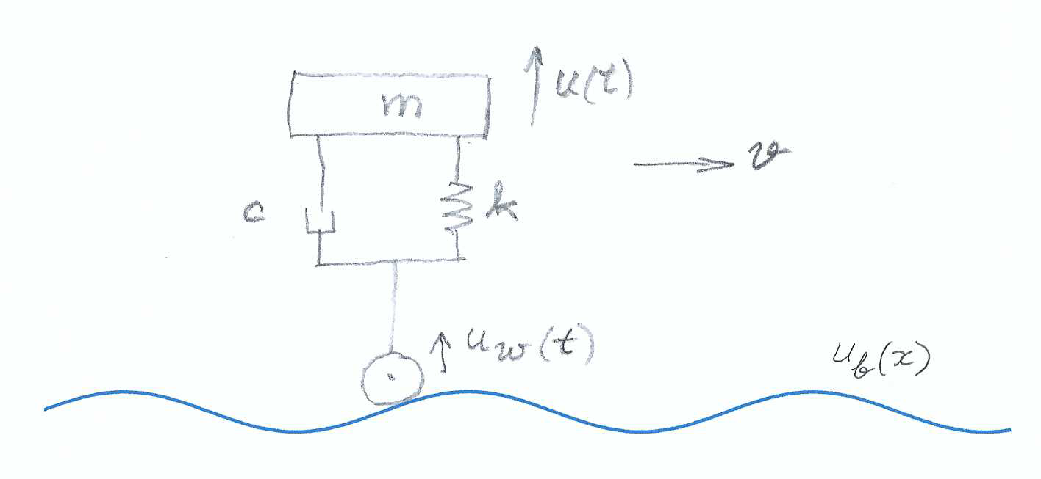
Figure 1 Car riding on a wavy road

Do the following:
- Display input data
- Calculate wavy road wavenumber γ
- Plot the wavy road profile u_{b}(x) for N_{λ}=2 wavelengths
- calculate wavy-road frequency f_{max} for a maximum car speed of v_{max} and define the frequency range f=linspace(0,f_{max},N_{f}) with N_{f}=2000
- plot |FRF(f ; f_{n})| for. Use datatips on the plot to locate the peak response and the matched-frequency response.
- Calculate the matched-frequency response value |FRF_{n}|. Compare with the matched-frequency readings at item (5)
- Calculate the car speed v_{n} needed to make wavy-road frequency f match the car natural frequency f_{n}
- Use the conversion f=v/λ to plot |FRF(v ; f_{n})|. Use datatips on the plot to find:
  - v_{n} and |FRF_{n}| and discuss them in comparison with results of items (6), (7)
  - v_{cr} and |FRF_{max}|
  - the limit speed v_{limit} for which the motion amplification is limited to |FRF_{lim}|=1.5
- Graduate work: Find the road wavelength λ_{new} that will make v_{n} =35 mph
- Graduate work: Repeat items (5) through (8) for the case of a car with worn-out shocks that can only give ζ=10% and comment on the comparison between the two cases

standing waves
- Follow the notes to develop the standing-wave concept:
  - write the complex-exponential expressions for two identical harmonic waves of amplitude ½ propagating in opposite directions
  - add the two waves and write the resulting complex-exponential expression
  - use Euler’s formula to arrive at a trigonometric expression
- Sketch a standing wave and identify the nodes and anti-nodes (bows)
- Assume wavespeed c=340m/s and frequency f=2.9kHz. Calculate:
  - rad/sec frequency ω
  - wavenumber γ
  - wavelength λ
  - distance Δx between standing wave nodes
- Graduate Work: explain intuitively the analogy between standing waves and the vibration of a taught string

musical notes
- Find the Hz frequency of note C5
- Find what musical note corresponds to 246.94 Hz
- What is the lowest frequency on the scale of equal temperament and what musical note does it correspond to?
- What is the commonly accepted frequency range of human hearing?
- What is the highest frequency on the scale of equal temperament and what musical note does it correspond to?
- Graduate Work: explain the scale of equal temperament:
  - what is the organizing principle of the scale of equal temperament
  - how many equal-temperament entries are in an octave?
  - what is the ratio between two adjacent entries on the scale of equal temperament?

musical instruments
- List at least three methods to produce sound in a string instrument
- List the two different methods to produce a sound in wind instruments
- List string instruments that use a hammer hit to produce sound
- List the three major categories of musical instruments. In each category, do the following:
  - describe how the instrument works
  - explain what physical principles are used to produce sound
- List at least five common string instruments

Fluid Waves and Vibration

Analyze wave equation in fluids

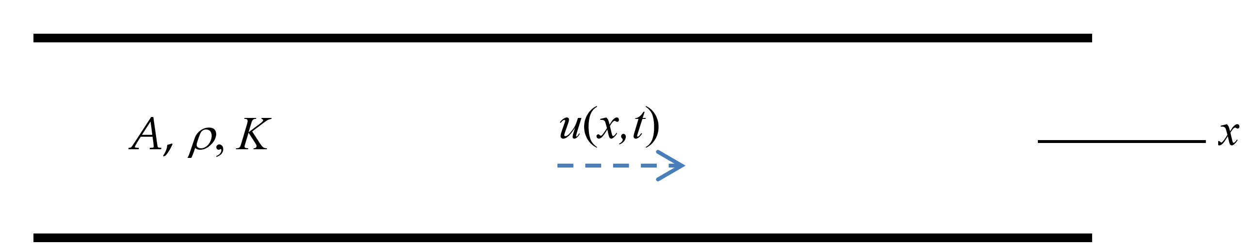
Figure 2: fluid waves in an infinite tube
Assume an infinite tube of cross section A containing fluid of density ρ and bulk modulus K (Figure 2). Develop the wave equation in fluids. Do the following:
- assume that the fluid in the tube undergoes time-varying axial displacement u(x,t) under the influence of a pressure disturbance p(x,t)
- Consider an infinitesimal element dx and draw the displacements and pressures on both of its sides
- draw FBD
- apply NLM and deduce relationship between pressure p, density ρ and acceleration
- apply fluid-elasticity equation and express the pressure p(x,t) in terms of displacement u(x,t) and bulk modulus K
- substitute (5) into (4) deduce the relationship between second derivative wrt space u’’ and second derivative wrt time
- define the wavespeed c
- substitute (7) into (6) and deduce the wave equation

Analyze and find solution of wave equation
Recall the results of Problem B.1 and do the following:
- recall the wave equation
- assume separation of time and space behaviors into U(x) and T(t) and write u(x,t) as a function of U(x) and T(t)
- do the appropriate differentiations wrt to space and time
- assume vibratory time behavior with angular frequency ω using a complex exponential formula for T(t)
- substitute (4) into (3) and write expressions for u’’ and
- substitute (5) into the wave equation (1) and express it only in terms of U(x), c, ω
- define wavenumber γ
- substitute (7) into (6) and obtain a linear ordinary differential equation (ODE) in terms of U(x), U’’(x), and γ
- assume exponential solution of the form U(x)=e^{sx}
- substitute (9) into (8) and obtain the characteristic equation
- solve the characteristic equation (10) and obtain the roots s₁, s₂
- use (11) into (9) and write the complete solution in terms of constants A₁, A₂ and complex exponentials of s₁, s₂
- add the vibratory time behavior from (4) to obtain the solution in terms of complex exponentials depending on both γ and ω
- use Euler’s formulae to rewrite (13) in terms of new constants C₁, C₂ and trigonometric functions depending on γ and ω and

Analyze air vibration in a tube closed at both ends

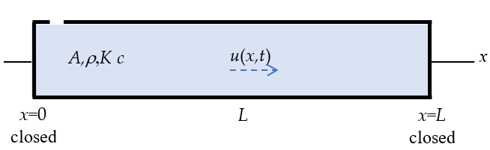
Figure 3: air vibration in a tube of finite length L closed at both ends
Assume a tube of finite length L and cross section A containing fluid of density ρ, bulk modulus K, and wavespeed c (Figure 3). The tube is closed at both ends. The air in the tube undergoes harmonic axial displacement u(x,t) with frequency ω. Do the following:
- write the boundary conditions at the two ends of the tube in terms of displacement u(x,t)
- recall the harmonic solution of the wave equation consisting of the multiplication of two terms:
  - first term: a function U(x) consisting of trigonometric functions depending on wavenumber γ, space variable x, and constants C₁, C₂
  - second term: a complex exponential depending on frequency ω and time variable t
- substitute (2) into (1) and write the boundary conditions at the two ends of the tube in terms of unknown constants C₁, C₂
- solve (3) for C₂ and obtain an equation for C₁
- discuss the trivial solution
- choose to search for the nontrivial solution and define the equation that needs to be solved to find a nontrivial solution
- introduce the notation z=γL into (6) and write the eigenvalue equation in terms of z
- solve the eigenvalue equation and write the general expression for the eigenvalues z_{j}, j=1,2,3,…
- use (7) to write the general expression for the wavenumber γ in terms of j and length L
- Recall from HW01 the definition of wavenumber γ in terms of frequency ω and wavespeed c
- solve (10) for frequency ω in terms of wavenumber γ and wavespeed c
- use (9) and (11) to write the general expression of the natural frequency ω_{j} in terms of j, wavespeed c, and tube length L
- use (12) to write the general expression of the Hz frequency f in terms of j, wavespeed c, and tube length L
- explain the meaning of fundamental frequency and overtones
- explain the meaning of fundamental harmonic and higher harmonics
- recall the relationship between wavelength λ and wavenumber γ
- use (9) into (16) to write the general expression for the wavelength λ_{j} in terms of j and tube length L
- use (17) to explain which wavelength multiples could accommodate vibratory standing waves in a tube of length L closed at both ends
- recall U(x) from (2)(a) and use (4) to eliminate C₂
- set C₁=1 in (19) and write the general expression of the displacement modeshape U_{j}(x) in terms of the wavenumber γ_{j}
- write the general expression of the pressure modeshapes

Calculate air vibration in a tube closed at both ends
Consider a tube of length L=0.85 m closed at both ends. Take sound speed c=340 m/s and air density ρ=1.2 kg/m³. Use the results of Problem B.3 to calculate the modal vibration characteristics and the modeshapes for j=1,…,N modes with N=5.
- Display input data
- Calculate and display the modal vibration characteristics:
  - eigenvalues z_{j}
  - wavenumbers γ_{j}
  - rad/s frequencies ω_{j}
  - Hz frequencies f_{j}
- Calculate and plot the displacement modeshapes
- Discuss your results
- Graduate work: Calculate and plot the normalized pressure modeshapes and discuss your result in comparison with item (3)

Calculate the slide whistle

Consider the slide whistle shown in Figure 4. The fully retracted whistle is shown in Figure 4a, whereas the fully extended whistle is shown in Figure 4b. The length of the residual cavity of the fully retracted whistle tube can be approximated to be $L_{0}=6mm$ (Figure 4a). The thickness of the piston inside the whistle can be approximated to be $L_{p}=6mm$. The thickness of the end walls can be approximated to be $L_{w}=6mm$. Assume sound speed in air to be c=340m/s.
The purpose of this problem is to calculate the fundamental frequency for various positions of the whistle slider

(a) 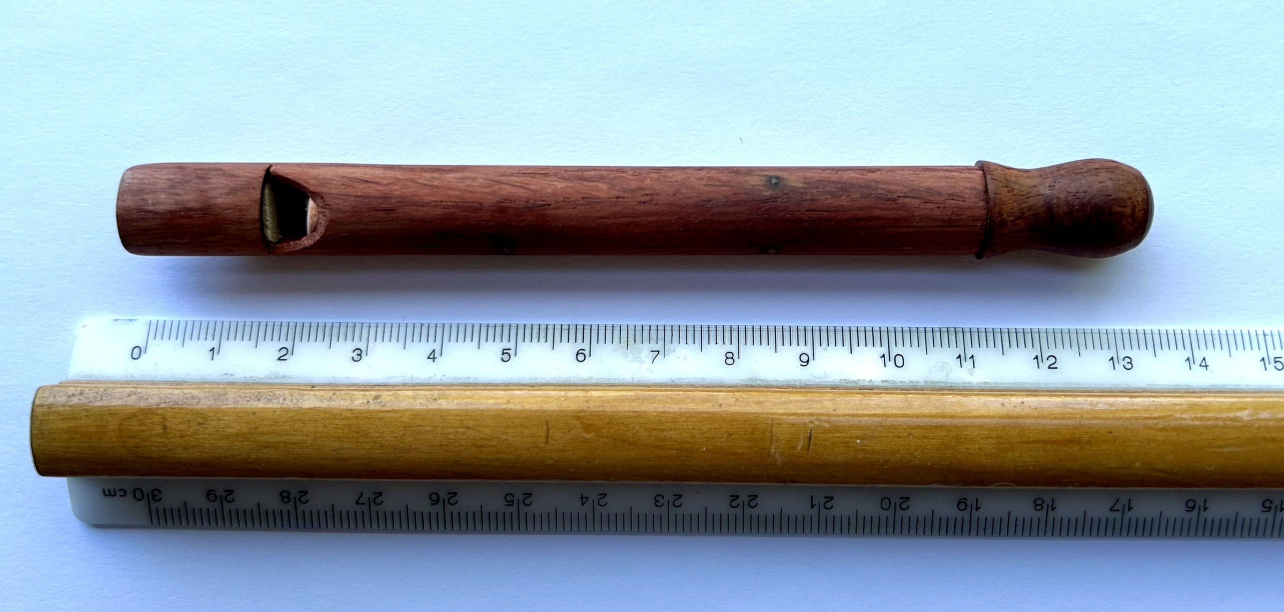
(b)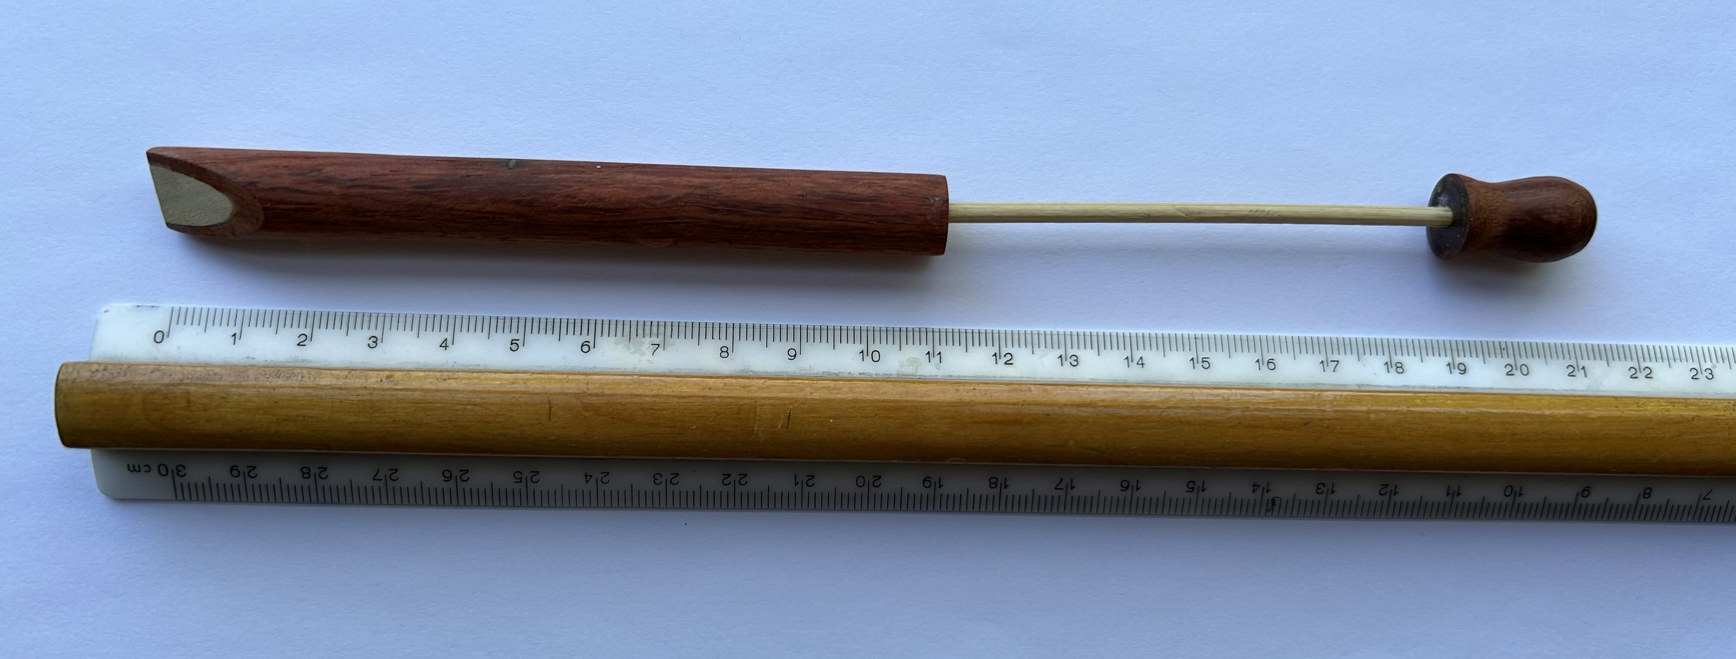
Figure 4 sliding whistle: (a) fully retracted, showing the piston end;
(b) fully extended. The ruler major markings are in cm.

Recall the theoretical results of Problem B.3 and do the following:

- display input data
- use Figure 4 to estimate the fully extended whistle length L_{e}
- use Figure 4 to estimate the fully contracted whistle length L_{c}
- use L_{e}, L_{c} to calculate the extension travel dL_{I} corresponding to fully extended slide whistle
- use dL_{I} and L₀ to calculate the cavity length L_{I} of a fully extended slide whistle
- estimate the fully extended frequency f_{I} in Hz and find the nearest musical note expressed as a letter name and an octave number (e.g., G3 signifies note G in the 3rd octave)
- use L_{e}, L_{c} to calculate the extension travel dL_{II} corresponding to 40% extended slide whistle
- use dL_{II} and L₀ to calculate the cavity length L_{II} of a 40%-extended slide whistle
- calculate the 40%-extended frequency f_{II} in Hz and find the nearest musical note expressed as a letter name and an octave number
- comment on your work
Graduate work: Estimate the position of the piston to obtain the musical note B7. Do the following:
- display the frequency f_{III} of the note B7
- calculate the cavity length L_{III} needed to generate frequency f_{III} of the note B7
- calculate the extension travel dL_{III} needed to generate frequency f_{III} of the note B7
- estimate what percentage of the piston has to be extended to generate the note B7
- comment on your work

Calculate sound intensity, dB scale
Take sound speed c=340 m/s and air density ρ=1.2 kg/m³. Do the following:
- Display input data
- Calculate air’s acoustic impedance Z
- Calculate the sound intensity I corresponding to a sound pressure p=55 mPa
- Give the values of the reference sound intensity I₀ and reference sound pressure p₀
- Covert to dB the sound pressure and the sound intensity of item (3) above
- Verify that the sound pressure and sound intensity calculated at item (5) have the same dB value and explain why it is so
- Calculate in physical units the sound intensity, sound pressure, and sound power from a loudspeaker with diameter D=1.55 m working at 78 dB
- Calculate the sound pressure p_{horn} created by a 118 dB car horn
- Give the values of the pain sound intensity I_{pain} and pain sound pressure p_{pain} and comment on the results of items (7) and (8) relative to pain values
- Graduate Work: explain why it is necessary to use different dB conversion formulae for sound intensity I and sound pressure p.

Extra Credit Challenge Problems
Challenge problems are optional.

Analyze air vibration in a closed-open tube
- sketch a tube closed at one end and open at the other end indicating all the information needed for the analysis
- write the boundary conditions at the two ends of the tube in terms of displacement u(x,t) and pressure disturbance p(x,t)
- recall from HW01 the harmonic solution of the wave equation consisting of the multiplication of two terms:
  - first term: a function U(x) consisting of trigonometric functions depending on wavenumber γ, space variable x, and constants C₁, C₂
  - second term: a complex exponential depending on frequency ω and time variable t
- recall from HW01 the expression of pressure p(x,t) in terms of displacement u(x,t) and bulk modulus K
- substitute (3) into (4) to obtain the pressure p(x,t) in terms of constants C₁, C₂
- substitute (3) and (5) into (2) and write the boundary conditions at the two ends of the tube in terms of unknown constants C₁, C₂
- solve (6) for C₂ and obtain an equation for C₁
- discuss the trivial solution
- choose to search for the nontrivial solution and define the equation that needs to be solved to find a nontrivial solution
- introduce the notation z=γL into (9) and write the eigenvalue equation in terms of z
- solve the eigenvalue equation and write the general expression for the eigenvalues z_{j}, j=1,2,3,…
- use (10) to write the general expression for the wavenumber γ_{j} in terms of j and length L
- Recall from HW01 the definition of wavenumber γ in terms of frequency ω and wavespeed c
- solve (13) for frequency ω in terms of wavenumber γ and wavespeed c
- use (12) and (14) to write the general expression of the natural frequency ω_{j} in terms of j, wavespeed c, and tube length L
- use (15) to write the general expression of the Hz frequency f_{j} in terms of j, wavespeed c, and tube length L
- explain the meaning of fundamental frequency and overtones
- explain the meaning of fundamental harmonic and higher harmonics
- recall from HW01 the relationship between wavelength λ and wavenumber γ
- use (12) into (19) to write the general expression for the wavelength λ_{j} in terms of j and tube length L
- use (20) to explain which wavelength multiples could accommodate vibratory standing waves in a tube of length L closed at one end and open at the other end
- recall U(x) from (3)(a) and use (7) to eliminate C₂
- set C₁=1 in (22) and write the general expression of the modeshape U_{j}(x) in terms of the wavenumber γ_{j}
- plot the normalized displacement modeshapes for the modes number 1 through 5 of air vibration in a tube of length L; discuss your results
- Graduate work: calculate and plot the normalized pressure modeshapes for the modes number 1 through 5 of air vibration in a tube of length L; discuss your results

Analyze air vibration in an open-open tube
- sketch a tube open at both ends indicating the information needed for analysis
- write the boundary conditions at the two ends of the tube
- repeat all steps of Problem C.1 paying particular attention to the values taken by C₁ and C₂

Calculate air vibration in a tube with various boundary conditions
Consider a tube of length L=0.85 m. Take sound speed c=340 m/s and air density ρ=1.2 kg/m³. The purpose is to calculate the modal vibration characteristics and the modeshapes for j=1,…,N modes with N=5. The following boundary conditions will be considered:

boundary conditions
case | x=0 | x=L
(i) | closed | open
(ii) | open | open

- Display input data
Then, for each of the two boundary conditions cases, do the following:
- Calculate and display the modal vibration characteristics:
  - eigenvalues z_{j}
  - wavenumbers γ_{j}
  - rad/s frequencies ω_{j}
  - Hz frequencies f_{j}
- Calculate and plot the displacement modeshapes
- Discuss your results in comparison with Problem B.4
- Graduate work: Calculate and plot the normalized pressure modeshapes and discuss your result in comparison with item (3)

