Collaborators: Jacob Christopher Vaught, Madelyn Leire Hines
Project Objective: The main purpose of this project is to design and implement an embedded system using Intel Quartus Software and develop an embedded application which will serve as a “Hello World” software using Nios Eclipse. The system and the application will be used as a base for the next projects.
Project Requirements: The project requirements state that in order to design and create the application program, the guidelines that are posted in Module1/Labs must be followed. Additionally, it is important to ensure that both data and instruction cache of NIOS processor are set to 4KB and Nios2 version is Nios II/f before starting the application project. Successful compilation and a successful board configuration should be achieved before proceeding with the application program. Once the program is run in Eclipse, the message “Hello from Nios II” should be printed on Nios console.
1.0: After compiling and synthesizing the system, the summary report from Quartus should be read.
Logical Elements | Registers | Total Pins | Memory Bits
3,321 | 1,881 | 5 | 587,840

2.0: In this step, the version of Nios II processor should be changed from Nios II/f to Nios II/e in the platform design. The new design should then be regenerated and the project recompiled.
Logical Elements | Registers | Total Pins | Memory Bits
1,675 | 874 | 5 | 535,552

3.0: The processor should be returned to Nios II/f and the Nios II Cache Configuration should be set on 4KB for instruction cache and 16KB for data cache. The new design should then be regenerated and the project recompiled.
Logical Elements | Registers | Total Pins | Memory Bits
3,325 | 1,878 | 5 | 705,024

4.0: Nios II/f “Hello World Message!”
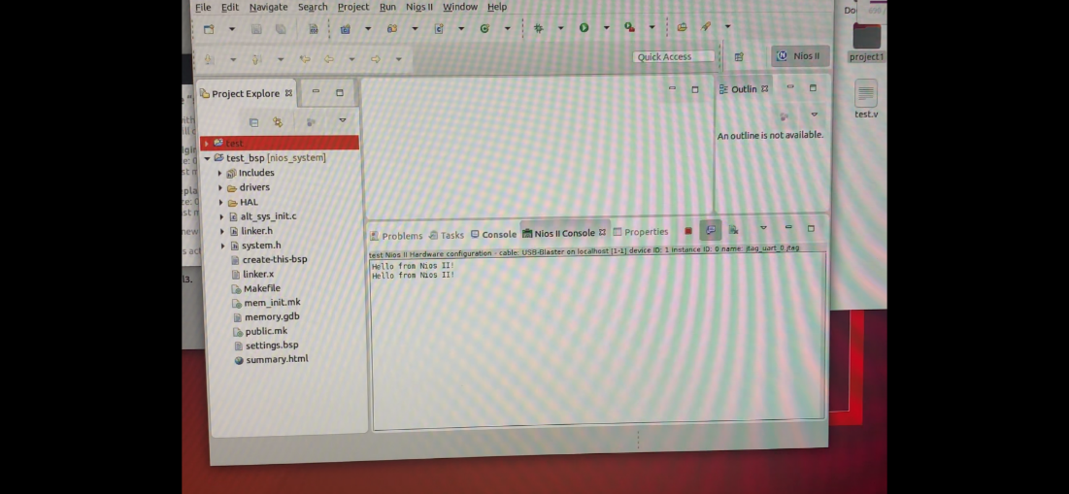
Overall, this project aims to learn how to design and implement an embedded system using Intel Quartus Software and Nios Eclipse and to understand the impact of changing processor version, and cache configuration on the hardware resources of the system.

