**Install Node js.**

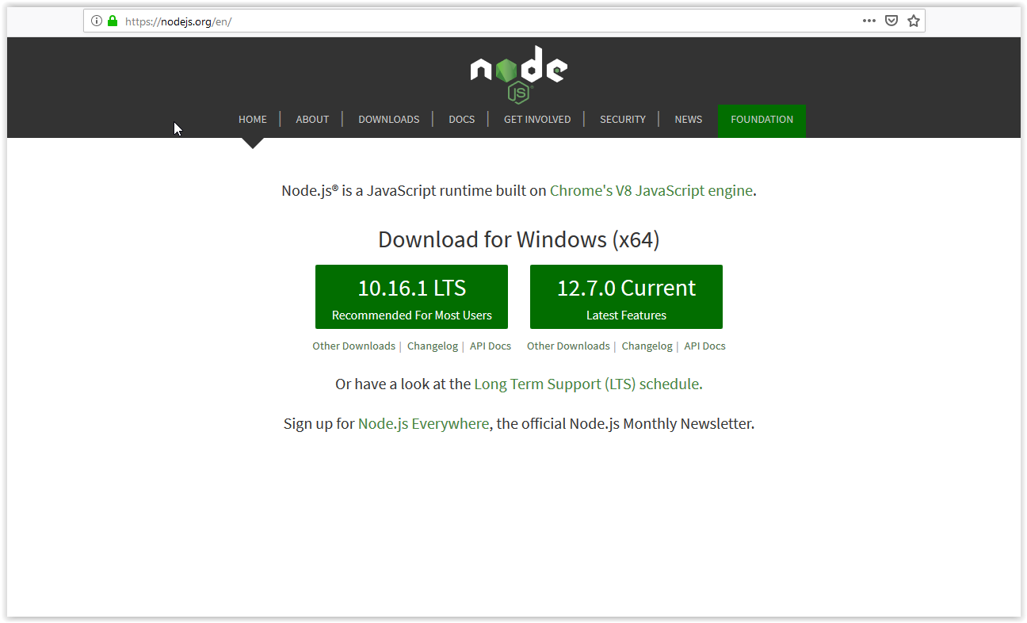

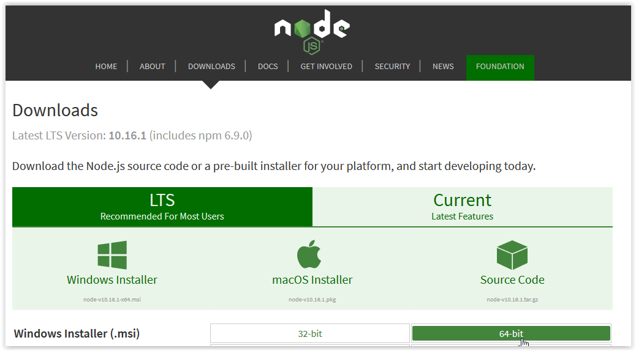

**Install Git (use whatever options you want, just make sure it works in powershell)**

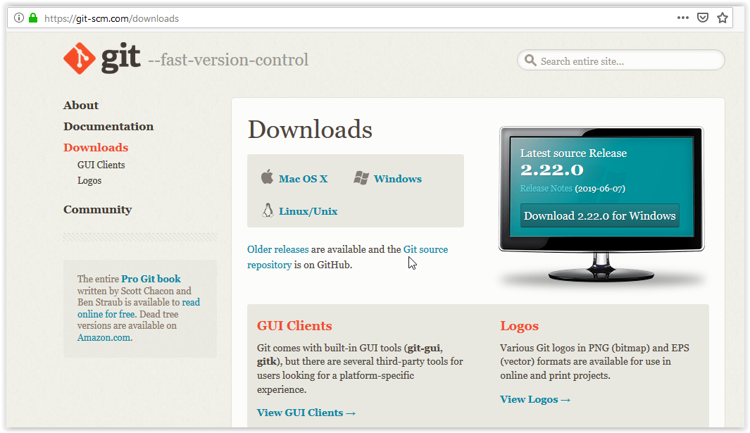

**Open powershell**

* **Verify install**
  + **node –v**
  + **git --version**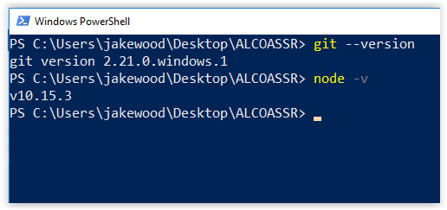
* **Navigate to any directory**
  + **Really any directory, it makes no difference.**

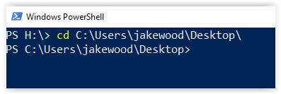

* **Clone repository**
  + **git clone** [**https://github.com/j-woodlee/ALCOASSR.git**](https://github.com/j-woodlee/ALCOASSR.git)

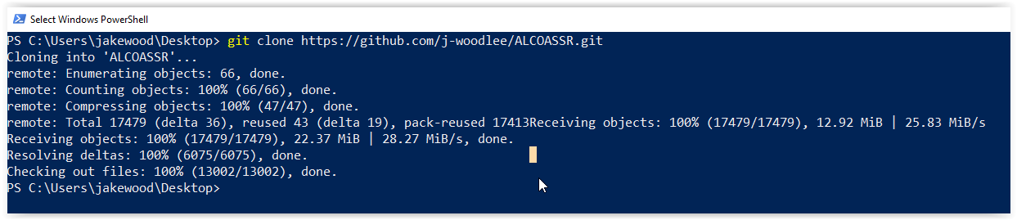

* + **cd ALCOASSR**

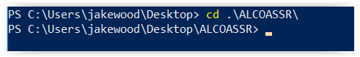

* + **Type “ls” command to see the files in the repo (one of them is DEBE)**
  + **Code is hosted for free at** [**https://github.com/j-woodlee/ALCOASSR**](https://github.com/j-woodlee/ALCOASSR)

**Running the Program**

* **Open Powershell**
* **Go to the location where you stored the repository, in my example it would be C:\Users\jakewood\Desktop\ALCOASSR**
* **Now all you have to do is run the following in PS:** 
  + **“node .\convertXLSMtoXLSX <city> <year> <month>**
* **Example:**



**Common Issues**

* **“Cannot read property eachRow of undefined”**

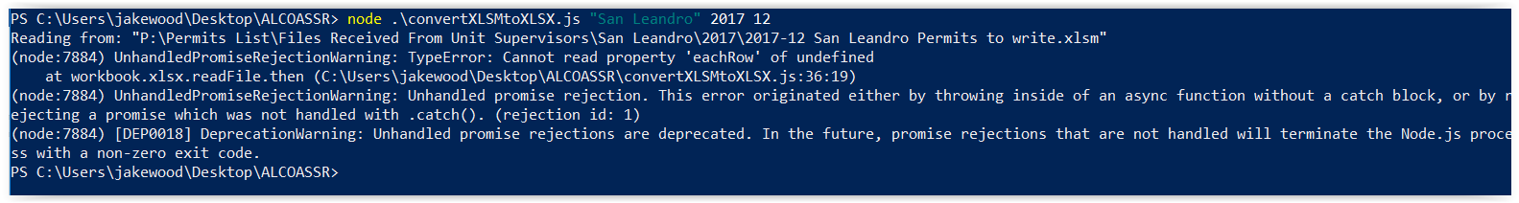

* + **This is just saying that it found the excel workbook, but it cannot read the rows of the worksheet it wants to get.**
  + **This is because the workbook’s main worksheet is not following the proper naming convention. Make sure the name of the worksheet you want to read follows this format:** 
    - **Example: “2018-12 HAY Issued” Where HAY is the first three letters of the city capitalized, Hayward = HAY, Livermore = LIV, San Leandro = SAN, Berkeley = BER, etc.**