Summary of Optical Modeling Information

From Chris Clifford

To Alex Piggott

12/6/2017

# Basic Optical Parameters

Here are the parameters used for this example. I assume no resist film.

Wavelength 0.193 um

NA = 1.35

demagnification from mask to wafer = 4

Refractive index of “immersion” water at the wafer 1.43664

# Source Details

The source looks like this

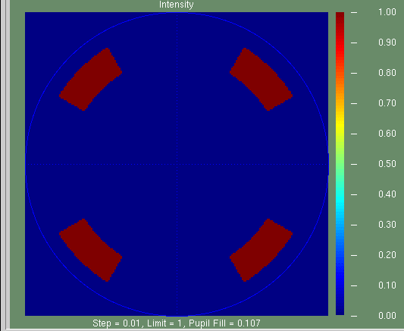

The exact grid is stored in sourcemap.mat as src_grid with a step of 0.01 sigma.

Parametrically, the source is two dipoles rotated +/-45 degrees with an inner sigma of 0.7, an outer sigma of 0.9, and an illumangle angle (width in phi) of 30 degrees.

# Kernels

The kernels are in this file: kernels.mat, which can be opened in matlab with the load command.

There are 10 kernel grids total, stored in the cell array “kernels”. To get kernel 3, for example, use “kernel_3 = kernels{3}”

The dx of all grids is 1nm.

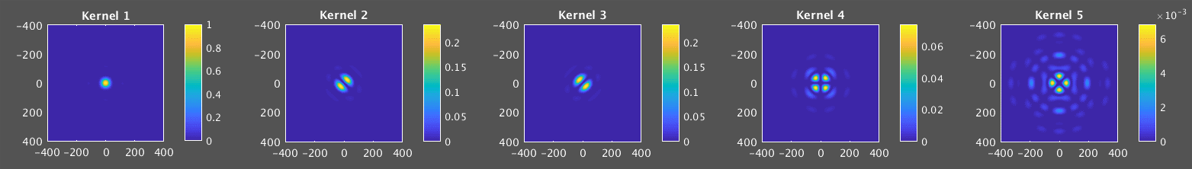

The kernels have been normalized so that the 1st kernel has a maximum of 1. I think the relative intensities of the kernels are after they are weighted. The kernels weights are in this table ( I don’t know how they are normalized )

|  |  |
| --- | --- |
| **Kernel** | **Weight** |
| 1 | 59.27 |
| 2 | 27.23 |
| 3 | 27.23 |
| 4 | 12.77 |
| 5 | 2.28 |
| 6 | 1.96 |
| 7 | 1.96 |
| 8 | 1.73 |
| 9 | 0.76 |
| 10 | 0.67 |

# Mask Rule Checks

Mask rule checks are included in OPC to be sure that all post-OPC shapes can be manufactured on the mask. A reasonable MRC rule is that no width or space between two edges can be < 50nm at the mask scale. Assume the mask scale is 4x larger than the wafer target scale. This does NOT mean the mask pixel size is 50nm. It’s possible to have a smaller “jog” from an edge as long as the width or space between opposite edges is not less than 50nm. See examples of an OK and BAD feature below. Assume measurement is nm mask scale

## OK

Left and right edges are more than 50nm apart. The jog is 3nm, but there are no facing edges which are less than 50nm

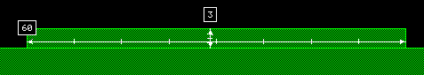

## BAD

The left and right facing edges are less than 50nm (they are 6 nm) so this is not allowed

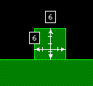

# Focus Range

The lithography process has to be robust to some focus variation. The required range varies, but I think a typical value for a 193nm lithography process is +/-80nm wafer focus variation.

# Resist Modeling

We should follow up on this more. If you want to try something, maybe a Gaussian blur with sigma = 5nm would be reasonable.