ERCOT Synchronous Inertial Response Service
Working Document – Work Session (4-25-2014):

Need for SIR Service
Synchronous Inertial Response (SIR) is an immediate response that is continuously self-deployed from synchronous machines to compensate for power imbalance and is a key determinant of the strength and stability of the power system.
Synchronous Inertial Response has significant implications on the rate of change of frequency (RoCoF) following a disturbance. With increasing non-synchronous generation SIR is reduced and RoCoF increases, leaving insufficient time for PFR to deploy and arrest system frequency, i.e. time between point A and C, Figure 1. High RoCoF can cause frequency to reach the nadir quickly and trigger under-frequency load shedding of firm loads. There is a need to assure the provision of a sufficient amount of inertial response on the ERCOT system. SIR service is intended to meet this need.
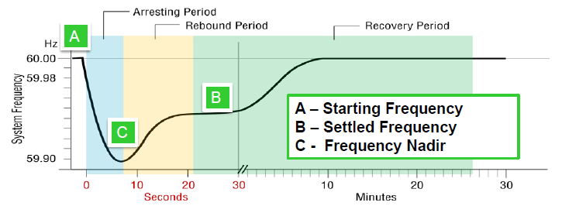

Figure 1 Typical frequency response following a generator trip.

Definition of Synchronous Inertial Response Service
Protocol Definition for Synchronous Inertial Response Service –Concept Level acceptance requested prior to Protocol Language development– Consensus (XXXX%)
Synchronous Inertial Response (SIR) is defined as the kinetic energy (at nominal frequency) that is extracted from the rotating mass of a synchronous machine to compensate an imbalance in a power system.
The kinetic energy (in MW-seconds) is based on the commissioned design capability of the Resource. It can be determined through appropriate validation procedures based on the following relationship:
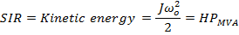
- J is the combined moment of inertia of a synchronous machine and turbine prime mover in kg·m², based on its size and weight;
- ω_{o} is the nominal machine rotor speed in rad/s, and
- P_{MVA} is the machines rated capacity in Mega Volt – Amperes.
- H is the figure of merit used to analyze the synchronous machine’s inertial response and is referred to as the machine’s inertia constant in seconds.
From the above expression H is:
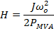

The inertial response that a synchronous machine can provide is independent of the machine’s power output and can be evaluated based on machine parameters (H and rated MVA) and machine status (online/offline).

ERCOT needs to verify that consistent MVA rating is used for both H constant and SIR calculation.
- Deployment, Sustain and Recall Requirements for Synchronous Inertial Response
Protocol Definition for Synchronous Inertial Response Service –Concept Level acceptance requested prior to Protocol Language development– Consensus (XXXX%)

Synchronous Inertial Response is immediately self-deployed from online synchronous machines to compensate for an imbalance in a power system. SIR is self-recovering as reserves (FFR, PFR, and Regulation) are deploying after initial frequency deviation. When the system frequency returns to nominal, the SIR is fully recovered.

- Performance Measurement
Protocol Definition for Synchronous Inertial Response Service –Concept Level acceptance requested prior to Protocol Language development– Consensus (XXXX%)

Performance of a Resources providing SIR is ensured as long as a Resource is synchronized with the ERCOT grid. Whenever a Resource is online its Synchronous Inertial Response will be calculated as:
SIR = H·MVA,

- Limits on Resources providing Synchronous Inertial Response

Protocol Definition for Synchronous Inertial Response Service –Concept Level acceptance requested prior to Protocol Language development– Consensus (XXXX%)

Resource providing SIR is limited based on Resource’s inertial constant H, nameplate MVA rating.
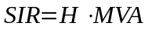

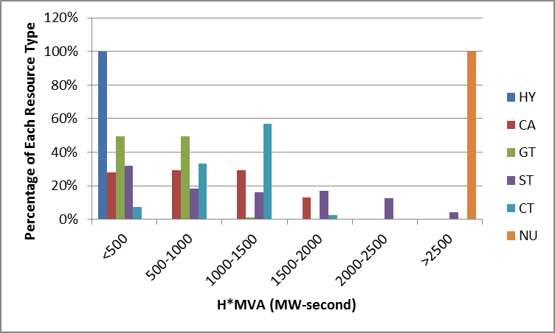
Figure 2 Inertial response of ERCOT generation fleet by unit type.

Qualification of Resources Providing Synchronous Inertial Response
Protocol Definition for Synchronous Inertial Response Service –Concept Level acceptance requested prior to Protocol Language development– Consensus (XXXX%)

Resources that operate synchronously with ERCOT grid can qualify for SIR service based on the commissioned design capability of the Resource as determined through appropriate testing procedures. Resource should provide ERCOT with the following parameters:
- Inertial constant H and
- Corresponding MVA base

Methodology to Determine Requirement for Synchronous Inertial Service
Total inertial contribution from all synchronous machines, committed for energy and AS, must achieve the required system inertial response. PFR and FFR requirements are always based on certain system inertia level. Minimal inertial response requirement should be such that after two largest units trip (currently 2750 MW) SIR, PFR and FFR should ensure f_{nadir} ≥ 59.4 Hz, that is 0.1 Hz above the prevailing initial threshold of Firm Load UFLS (59.3 Hz).
ERCOT will develop specific criteria for determination of minimum SIR requirement. To provide an example, if the target for the inertia requirement is to have the system frequency no less than 59.4 Hz after 0.5 seconds (RoCoF = 1.2 Hz/second) following two largest unit trip (2750 MW), the calculated minimum SIR requirement is estimated about 78 GW-second (at 24857 MW load and 2.44% per Hz load damping). The required amounts of PFR and FFR are expected to be significantly increased under low inertia condition. There may be other considerations, such as RoCoF tolerance, which can set additional limit on SIR requirement.
If synchronous condensers are owned and operated by TDSPs, the TDSPs are not expected to be eligible for SIR payments. Inertial response contribution provided by online synchronous condensers owned by TDSPs will be taken into account when determining minimum SIR requirement.
Based on current operations data the RoCoF during high wind low load condition was less than 0.2 Hz/second and the average time to reach frequency nadir during frequency events is within 4 to 6 seconds. Therefore, the system inertia available in the real time operations under current conditions is sufficient.
Studies based on 2013-2014 system conditions (presented at FAST Workshop on 3/28/2014) indicated RoCoF as high as 0.45 Hz/s for two largest unit trip (2750 MW as per recently approved NERC BAL-003 standard).
Table below shows presented at FAST Workshop on 3/28/2014 and two recent penetration record cases showing system inertia.

Case | Date/Time | Load  (MW) | Wind Output  (MW) | PRC  (MW) | Wind Penetration | Net Load  (MW) | 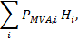  System Inertia  GW-seconds
1 | 08072013 17:00 | 67,148 | 2,398 | 4,105 | 3.57% | 64,750 | 372
2 | 02132014 19:00 | 36,460 | 1,188 | 5,062 | 3.26% | 35,272 | 236
3 | 01132014 03:00 | 24,857 | 7,196 | 5,812 | 28.95% | 17,661 | 174
4 | 03272014 3:19 | 25,677 | 9,868 | 5,826 | 38.43% | 15,809 | 148
5 | 03312014 02:12 | 24618 | 9,699 | 5,152 | 39.4% | 14,919 | 135
These data show a potential trend of SIR decreasing with increasing amounts of non-synchronous generation.
ERCOT plans to start tracking real time inertia, MVA*H and analyze periods with low inertia. Based on projections for additions of future non-synchronous generation, ERCOT will develop methodology to forecast synchronous inertia trends for low load high wind situations with 2-3 years look-ahead.
ERCOT will continue to investigate the possible impact from high RoCoF on conventional generators. References suggest RoCoF tolerance for generators between 0.5 Hz/s – 4 Hz/s. RoCoF tolerance limits may put additional constraint on minimum system inertia requirement.
The determination of requirements for SIR, FFR and PFR are interrelated. How much of one type is required depends on how much of the other is available. ERCOT will develop methodology for SIR, PFR and FFR requirements.

Discussion on SIR service implementation
Sufficient SIR needs to be maintained for every hour of a year. It is expected most of the time sufficient amount of synchronous inertia will be provided by synchronous machines committed for energy. The need for additional inertia might only arise during low load, high wind situations, about 15% of time (in 2013) according to Figure 3. Every online machine qualified to provide synchronous inertial response should be compensated for SIR service.
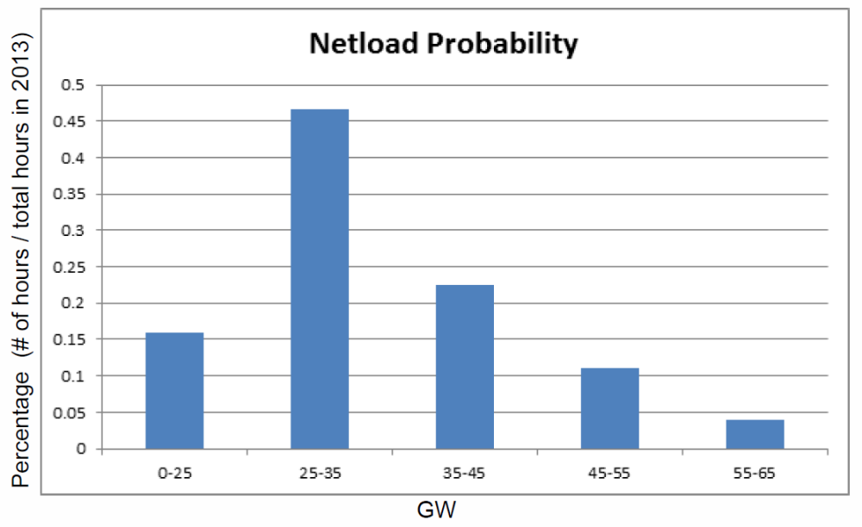
Figure 3 Distribution of netload levels in 2013
Synchronous machines will provide all of its SIR whenever synchronized with the grid. The amount of SIR provided does not depend of unit output and does not require capacity reservation that can be co-optimized with energy similarly to other AS. SIR procurement is expected to be a commitment process.
However in the Day Ahead Market the Resource participation is voluntary, therefore it is not transparent in DAM what Resources will be committed for energy and/or AS and be providing SIR inherently. Introduction of the procurement process (commitment process) for SIR in DAM will require changes to the DAM. During the work sessions one of the proposed options was to introduce Resource specific SIR offer in addition to corresponding energy offer in DAM. Otherwise, the SIR procurement (commitment process) needs to be initiated after DAM closure and when COPs become available.
Note that insufficient inertia conditions usually occur at high wind low load situations. It is desirable that synchronous machines brought online to ensure sufficient inertia response have low minimum power output. This prevents oversupply situations and negative impact on energy prices.
ERCOT RATF (Resource Adequacy Task Force) is currently discussing issues of Reliability Unit Commitment and mitigating its impact on RT market prices. The outcome of these discussions can also apply for mitigating the pricing impacts due to commitment for SIR procurement.
Existing Generation Resources capable of providing SIR can explore their capability to de-clutch between turbine and synchronous generator so as to operate in synchronous condenser mode and provide SIR without injecting energy to the grid.

Synthetic/Emulated Inertia
SIR product comes from the immediate response of the Resource to an event and while de-synchronized Resources (e.g. battery storage, Type III and IV WGRs) may be able to react very quickly there will be a moment in time where an inertial response is required but not provided. For this reason at this stage ERCOT does not consider it appropriate to extend the definition of the SIR Service to providers who are not synchronized. However, ERCOT recognizes that there is a potential value to such emulated inertial response, and will create Emulated Inertial Response service as a separate ancillary service. ERCOT will continue follow up the synthetic inertial response technology to identify the potential benefits to the ERCOT system.

Imbalance between mechanical power and electrical power
Physical Responsive Capability
Wind penetration = Wind Output / Load
Net Load = Load – Wind Output
References on Rate of Change of Frequency analysis: - DNV KEMA Energy & Sustainability by order of EirGrid, “RoCoF An independent analysis on the ability of Generators to ride through Rate of Change of Frequency values up to 2Hz/s”, February 2013 - PPA Energy by order of Commission for Energy Regulation (CER), “Rate of Change of Frequency (ROCOF) Review of TSO and Generator Submissions”, Final Report, May 2013 - EirGrid and SONI, “Summary of Studies on Rate of Change of Frequency events on the All-Island System”, August 2012 - EirGrid and SONI, “RoCoF Modification Proposal–TSOs’ Recommendations”, September 2012

