Practical 3 – Advanced SQL on shopdb — views, indexing, CTEs and window functions
use shopdb;
# 1. Create a view named vw_order_value (order_id, customer, order_value) that gives each order's total value; query the view.

create or replace view vw_order_value as
select
o.order_id,
name as customer,
sum(oi.quantity * p.price) as order_value
from orders o
join customers c
on o.customer_id=c.customer_id
join order_items oi
on o.order_id=oi.order_id
join products p
on oi.product_id=p.product_id
group by
o.order_id,
c.name;

select * from vw_order_value;

OUTPUT:
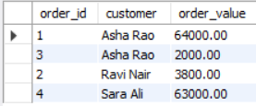

# 2. Create an index on orders(customer_id)
create index idx_create_customer_id
on orders(customer_id);
show index from orders;

OUTPUT:
# 3. Using a Common Table Expression, compute the revenue for each month, then add a column showing the month-over-month change (use an appropriate window function).

with monthly_revenue as (
select
date_format(o.order_date, '%Y-%m') as month,
sum(oi.quantity * p.price) as revenue
from orders o
join order_items oi
on o.order_id = oi.order_id
join products p
on oi.product_id = p.product_id
group by
o.order_date
)
select
month,
revenue,
lag(revenue) over (order by month) as previous_month_revenue,
revenue - lag(revenue) over (order by month) as month_over_month_change
from monthly_revenue
order by month;

OUTPUT:
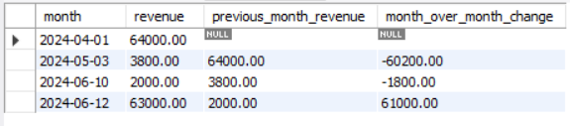

# 4. Using a window function, rank the products by revenue within each category (ranking should restart for each category).

with product_revenue as(
select
c.category_id,
c.category_name,
p.product_id,
p.product_name,
sum(oi.quantity*p.price) as revenue
from products p
join order_items oi
on p.product_id=oi.product_id
join categories c
on c.category_id=p.category_id
group by
p.category_id,
p.product_id,
p.product_name
)
select
category_id,
category_name,
product_id,
product_name,
revenue,
rank() over (
partition by category_id
order by category_name desc
) as revenue_rank
from product_revenue
order by
category_id,
revenue_rank;

OUTPUT:
