Practical 2 – Querying shopdb — joins, subqueries, aggregates and grouping.
USE shopdb;
-- 1. List each order with the customer's name and the order date.
select
o.order_id,
c.name,
o.order_date
from customers c
inner join orders o
on c.customer_id=o.customer_id;

OUTPUT:
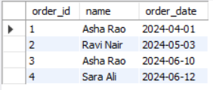

-- 2. List every customer with their number of orders, including customers who have none.
select
c.customer_id,
c.name,
count(o.order_id) as number_of_orders
from customers c
left join orders o
on c.customer_id=o.customer_id
group by
c.customer_id,
c.name;

OUTPUT:
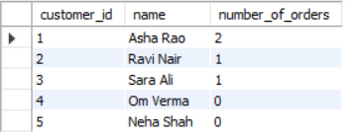

-- 3. List all products priced above the average product price.
select *
from products
where price>(
select avg(price)
from products
);

OUTPUT:
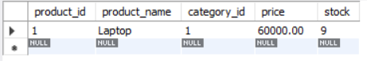

-- 4. Show the total revenue per category, excluding cancelled orders. (Revenue of a line = quantity × unit_price.)
select
c.category_name,
SUM(oi.quantity * oi.unit_price) AS total_revenue
from categories c
join products p
on c.category_id = p.category_id
join order_items oi
on p.product_id = oi.product_id
join orders o
on oi.order_id = o.order_id
where o.status <> 'Cancelled'
group by
c.category_id,
c.category_name;

OUTPUT:
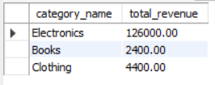

-- 5. Show only the categories whose total revenue exceeds ₹5,000.
select
c.category_name,
sum(oi.quantity * oi.unit_price) as total_revenue
from categories c
join products p
on c.category_id = p.category_id
join order_items oi
on oi.product_id = p.product_id
join orders o
on o.order_id=oi.order_id
where o.status <> "Cancelled"
group by
c.category_id,
c.category_name
having sum(oi.quantity * oi.unit_price)>5000;

OUTPUT:
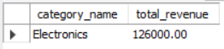

-- 6. List products priced above the average price within their own category.
select
p.product_id,
p.product_name,
p.price,
(
select round(avg(p2.price),2)
from products p2
where p2.category_id = p.category_id
) as average_category_price
from products p
where p.price > (
select avg(p2.price)
from products p2
where p2.category_id = p.category_id
);

OUTPUT:
