Skill Activity 2 - Analytical business reporting with SQL
use shopdb;
-- 1. Which products generate the highest revenue?
select
p.product_id,
p.product_name,
sum(oi.quantity * oi.unit_price) as total_revenue
from products p
join order_items oi
on p.product_id=oi.product_id
join orders o
on o.order_id=oi.order_id
where
o.status <> "Cancelled"
group by p.product_id
order by total_revenue desc;

OUTPUT:
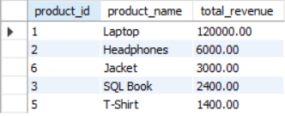

-- 2. How many orders are placed each month, and what is the monthly order trend?
select
year(order_date) as order_year,
month(order_date) as order_month,
count(order_date) as total_orders
from orders
group by
order_year,
order_month;

OUTPUT:
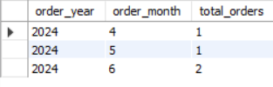
-- 3. Which category has the highest number of products?
select
c.category_id,
c.category_name,
count(p.product_id) as number_of_products
from categories c
join products p
on c.category_id=p.category_id
group by
c.category_id,
c.category_name
order by number_of_products desc
limit 1;

OUTPUT:
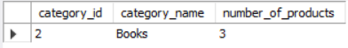

-- 4. Which product categories have the highest average product price?
select
c.category_id,
c.category_name,
round(avg(p.price),2) as average_product_price
from categories c
join products p
on c.category_id=p.category_id
group by
c.category_id,
c.category_name
order by average_product_price desc;

OUTPUT:
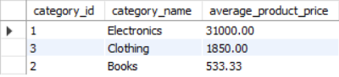

-- 5. What is the total number of orders and total revenue generated in each order status?
select
o.status,
count(distinct o.order_id) as total_orders,
sum(oi.quantity * oi.unit_price) as total_revenue
from orders o
join order_items oi
on o.order_id=oi.order_id
group by o.status
order by total_revenue desc;

OUTPUT:
