Program:
%{
#include <stdio.h>
%}
D [0-9]
L [a-zA-Z]
%%
{D}+\.{D}+ printf("%s is a real number", yytext);
{D}+ printf("%s is an integer", yytext);
{L}+ printf("%s is a word", yytext);
.* printf("Invalid input!");
%%
int main()
{
printf("\nInput: ");
yylex();
return 0;
}

int yywrap()
{
return 1;
}

Output:
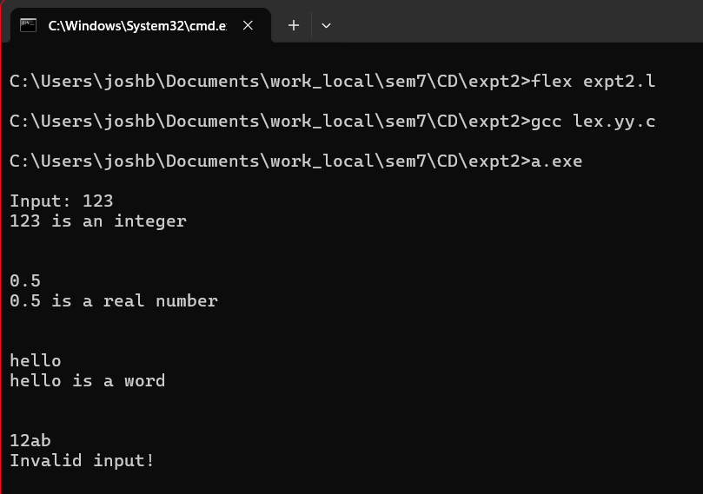
CONCLUSION: LEX program to find if the input is integer, real number or word was implemented and executed successfully.

