Program:
%{
#include<stdio.h>
#include<stdlib.h>
void dec_to_hex(int n){
if(n==0){
printf("0");
return;
}
char hex_char[] = "0123456789abcdef";
char hex_num[50];
int i = 0;
while(n>0){
int remainder = n%16;
hex_num[i] = hex_char[remainder];
n = n/16;
i++;
}
for(int j = i-1; j >= 0; j--){
printf("%c", hex_num[j]);
}
}
int yywrap(void) {
return 1;
}
%}

%%
[0-9]+ { int dec_val = atoi(yytext);
printf("Decimal: %d to Hex: ",dec_val);
dec_to_hex(dec_val);
printf("\n");}

[0-9]+[a-zA-Z]+|[a-zA-Z]+[0-9]+ { printf("Invalid input: %s\n", yytext); }

.|\n { printf("%s", yytext);}

%%
int main(void){
printf("Enter a decimal number:\n");
yylex();
return 0;
}

Output:
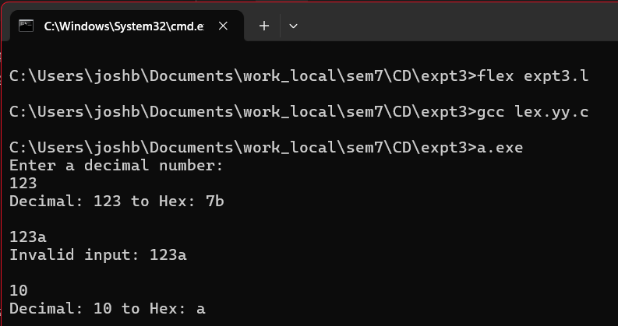

CONCLUSION: LEX program to convert decimal numbers to hexadecimal numbers was implemented and executed successfully.

