Program:
%{
int line_num = 1;
%}
%%
\n {printf("%s", yytext);
line_num++;
printf("%4d ", line_num);}
. {ECHO;}
%%

int main() {
printf("%4d ", line_num);
yylex();
return 0;
}

int yywrap(void) {return 1;}

Input text file:
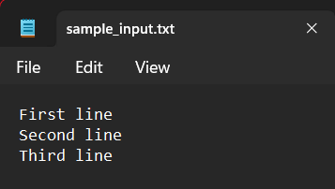

Output:
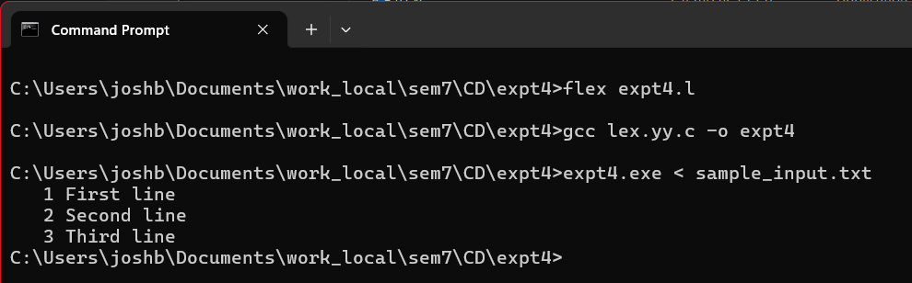
CONCLUSION: LEX program to include line numbers in a given source file was implemented and executed successfully.

