Program:
%{
#include <stdio.h>
#include <stdlib.h>
float sum = 0.0;
int count = 0;
int expected_count = 0;
%}

%%
[0-9]+(\.[0-9]+)? {
if (count < expected_count) {
sum += atof(yytext);
count++;
if (count == expected_count) {
float average = sum / expected_count;
printf("\nFinal Result:\n");
printf("Expected Terms: %d\n", expected_count);
printf("Total Sum: %.2f\n", sum);
printf("Calculated Average: %.4f\n", average);
printf("\n");
}
}
}
.|\n ;
%%

int main(void) {
printf("Enter number of terms: ");
if (scanf("%d", &expected_count) != 1 || expected_count <= 0) {
fprintf(stderr, "Invalid number of terms entered. Exiting.\n");
return 1;
}
while (getchar() != '\n');
printf("Enter the %d numbers: \n",expected_count);
yylex();
if (count < expected_count) {
printf("\nWarning: Only %d out of %d numbers were processed before input ended.\n", count, expected_count);
}

return 0;
}

int yywrap(){return 1;}

Output:
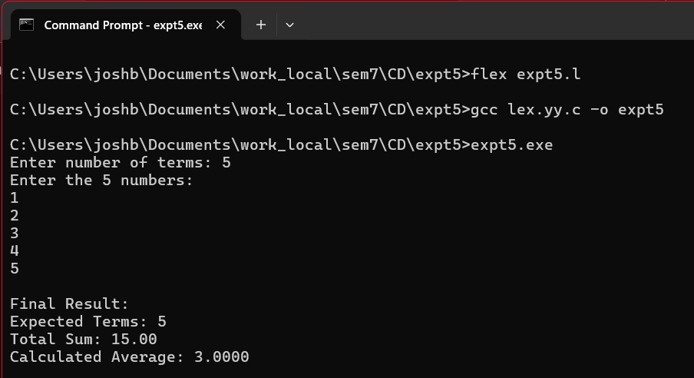

CONCLUSION: LEX program to compute average of given set of numbers was implemented and executed successfully.

