Program:
#include <iostream>
#include <string>
using namespace std;
int main() {
int num;
cout << "Enter number of productions: ";
cin >> num;
string productions[20];
for (int i = 0; i < num; i++) {
cout << "Enter production " << i + 1 << ": ";
cin >> productions[i];
}
cout << "\n--- Eliminating Left Recursion ---\n";
cout << "Note: '#' represents epsilon (empty string)\n";
for (int i = 0; i < num; i++) {
string prod = productions[i];
char non_terminal = prod[0];
string right = prod.substr(3);
string alphas[10], betas[10];
int alpha_count = 0, beta_count = 0;
string temp = "";
for (int k = 0; k < right.length(); k++) {
if (right[k] == '|') {
if (temp[0] == non_terminal)
alphas[alpha_count++] = temp.substr(1);
else
betas[beta_count++] = temp;
temp = "";
} else {
temp += right[k];
}
}
if (!temp.empty()) {
if (temp[0] == non_terminal)
alphas[alpha_count++] = temp.substr(1);
else
betas[beta_count++] = temp;
}
if (alpha_count > 0) {
cout << "\nLeft recursion found in production: " << prod << endl;
cout << "New Grammar:\n";
if (beta_count == 0) {
betas[beta_count++] = "#"; // epsilon represented as #
}
for (int j = 0; j < beta_count; j++) {
if (betas[j] == "#")
cout << non_terminal << " -> " << non_terminal << "'\n";
else
cout << non_terminal << " -> " << betas[j] <<
non_terminal << "'\n";
}
cout << non_terminal << "' -> ";
for (int j = 0; j < alpha_count; j++) {
cout << alphas[j] << non_terminal << "'";
if (j != alpha_count - 1)
cout << " | ";
}
cout << " | #\n";
} else {
cout << "\nNo left recursion in production: " << prod << endl;
}
}
return 0;
}
Output:
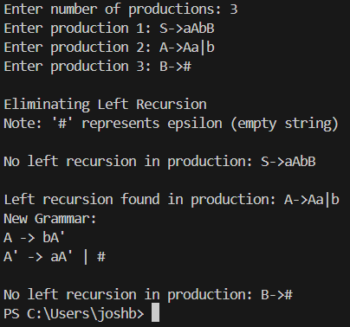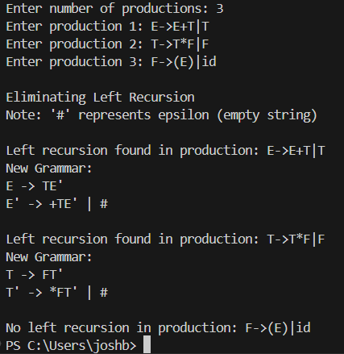

Conclusion: Program to eliminate left recursion was implemented successfully.

