EDUESSENTIALS / DESIGN PROPOSAL / OCTOBER 11 2026

A new coursebook experience
Courses should feel like opening a well-organized academic notebook: a clear index, a dated outline and room to work. This proposal gives the feature its own composition, visual identity and interaction model.
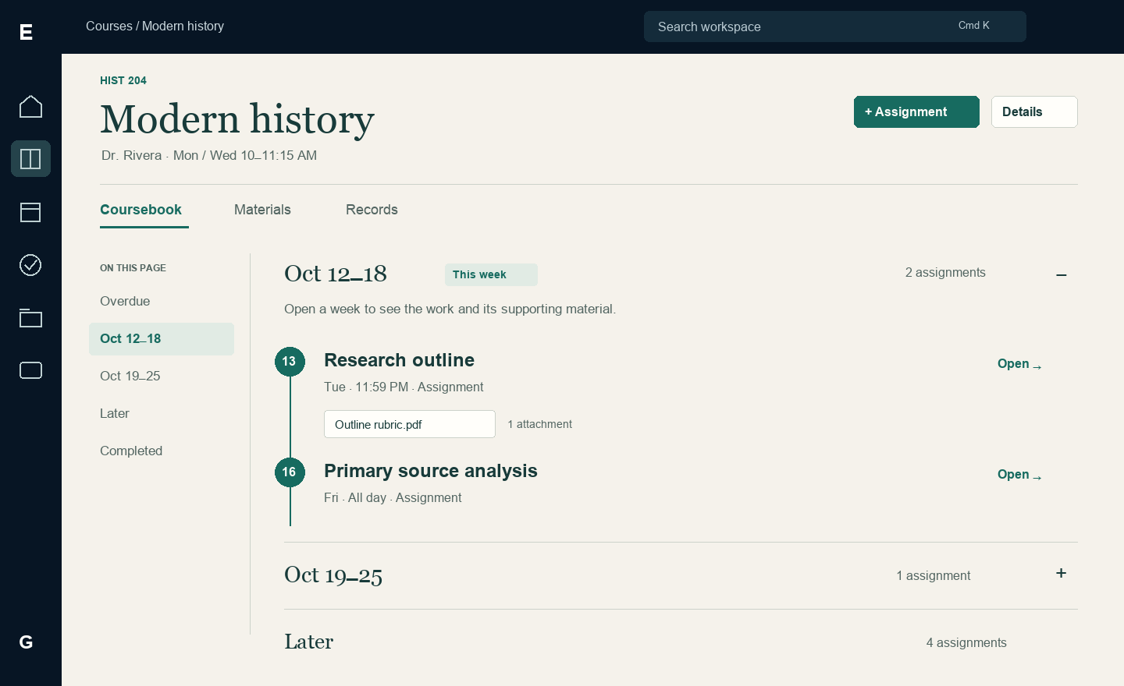
Concept 1 A class organized as a dated coursebook with expandable weeks

The direction
Make the class itself the organizing object. Students enter through an expandable class index, follow a coursebook organized by due date, and open assignments into a wide workbench with the brief beside their notes. A shared Planner reveals deadlines across classes; Records holds grades and study history.
The visual language is warm paper, deep green ink, editorial headings and small subject-color markers. The global navigation remains recognizable, while the course content uses its own typography, spacing and surface treatment. This is an intentional feature-level extension to the existing design standard.

What this document specifies
The following pages define the full journey, eight original interface concepts, external design precedents, drawers and popups, mobile behavior, animation, creation and import, error recovery, and implementation acceptance. Screens use fictional academic data and describe proposed behavior.
COURSES REDESIGN / 02

The design logic and external precedents
The organizing idea is a coursebook, not a collection of interchangeable widgets. A student should be able to scan all classes, unfold one for a quick decision, then move into a coherent sequence of work. Every interaction has a small, clear purpose.
Precedent | Observed pattern | Our interpretation
Moodle course homepage | A collapsible course index, expandable sections and a secondary drawer | Use an on-page week index and expandable dated sections. Put occasional class administration in a drawer.
Canvas course layouts | Courses can foreground modules, assignments or a syllabus; modules organize required work | Make the course outline the main class experience. Keep related assignment material beside the relevant work.
Notion projects and tasks | One information set supports contextual views, including grouping by parent project and dates | Classes, Planner and Records are purposeful views over shared records. An edit updates every relevant view.

What makes this design specific to EduEssentials
The class index unfolds in place. Inside a class, dates form the spine of the coursebook. An assignment opens as a two-column workbench for reading and doing. The week planner is a working view of real deadlines. These four ideas give Courses a distinct identity without introducing a separate navigation system for every action.

One path with useful shortcuts
Courses → class index → coursebook → assignment workbench → return to the same week. A quick-look expansion can jump directly to an assignment. Planner and search are alternate entry points to the same assignment. Materials and Records belong to the selected class when opened there, and return to that class afterward.

Research references
The links below document the observed patterns. Their products are references for interaction principles; the proposed visual compositions are original. Reviewed October 11, 2026.
Moodle Docs — Course homepage
Canvas — Course home page layout options
Notion — Getting started with projects and tasks
COURSES REDESIGN / 03

The expandable class index
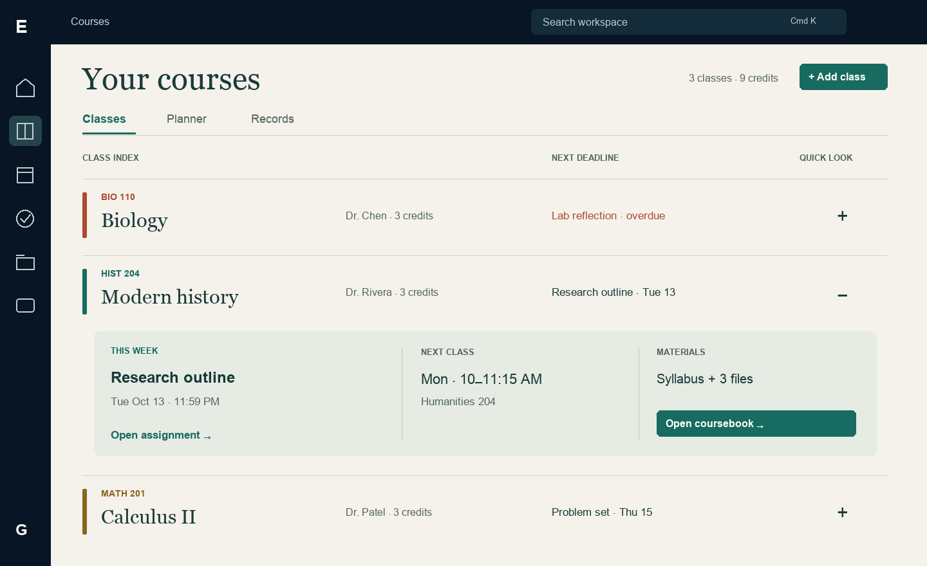
Concept 2 A class index with Modern history unfolded for a quick look

Scan first then unfold
The landing page is a set of generous horizontal rows separated by fine rules. Each row shows code, class name, instructor, credits and nearest unfinished deadline. Color is a narrow identifying stroke; overdue work has explicit text. There are no decorative cover cards or empty statistic tiles.
The class name is a destination link. A separate plus button expands Quick look and changes to minus. Only one quick look is open at a time. Its content contains the next assignment, next meeting and a material count, with Open coursebook as the entry to the complete class. Clicking outside does not collapse it or lose the student’s place.

A small amount of control
Classes, Planner and Records are the only top-level feature views. Add class is the primary creation action on Classes. A compact search appears when the collection is long; sorting offers name, nearest deadline or manual order. Reordering is optional and available through Move up / Move down as well as a drag handle in Arrange mode.
With no classes, replace the index and header creation button with one welcoming Add your first class action and a short import explanation. With one class, keep the same row proportions. A saved-import notice appears as one quiet link near Add class, never as a button for every draft.
COURSES REDESIGN / 04

The coursebook is the class home
Concept 3 The current week expanded with an assignment attachment visible in context

Dates form the structure
A class opens to its current week, or the next week with unfinished work when this week is empty. Sections are Overdue, dated weeks, Later, Undated when needed, and Completed. Date labels follow the student’s week-start and time-zone preferences. Sections are derived from existing due dates; no curriculum or module data is invented.

An outline that responds to the reader
The narrow On this page index scrolls to a section and highlights the section currently being read. Week headings independently expand or collapse; users can keep several open. Preserve the section heading’s position while content unfolds. A sticky Jump to current week control appears only after scrolling away from that week.
Assignments show a date marker, title, type and due time. Related attachments can appear below their assignment; unassigned class materials stay in Materials. The title opens the workbench. The outline is not an arbitrary learning sequence: completing an earlier item never unlocks a later one unless a future dependency feature is deliberately added.

The header stays useful
Keep the class title, code and meeting summary above three local views: Coursebook, Materials and Records. Add assignment is the one primary header action. Details opens the occasional-use class drawer. Long descriptions and administration stay out of the outline; the content should look like a readable syllabus that can be acted on.
COURSES REDESIGN / 05

An assignment becomes a workbench
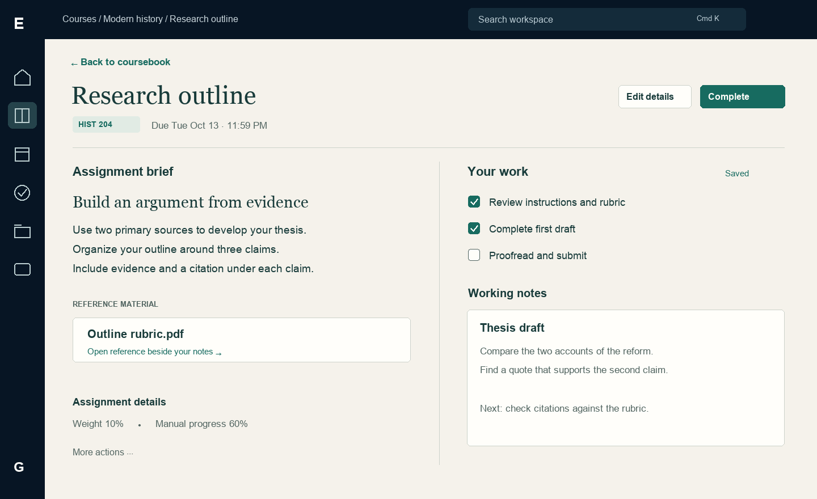
Concept 4 A wide workbench with the assignment brief and reference material beside working notes

Give the task enough room
Opening an assignment navigates to a dedicated workbench with a clear return link. The left column contains the assignment brief and reference files. The right contains checklist and notes. The primary completion action stays near the title. A thin divider separates reading from doing; no large modal sits over a blurred class page.

Reference material can replace the brief
Open rubric replaces the left column with its preview, while the checklist and notes remain available. A Back to brief control restores the text. Unsupported files offer Download with an explanation. On narrower screens, Brief, Your work and Files become tabs without duplicating the assignment or losing draft state.

Edit without changing context
Edit details reveals title, class, date, optional time, type, weight, description and manual progress in the same left region. Save changes and Cancel replace its controls. Checklist and note edits show Saving then Saved after acknowledgement; errors retain input. Changing assignment or leaving with unsaved edits invokes the existing recovery protection.
Mark complete updates the record and becomes Reopen; it does not navigate away. Checklist completion and manual progress remain separate, explicitly labeled values. Completion sets progress to 100%, and Reopen restores its prior estimate. The overflow menu contains deletion with confirmation. “Complete” means personally marked done, never submitted to an external learning system.
COURSES REDESIGN / 06

A planner built around real deadlines
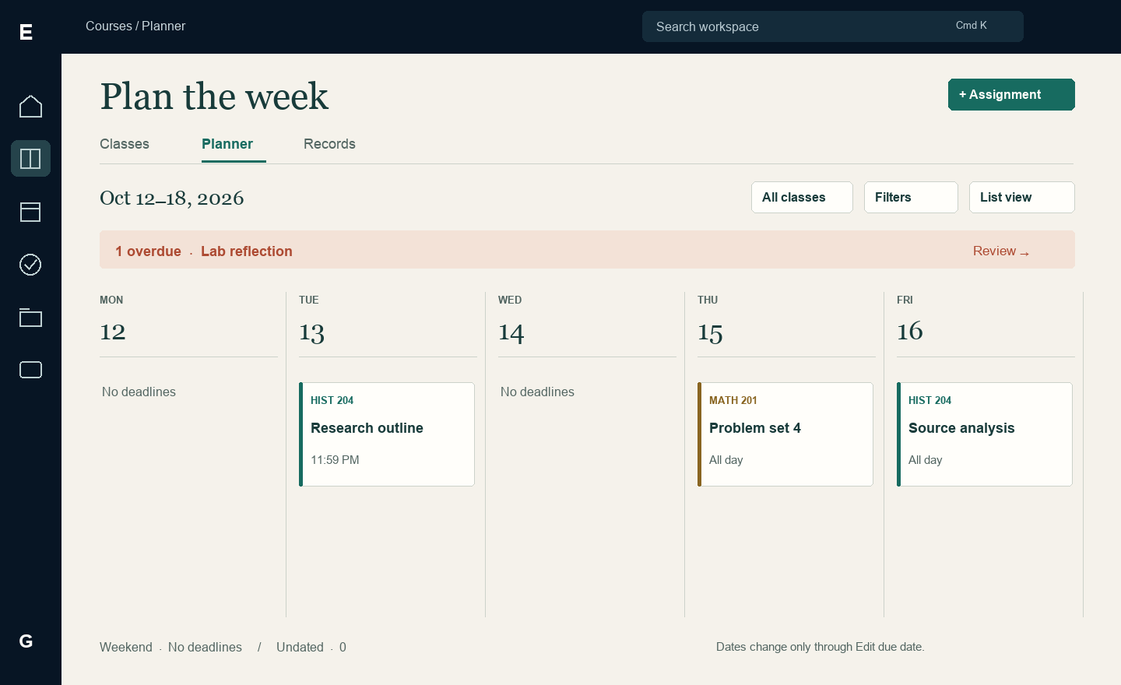
Concept 5 A weekly deadline view across classes with an overdue lane kept visible

See the load across classes
Planner offers Week and List views over the same assignments, with class, status and date filters. The week view groups real due dates by day; an overdue lane stays above the calendar. Weekend and undated work are explicitly reachable. Empty days say No deadlines, not No work. A keyboard-friendly list is always one action away.
Selecting an assignment opens its workbench and remembers the planner’s week and filters. In the first release, changing a due date uses Edit due date with confirmation; dragging a tile must not silently change an instructor’s deadline. A later study-planning feature would need separate planned-work dates.

Filters should remain visible
An active filter appears as a removable chip with the result count. Keep completed items optional and distinguish status from urgency: an in-progress task can still be overdue. List view groups the same work by date and offers the same actions without horizontal scrolling. The overdue lane is derived from current unfinished work, not a manually maintained category.
COURSES REDESIGN / 07

An academic ledger with clear evidence
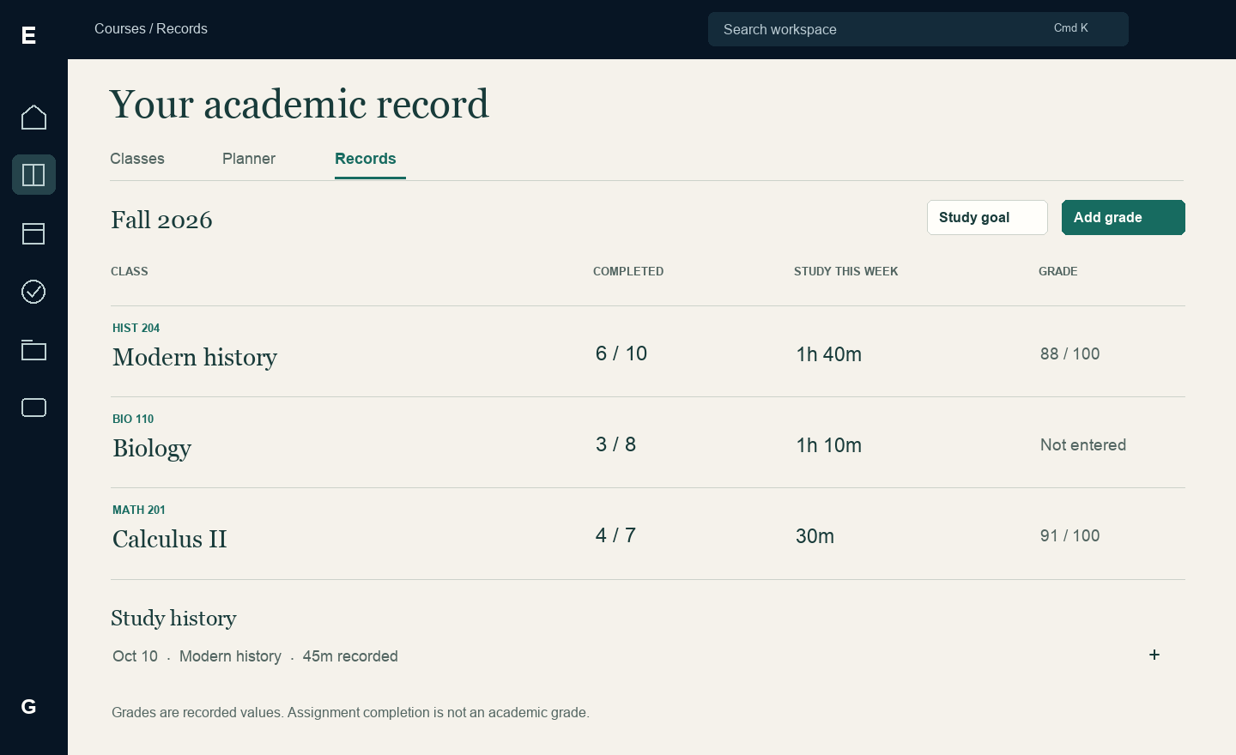
Concept 6 A readable record of completion, study time and entered grades

Records uses a plain academic ledger
Records places one class per row and compares completed assignments, recorded study time and entered grade. A class’s Records view narrows to that class. Grade values include their grading system and selected term; missing grades say Not entered. Expand study-history rows for individual sessions. Edit grade and Adjust study goal open focused dialogs.
Completion counts are not grades, time spent is not mastery, and a manual grade is not a calculated course average. Keep the three measures separate and label the source. All totals use the existing academic records and profile date preferences.

Small editors with explicit meaning
Add grade opens a compact dialog with class, term, grading system and value. The selected class is prefilled when opened inside a class. Validate against the chosen system and keep entered values after failure. Editing an existing grade changes the same record; Cancel discards only the local draft.
Study goal opens a duration and period editor. Study history expands to sessions with dates, durations and class association. Completed assignment counts link to the underlying completed list. Provide a text summary for any optional chart; the ledger remains the primary way to compare records.
COURSES REDESIGN / 08

Creation and import as a guided workspace
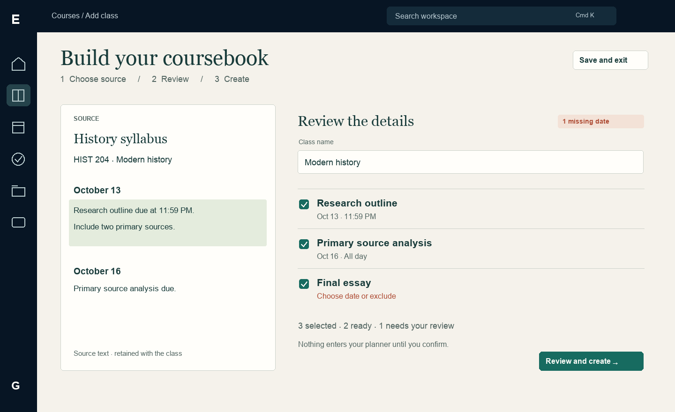
Concept 7 A retained syllabus source beside editable class information and selected assignments

Create a useful class quickly
Add class opens a compact choice popup: Enter details or Import syllabus. Manual entry begins with name and code. Credits and color are nearby; instructor and recurring schedule expand under More details. After a successful create, open the coursebook with Add assignment and Add material as empty-section actions, rather than several competing onboarding buttons.

Turn the syllabus into reviewed data
Import uses three steps: Choose source, Review, Create. Show supported source types and size limits before upload. Retain pasted text as a fallback. Review is a full-width comparison page with the original source on the left and editable extracted information on the right. Source highlights appear only when extraction provides reliable provenance.
Every selected item must have a valid title and due date before creation. Missing fields open inline; items may be excluded explicitly. Potential duplicates show the existing item and a deliberate keep, replace or add-separately choice. Review and create opens a final summary listing included and excluded counts; its final button names the actual records to create.

Long tasks can pause
Save and exit preserves the draft, selected rows and current step. Resume returns there. Extraction shows real stages and offers recovery without discarding the source. The final save is atomic and repeat-safe: a lost response must not create another class or another set of assignments.
COURSES REDESIGN / 09

Materials and the class details drawer
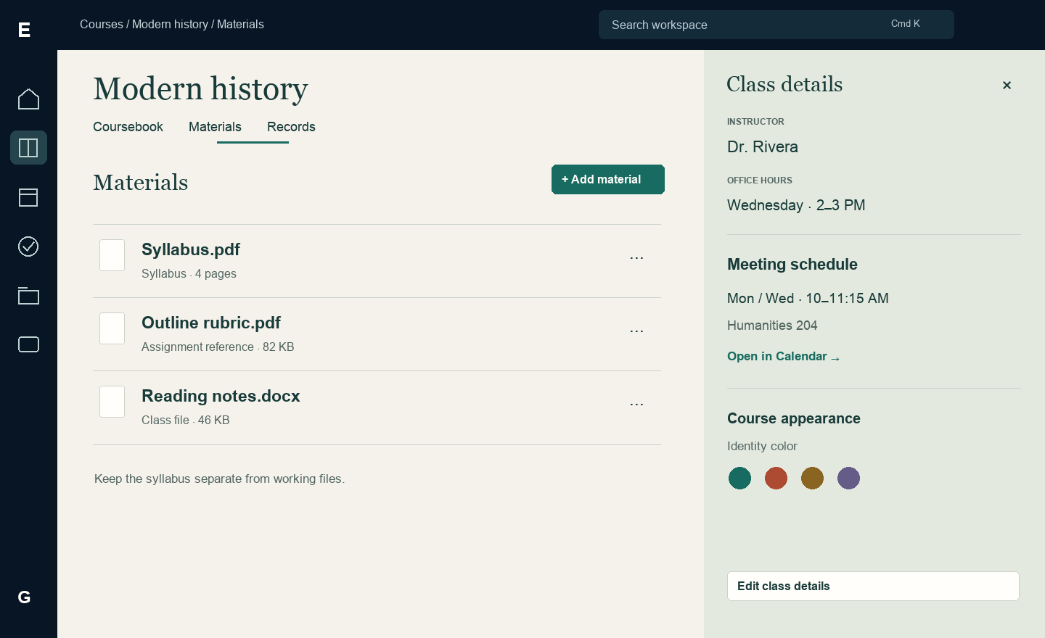
Concept 8 A document library beside a secondary class-information drawer

Files should look like files
Materials uses a clean document list with the syllabus pinned first, then supporting files. Filename, type, size and availability are readable on each row. Add material opens a short menu for upload, existing-file linking and syllabus text when supported. Image thumbnails appear only where they help identify an image; ornamental course covers are optional.

The drawer has one limited role
Details slides a class-information drawer into the right side of the page. It contains instructor, office hours, recurring meetings, appearance and Edit class details. On a wide screen it pushes content inward without obscuring the selected file; on a narrow screen it becomes a modal sheet. It is never the main class destination.
Editing replaces drawer values with labeled inputs and explicit Save changes / Cancel controls. Remove class appears under a separated destructive section. Desktop focus follows normal reading order in the nonmodal panel; a modal mobile sheet traps focus and makes the covered page inert. Both have a visible close control and return focus to Details.

Preview and attachment behavior
Selecting a file opens a full content preview with Back to materials, download and relevant metadata. Closing returns to the same row. Pending uploads retain their place and show progress when measurable. Failed uploads show Retry. Detach removes a relationship; Trash is a different action with different consequences. No preview opens inside an already modal drawer.
COURSES REDESIGN / 10

Mobile keeps the coursebook structure
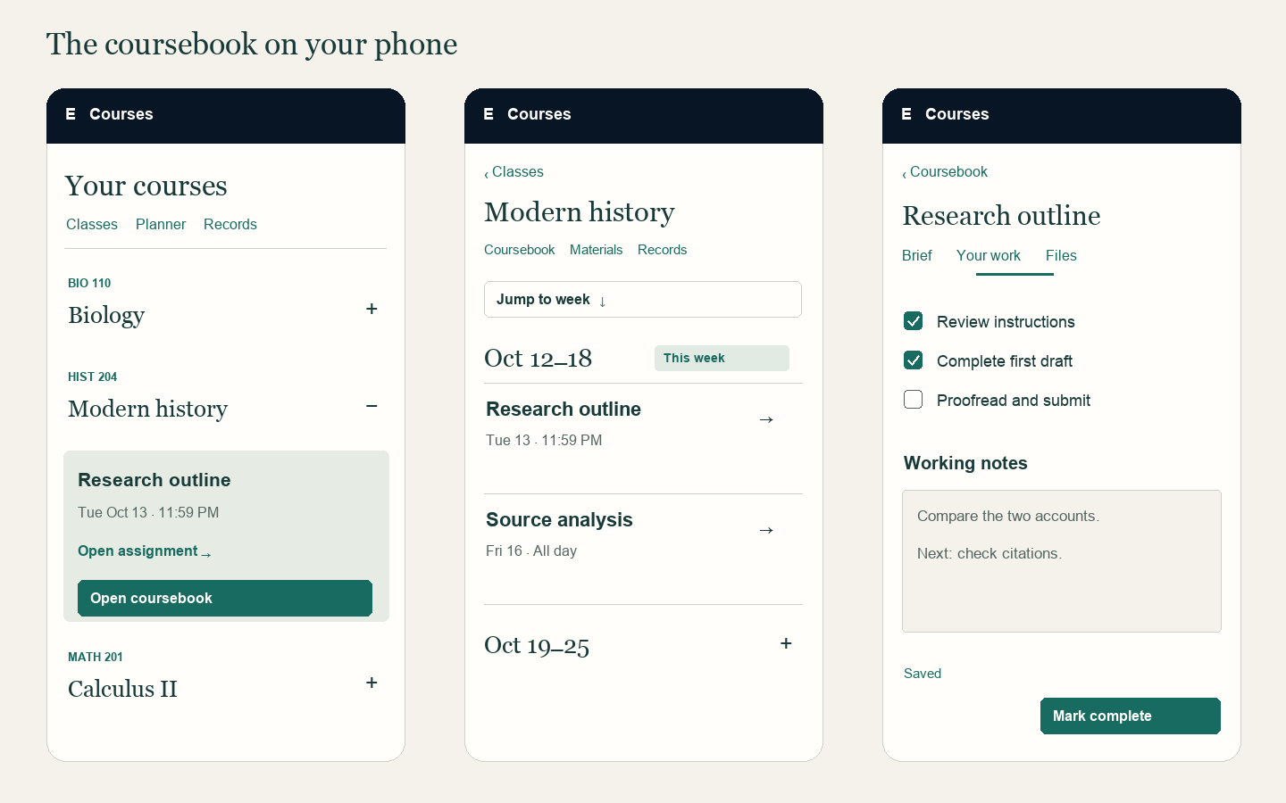
Concept 9 Expandable index, dated coursebook and tabbed assignment workbench on mobile

Adapt the layout rather than shrinking it
The class index becomes a single column with compact metadata and a full-width Quick look expansion. The on-page week index becomes a Jump to week sheet. Week headers remain large, readable expansion targets. Coursebook, Materials and Records stay in a horizontally scrollable local navigation row with the selected destination visible.

Working on a phone
The assignment workbench uses Brief, Your work and Files tabs. Preserve note draft, checklist and scroll position when switching tabs. Mark complete stays in a safe-area-aware footer; on focus in a text field, the keyboard must not obscure the edit or its save state. Browser Back and the explicit return link use the same safe-leave behavior.

Responsive rules
Use the two-column workbench only when each column can retain a readable width of about 360px. Below that, use tabs. The class Details drawer pushes content only when at least 640px of content remains; otherwise it overlays as a modal sheet. The existing app shell still handles expanded, collapsed and mobile navigation.
Keep 44px touch targets, named icon controls, visible keyboard focus and sufficient text contrast on the paper surface. Verify 320px and 390px phones, short viewports, 200% zoom, long titles and both motion preferences. Mobile bottom navigation remains available on ordinary pages and is covered only by a modal sheet.
COURSES REDESIGN / 11

Visual identity and interaction choreography
Courses introduces its own reading surface. The shell remains dark and familiar; course content uses warm paper, thin rules, generous row spacing, restrained green actions and an editorial title face. This distinction is local to Courses and does not require changing Home.
Role | Proposed treatment
Content canvas | #F5F2EB paper; #FFFEFA editable or file surfaces; #CCD2CA separators
Text and action | #183B3A primary ink; #526561 supporting text; #176B60 action with white text
Subject and urgency | Green, ochre and muted coral identify classes. Urgency always includes a label; never infer status from course color.
Typography | Editorial serif for class and page titles, about 40–48px desktop and 28–32px mobile; sans serif 16px body and controls. Preserve shell typography.
Geometry | 8px or smaller local corners, thin dividers, 24–32px section spacing; fewer enclosing boxes. No scenic feature header or glow treatment.

Action | Behavior and motion | Reduced motion
Unfold a class | 220ms height reveal; keep the class title anchored; sibling rows move together | Immediate expansion with the same final layout
Expand a week | 180ms reveal from its heading; preserve scroll position and reading location | Immediate reveal
Open assignment | 160ms content crossfade with the title retained as the visual anchor; use normal navigation | Immediate route change with focus moved to the title
Open Details | 240ms coordinated panel and content reflow; overlay only at narrow widths | Immediate final placement
Complete work | 120ms check transition, persistent Completed label and brief Undo feedback | Static check and status announcement
Open popup or toast | 120ms opacity and at most 4px travel; no bounce or repeated celebration | Immediate appearance

These are proposed timing targets. Interruptions resolve to the latest action, never a queued animation. Honor OS and account reduced-motion settings. Filter changes keep focus in the control; status regions announce the changed result count without announcing every animation frame.
COURSES REDESIGN / 12

Interaction rules and recovery states

Use the smallest suitable surface
Inline expansion is for a quick look or hidden section. A popover is for view options and short menus. A drawer is for class administration. A small dialog is for a focused form or consequential choice. A full page is for the coursebook, workbench, document preview and syllabus review. Keep at most one modal layer active; replace its content instead of stacking another modal.
State | Visible response | Recovery or next action
First visit with no classes | One Add your first class action and a short import option description | Create manually or import; no empty metric panels
No work this week | An empty dated section with the next available week linked | Jump to next work or add assignment
No filter matches | Retain the query and selected filters | Clear filters; never show first-use onboarding
Loading | Reserved index rows or week headings; shell remains usable | Replace silhouettes without changing layout
Saving or offline | Saving, then Saved only on acknowledgement; Unsaved when offline | Keep drafts visible and offer Retry
Upload or extraction failure | Failed item stays visible with a concrete reason | Retry, supported-source fallback or manual entry
Conflict or expired session | Persistent recovery message linked to the existing save-protection flow | Preserve draft before reload or reauthentication
Deleted or unavailable item | Clear unavailable state with a valid return destination | Return to the class or planner; no broken empty overlay

Feedback should tell the truth
Use a short toast for a confirmed save or completion, with Undo only where a real reverse action exists. Keep errors inline and persistent. Toasts use polite announcements, pause while focused, and do not carry the only way to recover. Invalid forms show nearby errors and preserve input. Closing dirty edits asks Keep editing or Discard changes.

Destructive behavior stays explicit
Remove class names the class and affected assignments and meetings. Preserve existing semantics: manual events become Personal and file records retain their content with invalid class links cleared. Delete assignment explains loss of notes and checklist and detachment of linked files. Do not offer archive or deletion undo until recoverable state is implemented.
COURSES REDESIGN / 13

Implementation scope and acceptance

One model with several useful views
Keep the existing academic save transaction, file ownership rules and date helpers. Extract the index, coursebook, planner, records, workbench and details drawer from the current shared workspace rendering path. Week groups derive from actual due dates, including explicit handling for legacy undated records. The same assignment ID appears in every view; views never maintain separate copies.
Proposed routes are /courses, /courses/:id and /assignments/:id, with explicit view and filter parameters. Keep /dashboard links working through a compatibility redirect. Store the return route and scroll context when opening a workbench; a direct link falls back to its class, or Planner for Personal work. Reopening a removed or unauthorized record must show a usable unavailable state.

Deliver in coherent slices
First ship the new class index and dated coursebook with reliable navigation. Next add the assignment workbench and material preview, then the planner, records and Details drawer. Reorganize creation and import around the existing save path. Finish with responsive behavior, motion and keyboard checks. Saved import step, manual course order and reliable source highlighting may require extra persisted fields; define migrations before exposing them.
Do not add LMS submission, instructor-authored modules, prerequisite unlocking, automatic grade prediction or drag-to-reschedule as implied functionality. These require new product and data contracts. The proposed coursebook remains useful with the academic data already present.

Acceptance scenarios
- Expand a class, open its coursebook, expand two weeks, open an assignment, edit notes, preview its rubric, complete it, reopen it and return to the same section.
- Open an assignment from Planner, Home, Calendar, Tasks and search. Confirm one record, correct return context, working direct links, browser Back and reload.
- Create manually and through import. Save and resume a review, resolve missing dates and duplicates, and retry after a lost save response without duplicate records.
- Verify empty, loading, no-match, failed-save, offline, conflict, expired-session and unavailable-file states. Confirm drafts survive all recoverable errors.
- Complete the flow by keyboard and screen reader. Check expansion state, tab behavior, focus return, modal containment, nonmodal drawer order and status announcements.
- Check 320, 390, 820, 821, 1280, 1440 and 1920px widths, expanded and collapsed shell, 200% zoom and reduced motion. No essential action may be clipped.
- Compare dates, completion and study totals across Home and Courses. Verify no cosmetic change alters deadline semantics, grades or academic save behavior.

Local implementation references
Inspect app/workspace-client.tsx for current dashboard, detail and navigation behavior; app/course-syllabus.tsx and app/syllabus-review.tsx for syllabus workflows; and PERSISTENCE_ACADEMICS.md for save and removal semantics. Treat docs/design-system.md as the shared-shell reference while documenting this Courses-specific visual extension. External precedents are linked on page 2.

