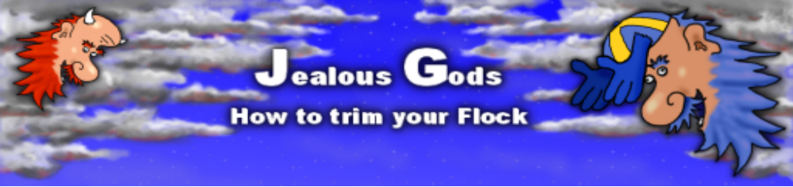

Index

Credits 1
Game Specs 2
Game Requirements 2
Technology 2
Game Genre 2
Game Setup 2
The Game Phases 2
Moving Phase 2
Selecting Taboo Phase 2
Taboos 3
Optional with children in the population 3
Winning 3
Optional Rules 3
Art Needed 4
3D 4
2D 4
Sounds Needed 4

Credits

Alphabetically
Anton Andersson, antonandersson16@hotmail.com, 3D artist
Emanuel Greisen, Gamalocus, eg@gamalocus.com, Programmer
Jørgen Havsberg, Gamalocus, jorgen@fabeljet.net, Programmer
Lars Peter Nielsen, Gamalocus, lars@gamalocus.com, 2D artist and text
Mikkel, Game Audio Denmark, me@gameaudiodenmark.dk, Sound effects
Paul Fluegel Usul, Gamalocus, paulusul@gmail.com, Programmer and coffee
Thorbjørn Vinther Christensen, IOI, vintor.dk@gmail.com, 3D artist

Game Specs

Game Requirements
- Windows, Linux and Mac and two Logitec Controllers or keyboard.
- Minimum resolution of 1024x768
- 3D enabled graphics card

Technology
Java and jMonkey.

Game Genre
- Strategy puzzle game
- 2 players

Game Setup
- A 5x5 checker board world. (Scalable)
- Red population: 12 men, 12 women (optionally 10 + 10 + 6 children)
- Green population: 12 men, 12 women (and optionally 10 + 10 + 6 children)
- All people distributed randomly on the board at game start. Ie. 0-3 people in each square.
- A list of 6 selectable Taboos in the sky
- A Red God and a Green God taking turns at selecting taboos with a simultaneous 5-20 second movement phase in between.

The Game Phases

Initially Player A (Red God) or Player B (Green God) is assigned randomly as the next Taboo Selector. The god’s face hovering above the map is made big.

Moving Phase
Both players simultaneously move their people around the map for 5-20 seconds using a large awkward puck. The people can only be moved into squares with less than three people. Time is reduced in the movement phase from 20 with max population and 5 with 1 man left.

Selecting Taboo Phase
Assigned Player takes a look at the playing field and within 6 seconds he must select a Taboo from his arsenal of taboos or lose his chance to strike down with divine vengeance.
Each taboo will destroy all the inhabitants in squares where there is a specific combination of males, females and children.

Taboos
Taboo Name Kills squares with
Gay: 2+ Men
Lesbian: 2+ Women
Masturbation: Man alone
Menstruation: Woman alone
Orgy: 3 mixed People
Wife Beater: Woman, Man

Optional with children in the population
Taboo Name Kills squares with
Incest: 2 Adults + Child
Paedophilia Adult + Child
Neglect: Child alone
Group Teasing: 2+ Children

The result of the taboo is applied. A mad god laughs and everybody in the squares with the taboo social combination will explode.

The other player is now assigned to be the next Taboo Selector and a new movement phase starts.

Winning
The game ends when one player has lost all his population. The players get rating equal to the amount of their own survivors.

Optional Rules

- Add children to increase taboo combinations.
- Add fixed location based taboos ie the dog, the pig, the cow, the burial grounds the giant negro dildo to kill off people near those on the map.
- Disallow the last used taboo for 1-2 turns.

Art Needed

3D
3D man
3D woman
3D Map with a grid
3D Aztec pyramid to support the map
3D some palm trees and stuff
3D object to push the people around (round puck)
3D going to explode animation (jumping)
3D Particle effects: Exploding / Death particle thing

2D
Background
6 Taboo choices as buttons. 2D icons default, selected, disabled.
Two gods in the sky (Monty Python style?)
Text with vital information

Sounds Needed

Ridiculous laughter
Pushing, shuffling, sliding sounds
Explosion, Implosion, Flesh turning into goo
Ambient music

Voiceovers if there is time.

