Security Incident Detection and Response Management System
Sprint I — Services 7, 8, 9
Joseph Awaida
18 October 2026
Contribution report: merge with the common team report before submission.

Table of contents

Update this table in Word to populate page numbers. All sections in this contribution: Joseph Awaida.

1. Title page (Joseph Awaida)
Security Incident Detection and Response Management System Backend. Software Tools Lab, Fall 2026–2027, Sprint I. Contribution: services 7, 8, and 9. Prepared 18 October 2026. GitHub: https://github.com/j123awaida/435L. This document is Joseph Awaida's contribution draft, to be merged into the team's common report with names, page numbers, real Postman screenshots, team history, and CREATES feedback.

2. Table of contents (Joseph Awaida)
The DOCX version contains a Word table-of-contents field. Update the field after merging the common report so page numbers reflect the final layout. Sections 1–11 here are Joseph Awaida's contribution. Other members must identify their own sections in the merged report.

3. Introduction (Joseph Awaida)
Organizations need consistent records of security weaknesses, notifications, and response procedures. These backend services associate discovered vulnerabilities with assets, deliver user alerts, and track ordered response actions. The implementation provides all eighteen required operations for this contribution, persistent relational storage, authentication, role checks, input validation, and runnable Postman scenarios. It does not implement the remaining six services or a frontend.

4. System architecture (Joseph Awaida)
Four independent FastAPI processes run locally: a temporary identity adapter on port 8000, vulnerability management on 8007, notifications on 8008, and response playbooks on 8009. Postman and API clients communicate with each process over HTTP. A shared SQLite file supplies reference identities, assets, tokens, owned service tables, and local audit records. This Sprint I arrangement is appropriate for a local demonstration, but it does not provide independent service databases or the complete team's cross-service API integration.
The identity, asset, and audit interfaces are explicit team integration boundaries. Teammates must replace the temporary adapter and reference tables with agreed APIs for Services 1, 2, and 5. Upstream incident and threat services may create notifications by calling Service 8 with an authorized administrator session. Event-driven automatic alert creation is not implemented because those upstream services are outside this contribution. See architecture.mmd for the diagram.
![Service architecture](architecture.png)

5. Implementation details (Joseph Awaida)

Service 7: vulnerability management
The service creates, lists, retrieves, updates, searches, and deletes vulnerability records. Each record stores title, description, CVE identifier, CVSS, severity, asset, discovery source, lifecycle status, creation time, and resolution time. Creation checks that the asset exists. Search combines exact CVE, severity, asset, and status filters with AND. Empty results return an empty array.
For example, POST /Joseph-Awaida/vulnerabilities accepts {"title":"Exposed remote service","description":"Review required","cve_identifier":"CVE-2026-12345","cvss_score":9.1,"severity":"Critical","asset_id":1,"discovery_source":"Lab scanner"}. A successful creation returns HTTP 201 and the stored object, including its generated id and timestamps. This CVE is synthetic input for exercising the application, not a claim about a published vulnerability.
Severity is stored as a constrained text enum. The caller selects severity independently of CVSS; no automatic severity calculation is claimed. The workflow enforces Open → Under Investigation → In Progress → Resolved → Closed. Moving directly from Open to Closed returns 409. The server sets resolution_date on entering Resolved and preserves it on closure, rather than accepting arbitrary client timestamps. This deliberately protects chronology.

Service 8: notification management
Notifications store recipient, title, message, type, severity, creation time, status, and read date. Administrators create alerts for existing users. Alert types cover incident assignments, security alerts, system events, threat alerts, and vulnerability alerts. Status starts Unread. Marking read sets a server timestamp only once, so repeated requests preserve the original read date.
For example, POST /Joseph-Awaida/notifications accepts {"user_id":3,"title":"Security alert","message":"Review suspicious activity","notification_type":"Security Alert","severity":"High"}. It returns HTTP 201 with the generated notification. GET /Joseph-Awaida/notifications/user/3 returns an array. A valid recipient with no notifications returns []. Analyst and employee access is limited to their own notifications; administrators and auditors can read across users. Only administrator, analyst, and employee roles may mark read, subject to ownership. Search accepts recipient, type, severity, and status. Analysts search only their own records; employees have no search permission.

Service 9: playbooks and response actions
Playbooks store name, description, incident category, severity, creator, and creation date. Their response actions are returned in ascending step order. Actions store description, positive unique step number within a playbook, status, assignee, and completion time. Administrators create/delete playbooks; administrators and analysts add actions and advance action status; auditors only read.
For example, POST /Joseph-Awaida/playbooks accepts {"name":"Malware containment","description":"Isolate and investigate","incident_category":"Malware","severity":"High"}. POST /Joseph-Awaida/playbooks/{id}/actions accepts {"description":"Isolate asset","step_number":1,"assigned_user_id":2}. PUT /Joseph-Awaida/actions/{id}/status accepts {"status":"In Progress"}. Successful updates return the persisted action. Steps progress Pending → In Progress → Completed. A user must be assigned before execution. Earlier steps must be completed before a later action starts. Completion time is generated by the server.
Each action creation/status update creates an immutable history row, including actor, assignee, old/new state, and time. Deleting a playbook cascades to its current actions but preserves execution history with the original action/playbook identifiers. Those history identifiers intentionally lack cascading foreign keys so deleted objects remain traceable.

6. Database design (Joseph Awaida)
The schema is app/schema.sql. SQLite foreign keys are enabled on every connection. Every operational table uses an integer primary key; session tokens use a SHA-256 digest primary key. Users own assets and receive notifications. Assets have many vulnerabilities. Users create playbooks. Playbooks contain many actions. Users can be assigned many actions and generate many history/audit entries. See schema.mmd for the ER diagram.
![Database schema](schema.png)
users is a minimal Service 1 reference with unique username, full name, password hash, role, and account status. assets is a minimal Service 2 reference with name and owner. They are integration scaffolding, not the full user/asset schemas required of the team. sessions holds hashed tokens, users, and expiry. vulnerabilities, notifications, playbooks, actions, and action_history belong to this contribution. audit_logs is a local Service 5 integration boundary and records permission denials and login results. All nine complete team service schemas must be merged by the team.
CHECK constraints validate database enum values, score ranges, and step numbers. UNIQUE(playbook_id, step_number) prevents ambiguous action ordering. Indexes support common vulnerability and notification filters. Parameterized queries prevent SQL injection; table names and update keys originate in trusted code/schema definitions. Transactions protect lifecycle updates from concurrent writes. History rows cannot be updated/deleted through database triggers. Audit rows cannot be updated. No audit modification API is exposed.

7. Error handling and validation (Joseph Awaida)
Requests reject unknown fields, empty or whitespace-only text, invalid CVE structure, scores outside 0–10, invalid severities/types/statuses, nonpositive identifiers, duplicate action steps, invalid references, and workflow skips. CVE identifiers must match CVE-YYYY-NNNN or longer numeric suffixes. This is syntactic validation, not a lookup in a CVE registry.
Errors consistently use {"status":"error","message":"..."}. Input errors also contain a sanitized list of field locations and messages. HTTP 401 identifies missing, invalid, expired authentication or inactive accounts; 403 identifies role or ownership denial; 404 indicates a nonexistent entity; 409 indicates constraint/workflow conflicts; 422 indicates malformed/invalid input. Internal SQL details are not returned in constraint errors. Permission violations persist in local audit logs with actor, method, path, related service, and warning severity.
Automated tests exercise all four roles, credentials, inactive accounts, ownership, malformed inputs, lifecycle ordering, action ordering, deletions, and history retention. Actual local execution records are saved by scripts/capture_evidence.py; evidence/SUMMARY.md records their outcome after execution. Real Postman screenshots still need to be added with identifying captions; the JSON records are not represented as screenshots.

8. API documentation (Joseph Awaida)
The full API list and request fields are in API.md; generated OpenAPI JSON documents include exact schemas. Interactive documentation is available at each process's /docs. All assignment endpoints include /Joseph-Awaida before the resource path. The Postman collection contains descriptions and assertions for all required operations plus success, failure, authorization, search, and workflow scenarios. Requests save tokens and created identifiers into local environment variables. The environment contains empty password/token fields so no credentials are published.
Postman users must enter their locally generated development passwords, run the folders in order, and record screenshots of actual requests and responses. Screenshots should show method, named route, request body as applicable, status, response body, and a caption such as “Joseph Awaida — Advance vulnerability to Under Investigation: demonstrates the permitted next lifecycle step.” Hide credentials and bearer tokens.

9. Authentication and authorization (Joseph Awaida)
The temporary identity adapter verifies salted PBKDF2-HMAC-SHA256 password hashes using 600,000 iterations and constant-time digest comparisons. Successful login returns a cryptographically random bearer token with a one-hour expiry. Only token digests are stored. Every service verifies token expiry, current account status, and role against the database on each request. Suspending a user immediately prevents use of an existing session.
admin corresponds to Security Administrator; analyst to Security Analyst; employee to Regular Employee/User; auditor to Auditor. Administrators have all eighteen operations. Analysts can read/update vulnerabilities, read their own notifications, mark their own notifications read, search their own notifications, read playbooks, and add/update response actions. Employees can only read/mark their own notifications. Auditors can read/search vulnerabilities and notifications and read playbooks; they cannot mutate records. Analysts cannot create/delete vulnerabilities, create/delete notifications, or create/delete playbooks. Forbidden role and ownership attempts are audited.
The development identity adapter is not a public registration service and does not allow callers to choose their own roles. The seed command provisions demo identities locally. Full identity registration/account management remains the responsibility of Service 1. Production deployment, distributed token verification, HTTPS termination, identity service contracts, and remote audit forwarding are outside this local Sprint I contribution.

10. GitHub and version control (Joseph Awaida)
Target repository: https://github.com/j123awaida/435L. The source and tests were successfully pushed to the repository on 18 October 2026. Commit history records implementation, tests, and documentation work. No backdated commits or teammate contributions are fabricated. Each teammate must push their own work, and the merged common report must include actual history/contribution screenshots. GitHub upload status must be checked against the actual push result; naming a target repository here is not proof of upload.

11. References and AI disclosure (Joseph Awaida)
Primary assignment: Final Project Fall 2026-2027-Sprint 1 (1).docx supplied by the student. Implementation documentation: https://fastapi.tiangolo.com/ ; https://docs.python.org/3/library/sqlite3.html ; https://docs.python.org/3/library/hashlib.html ; https://docs.pytest.org/ ; https://learning.postman.com/docs/collections/collections-overview/ .
OpenAI Codex assisted in interpreting requirements, implementing code, creating tests, preparing API/Postman artifacts, and drafting this report. Joseph Awaida must review and understand the implementation, reproduce its behavior, capture the required evidence, and accurately disclose assistance in the final team submission. The automated API evidence is produced by the local running implementation; none of it is claimed to be manually executed Postman evidence.

Actual execution records (Joseph Awaida)
Real HTTP requests captured at 2026-10-18T09:42:29.841271+00:00. These records supplement required Postman screenshots; they are not screenshots.
Operation | Expected | Actual
Login admin | 200 | 200
Login analyst | 200 | 200
Login employee | 200 | 200
Login auditor | 200 | 200
Reject incorrect password | 401 | 401
Create critical vulnerability | 201 | 201
Create second vulnerability | 201 | 201
Retrieve vulnerabilities | 200 | 200
Retrieve vulnerability | 200 | 200
Missing vulnerability | 404 | 404
Search severity=Critical | 200 | 200
Search asset_id=2 | 200 | 200
Search cve_identifier=CVE-2026-12345 | 200 | 200
Search status=Open | 200 | 200
Reject CVSS above ten | 422 | 422
Reject missing title | 422 | 422
Reject employee access | 403 | 403
Reject missing token | 401 | 401
Reject lifecycle skip | 409 | 409
Advance vulnerability to Under Investigation | 200 | 200
Advance vulnerability to In Progress | 200 | 200
Advance vulnerability to Resolved | 200 | 200
Advance vulnerability to Closed | 200 | 200
Reject analyst deletion | 403 | 403
Delete vulnerability | 200 | 200
Create employee alert | 201 | 201
Create analyst alert | 201 | 201
Retrieve own notifications | 200 | 200
Retrieve empty notifications | 200 | 200
Retrieve specific notification | 200 | 200
Reject another user notification | 403 | 403
Missing notification | 404 | 404
Search user_id=3 | 200 | 200
Search notification_type=Security%20Alert | 200 | 200
Search severity=High | 200 | 200
Search status=Unread | 200 | 200
Reject auditor marking read | 403 | 403
Mark own notification read | 200 | 200
Repeat mark read | 200 | 200
Reject employee deletion | 403 | 403
Delete notification | 200 | 200
Create playbook | 201 | 201
Create second playbook | 201 | 201
List playbooks | 200 | 200
Retrieve playbook | 200 | 200
Missing playbook | 404 | 404
Add response step 1 | 201 | 201
Add response step 2 | 201 | 201
Reject duplicate step | 409 | 409
Reject out of order action | 409 | 409
Step 1 In Progress | 200 | 200
Step 1 Completed | 200 | 200
Step 2 In Progress | 200 | 200
Step 2 Completed | 200 | 200
Retrieve completed workflow | 200 | 200
Reject analyst deleting playbook | 403 | 403
Delete playbook | 200 | 200

Create critical vulnerability
POST http://127.0.0.1:8007/Joseph-Awaida/vulnerabilities
{
"id": 1,
"title": "Exposed remote service",
"description": "Scanner detected an exposed service requiring review.",
"cve_identifier": "CVE-2026-12345",
"cvss_score": 9.1,
"severity": "Critical",
"asset_id": 1,
"discovery_source": "Lab scanner",
"status": "Open",
"created_at": "2026-10-18T09:42:29.700366+00:00",
"resolution_date": null
}

Create employee alert
POST http://127.0.0.1:8008/Joseph-Awaida/notifications
{
"id": 1,
"user_id": 3,
"title": "Security alert",
"message": "Review the reported suspicious message.",
"notification_type": "Security Alert",
"severity": "High",
"status": "Unread",
"created_at": "2026-10-18T09:42:29.757173+00:00",
"read_date": null
}

Retrieve completed workflow
GET http://127.0.0.1:8009/Joseph-Awaida/playbooks/1
{
"id": 1,
"name": "Malware containment",
"description": "Isolate and investigate a suspected malware infection.",
"incident_category": "Malware",
"severity": "High",
"created_by": 1,
"created_at": "2026-10-18T09:42:29.809099+00:00",
"actions": [
{
"id": 1,
"playbook_id": 1,
"description": "Isolate asset",
"step_number": 1,
"status": "Completed",
"assigned_user_id": 2,
"completion_date": "2026-10-18T09:42:29.830466+00:00"
},
{
"id": 2,
"playbook_id": 1,
"description": "Investigate artifacts",
"step_number": 2,
"status": "Completed",
"assigned_user_id": 2,
"completion_date": "2026-10-18T09:42:29.834447+00:00"
}
]
}

Postman Newman validation
The actual Postman collection was executed with Newman: 57 requests and 57 assertions passed, zero failures. Full terminal output: evidence/newman-output.txt.

Design diagrams (Joseph Awaida)
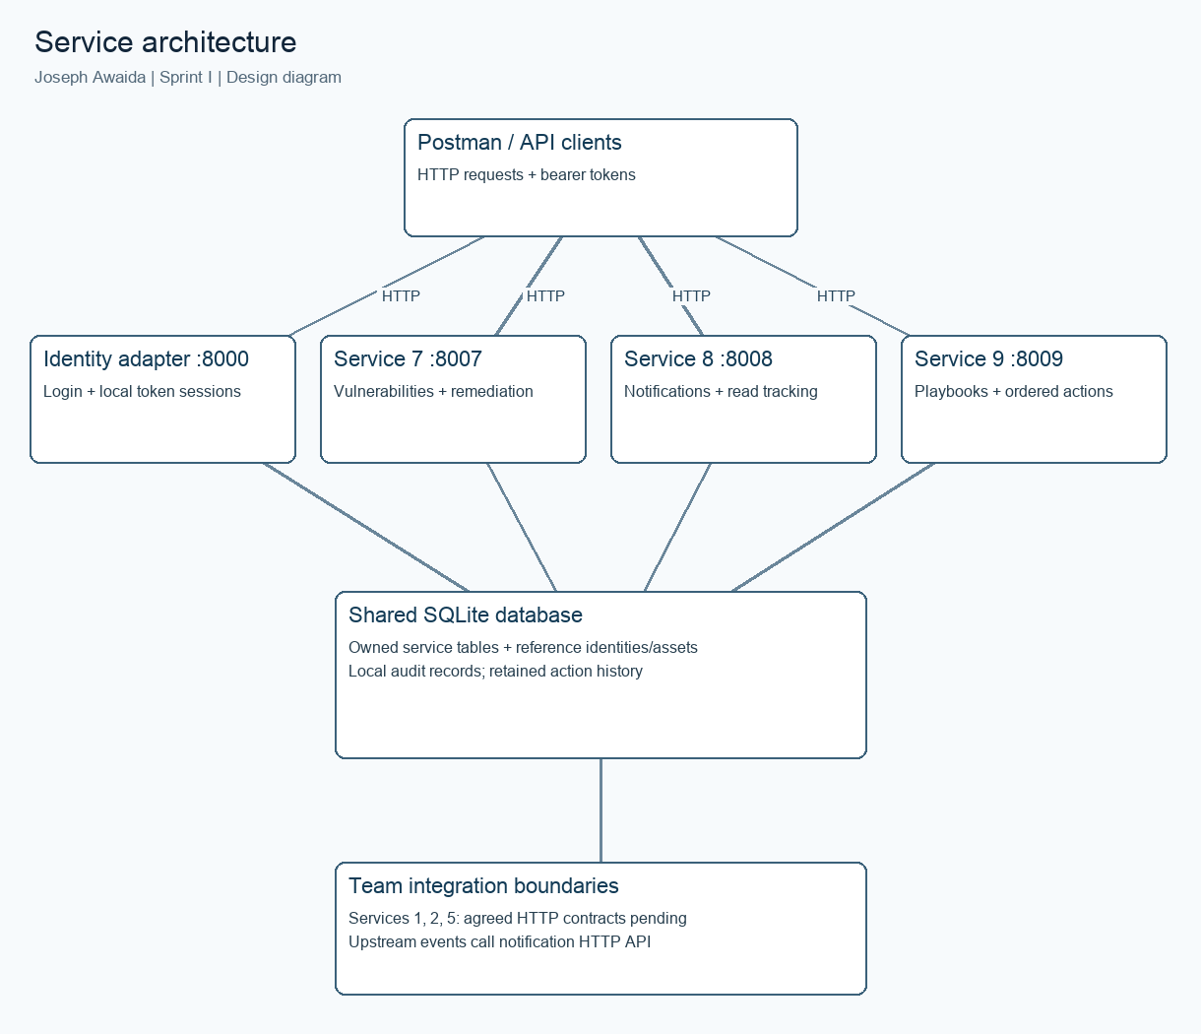
Service architecture: local processes and team integration boundaries.
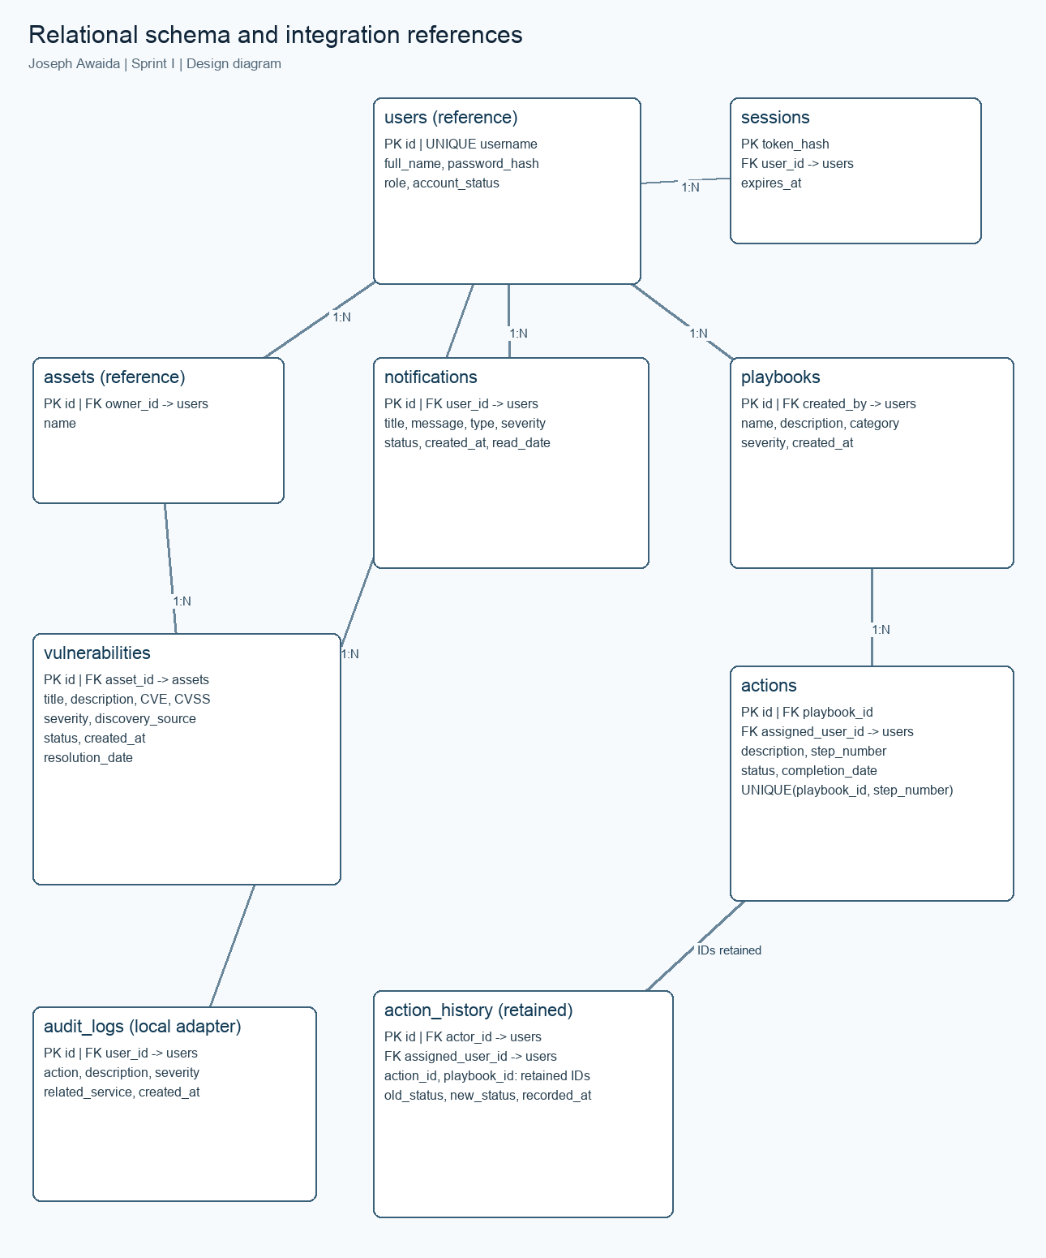
Database design: reference entities and owned service tables.

