
Lebanese University
Faculty of Science-II
Computer Science and Statistics Department

Final year project title:
AL Lijan AL Fahissa
(Correctors Management System)
Spring 2025-2026
Section: English
Group: B12
Prepared by:
Charbel OUTAYEK - 61222
Jean CHAMOUN - 60945

Project supervisor: Dr. Ziad EL BALAA

Table of Contents
I. Abstract 3
II. Introduction 3
2.1 Motivation and Background 3
2.2 Problem Statement 4
2.3 Project Objectives 4
2.4 Scope and Limitations 5
2.5 Report Roadmap 5
III. State of the art 6
1. Centralized Administrative Platforms 6
2. Digital Task Allocation and Workflow Automation 6
3. Digitization and Real-Time Monitoring 6
4. Comparison with Traditional vs. Modern Systems 7
IV. Analysis 7
1. Business Rules & Requirements 7
2. Use Case & Scenarios 9
3. Class Diagram 14
4. Activity Diagram 16
V. Development 20
1. Technical Environment 20
2. Menus Tree 21
3. Screens 22
4. Tasks Distribution 34
VI. Conclusion 35

Abstract
This project addresses the administrative challenges faced by the Departments at the Lebanese University (Faculty of Science-II) regarding the management of course corrector lists. The current manual process requires department chiefs to hand-fill Excel spreadsheets each semester method that is labor-intensive, prone to human error, and lacks a centralized backup, often leading to data inconsistency or loss.
To resolve these inefficiencies, we developed Al Lijan Al Fahissa, a web-based management system designed to digitize and centralize the corrector assignment process. The system provides a secure interface for department chiefs to input data directly into a campus-hosted database. A primary feature of the application is the automated generation of unified Excel reports, ensuring architectural consistency across all departments while significantly reducing manual entry time. This centralized approach further acts as a data recovery safety net, allowing users to re-export accurate lists at any time.
The system is implemented using a LAMP-inspired stack, utilizing HTML, CSS, and JavaScript for the responsive front-end, with PHP managing the server-side logic and MySQL for relational data storage. By transitioning from manual spreadsheets to a structured digital platform, this solution enhances data integrity and optimizes administrative productivity within the faculty.

Introduction

2.1 Motivation and Background
In modern departments, the evaluation of student work, ranging from theoretical exams to programming assignments and software projects, requires structured, efficient, and scalable processes. However, many institutions still rely on semi-manual workflows that lack proper automation and coordination. With the rapid advancement of software engineering practices, there is a growing need to adopt digital solutions that ensure accuracy, consistency, and efficiency in academic correction systems.
“Al Lijan Al Fahissa” is a software-based solution designed to modernize the correction process by leveraging key Computer Science concepts such as web-based system architecture, database management systems (DBMS), and user-centered interface design. The system introduces a centralized platform where professors and administrators interact through a structured workflow.

2.2 Problem Statement
The current correction processes in many departments face both technical and organizational challenges:
- Lack of a centralized information system for task assignment and monitoring
- Inefficient handling of large datasets.
- Absence of standardized evaluation models.
- Limited support for concurrent access and multi-user collaboration
- Difficulty in tracking progress due to a lack of real-time dashboards and reporting tools
These limitations highlight the need for a robust software engineering solution that applies principles such as modularity, data integrity, and system reliability.

2.3 Project Objectives
The system aims to achieve the following:
- Develop a multi-tier architecture system (presentation layer, business logic layer, data layer)
- Implement a relational database schema for managing users, tasks, and results
- Provide secure authentication and authorization using RBAC (Role-Based Access Control) mechanisms
- Enable task assignment and workload balancing using algorithmic logic
- Offer real-time monitoring dashboards for administrators
- Ensure data consistency through CRUD (Create, Read, Update, Delete) operations and transaction management
- Design intuitive user interfaces using UI/UX principles
The project also aims to apply practical knowledge of software development methodologies as well as tools like UML diagrams (use case, class, sequence diagrams) for system design and documentation.

2.4 Scope and Limitations
This project focuses on the design and implementation of a correction management system within the scope of a department. It includes features such as user management, task allocation, submission tracking, and number of corrected copies. The system may also support basic file handling for summary.
However, the project has several limitations:
- It does not include advanced automated code evaluation systems or machine learning–based work.
- Does not include integration with external systems, such as Learning Management Systems (LMS).
- The system is implemented as a prototype and may not fully address high scalability or distributed system requirements
- Advanced security features such as encryption protocols and penetration testing are only partially considered

2.5 Report Roadmap
This report is structured as follows:
- Chapter 1 - abstract: introduces the overall context and background of the project
- Chapter 2 - introduction: presents the problem definition, objectives, and scope
- Chapter 3 - Bibliography / State of the Art: reviews related work and existing academic management systems
- Chapter 4 - Analysis: details of the system analysis and design, including UML modeling and architecture design
- Chapter 5 - Development: discusses the implementation, including technologies such as frameworks, Programming languages, and database systems
- Chapter 6 - Conclusion: concludes the project and proposes future enhancements, such as AI-assisted grading and system integration

State of the art

1. Centralized Administrative Platforms
State-of-the-art systems like Modern Campus Catalog prioritize "Centralized Data Management" to ensure architectural consistency.
- Dynamic Cataloging: Modern systems offer a 75% reduction in production time and an 89% decrease in errors by replacing static PDFs and manual spreadsheets with relational databases.
- Automated Reporting: Current standards demand a "faster digital publication and .xlsx export" capability, allowing administrative lists to be generated instantly with 100% data integrity.

2. Digital Task Allocation and Workflow Automation
Modern academic workflows now leverage structured training management and automation to handle task distribution.
- Role-Based Access Control (RBAC): Systems utilize comprehensive user and role management to provide secure, tiered interfaces for department heads and faculty members.
- Resource Optimization: Emerging tools like Modern Campus Schedule focus on "maximized resource utilization" and "balanced course distribution," which aligns with the objectives of the Al Lijan Al Fahissa system to automate corrector assignments.

3. Digitization and Real-Time Monitoring
The "Digital Examination Process" has evolved to include on-screen marking and real-time dashboards.
- Data Recovery and Security: State-of-the-art solutions employ automated cloud backups and digitally encrypted files, acting as a "safety net" against the data loss often associated with local manual files.
- Decision-Support Dashboards: Modern EMS platforms provide "Insightful Detailed Progress Reporting," moving from simple data display to actionable insights for administrative decision-making.

4. Comparison with Traditional vs. Modern Systems
Feature | Traditional Manual Process | State-of-the-Art (2026)
Data Storage | Local Excel Files (prone to loss) | Centralized Relational Database (Cloud)
Consistency | Human-entry errors; inconsistent formats | Automated synchronization; unified templates
Task Assignment | Labor-intensive manual tracking | Algorithmic workload balancing
Access | Single-user file locks | Concurrent multi-user web access
Reporting | Manual spreadsheet aggregation | One-click unified report generation

Analysis

Business Rules & Requirements
The Al Lijan Al Fahissa system is governed by specific logic and constraints to ensure that the transition from manual Excel tracking to a digital platform remains secure and accurate. This section outlines the behavioral expectations, operational constraints, and the essential functional and non-functional requirements of the system.

Business Rules
Business rules define the core logic and policies that the software must enforce to maintain administrative integrity:
- Role-Based Access: Only authenticated Department Chiefs or authorized administrators can input professor data or modify task assignments.
- Data Consistency: Every course entry must be linked to a valid corrector and includes the specific number of copies to be corrected.
- Report Integrity: Automated Excel reports must be generated based on the most recent data stored in the central database to ensure "architectural consistency" across all departments.
- Standardization: All user inputs must follow predefined formats (e.g., specific course codes or professor IDs) to prevent the "human error" typical of hand-filled spreadsheets.

Functional Requirements
These requirements define the specific actions the system must perform to meet the project objectives:
- User Management: The system shall provide a secure login interface with RBAC.
- Task Allocation: Administrators shall be able to assign courses to correctors and track the number of copies for each.
- Automated Reporting: The system must generate unified Excel summaries that reflect the current state of the database for administrative use.
- Data Persistence: The system shall allow users to perform CRUD operations on courses, professors, and assignments.
- Monitoring: The system shall provide a dashboard to track the overall progress of the correction cycle in real-time.

Non-Functional Requirements
These requirements define the quality attributes and constraints under which the system operates:
- Usability: The interface must be responsive and intuitive, following established UI/UX principles to ensure ease of use for faculty staff.
- Reliability: The system shall act as a "safety net" for data recovery, ensuring that information is not lost as it was in the manual process.
- Performance: The system should handle concurrent access by multiple department chiefs without significant latency.
- Security: Unauthorized access must be prevented through secure authentication protocols, ensuring data integrity across the platform.
- Maintainability: The use of a modular LAMP-inspired stack (PHP, MySQL, HTML/CSS) ensures the system can be easily updated or extended in the future.

Use Case & Scenarios
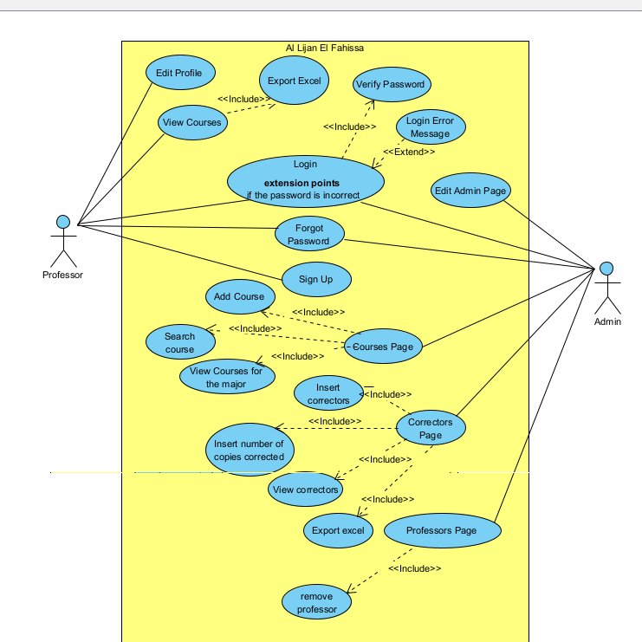
This picture above represents the use Case diagram of Al lijan al fahissa system and it is use cases are explained in the next pages.

Use Case: Login
This use case describes how users (Professors and Admins) access the system to perform their respective administrative tasks.
- Goal: To securely access a user account within the Al Lijan Al Fahissa system.
- Actors: Professor, Admin.
- Pre-Condition: The user has accessed the login page and entered an email and password.
- Post-Condition: The user is successfully authenticated and redirected to their specific dashboard.
- Main Flow (Successful Login)
The user enters their email and password into the login interface.
- The system validates the credentials against the central MySQL database.
- The system identifies the user's role using RBAC.
- Scenario 2 (Professor): If the user is a Professor, the system grants access to their profile to edit information or view assigned tasks.
- Scenario 3 (Admin): If the user is an Admin, the system grants access to the administrative dashboard for task management, data input, and report generation.

- Alternative Flow (Scenario 1: Authentication Failure)
The user enters an incorrect email or password.
- The system fails to find a matching record in the database.
- The system remains on the login page and displays an error message indicating incorrect credentials.
- The user is prompted to re-enter their information.
Use Case: Forgot Password
- Goal: To reset the account password and regain system access.
- Actors: Professor, Admin.
- Pre-Condition: The user is on the login page and cannot remember their password.
- Description: The user requests a password reset by providing their registered email address. The system then generates and sends a unique 6-digit verification code to that email.
- Scenario 1: The user enters their registered email and receives the 6-digit code. After entering the correct code into the system, they are prompted to create a new password. The system updates the credentials in the database, allowing the user to log in successfully.
- Scenario 2: The user enters an incorrect or expired 6-digit code. The system displays an error message indicating that the code is invalid and prevents the user from reaching the password reset screen, ensuring the account remains protected from unauthorized access.
- Post-Condition: The user’s password is successfully updated in the MySQL database, and they can proceed to log in with the new credentials.
Use Case: Sign Up
- Goal: To create an account for a professor
- Actors: Professor
- Pre-Condition: The information on the account is entered
- Description: There are 2 scenarios
- Scenario 1: The information entered was insufficient
- Scenario 2: The information entered was correct
- Post-Condition: The account was created successfully now the professor could edit his information if any changes occurred
Use Case: View Courses
- Goal: the professor sees the assigned courses to teach
- Actor: Professor
- Pre-condition: The Professor must be successfully authenticated (logged in) to the system.
- Description: This use case includes Export Excel. This means every time a professor views courses, the functionality to export that list to an Excel file is made available or integrated into that view.
- Post-condition: The Professor has viewed the courses; the system remains ready for the next action.
Use Case: Courses Page
- Goal: The Admin performs the desired management task or exits the page.
- Actors: Admin
- Pre-condition: The user must be logged in specifically with Admin privileges.
- Description: The Courses Page is a management interface where the Administrator can oversee the entire catalog of courses. It acts as a container or "parent" view that includes the functionality to add new courses, modify existing ones, or filter views by specific majors.
- Included Use Cases (Dependencies)
According to the <<Include>> arrows in your diagram, the Courses Page includes the following functionalities:
• Add Course: Allows the admin to create new course entries.
• Edit Course: Allows the admin to modify details of an existing course.
• View Courses for the Major: Provides a filtered view of courses based on a specific academic department or major.
-Post-condition: The system state is updated if a course was added or edited; otherwise, the Admin returns to the main dashboard.

Use Case: Correctors Page
- Goal: The system saves any entered data (like copy counts) and remains on the page or returns to the dashboard.
- Actor: Admin
- Pre-condition: The user must be authenticated as an Admin.
- Description: The Correctors Page is the primary management interface where the Admin handles everything related to exam markers (correctors). This page provides the administrative tools necessary to track who is grading, how many papers they have finished, and the ability to add new personnel to the system.
- Included Use Cases (Dependencies)
The diagram shows that the Correctors Page is quite busy! It includes four major functionalities:
• Insert Correctors: To add new individuals to the corrector database.
• Insert number of copies corrected: To input or update the workload progress for each corrector.
• View Correctors: To display the current list of all correctors.
• Export Excel: To generate a spreadsheet report of the corrector data (this is specifically linked via the "View Correctors" flow).
-Post-condition: Any changes to corrector data or corrected copy counts are committed to the database.

Use Case: Professors Page
- Goal: The professors list appears for the admin
- Actor: Admin
- Pre-condition: The Admin must be logged in with full administrative privileges.
- Description: The Professors Page provides a centralized interface for the Administrator to manage the lifecycle of professor accounts within the "Al Lijan El Fahissa" system. From here, the admin can oversee the list of department members and perform critical maintenance tasks like removing staff who are no longer active.
- Included Use Cases (Dependencies)
Based on the <<Include>> relationships in the diagram:
Remove Professor: This is the primary functional dependency linked to this page. It allows the admin to delete or deactivate a professor's profile from the database.
-Post-condition: The faculty database is updated, and the Professor's access to the system is revoked (if removed)
Use Case: Edit Admin
-Goal: Edit the role of a normal professor or admin in the department
-Actor: Admin
-Pre-condition: The user must have admin privileges.
-Description: This use case allows an authorized user to modify the role of a professor
-Post-condition: A professor becomes the first admin or an admin become a regular professor.

Class Diagram
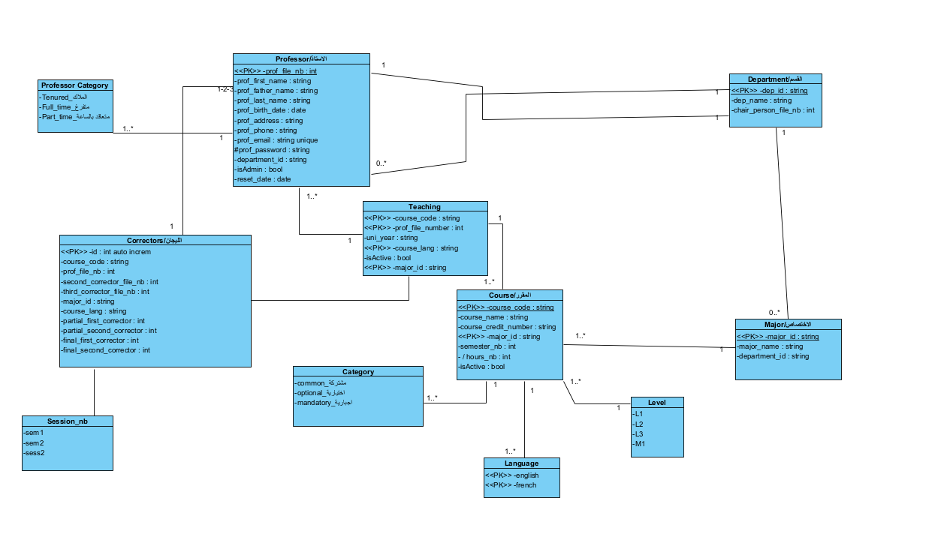
This class diagram represents the academic management system "Al Lijan Al Fahissa." It focuses on the relationships between professors, the courses they teach, and the administrative departments and majors they belong to.
Here is a brief description of each table and its attributes:
1. Professor (الاستاذ)
The central table for faculty management.
- prof_file_nb (PK): Unique identification number for the professor.
- Names: First name, father's name, and last name.
- Personal Info: Birth date, address, phone, and unique email.
- Security: Password and a reset_date for account recovery.
- Status: isAdmin (boolean to distinguish between admin users) and department_id (linking them to a specific department).

2. Course (المقرر)

Represents the subjects offered by the institution.
- course_code (PK): Unique identifier for the course.
- course_name: The title of the subject.
- course_credit_number: The weight or credit value of the course.
- major_id (PK): Links the course to a specific major.
- Metadata: semester_nb (which semester it's offered), hours_nb (total teaching hours), and isActive (status of the course).
3. Teaching
A junction table that links Professors to the Courses they actually teach.
- course_code & prof_file_number (PK): Identifies which professor teaches which course.
- Context: uni_year (academic year), course_lang (language of instruction), and isActive.
4. Correctors (اللجان)
Manages the committees or individuals responsible for grading exams.
- id (PK): Auto-incrementing identifier.
- Tracking: Links to course_code and prof_file_nb.
- Workflow: Tracks multiple correctors (first, second, third) and specific types of correctors (partial vs. final) for quality control.

5. Department (القسم)
The high-level organizational unit.
- dep_id (PK): Unique ID for the department.
- dep_name: Name of the department.
- chair_person_file_nb: ID of the professor who heads the department.

6. Major (الاختصاص)
Specific fields of study within a department.
- major_id (PK): Unique ID for the major.
- major_name: The name of the specialization.
- department_id: Foreign key linking the major back to its parent department.

Supporting Lookup Tables (Enums)
These tables define fixed categories used throughout the system:
- Professor Category: Defines the employment status (e.g., Tenured, Full-time, or Part-time).
- Category: Defines the course type (Common, Optional, or Mandatory).
- Language: Specifies if the course/teaching is in English or French.
- Level: Indicates the academic level (L1, L2, L3, M1).
- Session_nb: Tracks the specific exam session (Semester 1, Semester 2, or Session 2).

Activity Diagram
  - Login Page Activity
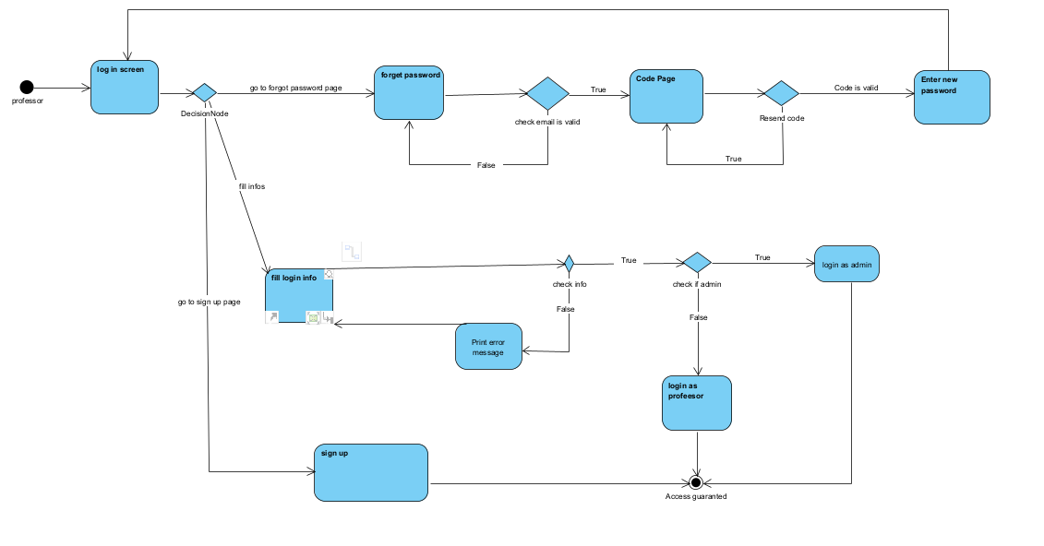
1. The Entry Point
The process begins with the Professor (or Admin) arriving at the Log In Screen. From here, a Decision Node offers three primary paths:
- Sign Up: Directs the user to create a new account.
- Fill Login Info: The standard path for existing users.
- Forgot Password: The recovery path if credentials are lost.
2. The Login & Validation Path
This is the core logic that handles daily access:
- Action: The user enters their credentials (Fill Login Info).
- Validation: A decision diamond checks if the info is correct (Check Info).
- If False: The system triggers the Print Error Message (this matches the <<Extend>> relationship in your Use Case diagram) and sends the user back to the login form.
- If True: The system checks the user's role (Check if Admin).
- Role Routing: * If the user is an admin, they proceed to Login as Admin.
- Otherwise, they proceed to Login as Professor.
- Result: Both roles lead to the final state: Access Guaranteed.
3. The Password Recovery Path (Forgot Password)
A more complex loop for security:
- Check Email: The system verifies if the entered email exists in the database.
- Code Page: If the email is valid, the user is sent to a page to enter a verification code.
- Resend Logic: There is a loop allowing the user to Resend Code if they didn't receive it.
- Verification: Once the code is validated, the user moves to Enter New Password.
- Return: After setting a new password, the user is looped back to the Log In Screen to try again with their new credentials.

  - Professor Page Activity

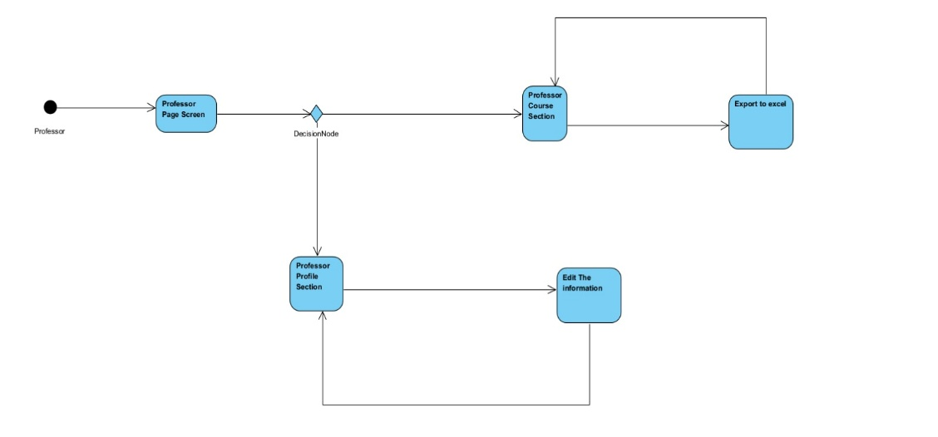
1. The Entry Point
The flow begins at the Professor Page Screen. This is the main landing hub for faculty members after a successful login.

2. Decision Node (Navigation)
From the landing page, the Professor reaches a Decision Node where they must choose between two primary functional paths:

- Professor Course Section: For academic and reporting tasks.

- Professor Profile Section: For personal data management.

3. Path A: Course Management & Reporting
If the Professor chooses the Course Section:

- View Courses: They enter the Professor Course Section (which corresponds to the "View Courses" use case in your first diagram).

- Action: From this view, they can trigger the Export to Excel action.

- Loop: After exporting, the flow returns to the Professor Course Section, allowing them to continue reviewing courses or perform another export.

4. Path B: Profile Management
If the Professor chooses the Profile Section:

- View Profile: They enter the Professor Profile Section (corresponding to the "Edit Profile" use case).

- Action: They can select Edit The Information to update their personal details (like phone number or address).

- Loop: Once the edits are submitted, the flow returns to the Professor Profile Section to show the updated information.

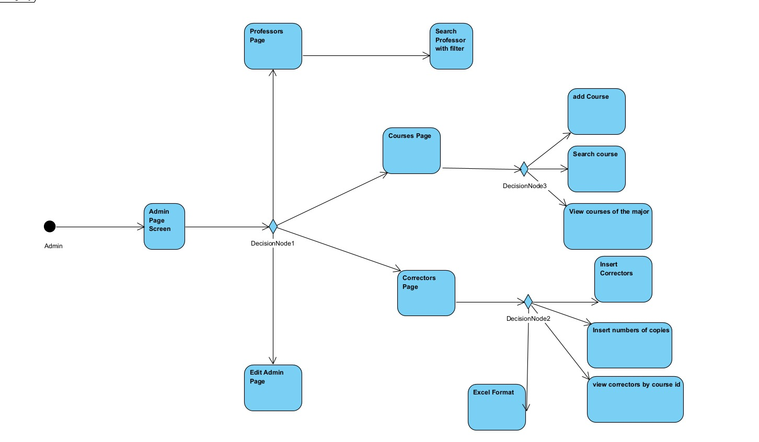
  - Admin Page Activity
1. The Entry Point
The Admin starts at the Admin Page Screen. This is the central dashboard where all administrative modules are accessible.

2. Main Navigation (DecisionNode1)
From the dashboard, the Admin can branch into four distinct management areas:
- Professors Page: For faculty oversight.
- Courses Page: For curriculum management.
- Correctors Page: For grading and staff tracking.
- Edit Admin Page: For personal account settings or managing other admin profiles.

3. Detailed Management Paths
A. Professors Management
- Action: The Admin moves to the Professors Page.
- Functionality: They can Search Professor with filter to locate specific faculty members based on criteria like department or status.

B. Courses Management (DecisionNode3)
When entering the Courses Page, the Admin has several operational choices:
- Add Course: Create a new course entry in the database.
- Search Course: Find an existing course to view or modify.
- View courses of the major: Filter the curriculum view by specific academic specializations.

C. Correctors Management (DecisionNode2)
The Correctors Page is the most feature-rich area for the Admin:
- Insert Correctors: Register new grading staff.
- Insert numbers of copies: Update the count of graded exams per person.
- View correctors by course id: A targeted search to see who is assigned to a specific subject.
- Excel Format: Generate and download reports in Excel (this represents the Export Excel use case).

D. Edit Admin Page
Provides the interface to update administrative credentials or profile settings.

Development

Technical Environment
  - Languages:
◦ HTML, CSS, and JS are utilized for front-end design and functionality.
◦ PHP handles server-side logic and backend development.
◦ MySQL is used for managing relational databases.

  - Frameworks and libraries:
Composer was employed to generate spreadsheets formats (Excel files) and to send code via email for the forgot password feature.

  - Development tools:
- Visual studio code and Antigravity were used for implementing the code
- Figma is utilized for UI/UX
- XAMPP Control Panel is used for the server-side output
- PhpMyAdmin is used for storing data while testing
- Git/GitHub handles the version control of the project

Menus Tree
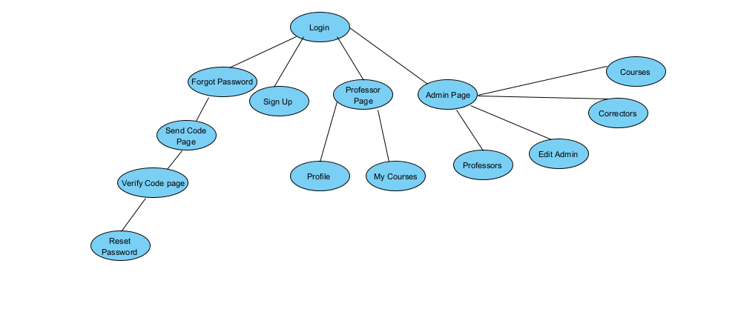
The system navigation is organized into a hierarchical structure that branches from a central Login gateway into four distinct functional modules: authentication recovery, registration, and role-based dashboards. The account recovery workflow follows a secure, linear progression from a "Forgot Password" request through code verification to a final password reset, while the "Sign Up" portal handles new user onboarding. Once authenticated, the interface diverges into two primary user paths: the Professor Page, which offers streamlined access to personal profiles and assigned course loads, and the robust Admin Page. This administrative hub centralizes the management of systemic entities—including courses, professors, and correctors—alongside a dedicated section for updating administrative credentials, ensuring a clear separation of concerns and an intuitive user experience.

Screens
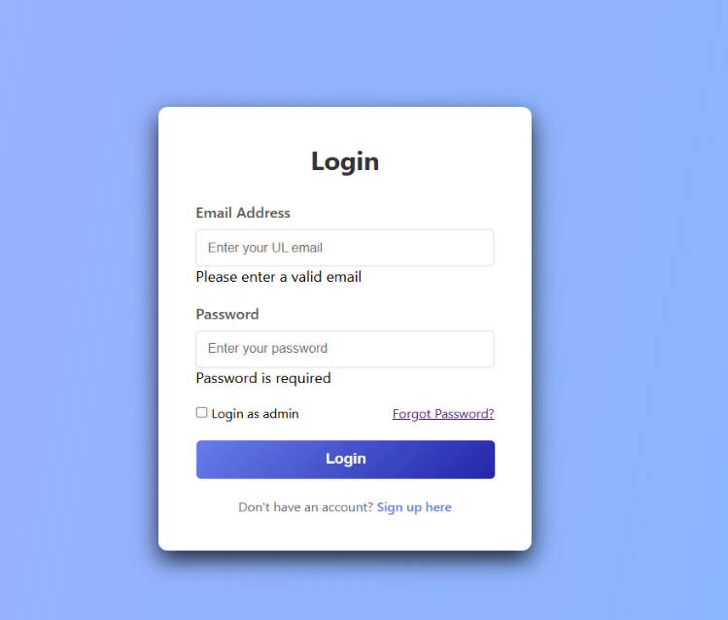
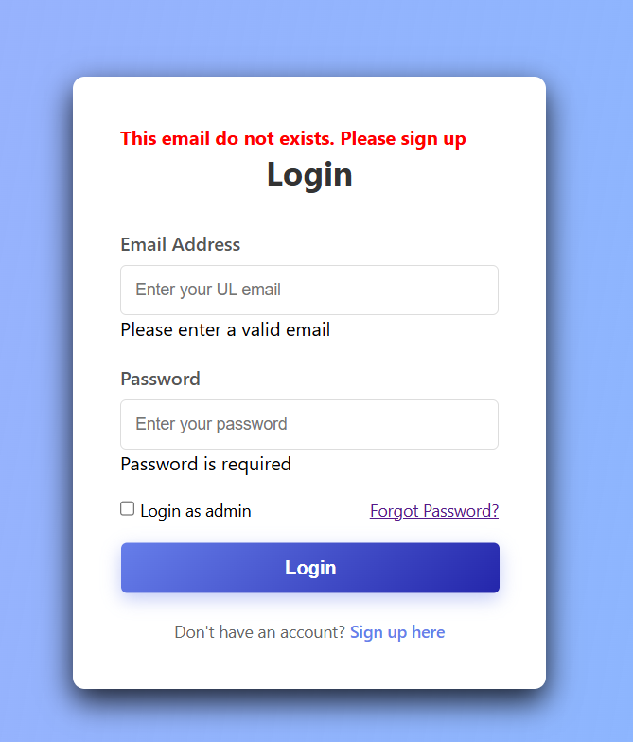
  - Login Page Screen

This is the login page; it is the first page that will appear in front of the user when entering the system. And if the user has an account already he can login directly using his UL email and password to the professor page or the admin page if any the required fields are wrong an error message will appear

  - Sign Up Page Screen
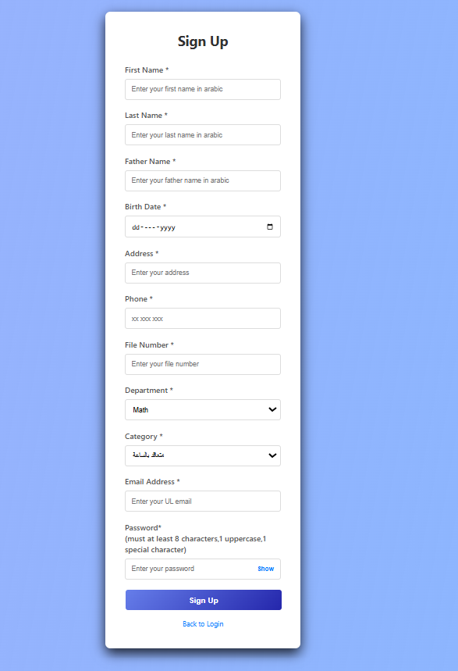
If the user does not have an existent account he can sign up to create a new account and fill out the required information. The user can access the sign up using the hyperlink in the login page. And if the user signed up successfully the system will take the user to verify email page

  - Verify Email Screen
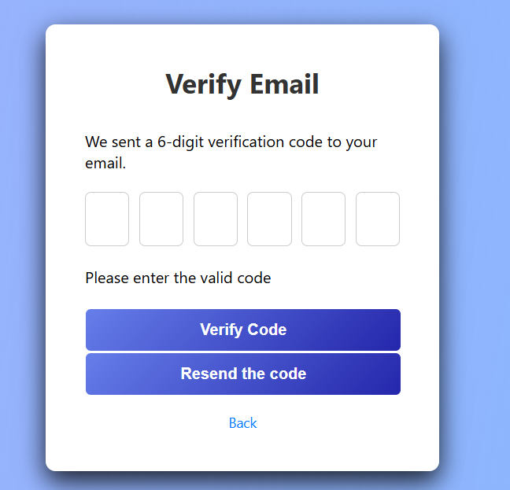
This screen will appear after the user press the button sign up to verify if the email exists or not by sending a code for the email entered in the sign up
After confirming the email, the user will return automatically to the login page

  - Forgot Password Screens
    - Forgot password Page

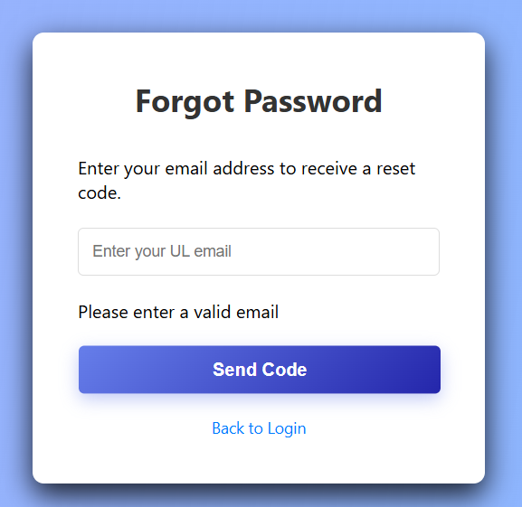

This page will appear after the user clicking the hyperlink (Forgot Password) in the login Page and it will ask to enter a valid email address to send a reset code otherwise it will throw an error message if the input was not as required

    - Verify Code Page

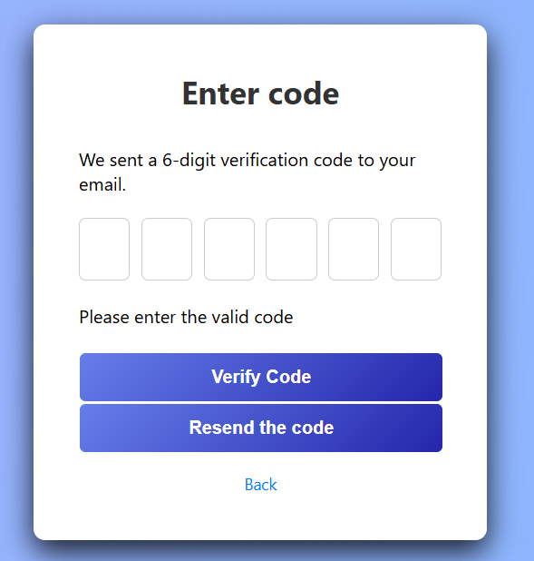

After pressing the send code button in the previous screen, the user will receive a reset code on the ul email that was entered if the user did not receive any reset code on his email he can the resend the code button and he enters the code he received in the small input than he press verify code to proceed to the next page

    - Reset Password Page

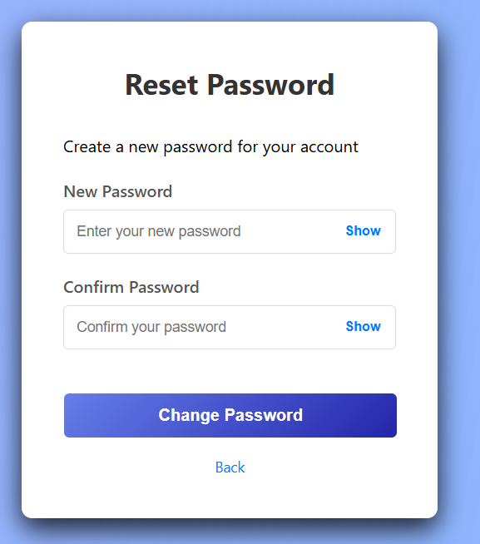

After entering the right reset code in the previous page, the page will appear the user can reset to a new password than he is redirected to the login page

  - The Professor Page
This page is composed of a welcome-header and sidebar:
- The welcome header is formed from the user name and a logout button
- The sidebar allows to navigate between different sections of the page
    - Professor Profile Section
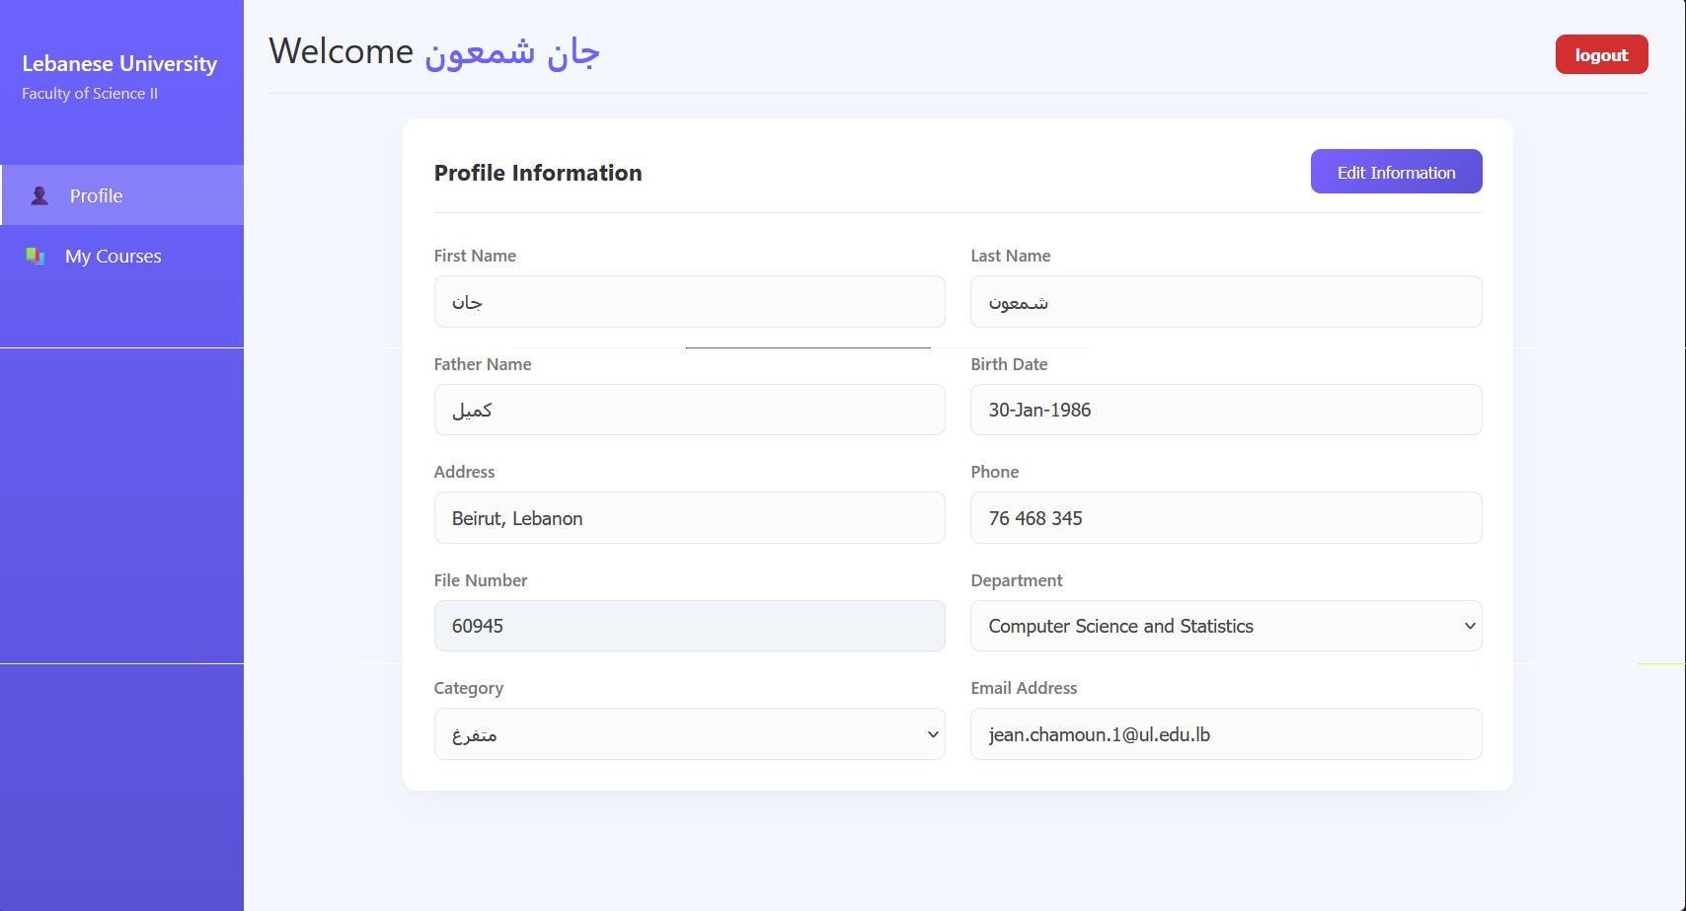
After logging in with the check box (login as admin) unchecked the user(professor) will be directed to this screen to where it shows the information entered in the sign-up page. Here in this section the user can edit the information by clicking the button edit information

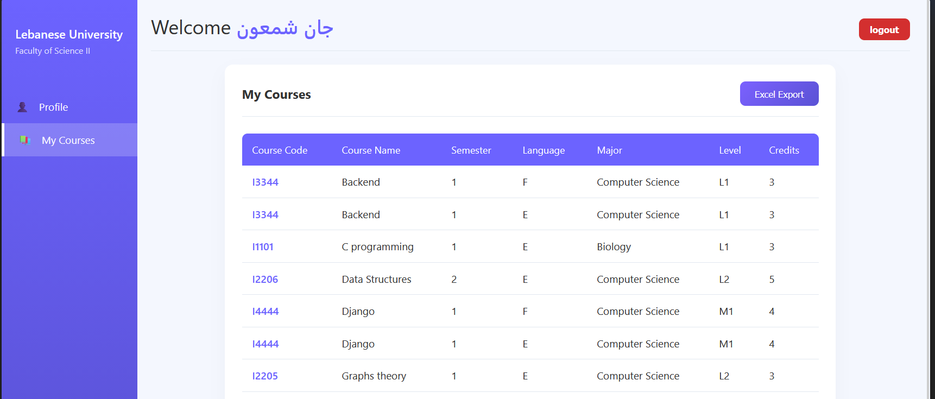
    - My Courses Section

After navigating using the sidebar to My Courses section it will shows all the courses assigned to the professor by the admin as a table form.
On the top right of the table, there is an export excel button that generates the excel below:
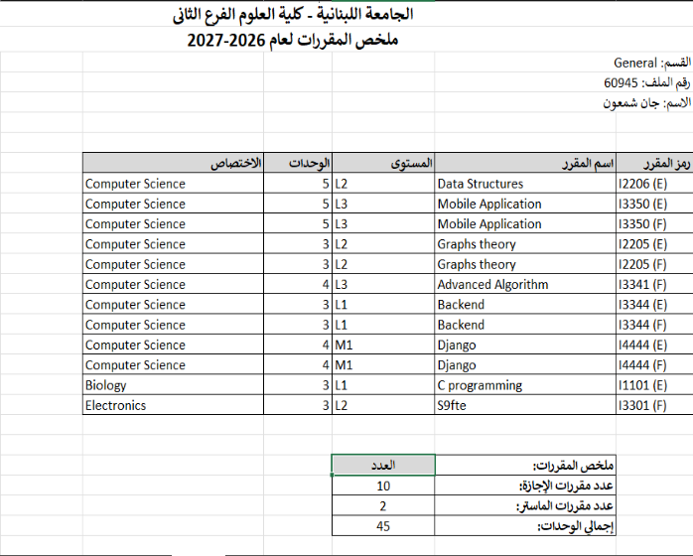
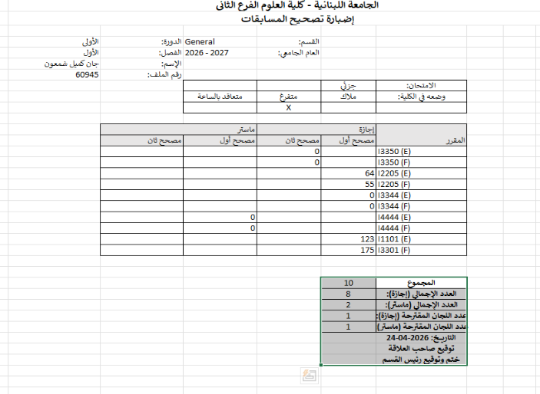

  - Admin Page
The user can access this page but checking the check box in the login page (login as admin) but he needs to have the privilege of being an admin
This page is composed of a welcome-header and sidebar:
- The welcome header is formed from the user name and a logout button
- The sidebar allows to navigate between different sections of the page
- Professors section
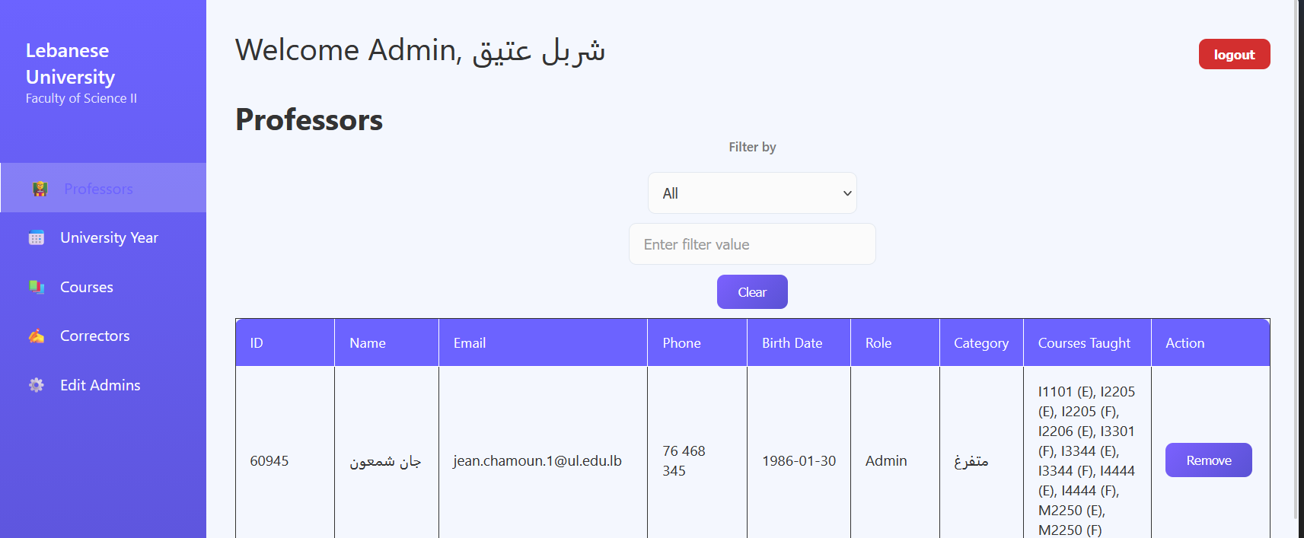
Here, the admin can see all the professors in his department and can remove any professor that is no longer active, and he can search for any professor, including a filter(ID, Name, Course, Category) of his choice

2. University Year section
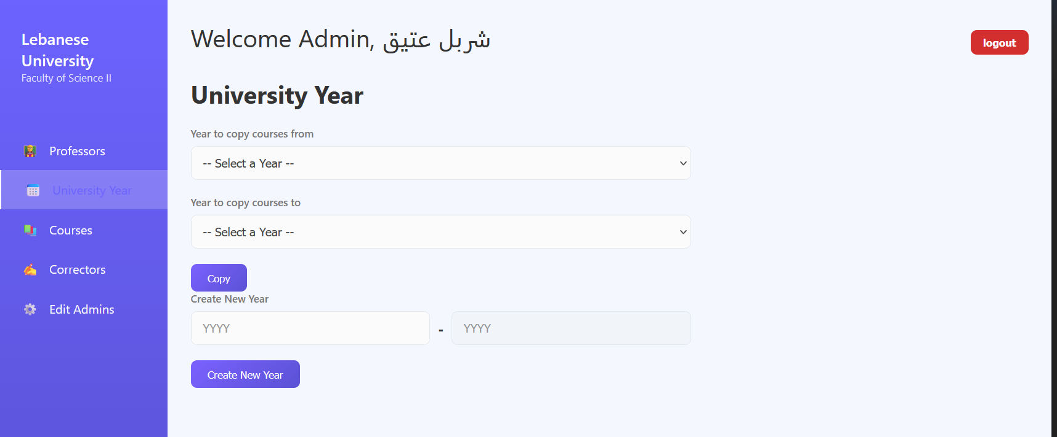
In this section, the admin can create a new university year to be added to the database, and he can copy all old courses from a previous year to an empty new year.

3. Courses Section
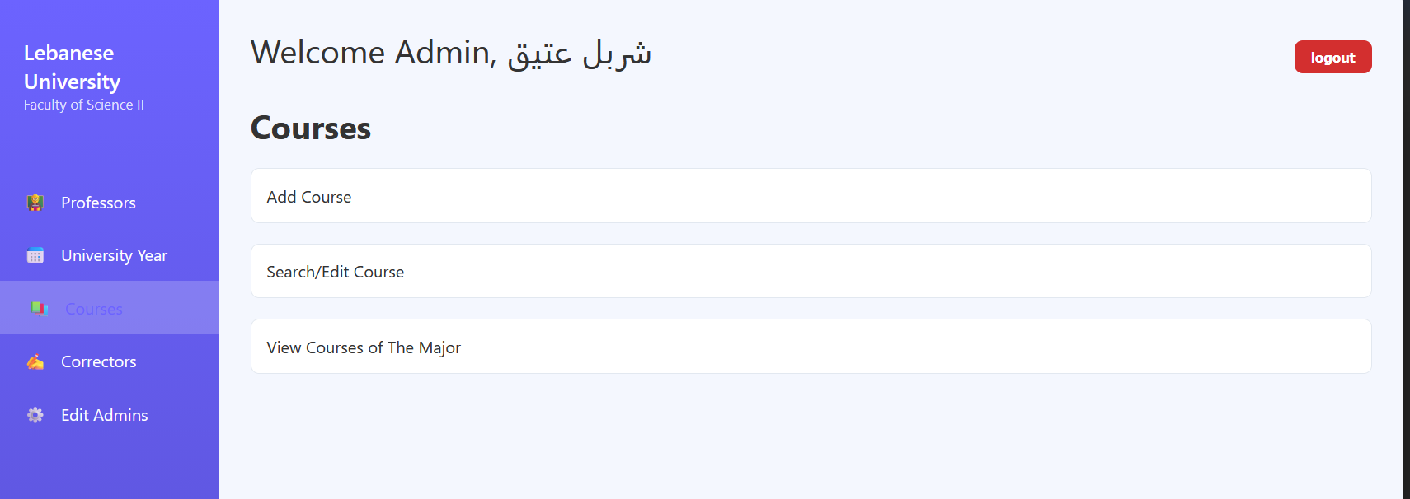

This section of the page contains 3 drop down menus :

  - Add Course drop down menu
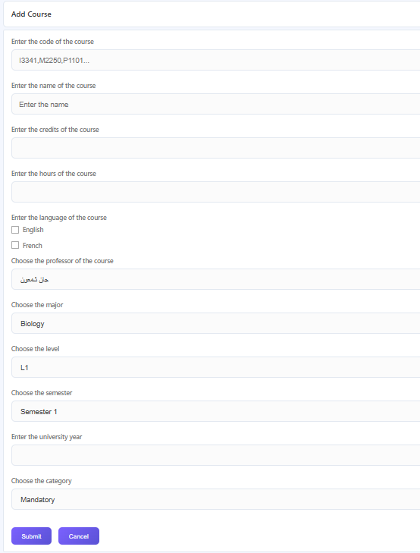

In this drop down menu, the admin can create a new course for a specific major and assign a professor from his department to teach it

  - Search Course drop down menu
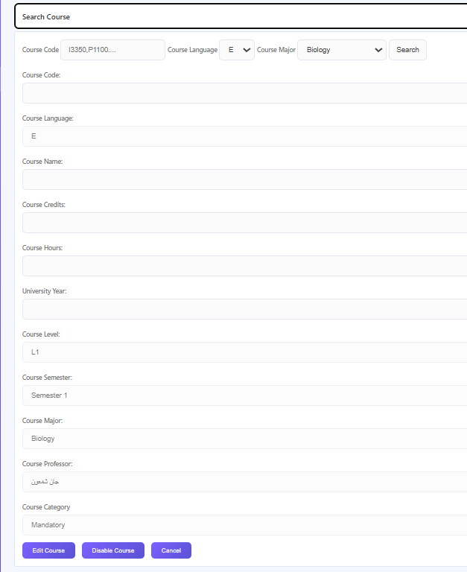

Here the admin can search for any course with a specified filter (course code, major, language) to see the course information
- Edit course: can change any course information
- Disable course: if the course is no longer taught
- Cancel: for canceling the search

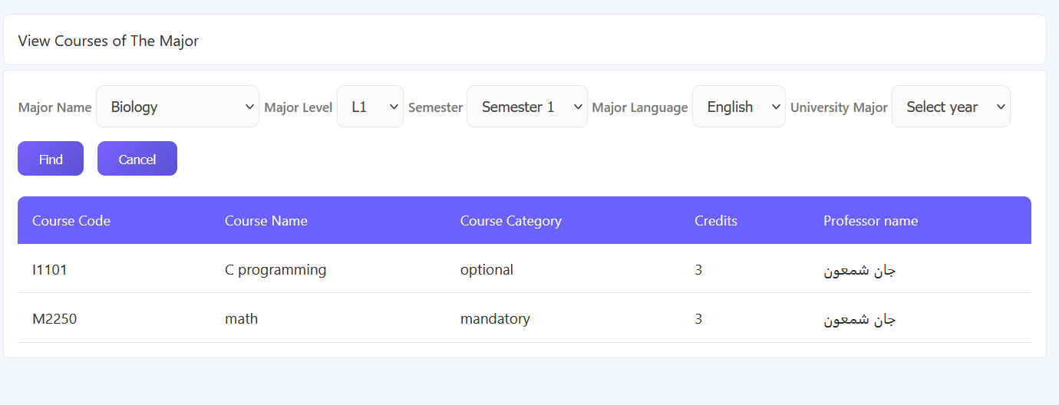
  - View courses of the major drop down menu

Here the admin can see each course assigned to a professor from his department for a specific major

4. Correctors’ Section
This section is consisted of 3 drop down menus:
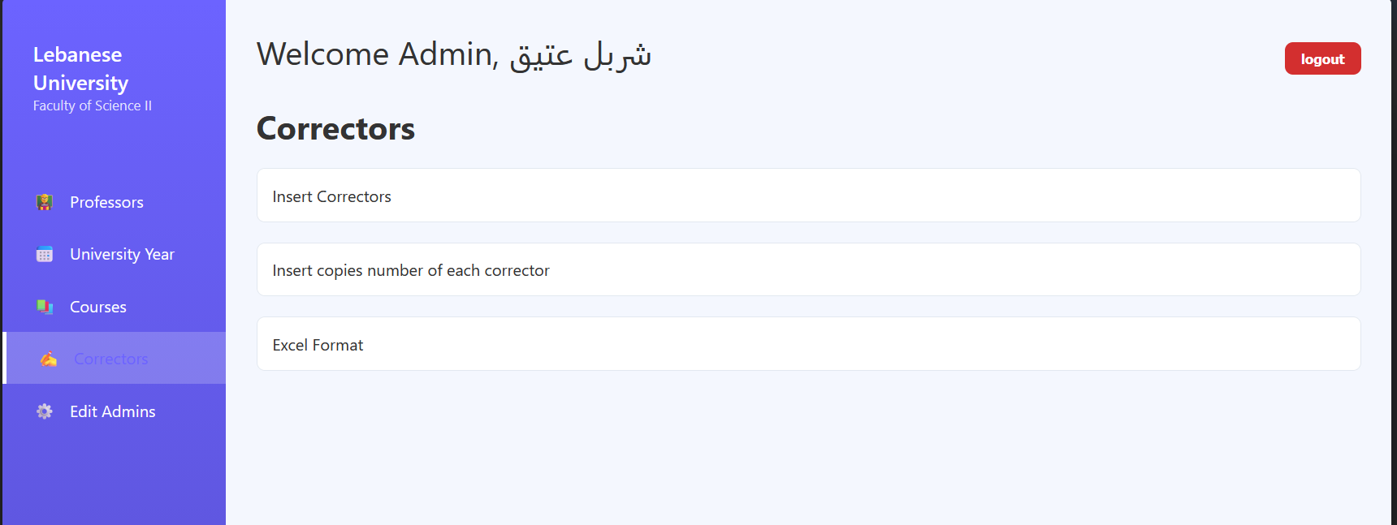

4.1. Insert Correctors drop down menu

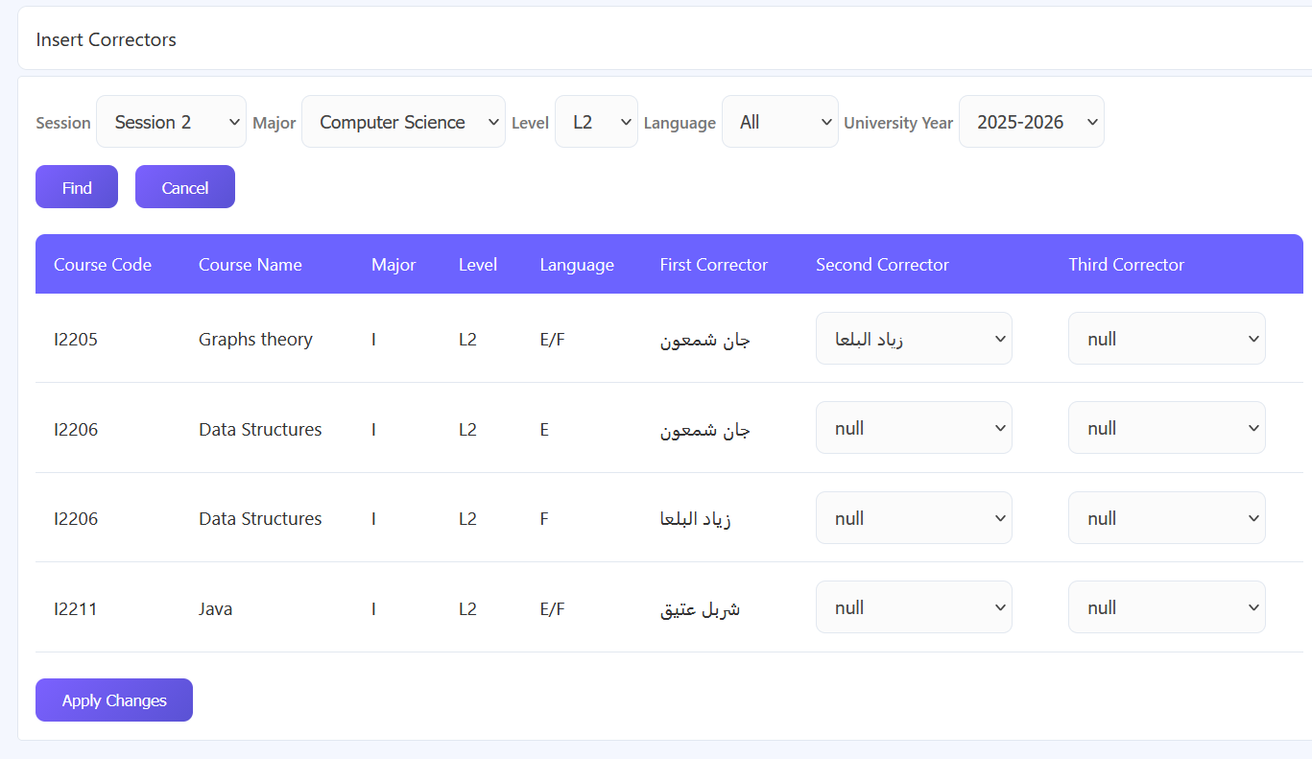

In this drop down menu appears, the correctors of the courses that were assigned from the admin’s department, the first corrector is assigned by default to the teacher of the course and the second corrector and third corrector are null by default. Then the admin can assign a second corrector and a third, then clicks the " Apply Changes " button.

4.2. Insert numbers of copies for each correctors drop down menu



After assigning the second and third correctors, the admin needs to insert the number of copies for each corrector, then insert the data, and then click the “Apply changes” button.

4.3. Excel Format drop down menu

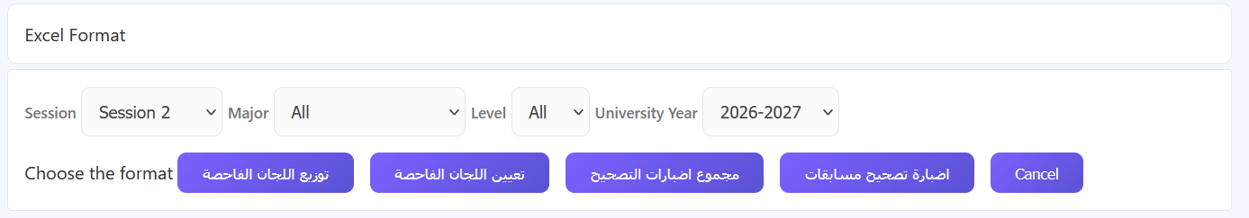

After the selecting which session, the admin can export the data of the correctors into an Excel file (or spreadsheet) with one of the following formats:

- توزيع اللجان الفاحصة :
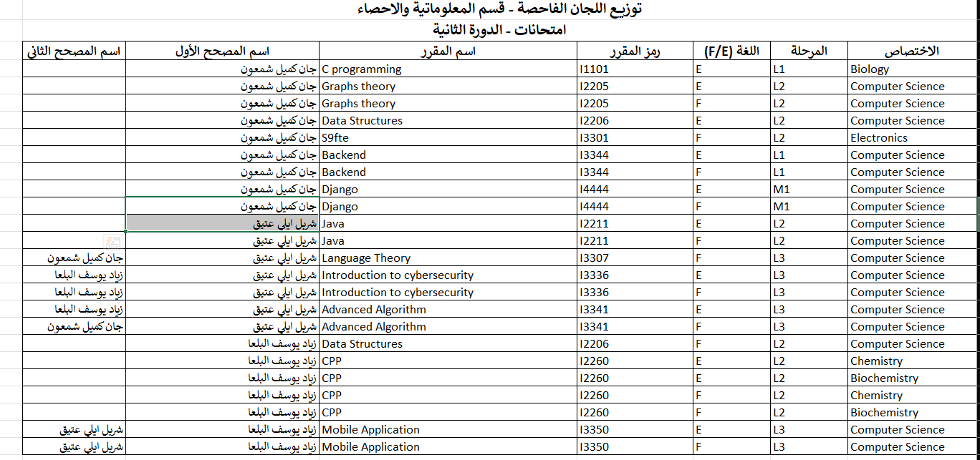
This spreadsheet displays the first and second correctors names and for which course they are assigned to

- تعيين اللجان الفاحصة:
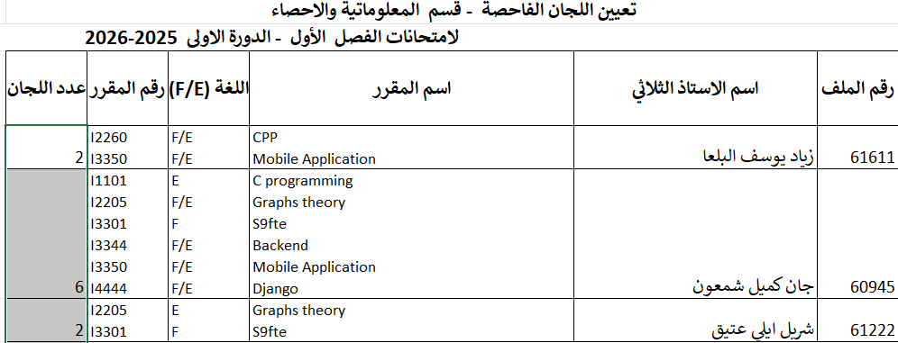
This spreadsheet displays each professor in how many there assigned as corrector to (if first or second)
- مجموع اضبارات التصحيح:
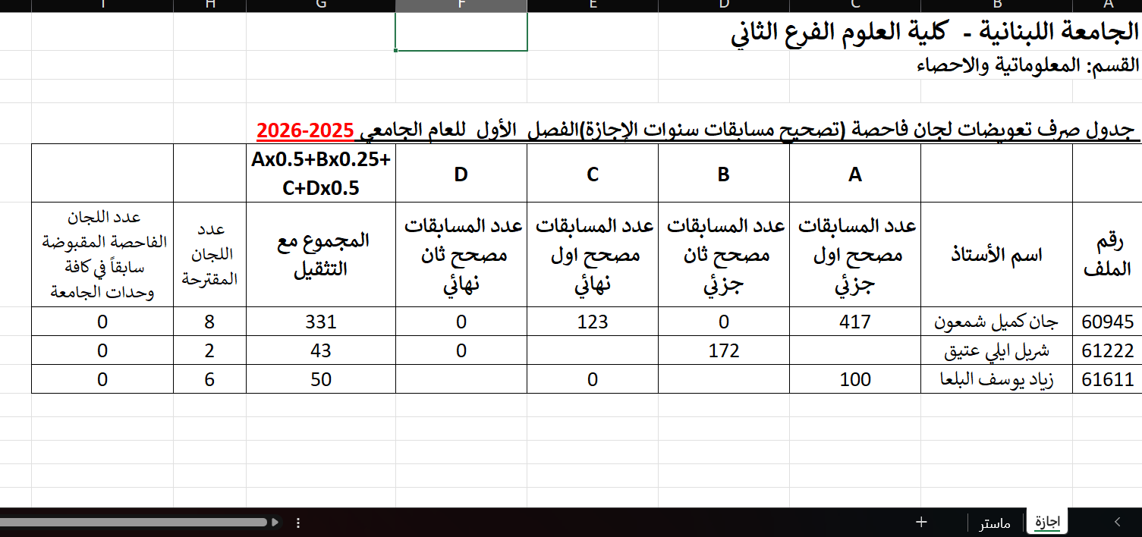
In this spreadsheet we see the total number of copies for each professor if he is a first or second corrector

- اضبارة تصحيح مسابقات
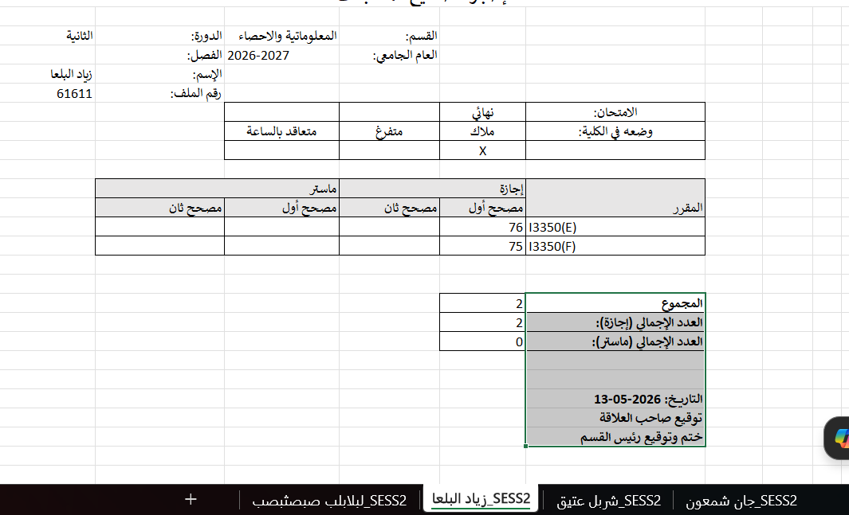
In this spreadsheet the admin can view all professors in the same department each one on a sheet and the courses assigned to each one.

5.Edit Admins Section
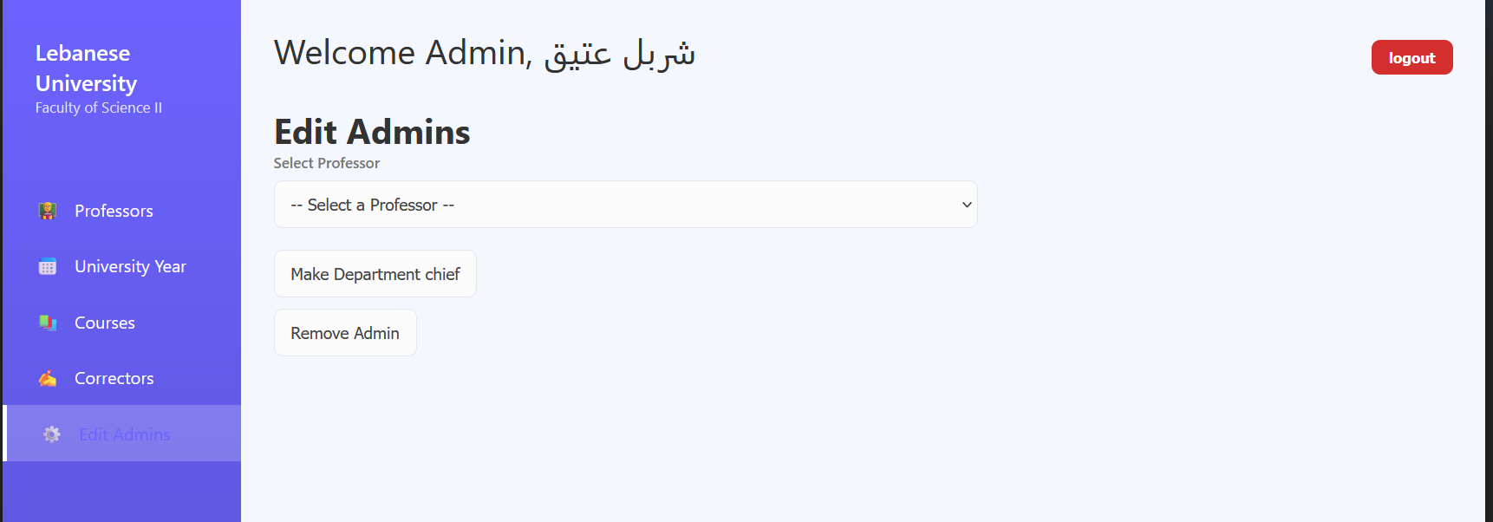
The current admin can choose a new admin from the drop-down list(select professor) the new admin selected will be assigned as new chief of department and can remove any old admins

Tasks Distribution
- Front-end Tasks:
- Log In Page
- Admin Check professor information page
- Edit Admins
- Insert Correctors
- Search Course with edit
- View courses of the major
- Professor profile page
- Sign up Page
- Add Course
- Professor Courses Pages(with export to excel)
- Excel format (in admin page)
- Insert number of copies for each correctors
- Forgot password page(with enter code and change password pages)

- Back-end tasks:
- Log in Page backend
- Professor profile page(fetch data,edit data)
- Professor Courses Page
- Admin Professors Page(fetching data from a specific query)
- Admin Correctors Page the first format in the excel format(توزيع اللجان الفاحصة )
- Edit Admin Page
- Sign up Page
- Forgot Password
- Admin Courses Page
* Add Course (send data , check existance)
* Search Course (fetch data using code)
* view Courses (fetch all possible data using a specific query)
- Admin Correctors Page (fetch data and send data)
* Insert Correctors
* Insert Numbers
* View Correctors
* Excel format (format2, format3)
- GitHub repository:
https://github.com/j12Ch05/FYP_AL_LIJAN_AL_FAHISSA

Conclusion
The development of Al Lijan Al Fahissa marks a significant transition from traditional, paper-based examination management to a streamlined, digital ecosystem. By centralizing the interactions between administrators, professors, and correctors, this system addresses the core inefficiencies of manual academic coordination—namely, communication delays, data fragmentation
Throughout the development of this system, several key objectives were realized:
  - Workflow Optimization: The hierarchical structure ensures that administrative tasks, such as course assignment and corrector oversight, are handled through a unified interface, reducing the overhead of manual tracking.
  - Security and Accessibility: By implementing a robust authentication and recovery flow, the system ensures that sensitive academic data remains protected while remaining easily accessible to authorized personnel.
  - Role-Specific Utility: The tailored "Professor" and "Admin" modules provide users with exactly the tools they need, from managing personal course loads to overseeing the entire academic review committee.

