RAG FRAMEWORK FOR EFFICIENT VIDEO QUERY AND UNDERSTANDING

BITS ZG628T: Dissertation by

Mehul Jain (2023ad05022)

Dissertation work carried out at

Microsoft, Hyderabad (Remote)

Submitted in partial fulfilment of the degree: M.tech AI/ML

Under the Supervision of Karthikeyan Dhanakotti
Microsoft, Hyderabad (Remote)



BIRLA INSTITUTE OF TECHNOLOGY & SCIENCE, PILANI
VIDYA VIHAR, PILANI, RAJASTHAN - 333031

February - 2026

Contents
List of Abbreviations 5
List of Tables 6
List of Figures 7
1. Abstract 8
1.1 Background 8
1.2 Objectives 8
1.3 Scope of the Work 10
2. Literature Review 10
2.1 Video Understanding and Retrieval in Surveillance Systems 10
2.2 Video Retrieval-Augmented Generation (VideoRAG) 11
2.3 Video Anomaly Detection in Surveillance 11
2.4 Multimodal Retrieval and Image-Based Search 12
2.5 Research Gaps Identified 12
2.6 Key Contributions of the Proposed System 12
3. System Design 13
3.1 High Level Design 13
3.1.1 Offline Indexing Phase 14
3.1.2 Online Query Processing Phase 14
3.1.3 Multimodal Reasoning and Response Generation 14
3.2 Low-Level Design 15
4. Implementation Details 19
4.1 Repository Structure and Runtime Organization 19
4.2 Environment and Dependencies 20
4.3 Offline Indexing Pipeline 20
4.4 Online Query Processing 21
4.5 Data Used 23
5. Observations 23
5.1 Query Examples 23
5.2 Processing Time Analysis 23
6. Evaluation Strategy 24
6.1 Dataset Preparation 24
6.1.1 Surveillance Dataset 24
6.1.2 Preprocessing and Index Construction 24
6.2 Question–Answer Dataset Construction 25
6.2.1 Question Design 25
6.2.2 Evaluation CSV Format 25
6.3 Abnormality Hit Rate 25
6.3.1 Definition of Abnormality 26
6.3.2 Selection of Evaluation Samples 26
6.3.3 Hit Rate Computation 26
6.4 LLM-as-Judge Evaluation 26
6.4.1 Scoring Dimensions 26
6.4.2 Judge Implementation 27
7. Results 27
7.1 Visual Examples 27
7.2 Retrieval Performance 33
7.3 Generated Response Performance 33
8. Limitations 35
9. Conclusion 35
10. Ethical Considerations 35
References 37

BIRLA INSTITUTE OF TECHNOLOGY AND SCIENCE, PILANI

CERTIFICATE

This is to certify that the Dissertation entitled RAG FRAMEWORK FOR EFFICIENT VIDEO QUERY AND UNDERSTANDING and submitted by Mr. Mehul Jain ID No. 2023ad05022 in partial fulfillment of the requirements of DSECLZG628T / AIMLCZG628T Dissertation, embodies the work done by him under my supervision.



Signature of Supervisor
Name: Karthikeyan Dhanakotti
Designation:
Date: 30th Jan 2026
Place: Hyderabad

List of Abbreviations

Abbreviation | Full Form | Description
VideoRAG | Video Retrieval-Augmented Generation | Framework combining video retrieval with LLM-based reasoning
HMESF | Hierarchical Multimodal Evidence Selection Framework | Proposed multi-stage retrieval and reranking mechanism
VLM | Vision–Language Model | Model that jointly processes visual and textual inputs
LLM | Large Language Model | Neural language model used for reasoning and generation
CLIP | Contrastive Language–Image Pretraining | Model used for joint image–text embeddings
BLIP | Bootstrapped Language–Image Pretraining | Model used for image captioning
LLaVA | Large Language and Vision Assistant | Multimodal LLM used for reasoning over images and text
FAISS | Facebook AI Similarity Search | Library for efficient vector similarity search
HNSW | Hierarchical Navigable Small World | Graph-based approximate nearest neighbor index
BM25 | Best Matching 25 | Sparse text retrieval ranking function
CCTV | Closed-Circuit Television | Surveillance video source
VQA | Visual Question Answering | Task of answering questions based on visual input
UCF | University of Central Florida | Source of the surveillance dataset
IoU | Intersection over Union | Metric for temporal or spatial overlap
FPS | Frames Per Second | Video frame rate
JSONL | JSON Lines | Line-delimited JSON storage format
GPU | Graphics Processing Unit | Hardware used for model inference and training
API | Application Programming Interface | Interface for system integration
UI | User Interface | Frontend interaction layer
RAG | Retrieval-Augmented Generation | Retrieval + generation framework
Top-k | Top-k Results | Number of highest-ranked retrieved items
Hit@k | Hit Rate at k | Retrieval evaluation metric
VQA Score | Visual Question Answering Score | LLM-based evaluation metric

List of Tables

Table No. | Title | Description
Table 1 | Stage-wise Latency Breakdown | Provides a detailed breakdown of computation time across different stages of the VideoRAG pipeline, including preprocessing, embedding generation, retrieval, reranking, and response generation.
Table 2 | Evaluation Dimensions | Summarizes the evaluation categories used in the study, including Contextual Integration (CI), Detail Orientation (DO), Contextual Understanding (CU), Temporal Understanding (TU)
Table 3 | Hit Rate Comparison: Visual-only VideoRAG vs VideoRAG with HMESF | Compares retrieval performance between a baseline visual-only retrieval system and the proposed Hierarchical Multimodal Evidence Selection Framework using Hit@k metrics.
Table 4 | Overview of Evaluated Open-Source Video Models and VideoRAG | Lists the video-language models evaluated in the study along with their architectural characteristics and input modalities.
Table 5 | Performance Comparison of Vision–Language Models vs VideoRAG with HMESF | Presents quantitative performance results across different QA categories, highlighting the improvements achieved by the proposed framework.

List of Figures

Figure No. | Caption
Figure 1 | Architecture Diagram of Video RAG HMESF
Figure 2 | 3 Stages of HMESF
Figure 3.1, 3.2, 3.3 | Text query Show me the abuse incident video and its results
Figure 4.1, 4.2, 4.3 | Text query “Show me the arrest video” and its results
Figure 5.1, 5.2, 5.3 | Text query “Show me the Burglary video” and its results
Figure 6.1, 6.2 | Cropped Image and its retrieved output
Figure 7.1, 7.2 | Cropped Image and its retrieved output
Figure 8.1, 8.2 | Cropped Image and its retrieved output

1. Abstract

With the rapid growth of CCTV deployments in public and private spaces, law enforcement agencies routinely collect terabytes of surveillance footage. Manually scanning these videos for specific incidents—such as road accidents, fights, thefts, or shootings—is slow, error-prone, and often impossible within operational time constraints. Traditional video analytics focus on low-level motion detection or simple object counts and are not well suited for natural language queries like “show me where a car crash happens and tell me how many vehicles were involved.”
In this project we design and implement a Video RAG (Video Retrieval-Augmented Generation) system tailored for crime-related CCTV footage. The system breaks videos into short segments, extracts keyframe and generates rich multimodal representations by combining CLIP-based visual embeddings, YOLOv8 object detection, and Blip based captions generation. These segment-level embeddings are indexed using FAISS to enable efficient similarity search. At query time, a user issues a natural language question (e.g., “find videos of a road accident”), the system retrieves the most relevant segments, and a multimodal LLAVA model analyzes associated keyframes to generate an evidence-based answer. A Streamlit-based web interface allows users to search existing indexed data or upload new videos, which are automatically processed, indexed into a separate “uploaded” index, and made searchable.
Our experiments on a crime-video dataset comprising classes such as RoadAccidents, Abuse, Fighting, Robbery, and Shooting demonstrate that the system can retrieve semantically relevant segments and provide time-stamped playback of the full videos around the detected events. The modular design and use of standard open-source components make the system extensible to larger datasets and more advanced downstream analysis.

1.1 Background

Modern cities deploy large-scale CCTV networks across streets, transportation hubs, commercial spaces, and critical infrastructure. These systems continuously record video streams, producing terabytes of footage daily.
While this data holds immense potential for:
- crime detection,
- forensic investigation,
- anomaly detection,
- public safety monitoring,
its practical utilization remains limited. Most surveillance footage is still analyzed manually or semi-automatically, making the process:
- time-consuming,
- error-prone,
- heavily dependent on human attention,
- infeasible at scale.
This gap between data availability and actionable insight motivates the need for automated, intelligent video understanding systems.

1.2 Objectives
The primary objective of this research is to design and implement an intelligent Video Retrieval-Augmented Generation (VideoRAG) framework that enables efficient, accurate, and explainable access to large-scale surveillance video data using natural language and image-based queries. The proposed system aims to bridge the gap between low-level video analytics and high-level semantic reasoning required in real-world surveillance and forensic applications.
The specific objectives of the proposed work are outlined below.

Natural Language–Based Video Retrieval
To develop a system that allows users to retrieve relevant video segments from long-duration CCTV footage using intuitive natural language queries such as:
- “Show incidents involving a car accident.”
- “Find scenes where a person is running or fighting.”
This eliminates the need for manual video inspection and enables efficient exploration of large surveillance archives.

Hierarchical Multimodal Evidence Selection
To design a hierarchical multimodal retrieval framework that progressively refines candidate video segments using multiple levels of analysis, including:
- Coarse-grained visual similarity matching
- Semantic relevance filtering using textual representations
- Temporal context aggregation for event continuity
This multi-stage approach improves retrieval precision while maintaining high recall and reduces the impact of noisy or irrelevant matches.

Integration of Visual, Textual, and Temporal Reasoning
To construct a unified reasoning pipeline that integrates:
- Visual embeddings extracted using CLIP
- Semantic captions generated through BLIP
- Temporal relationships between adjacent video segments
- Large Language Model (LLM)–based reasoning
This integration enables the system to understand not only what occurred, but also where, when, and how events unfolded over time.

Support for Image-Based Queries
To enable effective querying using cropped or partial images by:
- Generating semantic descriptions using LLaVA
- Combining visual and textual embeddings for retrieval
- Enhancing robustness to incomplete or low-quality visual inputs
This functionality is particularly useful in forensic investigations where only partial visual evidence may be available.

Explainable and Human-Readable Output Generation
To generate clear and interpretable natural-language explanations for retrieved video segments using multimodal LLMs.
The system aims to provide:
- Human-understandable summaries
- Context-aware explanations
- Reasoned descriptions of detected events
This improves usability for law enforcement, surveillance operators, and forensic analysts.

Scalability and Practical Deployment
To design a scalable and deployment-ready architecture by incorporating:
- FAISS HNSW indexing for efficient similarity search
- Modular pipeline design for extensibility
- Separation of offline feature extraction and online inference
This ensures that the system can operate effectively on large-scale CCTV datasets containing thousands of hours of video data.

1.3 Scope of the Work

The scope of the proposed VideoRAG system is defined as follows.

Surveillance Video Analysis
The system focuses on CCTV-style surveillance videos, particularly in scenarios involving:
- Traffic incidents
- Human activities
- Suspicious or anomalous behaviour
Multimodal Retrieval Capabilities
The system supports:
- Text-to-video retrieval
- Image-to-video retrieval
- Hybrid text–image queries

Temporal-Aware Retrieval
Temporal continuity is preserved by incorporating neighbouring video segments during retrieval and reranking.

Explainable AI Outputs
The system produces natural language explanations rather than only classification labels or anomaly scores.

Deep Learning–Based Architecture
The framework leverages state-of-the-art models including:
- CLIP for visual-textual alignment
- BLIP for caption generation
- LLaVA for multimodal reasoning
- Large Language Models for explanation generation

Offline–Online Processing Pipeline
- Offline phase: Feature extraction, embedding generation, and indexing
- Online phase: Query processing, retrieval, and response generation

2. Literature Review

2.1 Video Understanding and Retrieval in Surveillance Systems

The rapid expansion of surveillance infrastructure has led to an unprecedented growth in video data, making automated video understanding a critical research problem. Early surveillance analytics relied heavily on traditional computer vision techniques such as background subtraction, motion estimation, and handcrafted feature extraction. While these methods were effective for detecting simple motion patterns, they lacked the ability to capture semantic meaning or complex activities occurring in real-world scenes.
The advent of deep learning significantly transformed video understanding. Convolutional Neural Networks (CNNs) enabled spatial feature learning, while temporal modeling techniques and transformer-based architectures improved the representation of long-range dependencies in videos. More recently, multimodal learning approaches have further advanced the field by jointly modeling visual and textual information.
Vision–language models (VLMs) such as CLIP, BLIP, and VideoCLIP project visual and textual inputs into a shared embedding space, enabling cross-modal retrieval and reasoning. These models have demonstrated strong performance in tasks such as text-to-video retrieval, video captioning, and visual question answering. However, most existing systems are trained on generic datasets such as MSR-VTT, ActivityNet, and HowTo100M, which primarily consist of short, well-curated clips.
In contrast, surveillance videos pose unique challenges: they are long, untrimmed, and contain subtle or rare events that require fine-grained temporal reasoning. Furthermore, abnormal activities in surveillance footage often lack clear visual cues, making them difficult to detect using models trained on generic video datasets. These limitations highlight the need for surveillance-specific video understanding frameworks.

2.2 Video Retrieval-Augmented Generation (VideoRAG)

Retrieval-Augmented Generation (RAG) has emerged as a powerful paradigm for combining retrieval-based grounding with generative reasoning. Originally developed for text-based question answering, RAG frameworks have recently been extended to video understanding, giving rise to VideoRAG systems.
In VideoRAG, relevant video segments are first retrieved using multimodal embeddings and are then provided as contextual input to large language models (LLMs) for reasoning and response generation. Jeong et al. (2025) proposed one of the earliest VideoRAG architectures, demonstrating improved video question answering through multimodal retrieval. Similarly, Ren et al. introduced long-context VideoRAG systems capable of handling extended videos by leveraging hierarchical retrieval and graph-based representations.
These studies demonstrate that retrieval-based grounding significantly enhances the reasoning capability of video-language models, especially for long-form video content. However, several limitations remain unresolved. Most existing VideoRAG frameworks are designed for open-domain video understanding and do not explicitly address the characteristics of surveillance footage. Retrieval is typically performed at a single stage, often leading to noisy or contextually fragmented results. Moreover, temporal dependencies across video segments are rarely modeled explicitly, reducing the system’s ability to understand event progression.
Another key limitation is the limited support for image-based queries. Current systems primarily focus on text-driven retrieval and perform poorly when queries are provided in the form of cropped or partial images, which are common in forensic and surveillance scenarios.

2.3 Video Anomaly Detection in Surveillance

Video anomaly detection (VAD) is a well-established research area in surveillance analytics. Traditional and modern approaches aim to identify deviations from normal behavior patterns using various learning paradigms. Reconstruction-based methods, including autoencoders and GANs, detect anomalies by measuring reconstruction error. Weakly supervised approaches employ Multiple Instance Learning (MIL) to learn from coarse video-level labels. More recent methods leverage transformers and temporal attention mechanisms to model long-range dependencies.
Vision–language based approaches such as VadCLIP, MTFL, and TRACES further improve anomaly detection by aligning visual representations with semantic descriptions. These methods have achieved strong performance on benchmark datasets such as UCF-Crime and XD-Violence.
Despite their effectiveness, anomaly detection models exhibit several inherent limitations. Most systems produce only binary or class-level outputs, offering little semantic explanation of detected events. They do not support natural language interaction, making them unsuitable for investigative or forensic use cases. Furthermore, these models are not designed for large-scale retrieval or querying across extensive video archives. Most importantly, they operate independently of language models and therefore cannot provide human-interpretable reasoning or summaries.
Thus, while anomaly detection models are effective at identifying suspicious segments, they fail to answer higher-level questions such as what happened, why it happened, or whether similar incidents occurred elsewhere.

2.4 Multimodal Retrieval and Image-Based Search

Multimodal retrieval systems based on CLIP and BLIP have significantly advanced cross-modal search capabilities by aligning visual and textual representations. These models enable retrieval across images, videos, and text using a shared embedding space.
However, CLIP-based retrieval systems face notable challenges in real-world surveillance scenarios. Their performance degrades when query images are cropped, low-resolution, or lack sufficient contextual information—conditions that are common in CCTV footage. Moreover, while vision-language models such as LLaVA improve semantic understanding by generating descriptive captions, their integration into retrieval pipelines remains limited.
Most existing systems use such models solely for caption generation or visual question answering rather than leveraging them to enhance retrieval accuracy. As a result, the potential of LLM-assisted semantic enrichment for retrieval remains underexplored.

2.5 Research Gaps Identified

From the existing literature, several critical gaps can be identified:
- Lack of Surveillance-Oriented VideoRAG Systems
Current VideoRAG approaches are designed for open-domain videos and do not account for the characteristics of surveillance data such as long duration, sparse events, and subtle anomalies.
- Absence of Multi-Stage Retrieval Mechanisms
Most systems rely on a single retrieval step, which often leads to irrelevant or incomplete results.
- Limited Temporal Awareness
Existing methods do not explicitly exploit temporal continuity or neighborhood consistency across video segments.
- Insufficient Support for Image-Based Queries
Retrieval performance significantly degrades for cropped or partial image inputs, which are common in forensic investigations.
- Weak Integration Between Detection and Generation
Anomaly detection and language-based reasoning are typically treated as separate tasks, limiting the system’s interpretability and usability.

2.6 Key Contributions of the Proposed System

To address the above limitations, this work proposes a surveillance-oriented VideoRAG framework with the following key contributions:
- Dual-Embedding Multimodal Architecture
The system employs separate yet aligned visual and textual embedding spaces, enabling flexible and accurate multimodal retrieval.
- Hierarchical Multi-Stage Retrieval Pipeline
A three-stage retrieval framework is introduced:
  - Stage 1: Visual similarity search using FAISS with HNSW indexing
  - Stage 2: Textual relevance refinement using BM25 and semantic similarity
  - Stage 3: Temporal context–aware reranking to enforce event continuity
- Temporal Context Aggregation Mechanism
A novel temporal aggregation strategy leverages neighboring video segments to improve coherence and reduce retrieval noise.
- Robust Image-Based Query Handling
By combining CLIP embeddings with LLaVA-generated semantic descriptions, the system effectively handles cropped or partial image queries.
- Scalable and Deployment-Ready Design
The use of FAISS-based approximate nearest neighbor search enables efficient indexing and retrieval, making the system suitable for large-scale CCTV deployments.
- End-to-End Multimodal Reasoning
Integration with LLMs enables natural-language explanations, event summarization, and forensic-style responses—moving beyond simple anomaly detection toward intelligent video understanding.

3. System Design

3.1 High Level Design

At a high level, the proposed VideoRAG framework is organized into two logically decoupled phases: an offline indexing phase and an online query processing phase. This separation enables efficient large-scale indexing while ensuring low-latency query execution during inference.

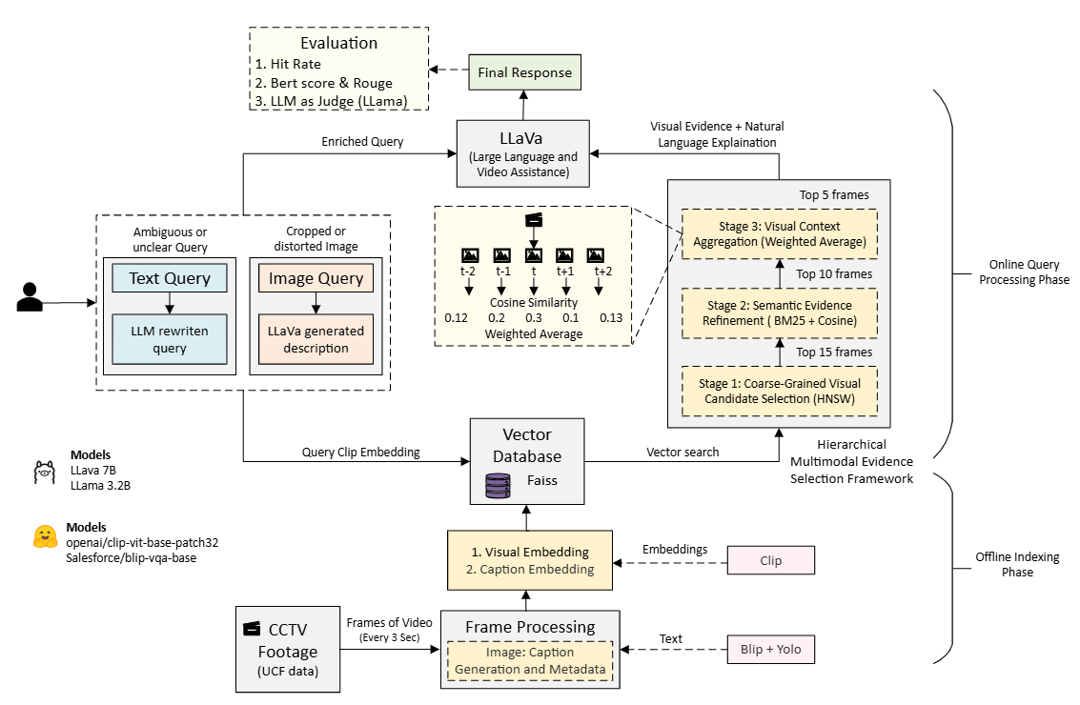
Figure 1: Architecture Diagram of Video RAG HMESF

3.1.1 Offline Indexing Phase

In the offline phase, raw surveillance video files are first processed through a video preprocessing pipeline. Each video is divided into fixed-duration segments (typically 3 seconds) to ensure uniform temporal granularity. From each segment, one or more representative keyframes are extracted to capture salient visual information while minimizing redundancy.
These keyframes are then passed to the feature extraction module, where multimodal representations are generated using state-of-the-art vision–language models. Specifically:
- CLIP is used to extract visual embeddings that capture semantic visual features.
- BLIP is employed to generate descriptive captions, which are further encoded into textual embeddings.
- Metadata such as video ID, segment ID, and temporal boundaries are also recorded.
The resulting visual embeddings, textual embeddings, and metadata are stored in a dual-index architecture based on FAISS with HNSW indexing. Two separate but aligned indexes are maintained:
- A visual index for image-based similarity search
- A textual index for semantic retrieval
Together, these indexes form a searchable video knowledge base that supports efficient multimodal retrieval.

3.1.2 Online Query Processing Phase

During the online phase, the system processes user queries and retrieves relevant video segments in real time. A user submits a natural language query to the VideoRAG query processor, which first converts the query into a CLIP-based text embedding.
Retrieval is then performed using a Hierarchical Multimodal Evidence Selection Framework, designed to progressively refine results and improve relevance:
Stage 1: Coarse-Grained Visual Candidate Selection
The query embedding is used to perform an initial similarity search over the visual FAISS index. This stage retrieves the top 15 candidate video segments based on visual-semantic similarity.
Stage 2: Semantic Evidence Refinement
The retrieved candidates are further refined using a combination of:
- Caption embedding similarity
- BM25-based textual relevance scoring
This stage filters the candidates to the top 10 segments that best match the semantic intent of the query.
Stage 3: Visual Context Aggregation
To ensure temporal coherence, the system aggregates information from neighboring video segments. This temporal reasoning step accounts for event continuity and contextual consistency, ultimately selecting the top 5 most relevant segments.

3.1.3 Multimodal Reasoning and Response Generation

The final set of selected video segments—along with their associated keyframes and textual context—is passed to a LLaVA-based multimodal reasoning module hosted via an Ollama server. The LLaVA model jointly analyses the visual inputs and the user’s query to generate a coherent, natural-language explanation.
The generated response is then formatted and returned to the user, providing:
- A clear description of the retrieved event
- Contextual interpretation of the scene
- Human-readable explanation suitable for surveillance or forensic use

3.2 Low-Level Design

This section presents the Low-Level Design (LLD) of the proposed VideoRAG system. It describes the internal architecture at the module, class, and function level, detailing how individual components interact during both the offline indexing phase and the online query processing phase. The LLD complements the High-Level Design by explaining implementation logic, data structures, and execution flow.

1. Configuration Layer (00_config.py)
1.1 Purpose
The configuration module acts as a centralized control point for all system-level parameters. It ensures consistency across modules and allows easy modification of system behavior without altering core logic.

1.2 Configuration Parameters
Path Configuration
- PROJECT_ROOT: Root directory of the project.
- DATA_DIR: Directory containing surveillance video data.
- SAMPLE_DATA_DIR: Alias for the dataset directory.
- OUTPUT_DIR: Stores extracted features, indices, and metadata.
- UPLOADED_OUTPUT_DIR: Stores user-uploaded videos.
- CACHE_DIR: Stores temporary and intermediate artifacts.
Video Processing Parameters
- CHUNK_DURATION: Duration (in seconds) of each video segment (default: 3s).
- KEYFRAMES_PER_CHUNK: Number of representative frames per segment.
- VIDEO_EXTENSIONS: Supported video formats (.mp4, .avi, .mkv, etc.).
Model Configuration
- CLIP_MODEL_NAME: CLIP backbone (e.g., ViT-B-32).
- CLIP_PRETRAINED: Pretrained weight source.
- YOLO_MODEL: Object detection model used in auxiliary workflows.
- EMBEDDING_DIM: Dimensionality of embeddings (512).
Indexing Configuration
- FAISS_INDEX_PATH: Location of serialized FAISS index.
- METADATA_PATH: Path to JSONL metadata store.
LLM Integration
- OLLAMA_BASE_URL: URL of local Ollama server.
- LLAVA_MODEL: LLaVA model identifier.
Query Parameters
- TOP_K_RETRIEVAL: Final number of retrieved segments.
- CONFIDENCE_THRESHOLD: Minimum confidence required for output filtering.

1.3 Initialization Behavior
Upon import, the module ensures that all required directories exist. Missing directories are created automatically to prevent runtime failures.

2. Video Preprocessing Module (01_preprocess.py)
2.1 Class: VideoPreprocessor
Responsibilities
- Discover videos in the dataset directory.
- Segment videos into fixed-duration chunks.
- Extract representative keyframes.
- Store structured metadata for downstream processing.

2.2 Processing Workflow
- Video Discovery
  - Iterates over supported video formats.
  - Extracts metadata such as duration and frame rate.
- Chunking Strategy
  - Each video is divided into fixed-length segments.
  - Chunk IDs follow the format:
video_name_chunk_XXXX.
- Keyframe Extraction
  - Extracts representative frames per chunk.
  - Frames are resized to match CLIP input dimensions.
  - Saved under structured directories for traceability.
- Fault-Tolerant Design
  - Uses FFmpeg when available.
  - Falls back to OpenCV-based extraction if FFmpeg is unavailable.

2.3 Output Metadata Structure
Each chunk produces a metadata record containing:
{
"chunk_id": "video_chunk_0001",
"video_path": "...",
"start_time": 3.0,
"end_time": 6.0,
"duration": 3.0,
"keyframes": ["path/to/image.jpg"]
}
This metadata is later enriched during feature extraction.

3. Feature Extraction (02_extract_features.py)
3.1 Class: CLIPFeatureExtractor
Responsibilities
- Load CLIP model and preprocessing pipeline.
- Encode images into fixed-length embeddings.
- Support robust inference for corrupted or rotated images.

3.2 Initialization
- Automatically selects GPU if available.
- Loads CLIP model using open_clip.
- Sets model to evaluation mode.
- Loads tokenizer for text encoding.

3.3 Core Methods
encode_image(image_path)
- Loads image via PIL.
- Applies EXIF correction if needed.
- Converts to RGB.
- Applies CLIP preprocessing.
- Extracts and L2-normalizes embedding.
- Returns a 512-dim vector.
encode_image_from_pil(image)
- Same logic as above but accepts in-memory images.
If encoding fails, a zero-vector is returned to maintain pipeline continuity.

3.4 BLIP Caption Generation
For each keyframe:
- BLIP generates a natural-language caption.
- The caption is encoded using CLIP text encoder.
- Caption embeddings are stored alongside visual embeddings.

4. Indexing and Storage (03_index.py)
4.1 Class: VideoIndex
Responsibilities
- Build and manage FAISS indices.
- Store and retrieve metadata.
- Support fast similarity search.

4.2 Internal Data Structures
- visual_index: FAISS HNSW index for image embeddings.
- textual_index: FAISS HNSW index for caption embeddings.
- metadata: List of chunk metadata dictionaries.
- chunk_id_to_idx: Maps chunk IDs to FAISS indices.

4.3 Index Construction
build_index(features_metadata_path)
Steps:
- Load extracted feature records.
- Validate embeddings.
- Normalize vectors.
- Construct HNSW indices (M=32, efConstruction=64).
- Store:
  - FAISS index
  - JSONL metadata
  - Chunk-to-index mappings

4.4 Index Loading
load_index():
- Loads FAISS index from disk.
- Loads metadata into memory.
- Rebuilds lookup mappings.

4.5 Search Operation
- Normalizes query embedding.
- Searches visual and textual indices.
- Retrieves top-k candidates.
- Attaches similarity scores to metadata.

5. Reranking and Temporal Reasoning (04_reranker.py)
5.1 Text Processing Utilities
- Tokenization via regex.
- BM25 scoring with fixed hyperparameters.
- Lightweight and dependency-free implementation.

5.2 Temporal Scoring Mechanism
compute_temporal_score()
- Identifies neighboring chunks.
- Collects embeddings from temporal neighbors.
- Computes similarity-weighted average.
- Produces a temporally smoothed score.
This improves robustness to fragmented detections.

5.3 Hierarchical Reranking
The reranker supports:
- Visual similarity ranking
- Textual relevance ranking
- Temporal consistency scoring
Final ranking is computed as a weighted fusion of all three.

6. Query Processing (05_query.py)
6.1 Dynamic Module Loading
Due to numeric filenames, Python’s importlib is used to dynamically load:
- VideoIndex
- CLIPFeatureExtractor
- HierarchicalReranker
This ensures modularity without renaming source files.

6.2 Class: OllamaClient
Handles communication with LLaVA via REST API.
Key Functions:
- is_model_available()
- generate_response()
- encode_image_to_base64()
Supports image + text prompts and non-streaming inference.

6.3 Class: VideoRAGQueryProcessor
Responsibilities
- Load index
- Encode queries
- Retrieve candidates
- Apply reranking
- Invoke LLaVA
- Return final response

6.4 Query Execution Pipeline
- Load index if not already loaded.
- Encode query using CLIP.
- Perform:
  - Visual retrieval
  - Textual reranking
  - Temporal aggregation
- Build multimodal prompt.
- Send prompt + images to LLaVA.
- Return:
  - Answer text
  - Retrieved segments
  - Confidence scores

4. Implementation Details

This section describes the practical implementation of the VideoRAG system, focusing on its execution flow, core modules, and operational design. The objective is to provide sufficient detail for reproducibility, debugging, and further extension of the system.

4.1 Repository Structure and Runtime Organization

The project follows a modular, pipeline-oriented structure that separates preprocessing, indexing, retrieval, and evaluation logic.
Source Code
- 00_config.py
Centralized configuration file defining global constants such as paths, chunk size, embedding dimensions, retrieval depth, and model names.
- 01_preprocess.py
Handles video discovery, temporal segmentation, and keyframe extraction.
- 02_extract_features.py
Extracts visual embeddings using CLIP and generates captions using BLIP.
- 03_index.py
Constructs, serializes, and loads FAISS HNSW indices.
- 04_reranker.py
Implements BM25 scoring, temporal reasoning utilities, and reranking logic.
- 05_query.py
Orchestrates the full retrieval pipeline and integrates with LLaVA via Ollama.
Evaluation Utilities
- evaluate_response_csv.py
Performs LLM-as-a-judge evaluation across:
  - Contextual Integration (CI)
  - Detail Orientation (DO)
  - Contextual Understanding (CU)
  - Temporal Understanding (TU)
- prompt.txt
Contains standardized evaluation prompts used for scoring consistency.
Data and Artifacts
- data/ – Raw videos grouped by category (e.g., Abuse, Robbery, RoadAccidents)
- outputs/ – Generated keyframes, embeddings, FAISS index, metadata
- cache/ – Intermediate files for faster recomputation
- docs/ – Design documentation and experiment notes

4.2 Environment and Dependencies

Runtime Environment
- Python ≥ 3.10 (virtual environment recommended)
Core Libraries
- torch – Model inference
- open_clip_torch – CLIP image/text encoders
- transformers – BLIP captioning
- faiss – Approximate nearest neighbor search
- opencv-python, ffmpeg – Video decoding and frame extraction
- numpy, Pillow – Data processing
- requests – Communication with Ollama
- tqdm – Progress visualization
Hardware Utilization
- CLIP and BLIP automatically run on GPU if available
- LLaVA runs independently inside Ollama and communicates via HTTP
- CPU fallback is supported for all components
Configuration-Driven Design
All major parameters—including chunk size, embedding dimensions, retrieval depth, and model selection—are defined in 00_config.py, enabling easy experimentation without modifying core logic.

4.3 Offline Indexing Pipeline

The offline phase prepares all artifacts required for efficient query-time retrieval.
1. Video Discovery and Chunking
- Videos are recursively discovered from DATA_DIR.
- Each video is split into fixed-length temporal chunks (CHUNK_DURATION seconds).
- For each chunk:
  - A representative frame is extracted using OpenCV or FFmpeg.
  - Frames are resized to CLIP-compatible resolution (e.g., 224×224).
  - Each chunk is assigned a unique ID:
video_name_chunk_000X
Metadata recorded per chunk:
- chunk_id
- video_path
- start_time, end_time
- duration
- keyframe_path

2. Feature Extraction and Captioning
For each extracted keyframe:
- Visual embedding
  - Image passed through CLIP image encoder
  - Output: 512-D L2-normalized vector
- Textual representation
  - BLIP generates a natural language caption
  - Caption encoded using CLIP text encoder
Each chunk stores:
- Visual embedding
- Caption
- Caption embedding
- Temporal metadata
All records are serialized into a JSON/JSONL file.

3. FAISS Index Construction
- Visual and caption embeddings are loaded and validated.
- Missing embeddings are handled gracefully via fallback logic.
- Two HNSW indices are constructed:
  - Visual index
  - Textual index
Index parameters
- Metric: Inner Product (cosine similarity via normalization)
- M = 32
- efConstruction = 64
Artifacts saved:
- FAISS index files
- metadata.jsonl
- chunk_id → index_id mapping

4.4 Online Query Processing

1. Initialization
When the system starts:
- FAISS indices are loaded
- Metadata mappings are reconstructed
- CLIP encoder and Ollama client are initialized
- Reranker utilities are prepared

2. Query Encoding
- User query is encoded using CLIP text encoder
- Resulting embedding is L2-normalized

3. Stage 1 – Visual Retrieval
- Query embedding searched against visual FAISS index
- Top-K candidates retrieved
- Each candidate assigned a visual_score

4. Stage 2 – Textual & BM25 Reranking
For each candidate:
- Caption similarity computed via CLIP
- BM25 score computed over caption tokens
- Final textual score computed as:
textual_score = 0.6 × caption_similarity + 0.4 × bm25_score
Top candidates are retained.

5. Stage 3 – Temporal Aggregation
To improve temporal coherence:
- Neighbouring chunks are identified using chunk indices
- Embeddings from adjacent segments are aggregated
- A weighted temporal embedding is computed
- Final score is based on similarity with query embedding
This enables reasoning over multi-second events instead of isolated frames.

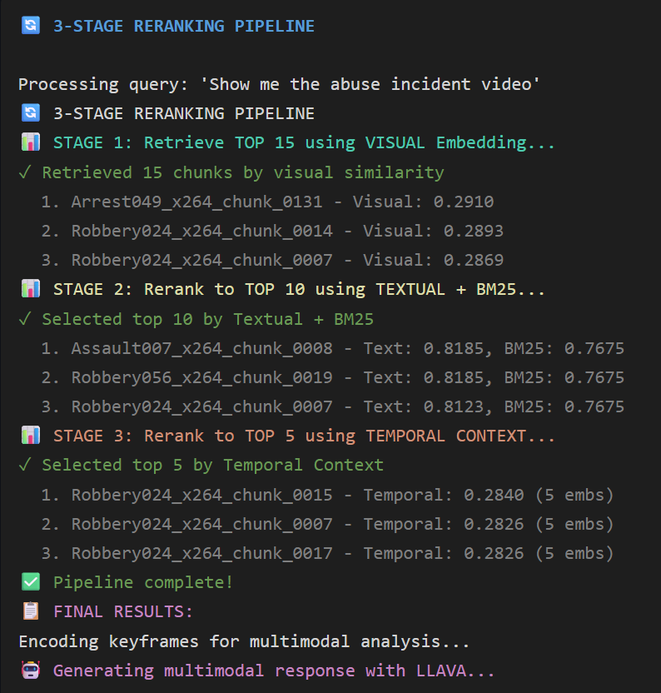
Figure 2: 3 Stages of HMESF

6. Prompt Construction and LLaVA Inference
- Selected chunks are summarized into a structured prompt
- Corresponding keyframes are encoded as base64 images
- LLaVA is invoked via Ollama with:
  - Prompt
  - Image list
  - Model name (e.g., llava:7b)
The model returns a grounded natural-language answer.

7. Output Format
The final response contains:
{
"answer": "...",
"retrieved_chunks": [...],
"scores": {
"visual": ...,
"textual": ...,
"temporal": ...
}
}

4.5 Data Used
For empirical evaluation and indexing in this work, UCF-Crime dataset, a large-scale real-world surveillance video corpus widely used for anomaly detection research. The dataset comprises 1,900 long, untrimmed CCTV videos spanning a total duration of approximately 128 hours of real surveillance footage. These videos are captured in diverse environments and lighting conditions, making the dataset particularly challenging for retrieval and understanding tasks. The dataset includes 13 distinct anomalous event categories—such as Abuse, Arrest, Arson, Assault, Burglary, Explosion, Fighting, Road Accident, Robbery, Shooting, Stealing, Shoplifting, and Vandalism—as well as normal activity videos that contain no crime events. These categories reflect a wide range of realistic abnormal behaviors encountered in public safety settings, and their inclusion enables evaluation across both binary anomaly detection and fine-grained event recognition scenarios.
Link - CRCV | Center for Research in Computer Vision at the University of Central Florida

5. Observations

5.1 Query Examples
Example Query: “Find out when the road accident happened.”
- System retrieved segments from:
  - RoadAccidents040_x264.mp4
  - RoadAccidents089_x264.mp4
  - Occasionally segments from other classes with similar patterns (e.g., motorcycles or traffic scenes).
- Similarity scores observed around 0.30–0.32, after tuning the threshold to 0.15 for the smaller dataset.
- LLAVA provided analysis describing:
  - Presence of multiple cars,
  - Potential collision scenes,
  - Estimated timestamps for accident-related events.

5.2 Processing Time Analysis

This section presents the end-to-end latency analysis of the proposed VideoRAG system. The total response time is composed of multiple sequential stages, ranging from query encoding and retrieval to multimodal reasoning using a vision–language model. All timings were measured under normal operating conditions using GPU acceleration for model inference.

Table 1: Stage-wise Latency Breakdown

Stage | Time (Approx.) | Description
Query Encoding | ~50 ms | Encoding the user’s natural-language query using CLIP’s text encoder
Stage 1: Visual Retrieval | ~10 ms | Approximate nearest-neighbor search using FAISS HNSW over visual embeddings
Stage 2: Textual Reranking | ~20 ms | Caption similarity + BM25-based semantic reranking
Stage 3: Temporal Aggregation | ~30 ms | Temporal neighborhood aggregation and score refinement
LLaVA Generation | ~2–5 s | Multimodal reasoning and natural-language answer generation
Total Latency | ~2–6 seconds | End-to-end response time

6. Evaluation Strategy

This section describes the evaluation methodology used to assess the effectiveness of the proposed VideoRAG system. The evaluation is designed to measure both retrieval correctness (via abnormality hit rate) and answer quality (via an LLM-as-judge framework). The evaluation is conducted on a real-world surveillance dataset and reflects realistic video understanding challenges.

6.1 Dataset Preparation

6.1.1 Surveillance Dataset

Evaluation is performed using a surveillance video dataset sourced from the Hugging Face Hub.
Link: fei213/SurveillanceVQA-589K · Datasets at Hugging Face
The dataset consists of short CCTV-style clips organized into event-specific categories, including:
- Abuse
- Arrest
- Burglary
- Explosion
- Fighting
- Road Accidents
- Robbery
- Shooting
- Normal activities
Each category represents a distinct type of abnormal event, while the normal class contains non-anomalous surveillance footage.
The dataset is downloaded locally and stored using the original directory structure:
Data/
├── Abuse/
├── Robbery/
├── RoadAccidents/
├── ...
Each video file corresponds to a single surveillance clip depicting one primary event.

6.1.2 Preprocessing and Index Construction

All videos undergo the same preprocessing pipeline as used in the main VideoRAG system to ensure evaluation consistency.
Video preprocessing steps:
- Videos are segmented into fixed-length chunks using CHUNK_DURATION = 3s.
- One representative keyframe is extracted per chunk.
- Each keyframe is resized to CLIP-compatible resolution.
- Metadata is recorded per chunk:
  - chunk_id
  - video_path
  - start_time, end_time
  - keyframe_path
Feature extraction:
- CLIP image embeddings are computed for each keyframe.
- BLIP generates a textual caption per keyframe.
- Captions are encoded using CLIP’s text encoder.
- Each chunk stores:
  - Visual embedding
  - Caption
  - Caption embedding
  - Temporal metadata
Indexing:
- All chunk-level embeddings are serialized into JSON/JSONL format.
- Dual FAISS HNSW indices (visual and textual) are constructed.
- Index and metadata files are stored under the outputs/ directory.
- Index construction is performed once offline.

6.2 Question–Answer Dataset Construction

6.2.1 Question Design

For evaluation, a curated question–answer (QA) dataset is constructed manually. Each question is paired with a single video and designed to probe different reasoning capabilities.
The following question types are used:
- Description_questions
Example: “What is happening in the video?”
- Cause_questions
Example: “What caused the incident?”
- Result/Outcome_questions
Example: “What happens after the collision?”
Each question is paired with a ground-truth answer written by manually inspecting the video. Answers strictly describe observable content and do not rely on external knowledge.

6.2.2 Evaluation CSV Format

Each evaluation instance corresponds to a single row in a CSV file with the following fields:
- video_id
- question_type
- question
- ground_truth_answer
- no_rerank_response
- rerank_response
Where:
- no_rerank_response is produced using visual-only retrieval.
- rerank_response is produced using the full three-stage retrieval pipeline.

6.3 Abnormality Hit Rate

6.3.1 Definition of Abnormality

Each video belongs to a known abnormal event category (e.g., robbery, explosion, assault). The abnormality corresponds to the primary event depicted in the clip, typically localized within a short temporal window.
Examples:
- A robbery → theft or threat behaviour
- A road accident → collision event
- A shooting → firearm discharge

6.3.2 Selection of Evaluation Samples

Only QA pairs that explicitly depend on recognizing the abnormal event are used for abnormality evaluation. These include:
- Description questions explicitly asking what is happening
- Cause questions tied to the abnormal action
- Result questions that depend on the abnormal event
This filtering ensures that evaluation focuses on whether the system correctly understands what went wrong in the scene.

6.3.3 Hit Rate Computation

For each selected QA pair:
- The model’s answer is normalized (lowercasing, light lemmatization).
- The predicted answer is compared with the ground-truth abnormality label.
- A hit is counted if:
  - The answer correctly identifies the abnormal event
  - Paraphrases or synonyms are allowed
  - The event is not confused with another class
Examples:
- “A man steals a bag” → ✔ robbery
- “A fight breaks out” → ✘ robbery
The abnormality hit rate is computed as:
$$\text{Hit Rate}=\frac{\text{Correct abnormality predictions}}{\text{Total abnormality QA pairs}}$$
This metric is reported for:
- No-rerank pipeline
- Full VideoRAG pipeline
The comparison directly measures the benefit of multi-stage retrieval.

6.4 LLM-as-Judge Evaluation

To evaluate answer quality beyond correctness, an LLM-based evaluator is used.

6.4.1 Scoring Dimensions

Each answer is evaluated on four dimensions:

Table 2: Evaluation dimensions

Dimension | Description
Contextual Integration (CI) | Factual correctness w.r.t. video
Detail Orientation (DO) | Completeness and specificity
Contextual Understanding (CU) | Alignment with scene intent
Temporal Understanding (TU) | Correct ordering and causality

Each dimension is scored from 0 to 5, where:
- 5 = Perfect
- 3 = Mostly correct
- 1 = Mostly incorrect
- 0 = Completely wrong
The final score is computed as:
$$\text{Avg}=\frac{CI+DO+CU+TU}{4}$$

6.4.2 Judge Implementation

Evaluation is implemented using Ollama with a local LLM (e.g., llama3.2).
For each QA pair:
- The judge receives:
  - Question
  - Ground-truth answer
  - Model-generated answer
- A dedicated prompt is used per dimension.
- The model is instructed to return only a single integer (0–5).
- Temperature is set to 0.0 for determinism.
- Scores are validated and logged.
Each QA pair produces:
- CI, DO, CU, TU scores
- Final averaged score

7. Results

7.1 Visual Examples

Few Text Query Examples
- Abuse – Show me the abuse incident video.
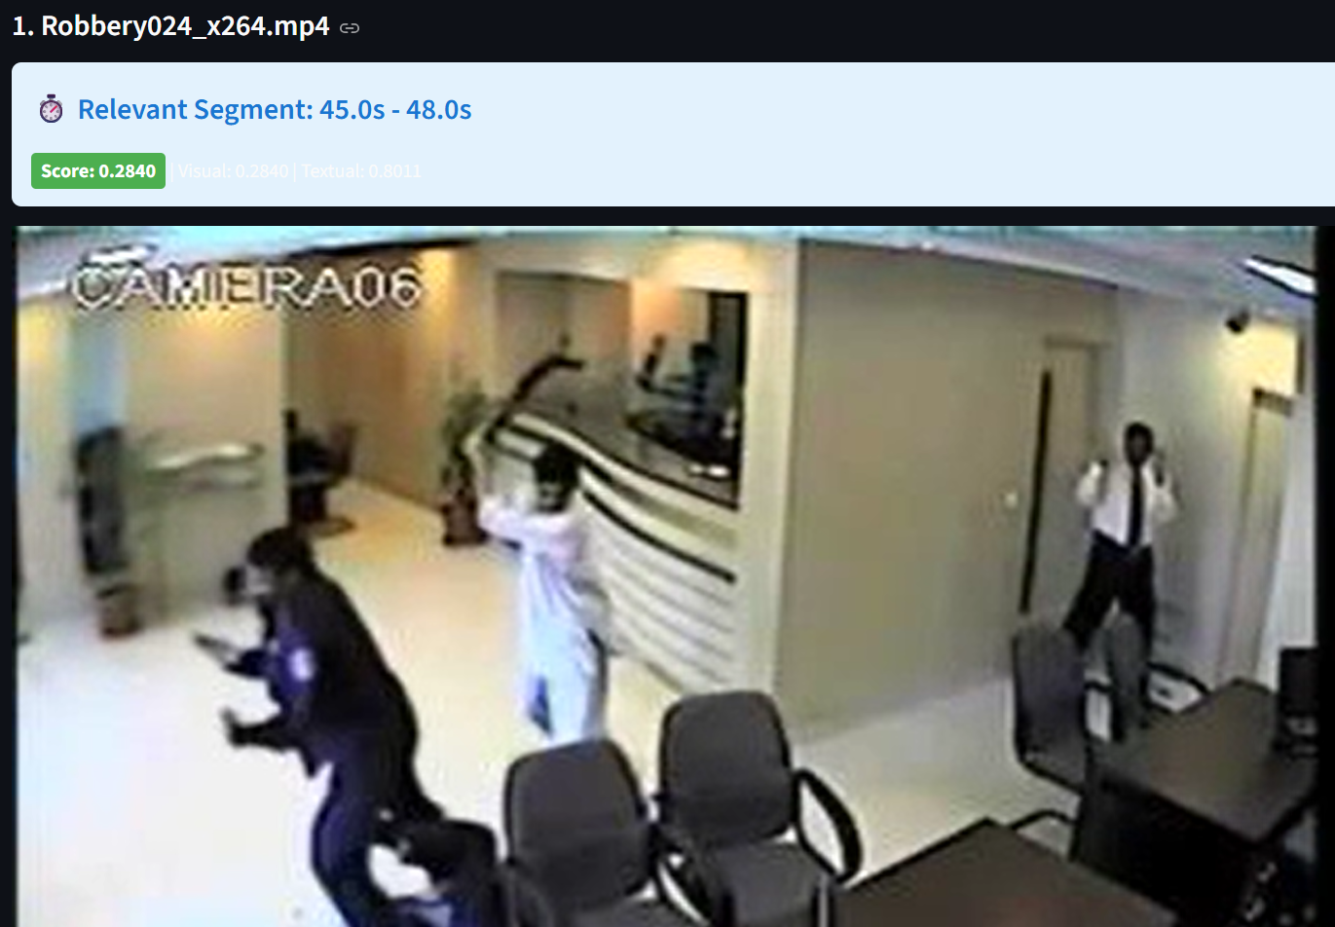
Figure 3.1 Rank 1 Retrieved Results
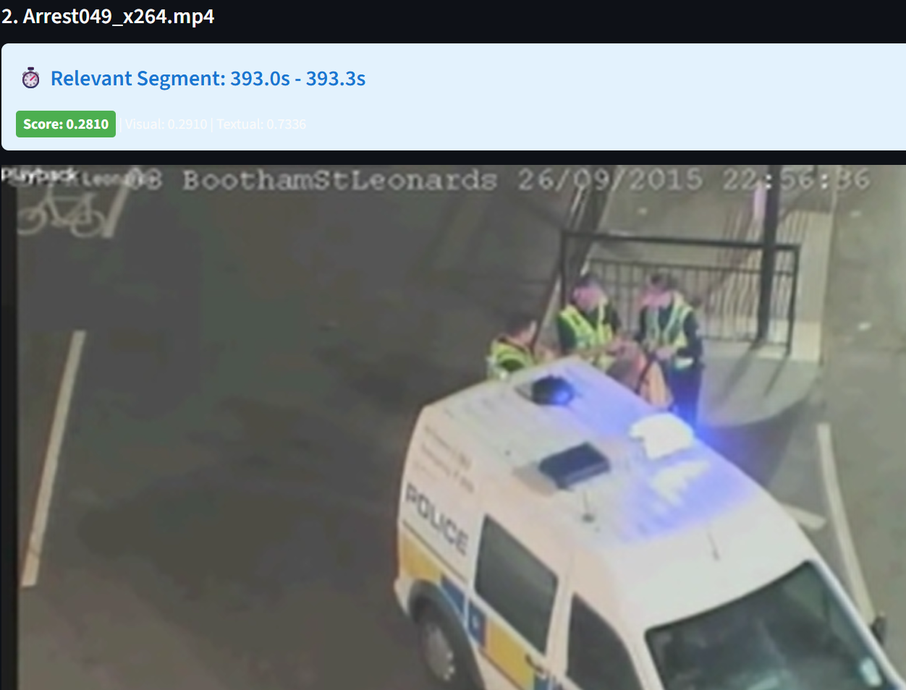
Figure 3.2 Rank 2 Retrieved Results
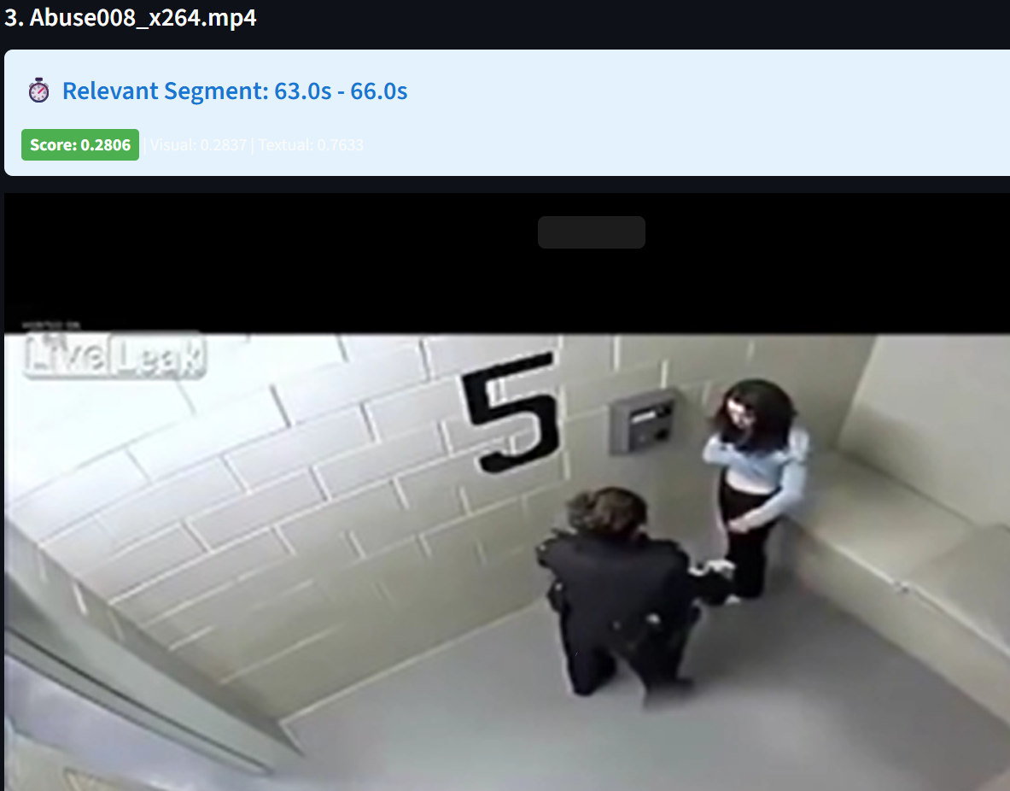
Figure 3.3 Rank 3 Retrieved Results

- Arrest – Show me the arrest video.
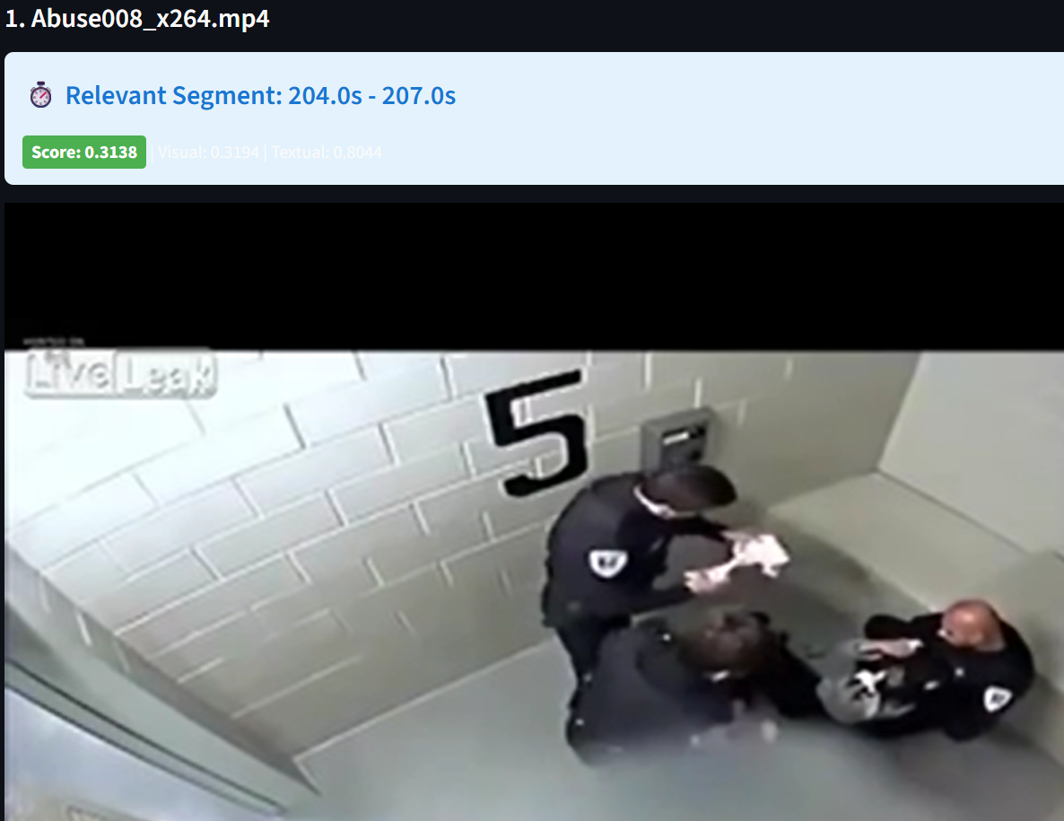
Figure 4.1 Rank 1 Retrieved Results
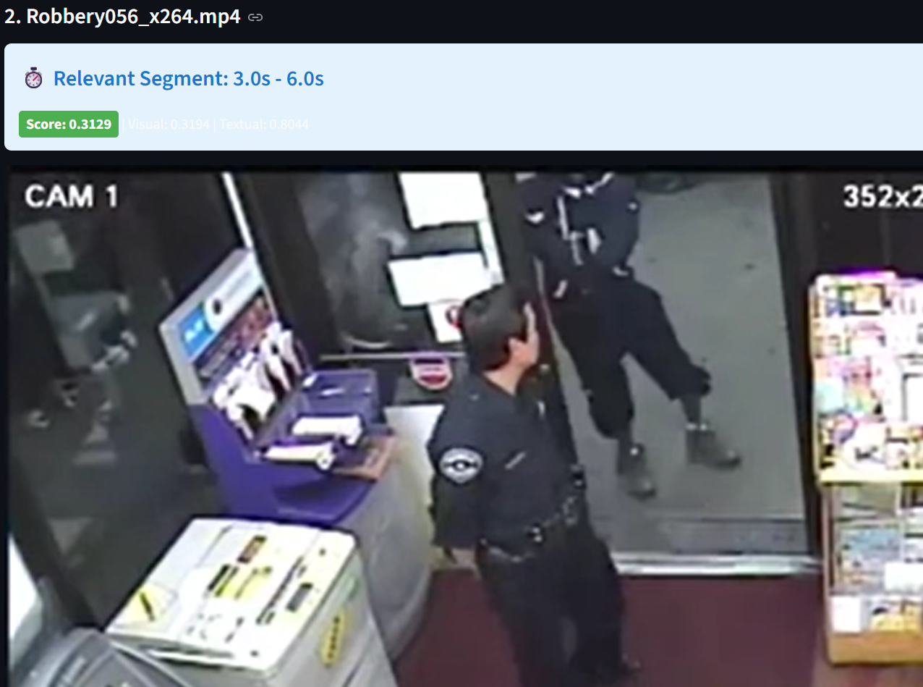
Figure 4.2 Rank 2 Retrieved Results
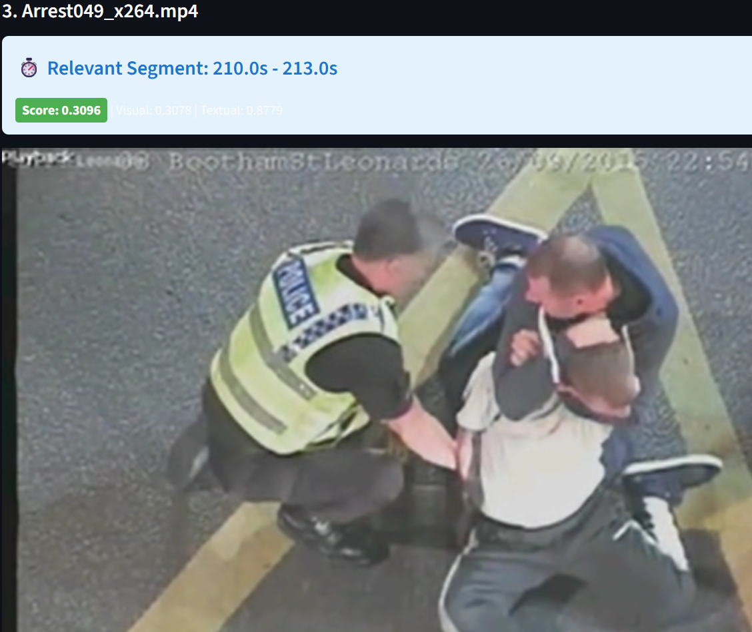
Figure 4.3 Rank 3 Retrieved Results
- Burglary – Show me the Burglary video.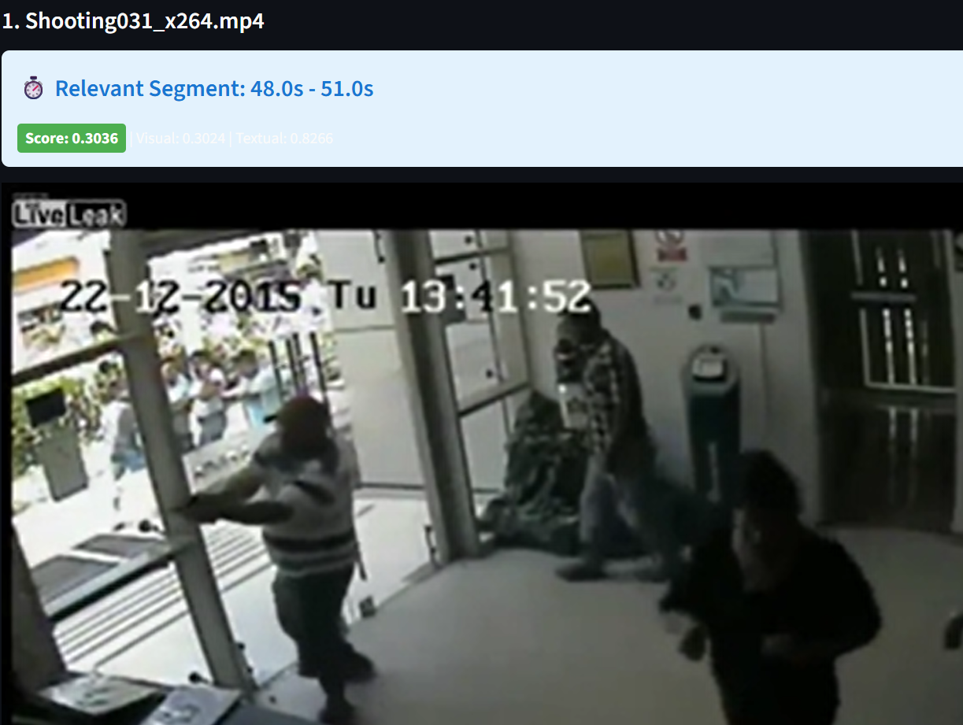
Figure 5.1 Rank 1 Retrieved Results
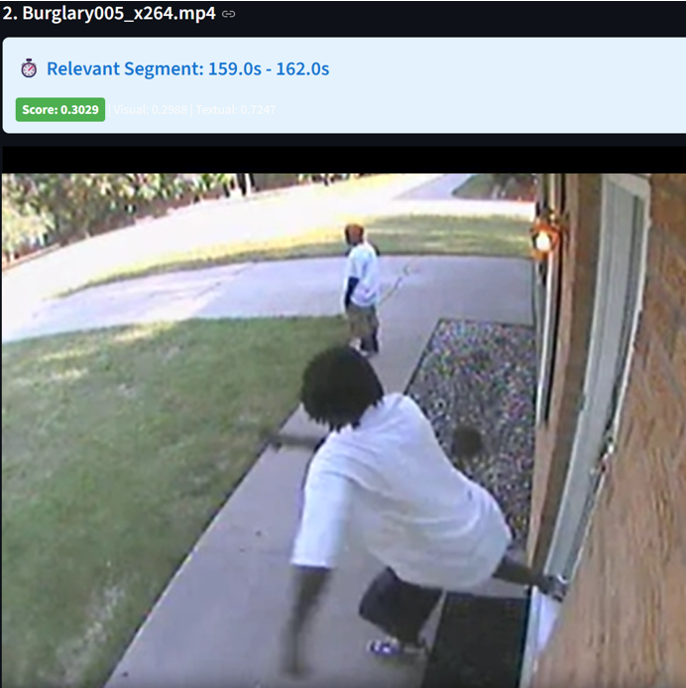
Figure 5.2 Rank 2 Retrieved Results
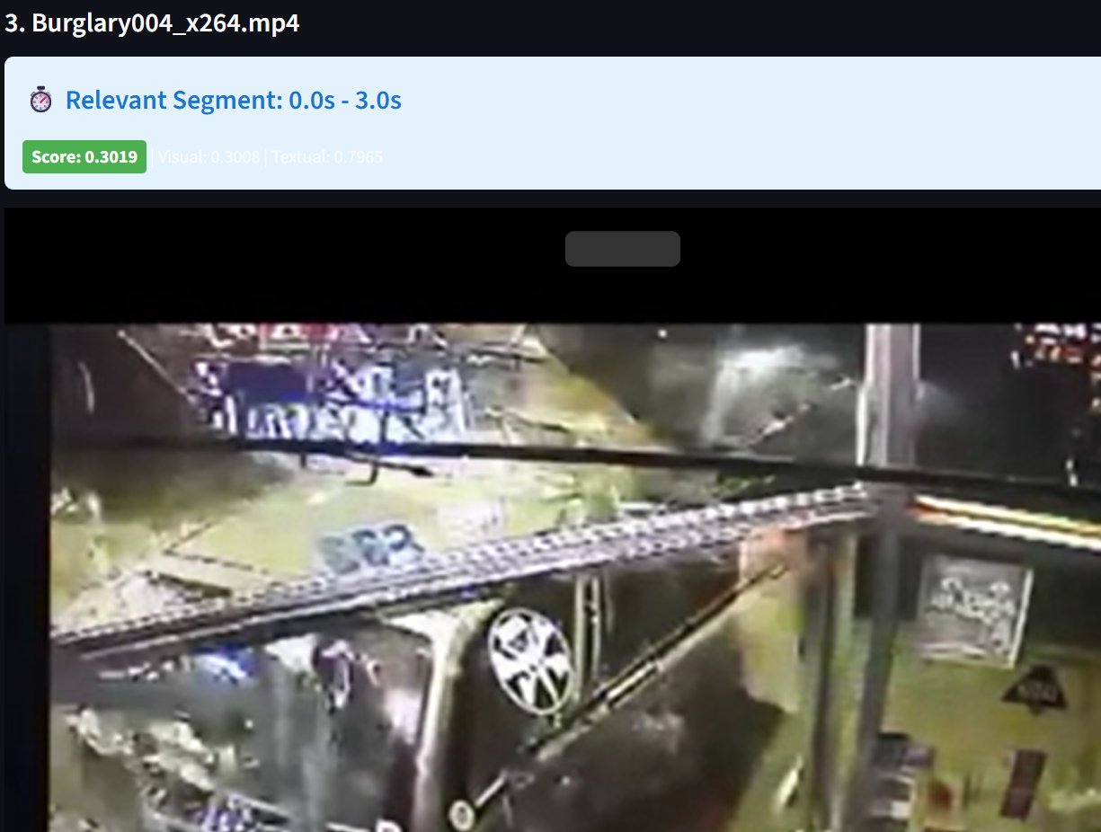
Figure 5.3 Rank 3 Retrieved Results

Few Image Query Examples

Figure 6.1 Cropped Image Query

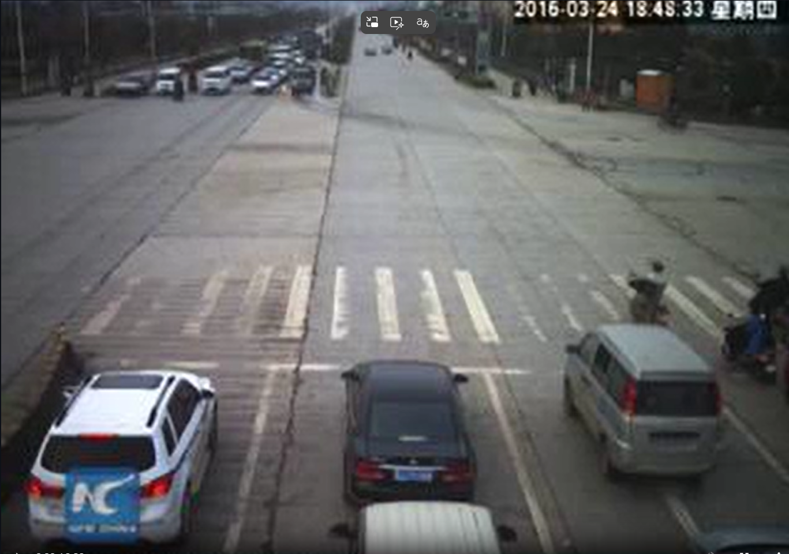
Figure 6.2 Retrieved Result


Figure 7.1 Cropped Image Query


Figure 7.2 Retrieved Result


Figure 8.1 Cropped Image Query


Figure 8.2 Retrieved Result

7.2 Retrieval Performance

We evaluate the proposed Video RAG system on 177 query–video pairs, measuring anomaly localization performance using hit@k, where a retrieval is considered correct if any of the top-k retrieved temporal segments overlaps with the ground-truth anomaly window. We compare a visual-only baseline against our proposed Video RAG system with Hierarchical Multimodal Evidence Selection Framework, which combines visual similarity, text-based reranking (BM25 + captions), and temporal aggregation.

Overall Performance
The proposed hierarchical reranking strategy significantly outperforms the visual-only baseline across all evaluation metrics:

Table 3: Hit Rate comparation Visual-only Video RAG vs Video RAG with HMESF

Hit Rate | Visual-only Video RAG | Video RAG with HMESF
hit@1 | 12 / 177 (6.8%) | 43 / 177 (24.3%)
hit@3 | 33 / 177 (18.6%) | 64 / 177 (36.2%)
hit@5 | 53 / 177 (29.9%) | 80 / 177 (45.2%)

At our primary operating point, hit@5 improves from 29.9% to 45.2%, a gain of 15.3 percentage points (≈1.5× relative). The gains are even more pronounced for stricter metrics: hit@1 increases from 6.8% to 24.3% (≈3.6×) and hit@3 from 18.6% to 36.2% (≈2.0×). These results indicate that the Hierarchical Multimodal Evidence Selection Framework not only retrieves the correct anomalous segment more often within the top-5 results but also pushes the correct evidence much higher in the ranking. This suggests that combining visual similarity with caption/BM25 evidence and temporal neighborhood aggregation is substantially more effective than a purely visual, single-stage retrieval baseline for anomaly localization in surveillance videos.

7.3 Generated Response Performance

We evaluate our Video RAG system with Hierarchical Multimodal Evidence Selection Framework on the SurveillanceVQA benchmark, which is specifically designed to test video understanding and reasoning in long, untrimmed surveillance footage.

To ensure a fair and consistent comparison, we evaluate 181 questions per category, resulting in a balanced test set across all models.
All models are evaluated using the same scoring protocol:
- Each response is graded on a 0–5 scale, following the official SurveillanceVQA evaluation guidelines.
- Final scores are reported as average scores per category.

Compared Models
We compare our approach against strong recent video–language models:

Table 4: Overview of Evaluated Open-Source Video Models and our Video RAG

Model | Description
LLaVA-NeXT-7B | Image-based VLM
LLaVA-OV-Qwen2-7B | Multimodal model with cross-modal transfer
LLaVA-Video-7B | Video-tuned LLaVA variant
VideoLLaMA3-7B | Video-first multimodal architecture
Video RAG (HMESF) | Retrieval-augmented framework with hierarchical multimodal reranking

Quantitative Results

Table 5: Performance of different vision-language models vs Video RAG with HMESF across QA tasks

Model | Description | Cause | Result
LLaVA-NeXT-7B | 2.11 | 1.96 | 1.65
LLavA-OV-Qwen2-7B | 2.54 | 1.46 | 1.55
LLaVA-Video-7B | 2.76 | 1.52 | 1.81
VideoLLaMA3-7B | 2.01 | 1.75 | 1.27
Our Video RAG | 2.65 | 2.84 | 2.61

Key Observations
  - Superior Performance on Reasoning-Heavy Queries
Our method achieves the highest overall score (2.61) among all evaluated models.
Notably:
- +0.80 improvement over the strongest baseline (LLaVA-Video-7B)
- +1.34 improvement over VideoLLaMA3 on Result-based questions
This demonstrates that retrieval and evidence selection are more critical than raw model capacity for surveillance-oriented reasoning tasks.

  - Significant Gains on “Result” Questions
The largest performance gains are observed in Result-type queries, which require understanding what happens after an event. This corresponds to a 57% relative improvement.
These questions demand:
- Temporal reasoning across multiple segments
- Causal inference
- Aggregation of distributed visual evidence
Our hierarchical pipeline explicitly addresses these challenges by:
- Retrieving relevant video segments
- Filtering noisy candidates
- Re-ranking based on multimodal consistency
In contrast, conventional VLMs rely on single-pass inference over sparse frames, which limits their reasoning capability.

  - Balanced Performance Across Categories
Unlike baseline models that perform well only in specific categories, our approach maintains consistently high performance across Description, Cause, and Result questions.
This indicates:
- Robust evidence selection
- Reduced hallucination
- Improved temporal grounding
- Better alignment between visual cues and generated answers
Such consistency is essential for real-world surveillance analysis, where query types vary significantly in complexity and intent.

8. Limitations

A key limitation of the proposed VideoRAG system arises from its reliance on fixed-length video segmentation and visual quality constraints inherent to surveillance footage. Videos are divided into uniform 3-second chunks, each represented by a single keyframe, which restricts the system’s ability to capture fine-grained temporal dynamics. As a result, short-duration or instantaneous events—such as sudden physical actions or rapid interactions—may be temporally blurred or partially missed. Additionally, the overall performance is sensitive to video quality. Surveillance footage often suffers from low resolution, motion blur, poor lighting, occlusions, and compression artifacts, which negatively affect CLIP-based embeddings and BLIP-generated captions. These degradations propagate through the retrieval and reasoning pipeline, leading to reduced retrieval accuracy and occasional misinterpretation of events. Together, coarse temporal granularity and variable video quality impose fundamental constraints on fine-grained understanding and precise event discrimination.

9. Conclusion

In this work, we presented a Video Retrieval-Augmented Generation (Video RAG) framework with a Hierarchical Multimodal Evidence Selection mechanism for effective reasoning over large-scale surveillance videos. Unlike conventional video–language models that rely on limited frame sampling or single-pass inference, our approach explicitly decomposes the problem into retrieval, filtering, and reasoning stages, enabling more accurate and interpretable analysis of long, untrimmed CCTV footage.
Through extensive experiments on the SurveillanceVQA benchmark, we demonstrated that our method significantly outperforms strong video-language baselines, achieving the highest overall scores across description, cause, and result-based queries. In particular, the substantial gains observed in result-oriented reasoning highlight the importance of structured temporal evidence selection over raw model capacity. These results validate our hypothesis that effective retrieval and multimodal grounding are essential for complex surveillance understanding tasks.
Beyond quantitative improvements, our system offers several practical advantages. The modular architecture allows scalable indexing of large video collections, supports incremental updates with new footage, and enables explainable retrieval through time-aligned evidence segments. By combining CLIP-based visual representations, caption-based semantic cues, and hierarchical re-ranking, the system provides a robust and extensible foundation for real-world surveillance analytics.
Overall, this work demonstrates that retrieval-centric design, rather than end-to-end black-box modelling, is a more effective paradigm for long-form video understanding. The proposed framework moves a step closer toward practical, explainable, and reliable AI-assisted video analytics systems that can support law enforcement, public safety, and large-scale video monitoring applications.

10. Ethical Considerations

The deployment of video-based retrieval and analysis systems raises important ethical and societal concerns that must be carefully addressed.
First, privacy and surveillance risks are inherent in CCTV-based systems. Although this project operates on pre-recorded datasets, real-world deployment must ensure strict access control, anonymization where possible, and compliance with data protection regulations. The system should not be used for indiscriminate monitoring or profiling of individuals.
Second, model bias and fairness remain critical challenges. The underlying models (CLIP, BLIP, LLaVA) are trained on large-scale web data that may encode social or cultural biases. These biases can propagate into surveillance interpretations, potentially leading to incorrect or unfair conclusions about human behavior. Regular auditing and dataset diversification are essential to mitigate such risks.
Third, hallucination and overconfidence pose operational risks. Even with correct retrieval, the language model may generate plausible but incorrect explanations. For safety-critical applications such as law enforcement, the system should be treated as a decision-support tool rather than an authoritative source, with human verification always required.
Finally, responsible deployment practices are essential. Clear usage policies, transparency about system limitations, and human-in-the-loop validation should be mandatory to prevent misuse and ensure ethical application of VideoRAG in real-world settings.

References
1. Research Papers & Articles
- Radford, A., et al. Learning Transferable Visual Models From Natural Language Supervision. OpenAI, 2021.
- Li, J., et al. BLIP: Bootstrapping Language-Image Pre-training for Unified Vision-Language Understanding and Generation. ICML, 2022.
- Liu, H., et al. LLaVA: Large Language and Vision Assistant., 2023.
- Jeong, M., Kim, S., Kim, J., Yoon, S., & Park, C. VideoRAG: Retrieval-Augmented Generation over Video Corpus. arXiv preprint arXiv:2501.05874, 2025.
- Ren, J., Wang, F., Zhang, L., & Zhao, S. VideoRAG: Retrieval-Augmented Generation with Extreme Long-Context Videos. arXiv preprint arXiv:2502.01549, 2025.
- Zhou, Y., Chen, X., Wang, L., & Tan, M. E-VRAG: Enhancing Long Video Understanding with Efficient Retrieval-Augmented Generation, 2025
- Jeong, J., et al. Hierarchical Retrieval for Long-Context Video QA. CVPR, 2025.
- Wu, J., et al. VadCLIP: Adapting CLIP for Weakly Supervised Video Anomaly Detection. CVPR, 2023.
- Sultani, W., et al. Real-World Anomaly Detection in Surveillance Videos. CVPR, 2018.
- Bo L., P., et al. SurveillanceVQA-589K: A Benchmark for Comprehensive Surveillance Video-Language Understanding with Large Models. 2024.

2. Tools & APIs
- CLIP (OpenAI)-Used for visual–text embedding generation and similarity matching.
- BLIP - Used for generating semantic captions from video keyframes.
- LLaVA (Large Language and Vision Assistant) - Used for multimodal reasoning and answer generation.
- FAISS (Facebook AI Similarity Search) - Used for efficient vector indexing and nearest-neighbor retrieval.
- YOLOv8 (Ultralytics) - Used for object detection to enrich visual understanding.
- Ollama - Used to host and serve LLaVA models locally for inference.
- FFmpeg & OpenCV - Used for video decoding, frame extraction, and preprocessing.
- Streamlit - Used to develop the interactive web-based interface.

3. Datasets & Benchmark Sources
- UCF-Crime Dataset
University of Central Florida
— Large-scale surveillance dataset with 13 anomaly categories including fighting, robbery, accident, and shooting.
- SurveillanceVQA Dataset
— Used for evaluating video question answering and reasoning over surveillance videos.
— Contains long untrimmed videos with temporal annotations for abnormal events.

BIRLA INSTITUTE OF TECHNOLOGY & SCIENCE, PILANI

STUDENT ID No. | 2023ad05022
NAME OF THE STUDENT | Mehul Jain
STUDENT'S EMAIL ADDRESS | 2023ad05022@wilp.bits-pilani.ac.in
STUDENT’S EMPLOYING ORGANIZATION & LOCATION | Microsoft, Hyderabad (Remote)
SUPERVISOR’S NAME | Karthikeyan Dhanakotti
SUPERVISOR’S EMPLOYING ORGANIZATION & LOCATION | Microsoft, Hyderabad
SUPERVISOR’S EMAIL ADDRESS | kartdh@microsoft.com
ADDITIONAL EXAMINAER’S NAME | Diljeet Sethi
ADDITIONAL EXAMINER’S EMPLOYING ORGANIZATION & LOCATION | Microsoft, Hyderabad (Remote)
ADDITIONAL EXAMINER’S EMAIL ADDRESS | diljeetsethi@microsoft.com
DISSERTATION / PROJECT / PROJECT WORK TITLE | RAG FRAMEWORK FOR EFFICIENT VIDEO QUERY AND UNDERSTANDING

Supervisor’s Rating of the Technical Quality of this Dissertation Outline
EXCELLENT / GOOD / FAIR/ POOR (Please specify): Excellent

Additional Examiner’s Rating of the Technical Quality of this Dissertation Outline
EXCELLENT / GOOD / FAIR/ POOR (Please specify): Excellent

 |  | 
Signature of Student | Signature of Supervisor | Signature of Additional Examiner
Name: Mehul Jain | Name: Karthikeyan Dhanakotti | Name: Diljeet Sethi
Date: 30th Jan 2026 | Date: 30th Jan 2026 | Date: 30th Jan 2026

