Dissertation / Project / Project Work Title:
RAG FRAMEWORK FOR EFFICIENT VIDEO QUERY AND UNDERSTANDING

Course No.: S1-25_AIMLCZG628T

Course Title: Dissertation

Dissertation / Project /Project Work Done by:

Student Name: Mehul Jain

BITS ID: 2023ad05022

Degree Program: M.tech AI/ML

Research Area: Information Retrieval

Dissertation / Project Work carried out at:

Microsoft, Hyderabad (Remote)



BIRLA INSTITUTE OF TECHNOLOGY & SCIENCE, PILANI
VIDYA VIHAR, PILANI, RAJASTHAN - 333031

November - 2025
Contents

1. Broad Area of Work 3
2. Background 3
3. Objectives 3
4. Scope of Work 4
5. Plan of Work 4
6. Literature References 6
7. Particulars of the Supervisor and Examiner 6
8. Remarks of the Supervisor 7

Broad Area of Work
This dissertation is centered around Information Retrieval, emphasizing the integration of Retrieval-Augmented Generation (RAG) with Artificial Intelligence (AI) for multimodal data processing, particularly focusing on video-based query understanding and retrieval.
The work explores the convergence of recent advancements in AI, information extraction, and retrieval methodologies. Emerging domains such as conversational systems and intelligent chatbots within Information Science are also considered relevant contexts for this study.
The primary application domains include:
- Natural Language Processing (NLP): To interpret and extract relevant information from user-generated queries.
- Computer Vision (CV): To interpret and extract relevant information from video corpus.
- Knowledge Representation: To organize retrieved information within structured repositories such as vector databases for efficient access and reasoning.
- Automated Reasoning: To synthesize insights from both retrieved and stored data, enabling the system to generate meaningful, context-aware responses.

Background
Modern surveillance systems generate an overwhelming amount of video every day, and organizations often struggle to sift through hours of footage just to find moments that actually matter—like an accident, a theft, or any unusual activity. Although deep learning has boosted the accuracy of video analysis, most existing methods still operate at a very surface level. They classify individual frames spotting objects or simple actions but missing the bigger picture or the true meaning behind events. Some newer techniques use CLIP features for similarity search, yet these models are not built for noisy, low-quality CCTV feeds and frequently return mismatched or unreliable results.
Because of these limitations, current systems still fall short when it comes to retrieving precise and meaningful video segments. Users often end up with a list of loosely relevant clips and must manually sort through them—defeating the purpose of automation. A key reason for this problem is the lack of a strong re-ranking layer that can intelligently refine the initial retrieval results. Without it, false positives slip through easily, especially in long recordings where scenes are repetitive, cluttered, or poorly lit.
This project aims to bridge that gap by building a smarter, context-aware video retrieval system centered around a Hierarchical (Local + Global) re-ranking framework.
- The Local component re-evaluates the initial candidates using fine-grained semantic signals, improving the quality of the top results.
- The Global component looks at the bigger temporal and contextual picture, ensuring the final ranked list is coherent, consistent, and free from isolated false positives.
By combining pretrained vision-language models with this two-step re-ranking strategy, the system is designed to deliver far more accurate and trustworthy search results from long CCTV recordings—addressing a major shortcoming in today’s video retrieval technologies.

Objectives
The objectives of my project are as follows:

- Conceptual Understanding: To explore the current landscape of conversational systems and identify the growing need for intelligent, context-aware search agents capable of handling complex user queries.
- Design: To design an intelligent system that functions as an intermediary between the user and information repositories such as video corpora, thereby improving the efficiency of information retrieval.
- Development: To develop a conversational search agent that assists users in formulating and refining queries, enabling faster and more accurate retrieval of relevant results from video data sources.
- Core RAG Implementation: To implement a Retrieval-Augmented Generation (RAG) framework that dynamically retrieves relevant video segments—keyframes and temporal portions—and employs vision-language models and text extraction methods to produce concise, contextually meaningful outputs.
- Validation and Evaluation: To validate the system’s performance through user evaluation and feedback, assessing the effectiveness and usability of the prototype as defined in the research methodology.

Scope of Work
The scope of this dissertation encompasses the design and implementation of a Retrieval-Augmented Generation framework that serves as a conversational search agent for video data retrieval and understanding.
The project focuses on developing an intelligent system capable of:
- Processing natural language queries from users to interpret intent and context.
- Searching video repositories by identifying relevant keyframes and temporal segments that align with the user’s query.
- Employing a multimodal retrieval strategy that integrates both visual and textual information to enhance accuracy and relevance.
- Applying vision-language models and text extraction techniques to the retrieved video segments to generate concise, context-aware, and human-understandable responses.
This work aims to bridge the gap between raw video content and meaningful information retrieval, offering a scalable and adaptable framework for intelligent video understanding.

Plan of Work

Phases | Start Date-End Date | Work to be done
Dissertation Outline | 01 Nov 2025 - 09 Nov 2025 | Literature Review and prepare Dissertation Outline
Design & Development | 10 Nov 2025 - 31 Dec 2025 | Design & Development Activity
Testing | 1 Jan 2026 - 31 Jan 2026 | Software Testing, Evaluation & Conclusion
Dissertation Review | 1 Feb 2025 - 3 Feb 2026 | Submit Dissertation to Supervisor & Additional Examiner for review and feedback
Submission | 6 Feb 2026 - 16 Feb 2026 | Final Review and submission of Dissertation

Literature References

The literature review focuses on the state-of-the-art in the new domain of Conversational Information Retrieval. The following are referred research papers/journals from the preliminary literature review:
- Jeong, M., Kim, S., Kim, J., Yoon, S., & Park, C. VideoRAG: Retrieval-Augmented Generation over Video Corpus. arXiv preprint arXiv:2501.05874, January 2025.
- Ren, J., Wang, F., Zhang, L., & Zhao, S. VideoRAG: Retrieval-Augmented Generation with Extreme Long-Context Videos. arXiv preprint arXiv:2502.01549, February 2025.
- Zhou, Y., Chen, X., Wang, L., & Tan, M. E-VRAG: Enhancing Long Video Understanding with Efficient Retrieval-Augmented Generation. arXiv preprint arXiv:2508.01546, August 2025.
- Arefeen, S., et al. ViTA: An Efficient Video-to-Text Algorithm using VLM for RAG-based Video Corpus Understanding. Proceedings of CVPR 2024 Workshop on Multimodal AI Research (MAR), 2024.
- Zeng, X., Luo, J., & Zhang, Z. SceneRAG: Scene-level Retrieval-Augmented Generation. arXiv preprint arXiv:2506.07600, June 2025.
- Yuanhan Z., Jinming Wu, Wei Li, Bo Li, Zejun Ma, Ziwei Liu, Chunyuan Li: LLaVA-Video: Video Instruction Tuning with Synthetic Data. arXiv preprint arXiv: 2410.02713, Oct 2024
- Junnan Li, Dongxu Li, Silvio Savarese, Steven Hoi: BLIP-2: Bootstrapping Language-Image Pre-training with Frozen Image Encoders and Large Language Models. arXiv preprint arXiv: 2301.12597, Jan 2023

Particulars of the Supervisor and Examiner

 | Supervisor | Additional Examiner
Name | Karthikeyan Dhanakotti | Diljeet Sethi
Qualification | Bachelor's of Engineering in Computer Science | Bachelor of Technology in Computer Science & Engineering
Designation | Senior Software Engineer | Senior Software Engineer,
Employing Organization and Location | Microsoft, Hyderabad | Microsoft, Hyderabad
Phone No.(with STD Code) | 9986006013 | 9711373406
Email Address | kartdh@microsoft.com | diljeetsethi@microsoft.com

Remarks of the Supervisor

The proposed study and project demonstrate strong potential and academic rigor. The student has conducted a comprehensive literature review covering all relevant areas of research. The chosen topic, focusing on Retrieval-Augmented Generation (RAG) and video-based query understanding, aligns well with current advancements in the field of Information Science and is well-suited for a master’s-level dissertation.
The project’s expected outcomes are both innovative and relevant to the evolving landscape of intelligent information retrieval. The inclusion of a user study for validating the working prototype further strengthens the credibility and applicability of the research. Additionally, the work shows clear potential for future publication in reputed venues.
Having closely supervised Mehul throughout the project, I can confirm that he possesses the necessary skills and research aptitude to successfully implement the proposed framework within a standard research paradigm. I therefore approve the project for submission and evaluation.

Information about the Supervisor:

BIRLA INSTITUTE OF TECHNOLOGY & SCIENCE, PILANI
WORK INTEGRATED LEARNING PROGRAMMES (WILP) DIVISION
SECOND SEMESTER OF ACADEMIC YEAR 2021-2022

(INSERT COURSE NUMBER HERE) : (INSERT COURSE TITLE HERE) OUTLINE

STUDENT ID No. | 2023ad05022
NAME OF THE STUDENT | Mehul Jain
STUDENT'S EMAIL ADDRESS | 2023ad05022@wilp.bits-pilani.ac.in
STUDENT’S EMPLOYING ORGANIZATION & LOCATION | Microsoft, Hyderabad (Remote)
SUPERVISOR’S NAME | Karthikeyan Dhanakotti
SUPERVISOR’S EMPLOYING ORGANIZATION & LOCATION | Microsoft, Hyderabad
SUPERVISOR’S EMAIL ADDRESS | kartdh@microsoft.com
ADDITIONAL EXAMINAER’S NAME | Diljeet Sethi
ADDITIONAL EXAMINER’S EMPLOYING ORGANIZATION & LOCATION | Microsoft, Hyderabad (Remote)
ADDITIONAL EXAMINER’S EMAIL ADDRESS | diljeetsethi@microsoft.com
DISSERTATION / PROJECT / PROJECT WORK TITLE | RAG FRAMEWORK FOR EFFICIENT VIDEO QUERY AND UNDERSTANDING

Please prepare the outline as a separate document with the following sections along with the above identification information.
1. Cover Page with Student ID No., Name, Course Number, Course Title and Dissertation / Project / Project Work Title, Broad Academic Area of Work.
2. Background (Relevance of the Project to the current work environment in the employing organization)
3. Objectives
4. Scope of Work (To be done by the student independently)
5. Plan of Work (Work to be done during the semester)
6. Literature References
7. Particulars of the Supervisor and Additional Examiner
8. Remarks of the Supervisor

 | 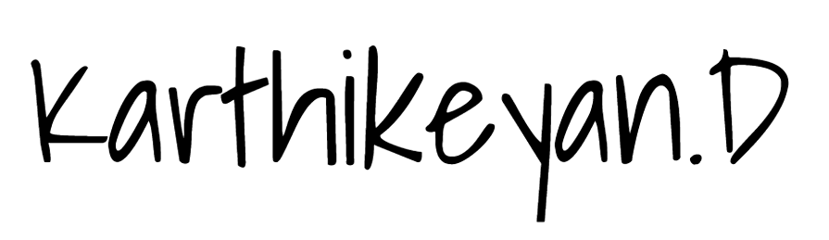 | 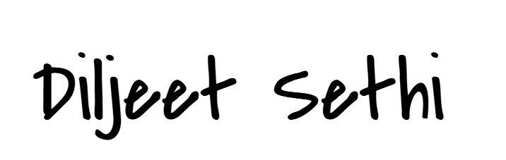
Signature of Student | Signature of Supervisor | Signature of Additional Examiner
Name: Mehul Jain | Name: Karthikeyan Dhanakotti | Name: Diljeet Sethi

