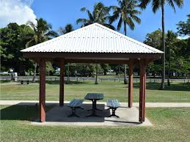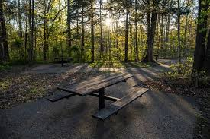

**Title**: Exploring Public picnic Setting Locations in Melbourne

**Members**: Jalaj Sharma, Sandeep Sumithran, Owen Johannes, Kirandeep,Tattwamasi Ray

**Project Description**: The project aims to develop a user-friendly application that assists Residents and visitors in finding public seating locations throughout the city of Melbourne. The project will leverage available data sources such as Municipal records, Park databases to compile a comprehensive database of public seating locations across Melbourne. Users of this application will have a access to a map interface that visually displays the public seating locations throughout the city. The map will be interactive, allowing users to Zoom in and explore different areas of Melbourne.

**Research Questions to Answer**:

1. The dataset contains at least 100 unique records.
2. A database is used to house the data SQLite.
3. The project is powered by a Python Flask API and includes HTML/CSS, JavaScript, and the chosen database.
4. A JavaScript library not shown in class is used in the project.
5. Multiple user-driven interactions (such as dropdowns, filters, or a zoom feature) are included on the final page.

**Datasets to be used**: <https://discover.data.vic.gov.au/dataset/public-picnic-setting-locations>

<https://yo3dxhxhsj.execute-api.ap-southeast-2.amazonaws.com/prod/tattwamasi-project>

**Rough Breakdown of Tasks**:

1. Create a project repository.
2. Find API Geojson data points and datasets. Assign a person to each question.
3. Work out which visualizations to use.
4. Create the visualizations
5. Conclusion
6. Pretty presentation!