Proposal
For
Record Room Management & Digitization
(Software Solution, Digitization and Implementation)
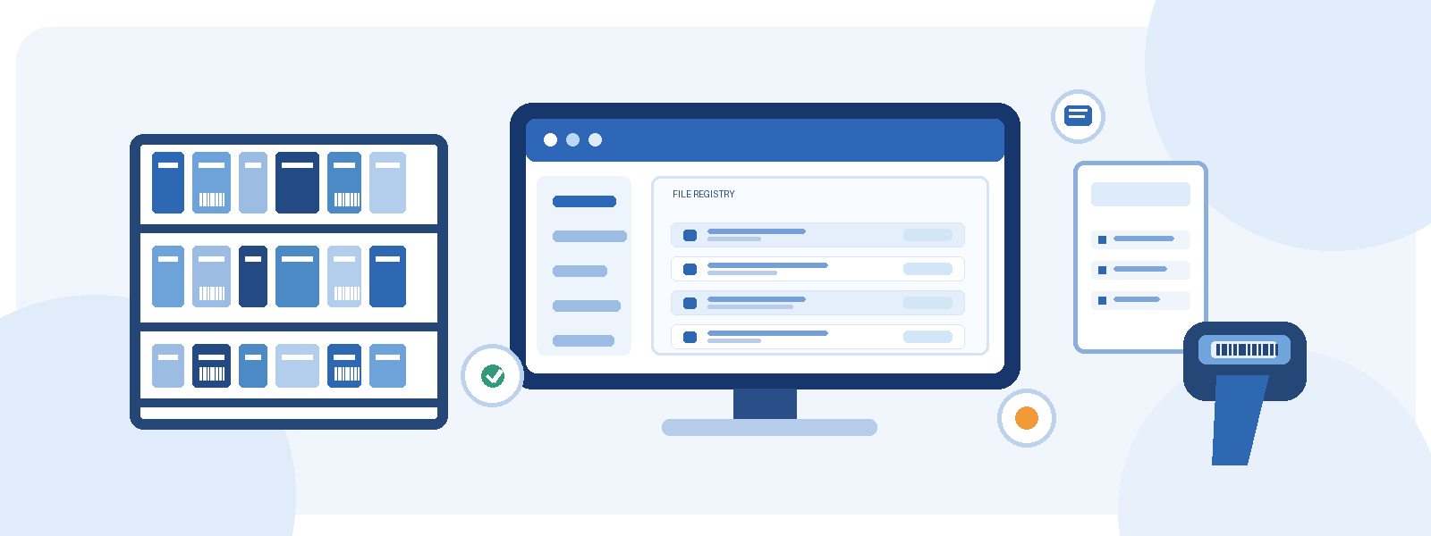

Understanding of the Requirement
Record rooms hold the files on which day-to-day administration depends. Over the years these files grow in number, get older and pass through many hands. Locating a particular file takes time, it is not always clear who is holding it, and the older papers suffer a little more each time they are handled. Large-format drawings and bulky volumes add to the difficulty, and requests for copies or information often wait on a manual search.
We understand that the department wishes to deal with this in two connected steps. First, the physical record room has to be brought under a structured and traceable system, so that every file has a known identity, a known location and a known custodian. Second, the records have to be digitized, uploaded to e-office and made available for reference without disturbing the originals.
Done well, this gives the department the following:
- Quick answers to queries from officials and other authorized users.
- Access to old and fragile documents without handling or damaging them.
- Relief from pressure on physical storage space.
- Fast retrieval of a document, regardless of the size of the archive.
- A reliable, searchable digital record that stays linked to its physical file.
Our proposal is built around this understanding. It brings together a robust software system, careful physical handling of records and a controlled digitization process, all delivered with training and support so that the department can run the system on its own.

Proposed Solution
We propose a robust and integrated Record Room Management and Digitization Solution. It combines a web-based software application with the physical organization of records, barcode tagging, document digitization, metadata entry, quality verification, training and the allied implementation services needed to put it all into regular use.
The aim is a single, systematic method of managing physical records and their digital counterparts. The department will be able to maintain an organized record registry, know the exact storage location of every file, control how files are issued and returned, and track every movement. Records will be digitized, uploaded to e-office, and a reference copy will be retained within the application. Authorized users will reach the system through a secure web login.
The solution is designed to meet the following requirements:
- A unified and organized record management system across the department.
- Simple identification, search and retrieval of physical files and archived records.
- Mapping of every physical file to its room, section, almirah and shelf.
- Barcode-based identification and tracking of files and storage locations.
- Proper records of file issue, return, relocation and other movements.
- Digitization of physical records, with each resulting document linked to its file record.
- Controlled access for authorized personnel to file details and digital documents.
- Upload of digitized documents to e-office, with a reference copy retained in the application.
- Reports on record availability, location occupancy, file movements, digitization progress and overdue files.
- Training, implementation assistance and operational support for smooth adoption.
- A Document Management System (DMS) for the digital archive, with role-based access control, secure storage, search functionality and audit trails.

Why Our System
The software is not a generic tool adapted to a record room. It has been built around the way record rooms actually work, and it is designed to stay dependable as the registry and the number of users grow. Its main strengths are these.
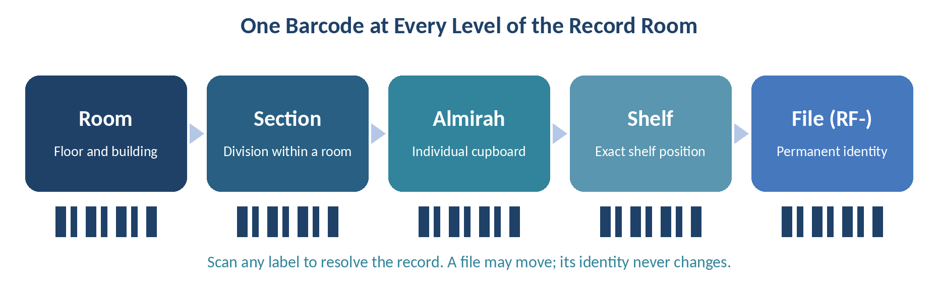
A permanent identity for every file. Each file receives a permanent RF- barcode that never changes, even when the file is moved to another shelf or room. Only the location is updated, and the change is recorded with a reason.
Locations that mirror the real room. The Room, Section, Almirah and Shelf hierarchy follows the physical layout, and a floor-layout canvas lets the department see and revise it. Scanning the barcode of a file, shelf, almirah, section or room takes the user straight to the right record.
Accountability at every step. Issues, returns and relocations are written to an append-only movement log, with before and after audit records and login history. Nothing is silently overwritten.
Digitization under control. Work is organized in employee-scoped batches with page versioning, approval or rejection of each page or batch, recorded rejection reasons and detection of duplicate pages.
Built for large registries. Server-side paging keeps search fast on big collections, and bulk CSV import validates every row before anything is committed, so errors are caught early.
Live visibility. The dashboard and live activity feed show registry size, mapped records, issued and overdue files, pending approvals and digitization progress as work happens.
Secure by design. Role-based access with a capability matrix, token-based sign-in and PBKDF2 password protection keep access limited to the people who should have it.
Flexible deployment. The platform can run on an in-memory data source or on a .NET 10 API data source, depending on the deployment model agreed with the department.

Scope of Work

Record Room Management Software
- Web login for authorized users, with four roles: Admin, Supervisor, Operator and Employee.
- A capability matrix that decides what each role may do, along with audit stamps, login history and account controls.
- A dashboard showing registry size, percentage of files mapped, files issued, files due today, digitization percentage, overdue files, rooms, borrowers and pending approvals.
- Location hierarchy of Room, Section, Almirah and Shelf, supported by a floor-layout canvas, layout revisions, safeguards that protect the hierarchy and an area and pincode lookup.
- A file registry in which the RF- barcode is the permanent identity of the file while its location can change.
- Issue and return with multi-file receipts, partial returns, a borrower ledger, due dates and overdue tracking.
- Movement and audit records: an append-only log, per-file history, a live feed, before and after audit and CSV export.
- Barcodes and scanning: Code 128 labels and QR stickers, scan-based lookup of a file, shelf, almirah, section, room or area, and a queue for label print jobs.
- Reports on issue, return, movement, registry, digitization progress, login history, location occupancy and overdue files, with on-screen viewing and CSV export.
- Administration of users, employees, locations, imports, map uploads, media links and audit, all controlled by permissions.
- Upload of digitized documents to e-office, with a reference copy retained in the application.

Physical Record Organization and Digitization
- Receiving, counting and secure handover of physical files from the department, with the handover recorded.
- Organization of physical files and storage units, and barcode tagging of both.
- Data entry of file details and identifiers, mapped to barcodes and storage locations.
- Preparation of documents for scanning, including unbinding where required, removal of staples and pins, dusting, and flattening of creases so that pages feed smoothly through the scanner.
- Scanning of the agreed document sizes (A4/Legal, A3 and A0/A1/A2), per page per side.
- High-resolution scanning at a minimum of 200–300 DPI, with output in PDF/A format that is legible, properly aligned and cropped.
- Image enhancement, including de-skewing and despeckling, wherever needed.
- Quality verification, with correction or rescanning wherever required.
- Optical Character Recognition (OCR) to make the digitized documents searchable.
- Metadata creation and indexing on the fields finalized with the department, such as file number, date, subject and department, entered into the database for easy retrieval.
- Association of each digitized document with its file registry entry.
- Upload to e-office, with a reference copy stored in the application.
- Rebinding of physical records in their original order after scanning, and their secure return to the designated custodian or storage area, with the department’s sign-off.
- Preparation and handover of the agreed digital deliverables and supporting data in the approved format, with the department’s sign-off on the digital handover.

Document Management System (DMS) Implementation
- Providing, configuring or integrating the digitized files into a Document Management System.
- Role-based access control, so that each user sees and does only what the assigned role permits.
- Secure storage of the digital archive, with a reference copy retained in the application.
- Search functionality across the indexed metadata and the OCR text of digitized documents.
- Audit trails that record who accessed, changed or uploaded a document, and when.

Implementation, Training and Support
- Requirement finalization, configuration, deployment and operational setup.
- Coordination with the department on location mapping, file identification rules, metadata fields and reporting needs.
- Training of administrators, supervisors, operators and departmental users.
- Support for hosting, hardware and IT infrastructure procurement, where this is included in the approved scope.
- Operational support and maintenance for the service period and on the conditions agreed in the final proposal.

Solution Details

How the System Will Work
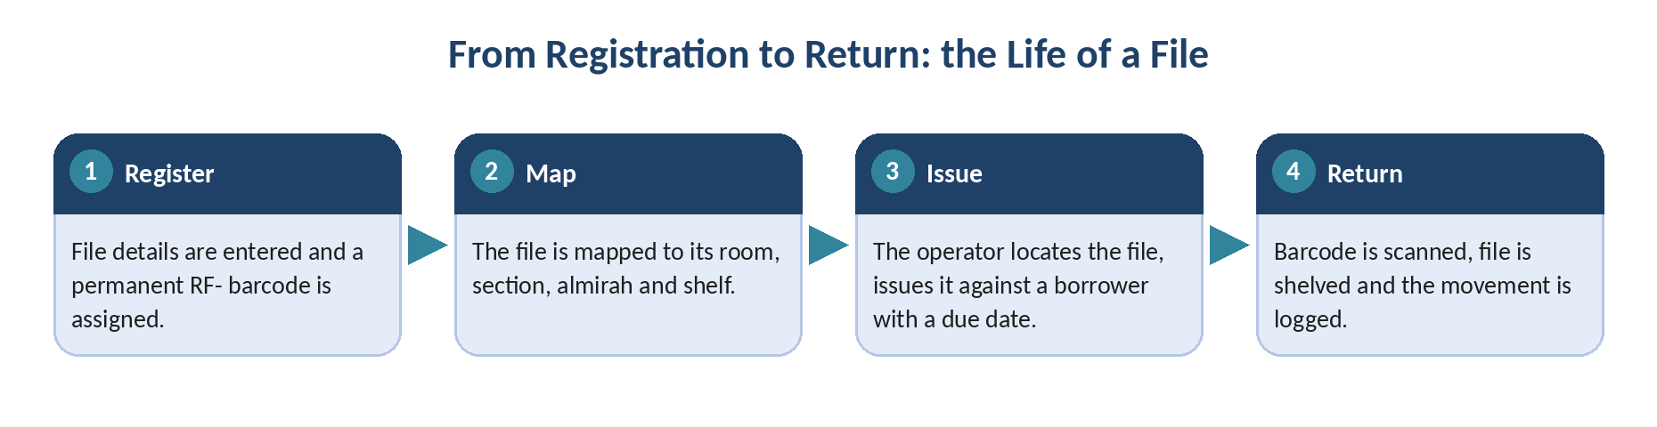

File registration and storage mapping
The process begins with identifying and registering the physical files. The required details of each file are entered into the system, and a unique record identifier and barcode are assigned. The file is then mapped to its room, section, almirah and shelf. The storage units themselves also carry barcode labels and are recorded in the location hierarchy.
Once registration and mapping are complete, an authorized user can find a file by its registered details or its barcode and see where it is kept. If a file is relocated, only its location is updated. Its permanent identity stays the same and the relocation is recorded for traceability.

Issuing and searching for a file
When an official needs a physical file, the record room operator finds it through the application. The system shows the file details, its storage location and its current status. The operator takes the file from its location and records the issue against the borrower. Several files can be issued on a single receipt, and borrower details and due dates are recorded wherever required.

Returning files to the record room
When a file comes back, the operator confirms its identity by scanning the barcode and updates its status. The system helps the operator find the right place for it. The return is completed once the file has been placed in that location and, where the configured process requires it, the location barcode has been scanned. If a receipt covers several files, they can be returned separately, and the receipt is closed only when every file on it has been returned.
Issue, return and relocation activities are all entered in the file movement history. The borrower ledger lets authorized personnel review files that are still outstanding and returns that are overdue.

Digitization and verification
Physical records are processed in batches, and the scanned pages are linked to the relevant file records. Quality checks cover legibility, image quality, page sequence and completeness. Pages or batches that need correction are sent back for action, and the reason for rejection is recorded. Metadata creation and indexing are completed on the fields finalized with the department.
After these checks, records go to the department for verification and acceptance under the agreed workflow. If a page has to be scanned again, its version history is kept. Approved documents are uploaded to e-office, and a reference copy is stored in the application.

Reports and monitoring
Authorized personnel can use the dashboard and reports to review file availability, issued and overdue records, location occupancy, movement history and digitization progress. Outstanding tasks, pending approvals and operational exceptions are easy to spot, which helps the department keep control over both its physical records and its digital documents.

Digitization Standards and Deliverables
Digitization is carried out to defined standards so that the output is consistent and usable. The working practice we propose is as follows, subject to final confirmation with the department.
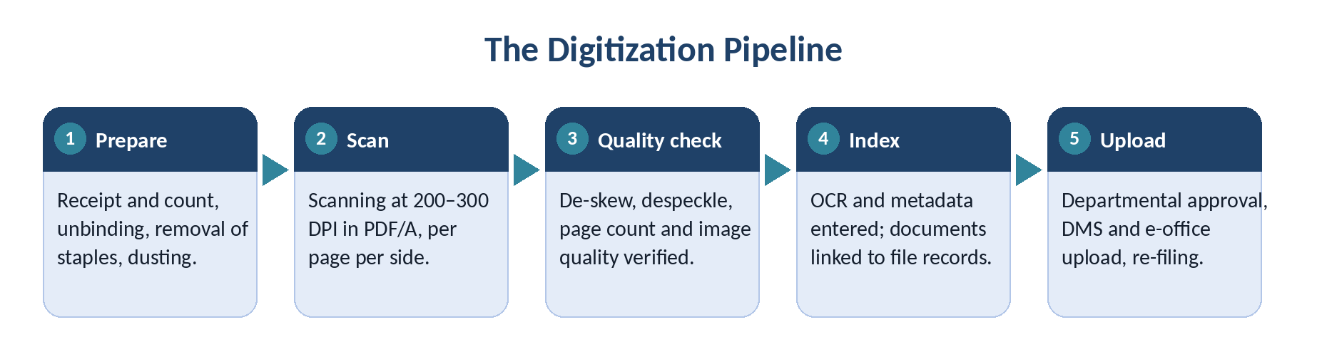
Document preparation. Files are received from the department in counted numbers and taken over under a secure handover record. Where required, documents are unbound or unstitched, staples and pins are removed, pages are fanned and cleaned of dust, and creased pages are flattened so that they feed smoothly.
Scanning. Records are scanned at a minimum of 200–300 DPI in black and white, grey or colour, using scanners suited to the document size. Pages that are not legible at this resolution are rescanned at 300 or 600 DPI or higher, at no additional charge. Completely blank pages are not scanned, and no page is scanned more than once unless a correction is needed.
Image enhancement. Images are de-skewed, despeckled, cropped and cleaned, with even margins around the text, so that each page is legible, properly aligned and reads clearly.
Quality control. Every batch is reconciled so that the number of images matches the number of pages. Missing images are inserted and the sequence is corrected electronically. Scan quality is checked and poor images are rescanned.
Indexing and metadata. Each document is indexed and linked to the data entered for its file. Metadata is created on the fields finalized with the department, such as file number, date, subject and department, and the language of each record is captured. The metadata is entered into a database so that records can be retrieved easily. A random final check is carried out before the batch goes to the department.
Output formats. For every record we will store and deliver a raw image (lossless PDF/A), a master image (cleaned, lossless PDF/A) and a web image (cleaned, compressed PDF/A). Optical Character Recognition (OCR) is applied so that the digitized documents are searchable, with the best results on printed English text. Files are named in the convention decided with the department.
Departmental verification. The department checks the batches and raises any issue within the agreed review period. We suggest 24 hours from handover of a batch, and any page found faulty in that time will be rescanned.
Documents unfit for scanning. Any document that cannot be scanned safely will be noted and discussed with the department authority before further action is taken.
After scanning. Physical records are rebound and put back in the exact order in which they were received, and are marked to show that they have been scanned. They are then securely returned to the designated custodian or storage area, and the department’s sign-off is obtained for the physical return and for the digital handover.
Storage, upload and backup. Once a lot has been completed and checked, its documents are uploaded to e-office. Digitized data is held on the agreed local server, web server or hard disk. A complete set of the data is also handed over to the department on an external hard disk for disaster recovery.
Document Management System. The digitized files are configured in a Document Management System with role-based access control, secure storage, search on metadata and OCR text, and audit trails, so that the digital archive stays controlled, searchable and traceable.
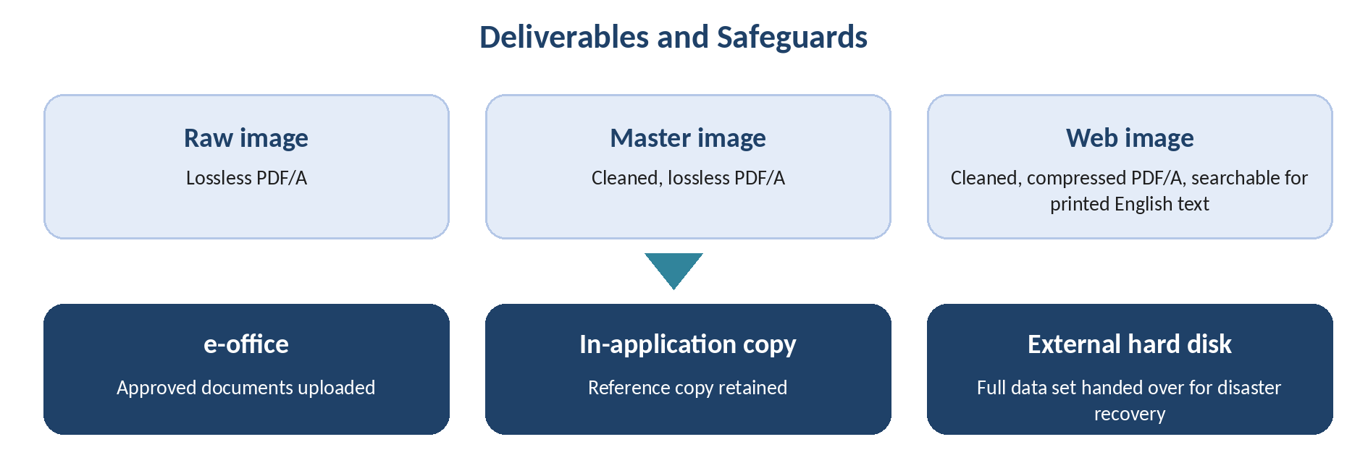

Execution Plan
The project will be carried out in coordinated phases, so that the software and the digitization work are established in a controlled manner.
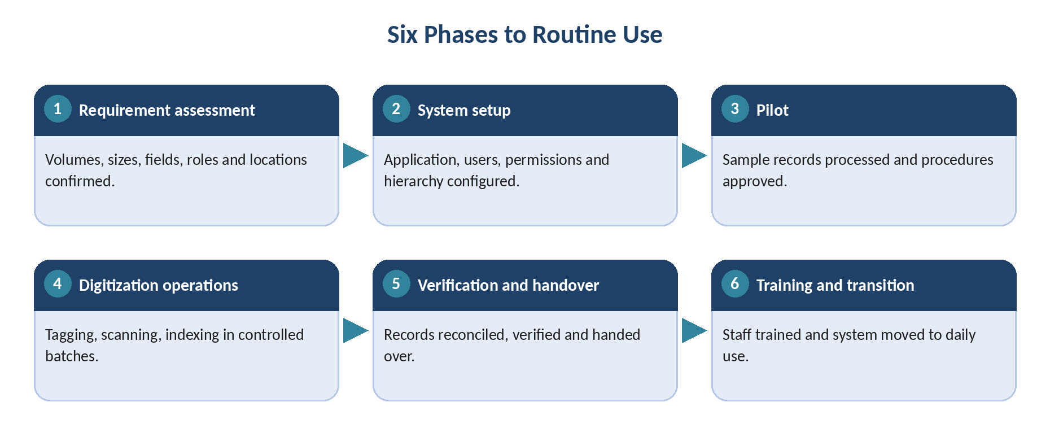
Phase 1. Requirement assessment: Confirm the department’s requirements, record and page volumes, document sizes, metadata fields, user roles, locations and reporting formats.
Phase 2. System setup: Configure the application, users, permissions, location hierarchy, file registration rules and reporting requirements.
Phase 3. Pilot implementation: Process an agreed sample of records, verify barcode mapping, test the issue and return workflows, and obtain approval of the digitization and quality-check procedure.
Phase 4. Digitization operations: Carry out physical record organization, barcode tagging, scanning, indexing and metadata entry in controlled batches.
Phase 5. Quality verification and handover: Reconcile file and page records, correct any discrepancies, obtain departmental verification, prepare the agreed data handover and obtain the department’s sign-off on the digital handover.
Phase 6. Training and operational transition: Train the designated personnel, provide operating instructions and move the system into routine departmental use.
We propose to complete the project in an indicative timeline of six months. The final schedule will depend on the confirmed file and page volumes, the number of scanning locations, the availability of staff and infrastructure, the physical condition of the records, the daily scanning capacity and how quickly the department can verify batches. The operational support period will be specified separately in the final agreement.

Technology, Security and Data Protection
The platform is built on proven, widely used technology, chosen for reliability and for ease of long-term support.
- Sign-in is token-based (JWT), and passwords are protected with PBKDF2 hashing.
- Access is governed by roles and a capability matrix, so users see and do only what their role allows.
- Audit stamps, before and after audit records and login history make it possible to trace system activity.
- Real-time updates through SignalR keep the dashboard and activity feed current.
- Background jobs through Hangfire handle long-running work such as imports and label printing, without slowing down users.
- Redis can optionally be used where faster response is needed on larger deployments.
- The data source can be in-memory or the .NET 10 API, depending on the agreed deployment model.
- Digitized data is backed up, and a complete copy is handed over to the department on an external hard disk.

Benefits of Record Room Management
1. Improved record organization. A structured location hierarchy and a central file registry keep an orderly inventory of physical records and their storage positions.
2. Easier retrieval. Authorized users can find files through registered details, barcodes and storage locations, which reduces dependence on manual registers and repeated physical searches.
3. Better control over file movements. Issue, return and movement records show who holds a file, its current status and which files are outstanding.
4. Protection of physical records. Digitized copies allow document content to be consulted without handling the original every time.
5. Improved monitoring and reporting. Dashboards and reports give visibility into registry size, location occupancy, issued files, overdue records and digitization progress.
6. Consistent digitization records. Batch processing, metadata entry, version history and quality verification keep a clear link between each physical file and its digital copy.
7. Access control and accountability. Role-based permissions, account controls and audit records manage access and make recorded activity traceable.
8. Operational continuity. Defined workflows, staff training and documented procedures give the department repeatable processes for registration, handling, digitization, verification and retrieval.
9. E-office access. Approved digitized documents are uploaded to e-office, and a reference copy is retained in the application.

Training
Effective implementation depends on users being comfortable with the system and the procedures around it. We will therefore train administrators, supervisors, operators and departmental users, with each group covering what is relevant to its responsibilities.
Training will cover user access, file registration, location mapping, barcode operations, issue and return, movement tracking, document access, digitization batch handling, verification, reporting and administrative functions. The schedule, number of sessions, participant capacity and training location will be agreed with the department before implementation.

Support and Maintenance
Support and maintenance will be provided according to the agreed service scope. It will cover help with using the application, operational issues, user access, record room workflows and report generation. A clear procedure will be put in place for reporting issues, tracking their status and escalating those that need further attention.
The final agreement will state the duration of support, the on-site and remote arrangements, service hours, response procedures, responsibility for software changes and the treatment of requests for additional customization. Any requirement for one year of operational support will be reflected in the commercial proposal.

Responsibilities of the Department
- Nominate a nodal officer and departmental representatives for project coordination.
- Provide access to the record room, the physical records and the designated storage locations.
- Confirm file identification rules, metadata fields, naming conventions and location details.
- Finalize file and page volumes, document sizes, barcode requirements and delivery formats.
- Provide the workspace, furniture, electricity, connectivity and other agreed facilities for scanning operations.
- Provide computers, scanners, printers, hosting, storage and other infrastructure where these are not included in the approved commercial scope.
- Provide departmental resources for metadata finalization, record classification and data verification.
- Review digitized batches within the agreed review period and communicate any corrections required.
- Provide access, interface specifications and approvals for any agreed integration with existing departmental systems.
- Approve the pilot process, quality requirements, reports and final handover arrangements.

Assumptions and Scope Finalization
Before work begins, the department and the implementation team will confirm file and page volumes, document sizes, the number of sites, barcode quantities, metadata fields, output formats, quality acceptance procedures, infrastructure responsibilities, data handover and integration requirements. Records that need special handling will be identified before processing, and those that fall outside the approved scope will be assessed separately.

Commercial Proposal
The commercial proposal will be finalized after confirmation of the software deployment model, digitization volumes, number of locations, document sizes, resource requirements and the duration of operational support.

Software, Implementation and Support
S. No. | Component | Unit | Qty. | Unit Price (INR) | Amount (INR)
1 | Record Room Management Software - web application | Lump sum | 1
2 | Application configuration and deployment | Lump sum | 1
3 | Physical file barcode tagging | Per label or file, as agreed
4 | Storage location barcode labeling | Per label
5 | Training of departmental personnel | Per session or agreed package
6 | Operational support and maintenance | Agreed support period
7 | Hosting, hardware and storage media, where required | As agreed
Notes:
- Applicable taxes will be charged extra unless expressly included in the final quotation.
- Hosting, hardware, scanning equipment, storage media and associated infrastructure will be supplied by the party specified in the final commercial agreement.
- Any integration with existing departmental systems will require confirmation of feasibility, technical access, interface specifications, dependencies and cost.
- Customizations beyond the approved scope will be undertaken only after written approval of the associated effort and charges.
- The scope, duration and service conditions for operational support will be specified in the final agreement.

Digitization Job
S. No. | Description | Size / Unit | Qty. | Unit Rate (INR) | Amount (INR)
1 | Document preparation and scanning | A4 / Legal, per page per side
2 | Document preparation and scanning | A3, per page per side
3 | Document preparation and scanning | A0 / A1 / A2, per page per side
4 | Metadata creation and indexing | Per file or agreed field
5 | Data entry and preparation for system upload | Per file or agreed unit
6 | Barcode file tagging | Per label
invoicing, billing basis and other conditions to be added.]

