Create the page below. Put 20 divs on the page. Have all divs flex-grow: 1 and div #20 flex-grow: 2

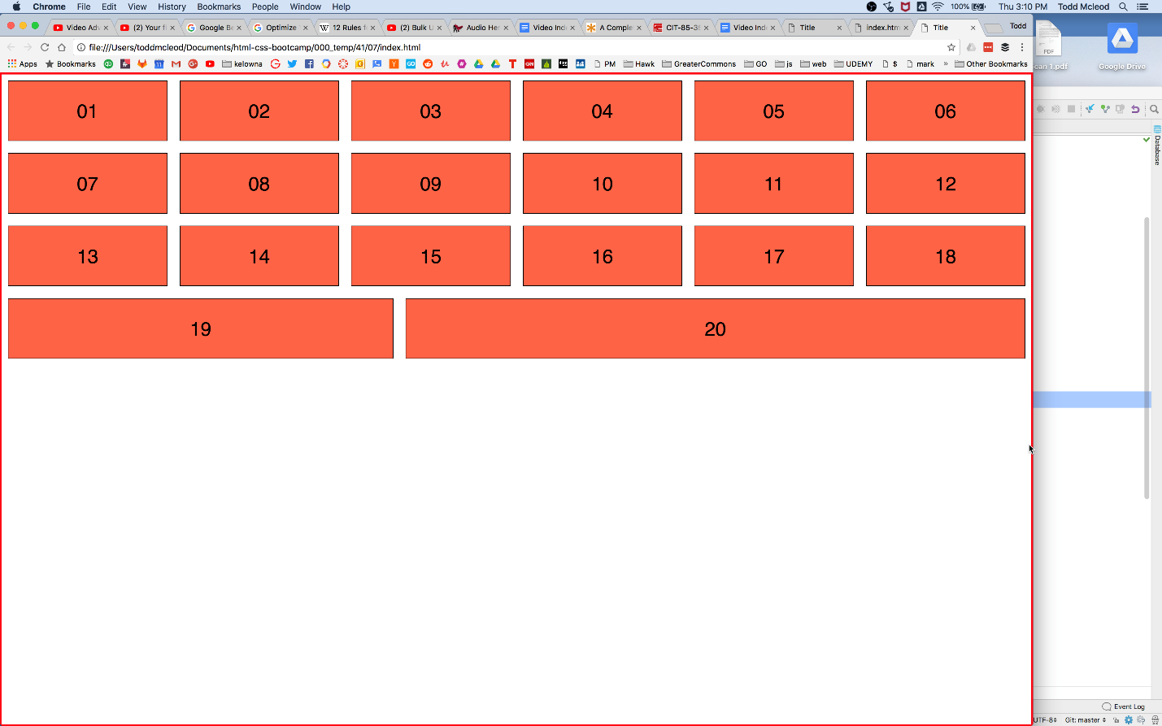

_____

From Rio:

For this work create a new folder that indicates the assignment name, something like "week-assignment-name" and in that folder create the standard files and complete the work.  Once you are done, submit the github folder where you have completed this work.  **Remember folder and filename should be lowercase and no spaces.**