Put three divs on a page. Have each div width set to 400px. Have div #1 & #3 grow 1. Have div #2 grow 2.

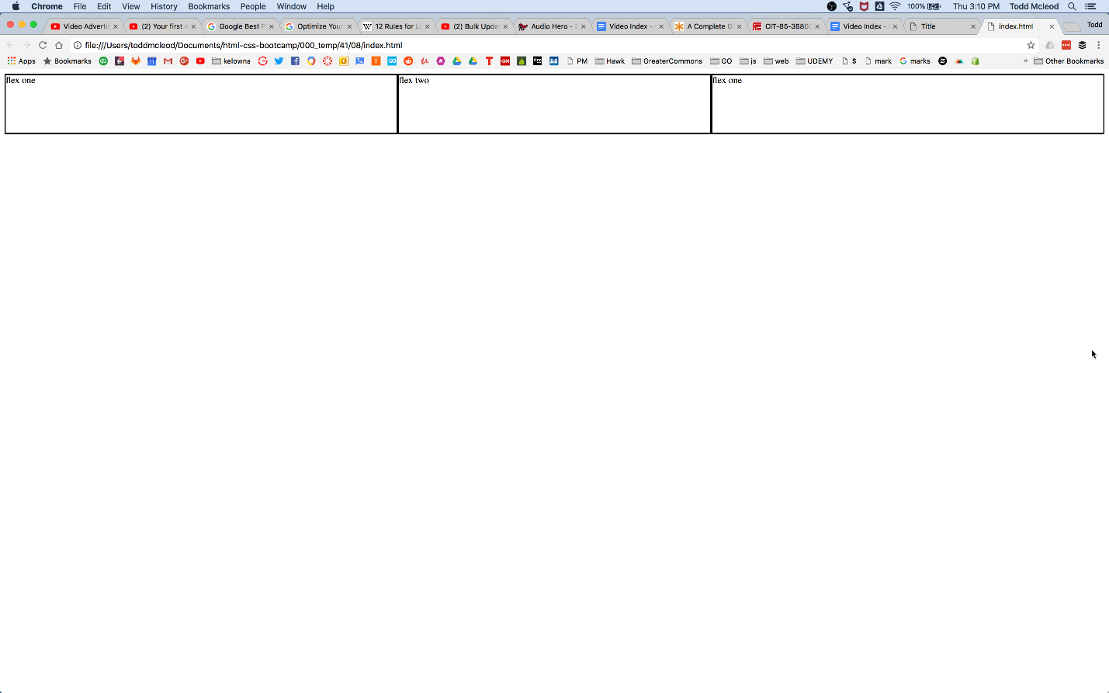

_____

From Rio:

For this work create a new folder that indicates the assignment name, something like "week-assignment-name" and in that folder create the standard files and complete the work.  Once you are done, submit the github folder where you have completed this work.  **Remember folder and filename should be lowercase and no spaces.**