On mobile

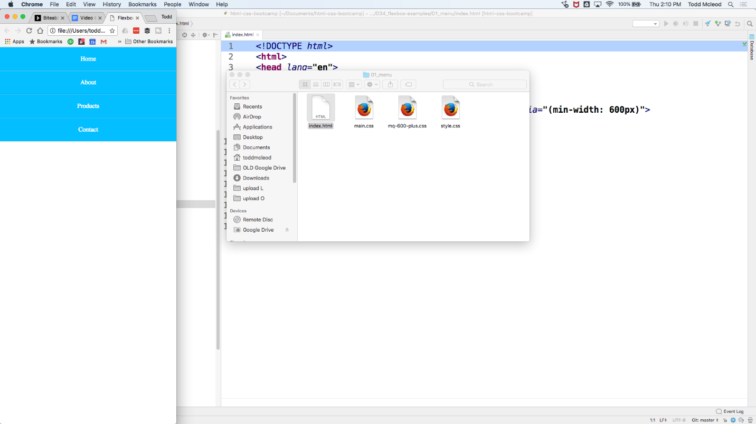

on desktop

you html

