1.Draw a labelled diagram of a desktop PC, clearly marking the motherboard, CPU, RAM, GPU, and both HDD and SSD storage components.
Ans:
- A desktop computer has different hardware components that work together to run programs and games.
- The motherboard connects most of these components, while the CPU processes instructions, RAM stores temporary data, the GPU handles graphics, and storage devices save files.
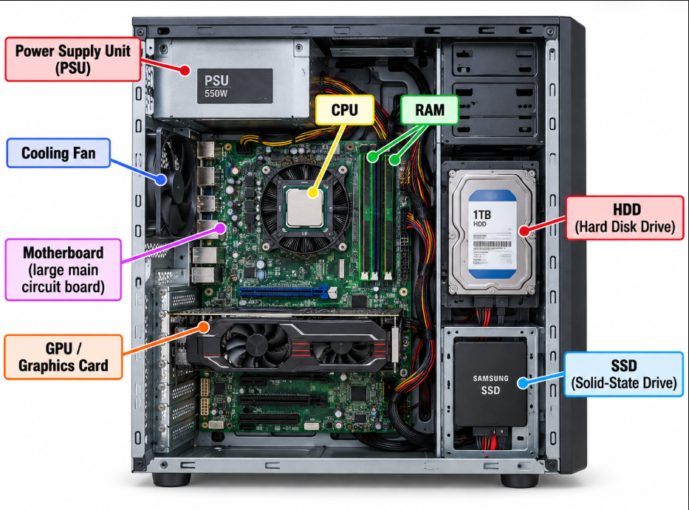
- Explanation of the hardware components
- Motherboard: It is the main circuit board that connects all the computer parts.
- CPU (Central Processing Unit): It is like the brain of the computer. It processes instructions and performs calculations.
- RAM (Random Access Memory): It temporarily stores data that the computer is currently using.
- GPU (Graphics Processing Unit): It processes images, videos, animations, and game graphics.
- HDD (Hard Disk Drive): It stores files, games, videos, and other data for a long time.
- SSD (Solid-State Drive): It also stores data permanently, but it is generally faster than an HDD.
- PSU (Power Supply Unit): It supplies electrical power to the computer components.
- Cooling fan: It helps keep the computer cool and prevents overheating.

2. Create a comparison table showing the main differences between HDD and SSD storage in terms of speed, durability, and typical use cases. Hint: Think about which one is faster, which is more shock-resistant, and where you would usually find each type (laptop, gaming PC, etc.)
Ans:
- HDD and SSD are both storage devices used to save data, but they work differently.

Feature | HDD (Hard Disk Drive) | SSD (Solid-State Drive)
Speed | Slower | Faster
Durability | Less durable because it has moving parts | More durable because it has no moving parts
Price | Usually cheaper | Usually more expensive
Noise | Can make some noise | Works silently
Shock resistance | More easily damaged by physical shocks | More resistant to physical shocks
Common uses | Storing movies, photos, backups, and large files | Operating systems, games, applications, and frequently used files
Loading time | Takes more time to load games and programs | Loads games and programs more quickly

- I would prefer an SSD for installing Windows and games because it makes the computer start faster and reduces loading times. An HDD is useful for storing large amounts of data at a lower cost.

3. Write a short explanation (2-3 sentences each) describing the role of the CPU, RAM, and GPU in running a game like PUBG or Free Fire on a PC.
Ans:
- Imagine I am playing a game like PUBG or Free Fire on my PC.
1. CPU (Central Processing Unit)
The CPU handles the main instructions of the game. It calculates player movements, game logic, and other activities happening in the game. A good CPU helps the game run smoothly and respond quickly to my actions.
2. RAM (Random Access Memory)
RAM temporarily stores the game data that the computer needs while playing. If I have enough RAM, the game can run more smoothly, especially when other applications are open in the background. If RAM is insufficient, the game may lag or become slow.
3. GPU (Graphics Processing Unit)
The GPU is responsible for displaying the game's graphics, such as characters, buildings, shadows, and animations. A powerful GPU can provide better visual quality and higher frame rates. It helps make the gaming experience smoother and more realistic.

4. Imagine you want to upgrade your PC to run the latest version of FIFA smoothly. List which hardware components you would consider upgrading and explain why for each.
Ans:
- If I want to upgrade my PC to run the latest version of FIFA smoothly, I would consider upgrading the following components.

Hardware component | Upgrade I would consider | Reason
GPU (Graphics Card) | A more powerful graphics card | It helps display better graphics and maintain smooth frame rates.
CPU (Processor) | A faster, compatible processor | It helps process game instructions and reduces performance bottlenecks.
RAM | At least 16 GB, if supported and sufficient for the game's requirements | It provides enough memory for the game and background applications.
SSD | Install the game on an SSD | It helps reduce loading times and makes the game load faster.
Cooling system | Better cooling fans or a suitable CPU cooler, if needed | It prevents overheating during long gaming sessions.
PSU (Power Supply Unit) | A suitable higher-capacity PSU, if required | It provides enough power for upgraded components.

- I would first check my PC's current specifications and the game's minimum and recommended system requirements. Then, I would prioritize upgrading the GPU, CPU, and RAM if they are not powerful enough. I would also use an SSD for faster loading and ensure that my power supply and cooling system can support the upgrades.

