1.Draw a labelled diagram of an ATX motherboard and mark at least 8 different slots and ports (such as RAM slots, PCIe slots, SATA ports, USB headers, CPU socket, power connector, etc.).
Ans:
- An ATX motherboard is the main circuit board of a desktop computer. It connects the CPU, RAM, storage devices, graphics card, and other components so that they can work together.
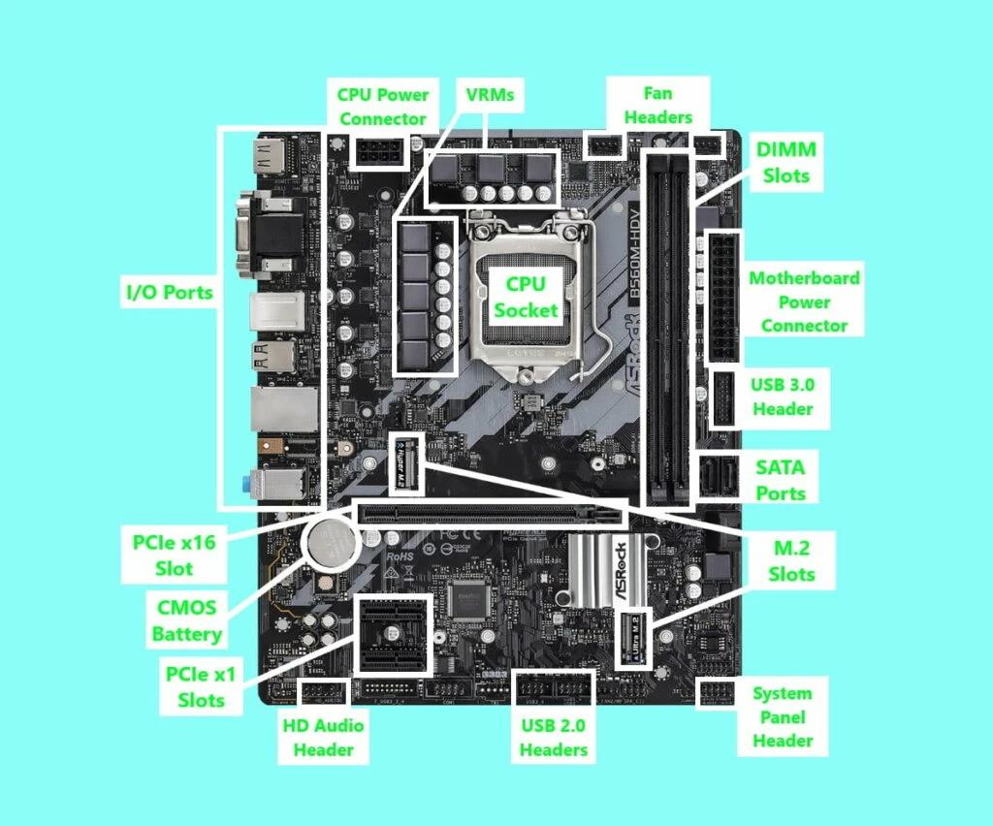
- Main motherboard components
- CPU socket
- RAM slots
- PCIe slot
- SATA ports
- 24-pin motherboard power connector
- CPU power connector
- M.2 SSD slot
- Rear USB ports
- CMOS battery
- Chipset heatsink

- Functions of the components
Component | Function
CPU socket | Holds the CPU in place and connects it to the motherboard.
RAM slots | Hold RAM, which temporarily stores data used by running programs.
PCIe slot | Connects expansion cards, such as a graphics card.
SATA ports | Connect storage devices like HDDs and SATA SSDs.
24-pin power connector | Supplies main power to the motherboard.
CPU power connector | Supplies power to the CPU.
M.2 slot | Holds a compatible M.2 SSD.
USB ports | Connect devices such as a keyboard, mouse, and pen drive.
CMOS battery | Helps maintain the system clock and firmware settings.
Chipset heatsink | Helps keep the chipset cool.

2.Research and list 3 popular CPU socket types (for example: LGA1151, AM4, LGA1200) and name one compatible CPU model for each.
Ans:
- A CPU socket is the part of the motherboard where the processor is installed.
- Different CPUs use different socket types, so we must check compatibility before buying or installing a processor.

CPU socket type | Example compatible CPU | Explanation
LGA1151 | Intel Core i7-9700 | This processor works with supported LGA1151 motherboards designed for Intel's 300-series chipsets.
AM4 | AMD Ryzen 5 5600 | This processor uses the AM4 socket and requires a compatible motherboard and BIOS.
LGA1200 | Intel Core i5-10400 | This processor works with compatible LGA1200 motherboards, such as supported Intel 400-series and 500-series boards.

- A processor cannot be selected only by looking at its brand. We must check the socket type, motherboard chipset, and BIOS support to make sure that the CPU will work properly.

3.Explain in your own words the primary functions of the CPU and the chipset on a motherboard, and describe how they work together when you open a music app like Spotify.
Ans:
- The CPU (Central Processing Unit) is like the brain of a computer. It processes instructions, performs calculations, and runs the tasks required by applications.
- The chipset helps manage communication between the CPU and various motherboard devices. Depending on the motherboard, it supports functions such as USB connections, storage interfaces, and some expansion features.
Example: Opening Spotify
When I open Spotify, the CPU processes the instructions needed to start the application and play music. The chipset helps the computer communicate with supported storage devices and connected peripherals, while the network hardware allows Spotify to connect to the internet and stream songs.
- In simple words, the CPU does the processing work, while the chipset helps coordinate communication with other parts of the computer.

4.Find a clear photo of a real motherboard (from the internet or your own device), and identify at least 5 different ports or slots by circling them and labelling each one.
Ans:
- A motherboard has different slots and ports that connect the CPU, memory, storage devices, and external devices. I have identified the following components on a motherboard and explained their functions.
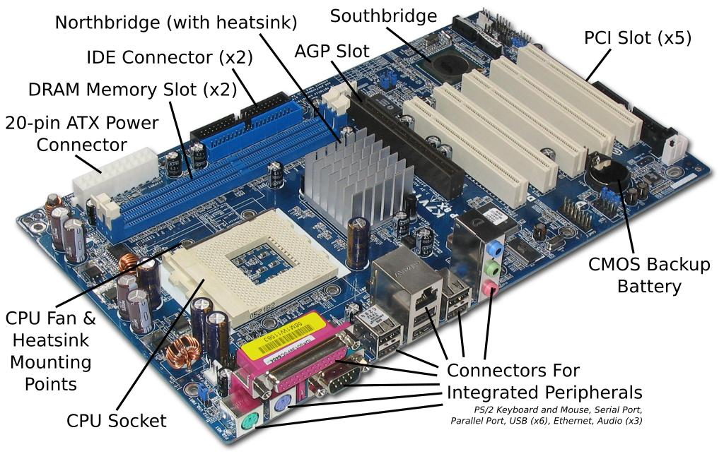
- The motherboard is the main circuit board of a computer. I identified six components on the motherboard, including the CPU cooling fan, RAM slots, PCI expansion slots, CMOS battery, IDE connectors, and rear I/O connectors. Each component has a different function, and all of them help the computer operate properly.

- Circle these six components on the photo and write the matching labels with arrows.
No. | Component | Location in the photo | Function
1 | CPU cooling fan | Large black fan on the left | Cools the processor.
2 | RAM slots | Two long black slots near the upper-middle area | Hold memory modules.
3 | PCI expansion slots | Long white slots on the right | Connect expansion cards.
4 | CMOS battery | Round silver battery near the upper-left corner | Maintains the clock and firmware settings.
5 | IDE connectors | Long connectors along the top edge | Connect older storage devices using IDE cables.
6 | Rear I/O connectors | Metal connectors along the bottom-left edge | Connect external devices and peripherals.

