1.Create a comparison table listing the main differences between DDR3, DDR4, and DDR5 RAM, including speed, voltage, and typical use cases.
Ans:
- RAM stands for Random Access Memory.
- It temporarily stores data that the computer is currently using.
- DDR3, DDR4, and DDR5 are different generations of RAM.
- Each newer generation generally provides better speed and power efficiency.
Feature | DDR3 | DDR4 | DDR5
Speed (typical data rates) | 800–2133 MT/s | 1600–3200 MT/s | Starts at 4800 MT/s
Operating voltage | Usually 1.5 V | 1.2 V | 1.1 V
Performance | Older and slower | Faster than DDR3 | Generally faster than DDR4
Power efficiency | Lower | Better than DDR3 | Better nominal voltage efficiency
Typical use | Older computers | Many desktop PCs and laptops | Newer computers
Compatibility | DDR3-compatible motherboard | DDR4-compatible motherboard | DDR5-compatible motherboard

- Note: These are typical ranges, not absolute limits. Actual speeds and supported memory depend on the module, CPU, and motherboard.

2.Open your laptop or desktop (with power disconnected), locate the RAM slots, and take a clear photo of the installed RAM module. Reinstall the RAM module and verify that your system boots up successfully. Hint: Refer to your device manual or a trusted YouTube guide if unsure about RAM removal and installation steps.
Ans:
Task 2: YouTube help — Remove and reinstall RAM
Watch this official Dell tutorial for a practical example:
How to Remove and Reinstall RAM
Dell Latitude 3420 laptop · Official support video
Watch the RAM removal and reinstallation video on Dell's website

Dell India
The steps shown in the tutorial are specific to that laptop model. Your laptop may be different, so check its service manual before opening it.
Aim: To locate, remove, and reinstall a RAM module safely.
Procedure:
- I would shut down my computer and disconnect the power supply or charger.
- I would follow the manufacturer's instructions to open the computer and locate the RAM module.
- I would take a clear photograph of the installed RAM before removing it.
- I would carefully release the retaining clips and hold the RAM by its edges without touching the gold contacts.
- I would align the notch correctly and reinstall the RAM in its slot.
- I would close the computer, reconnect the power, and turn it on to check whether it boots successfully and recognizes the RAM.
Result: The RAM should be securely installed, and the computer should start normally with the memory recognized.

3.List three key differences between HDD, SSD, and NVMe storage types, and for each, name one app or use case (from apps you use daily) that would benefit most from that storage type.
Ans:
- HDD, SSD, and NVMe are related to computer storage.
- They store files, applications, and the operating system, but they differ in speed, construction, and typical use.
Feature | HDD | SATA SSD | NVMe SSD
Speed | Slowest in general | Faster than HDD | Usually the fastest of these three
Technology | Uses spinning magnetic disks | Uses flash memory | Uses flash memory and the PCIe interface
Durability | Has moving parts and is more sensitive to shocks | No moving parts; more shock-resistant | No moving parts; more shock-resistant
Price per GB | Usually cheapest | Usually more expensive than HDD | Often more expensive, depending on the model
Best use | Large files, photos, and backups | Everyday apps and operating system | Games, video editing, and large file transfers
Example use | Storing photos in File Explorer | Opening Chrome and other apps quickly | Reducing loading times in large games such as PUBG

- I would choose an HDD when I need a large amount of storage at a low cost. A SATA SSD is a good choice for everyday computer use because it loads programs faster. An NVMe SSD is useful when I need very fast loading and file transfers.
- One important point is that NVMe is a storage protocol, not a separate type of memory.
- Most NVMe drives use the M.2 form factor, but not every M.2 drive is an NVMe drive.

4.Remove the storage drive (HDD or SSD) from your system, take a photo of the connector type (SATA, M.2, or NVMe), and reinstall the drive. Confirm that your device recognizes the storage after reassembly. Constraint: Only perform this task if you have access to a device you are allowed to open. If not, find and share a YouTube video link showing the process for your laptop/PC model.
Ans:
Task 4: Remove and reinstall a storage drive (with YouTube help)
Aim
To identify the storage connector, learn how to remove and reinstall an HDD or SSD, and check whether the computer recognizes the drive afterward.
YouTube tutorial
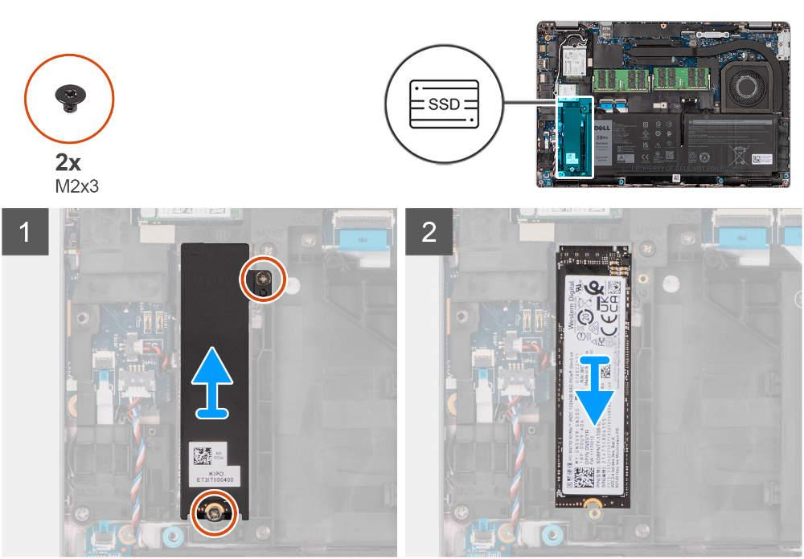
How to Remove and Reinstall SSD for Latitude 5430
Official Dell support tutorial
Watch the video tutorial
Dell India
This video demonstrates how to remove the SSD, release its retaining screws, reinstall it, and secure the laptop cover. The exact procedure depends on your computer model.
Procedure
- I would shut down my computer and disconnect the charger and other cables.
- I would read the manufacturer's service manual and locate the storage drive.
- I would take a clear photo of the drive and its connector before removing it.
- I would carefully remove the retaining screw or disconnect the SATA cables, depending on the drive type.
- I would reinstall the drive in its original position and secure it properly.
- I would reassemble the computer and turn it on.
- I would check whether the drive is recognized in File Explorer, Disk Management, or BIOS/UEFI.
Storage connector identification
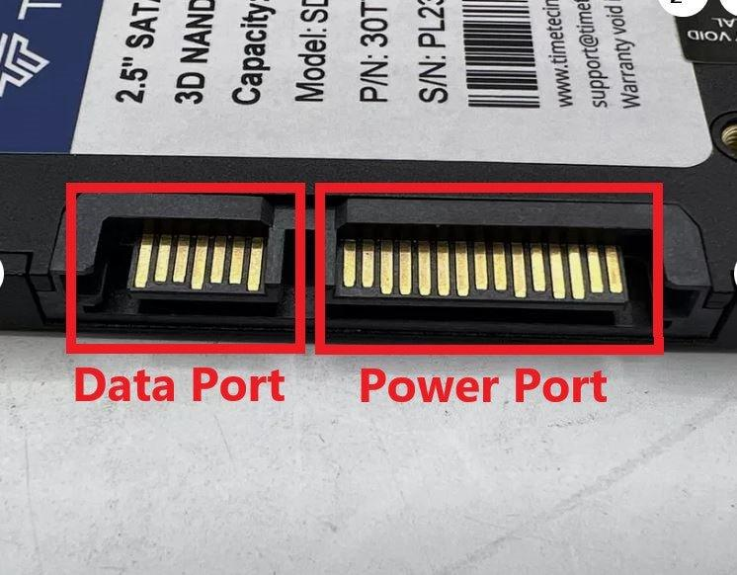

SATA connector
Commonly used by 2.5-inch SSDs and HDDs. It has separate power and data connections.
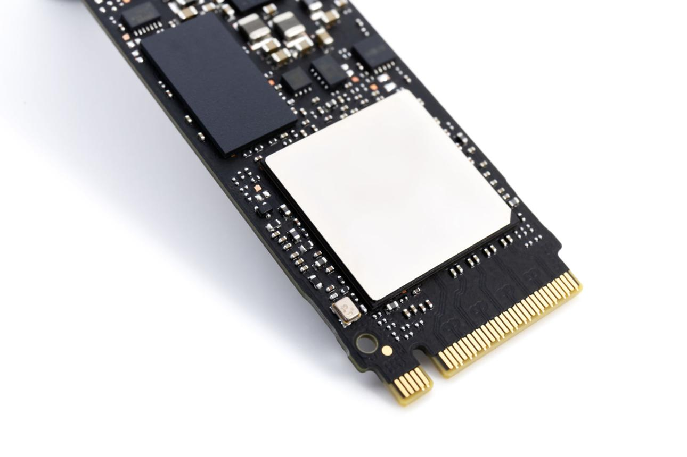
M.2 connector
A small slot for compatible M.2 SSDs. The drive may use NVMe or SATA, depending on its design.
Result
After reinstalling the drive correctly, the computer should start normally and recognize the storage device.
.

