1.Open your own laptop or desktop (or use an online PC hardware simulator if you don't have access to a real system) and identify the GPU model installed. Write down the GPU's brand, model number, and whether it is integrated or dedicated.
Ans:
- A GPU (Graphics Processing Unit) is a computer component that processes graphics, images, videos, and games.
- It helps display images smoothly and improves performance in graphics-heavy applications.
- There are two main types of GPUs:
- Integrated GPU: Built into the processor or processor package. It usually shares the computer's RAM and is suitable for everyday tasks and light gaming.
- Dedicated GPU: A separate graphics processor that usually has its own video memory (VRAM). It is useful for gaming, video editing, and other demanding graphics tasks.
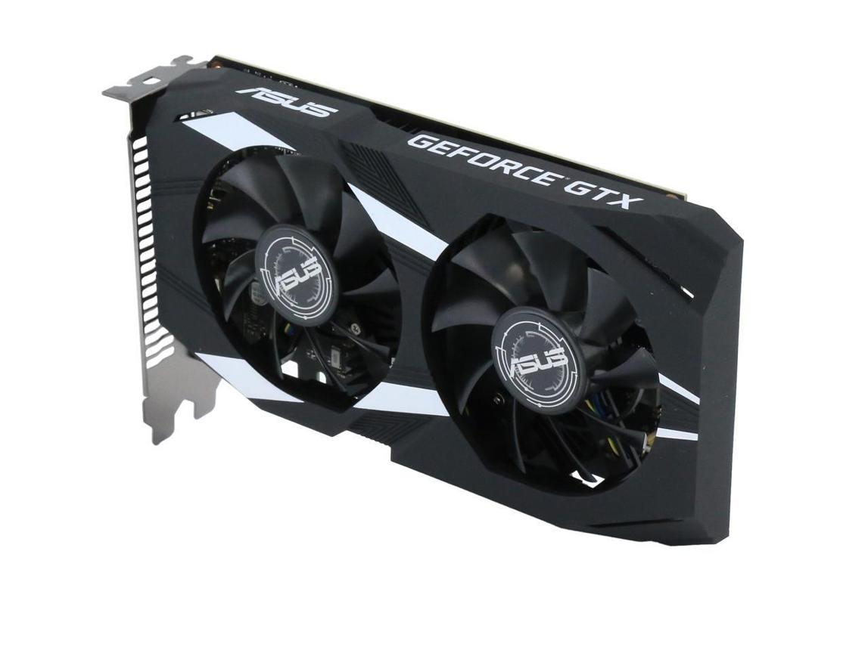

Reference example — GPU identification
- GPU brand: NVIDIA
- GPU model: GeForce GTX 1650
- GPU type: Dedicated GPU
- I would identify the GPU by opening Task Manager in Windows, selecting the Performance tab, and clicking GPU.
- The name shown there tells me which graphics processor is installed.
- The NVIDIA GeForce GTX 1650 is only an example; the GPU in my own computer may be different.
- How to check my own GPU without opening the computer:
- Press Ctrl + Shift + Esc to open Task Manager.
- Select the Performance tab.
- Click GPU 0 or GPU 1, if shown.
- Read the model name displayed on the screen.

2.Take a clear photo or screenshot of the cooling system (fan, heatsink, or liquid cooling setup) inside your PC or from a PC hardware simulator. Label the main cooling components and briefly describe their function.
Ans:
- A cooling system helps keep the computer's CPU and GPU from overheating. When we play games or run heavy applications, these components produce heat. The cooling system removes this heat and helps the computer work properly.
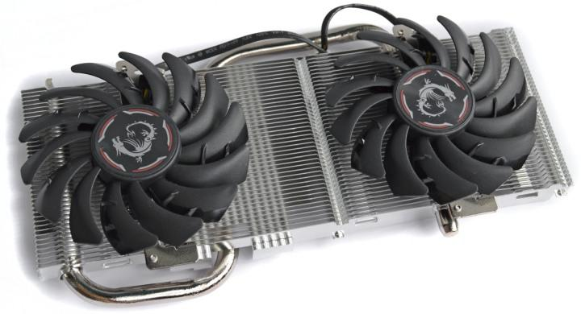
Main components and their functions
Component | Function
Cooling fan | Moves air over the heatsink to remove heat.
Heatsink | Absorbs heat from the GPU and spreads it out.
Heat pipes | Transfer heat from the GPU area to the heatsink.
Metal fins | Increase the surface area so heat can escape into the air.
Thermal paste | Helps transfer heat from the GPU chip to the cooler.

- The fan, heatsink, and heat pipes work together to control the GPU's temperature.
- Without proper cooling, the GPU may become too hot and reduce its performance.
Practical note: As I cannot open my computer, I am using a reference image to understand the cooling components. The image is for learning purposes and is not a photograph of my own PC.

3.Create a comparison table listing at least 3 differences between air cooling and liquid cooling systems for GPUs, including factors like cost, efficiency, and maintenance.
Ans:
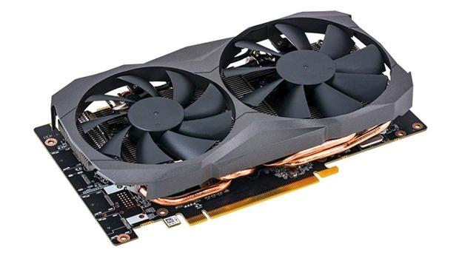
Air cooling
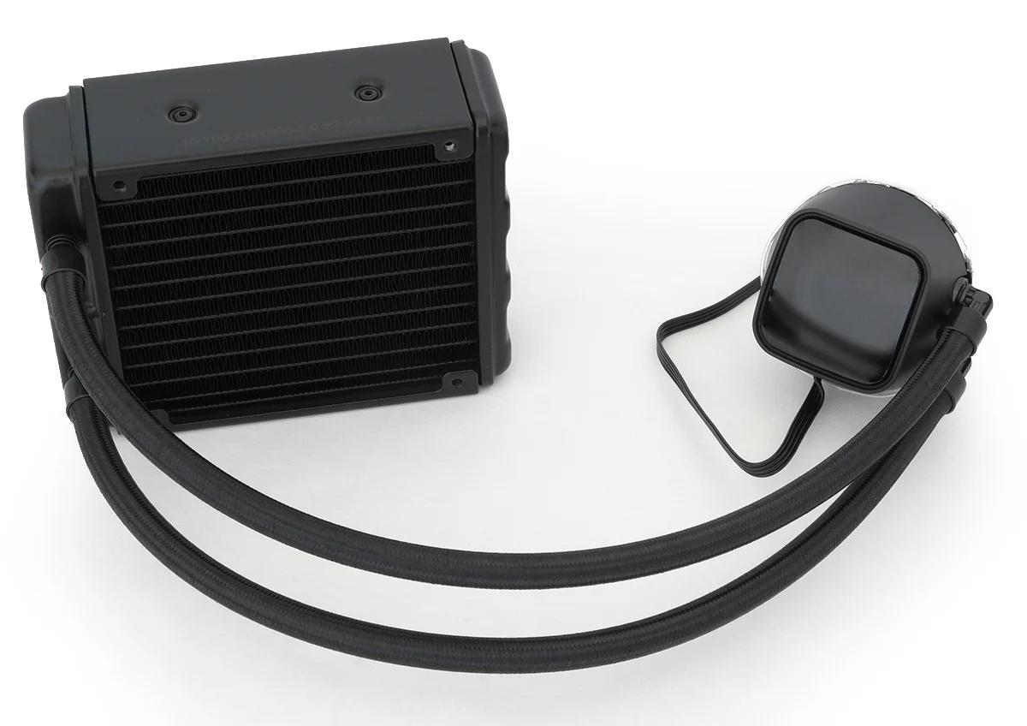
Liquid cooling
Feature | Air Cooling | Liquid Cooling
Working method | Uses fans and metal heatsinks to remove heat. | Uses liquid to transfer heat to a radiator.
Cost | Usually cheaper. | Usually more expensive.
Cooling efficiency | Good for most normal gaming computers. | Can provide better cooling for some high-performance setups.
Maintenance | Easy to maintain; mainly requires dust cleaning. | More complex, especially with custom cooling loops.
Installation | Simple and easy to install. | More complicated to install.
Noise | Fans can become noisy under heavy load. | Can be quiet, but pumps and radiator fans also produce noise.
Risk | No risk of liquid leakage. | Liquid leakage is possible, especially in custom loops.

My understanding
Air cooling uses fans and heatsinks to remove heat from computer components. It is affordable, reliable, and easy to maintain.
Liquid cooling uses coolant to carry heat to a radiator, where it is released. It can be useful for high-performance computers, but it usually costs more and may require additional maintenance.
Both systems are useful, and the better choice depends on the computer's performance requirements and budget.

4.Imagine you are building a gaming PC for streaming IPL matches and playing graphics-heavy games. Choose between air cooling and liquid cooling for your GPU, and justify your choice in 3-4 sentences based on your research.
Ans: I would choose air cooling for my gaming PC because it is affordable, reliable, and easy to maintain. A good GPU air cooler can keep the graphics card at a safe temperature while I stream IPL matches and play graphics-heavy games. It does not require a pump or liquid coolant, so maintenance is simpler. I think air cooling is a good choice because it provides good performance without spending too much money.
.

