**CS6016 Lab 2: ER Model**

**U1426365 Jin-Ching Jeng**

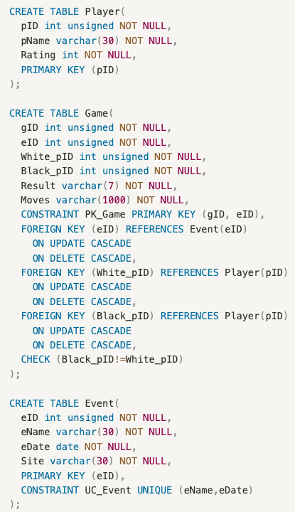

|  |  |  |
| --- | --- | --- |
| Player | | |
| pID | pName | Rating |
| … | … | … |
| NN | NN | NN |
| PK |  |  |

|  |  |  |  |  |  |
| --- | --- | --- | --- | --- | --- |
| Game | | | | | |
| gID | eID | White_pID | Black_pID | Result | Moves |
| … | … | … | … | … | … |
| NN | NN | NN | NN | NN | NN |
| PK | PK | FK | FK |  |  |
|  | FK |  |  |  |  |

|  |  |  |  |
| --- | --- | --- | --- |
| Event | | | |
| eID | eName | eDate | Site | |
| … | … | … | … | |
| NN | NN | NN | NN | |
| PK | Unique | |  | |