--Set Colors/Pixel (So far)

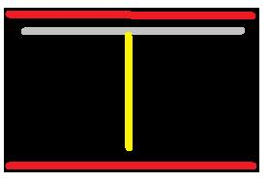

if (VSync < 480 AND HSync < 640) then **-- Active Region**

**--Create Red Borders**: if ((y < 10) OR (y > 470)) then sR <= "11111111";

**--Create that 'TOP' barrier:** then elsif((y > 15 AND y < 40) AND (x > 30 AND x < 610))

then sR <= "11111111"; sG <= "11111111"; sB <= "11111111";

**--Create that 'BOT' barrier: elsif (y < 465 AND y>440) AND (x > 30 AND x < 610))**

then sR <= "11111111"; sG <= "11111111"; sB <= "11111111";

**-- Create 'LEFT' border: elsif((y>15 AND y<200) AND (y>280 AND y<465) AND (x>30 AND x<55))**

**then sR <= "11111111"; sG <= "11111111"; sB <= "11111111";**

**--Create ' RIGHT' border: elsif((y>15 AND y<200) AND (y>280 AND y<465) AND (x>585 AND x<610))**

**then sR <= "11111111"; sG <= "11111111"; sB <= "11111111";**

--Create **Doted** Yellow Dividing Line in the Center elsif ((x > 315 AND x < 325) AND **(y>60 AND y<120) AND (y>140 AND y<200) AND (y>220 AND y<280) AND (y>300 AND y<360) AND (y>380 AND y<420))**

sR <= "11111111"; sG <= "11111111"; else Black --Blanking Region

**Paddle's Range between 200 to 280 on the y-axis on both sides**