Xperior Application
TECHNICAL NOTE

Xperior helps your company to survey the protocol stack implementation, find the critical parts in it and will give you the overview of the system functionality and stability. Application aims on testing with measurement devices connected to PC via VISA interface and supports SOAP communication.


Table of Contents

1 Abstract 3
2 Introduction 3
3 Xperior Application 4
4 Xperior Features 5
4.1 Script Engine and Interactive Shell 5
4.2 Database of Reports 7
4.3 Multitesting 9
4.4 Automation 9

Table of Figures

Figure 1: Usecase example 4
Figure 2: Instruments Configuration 5
Figure 3: Editor and Shell 6
Figure 4: Debugger 6
Figure 5: Schematic of Report Entry 7
Figure 6: Database of Reports Example 8
Figure 7: Multitesting principle 9
Figure 8: Xperior Application: One of perspectives 10

Abstract

Document describes the necessity of RF and protocol stack automated testing in complex multi RAT environment and introduces a solution for verification and validation of target devices.

Introduction

Need for intensive, in-depth testing in mobile telecommunication area is increasing for several reasons. New RAT standards are technically more challenging to implement, target platforms needs to support multiple RATs simultaneously, set of predefined standard test cases which proves the product’s quality is getting larger. Also internal or platform specific requirements add a degree of freedom to already complex test requirements. Manual testing can be sufficient for initial stage of development, but when reached beyond the point where repetitive procedures exceed research tasks, there is a need for change.

Wireless device, UE, under test is connected to cell/network emulator and signalling setup is initiated as shown on Figure 1. The functionality and stability of the same emulator is verified across different reference UEs. Signal generator and signal analyser are in non-signalling setup with device where the RF characteristics are analysed. There are different setup variants having at least one common attribute – remote control and automation possibility.

Automation of test and measurement sequences is an important part of the software and hardware testing and leads to reliable, high-quality product. Correct implementation of instrument-specific requirements in the remote control application becomes of critical importance. These requirements range from synchronization and triggering of measurement routines to processing measurement data and error management. A key criterion in test development is minimizing configuration and measurement time. For development labs and production lines, it is also important that different instruments of various measurement instrument families, such as generators and analyzers, are supported. Taking all these parameters into account, the development of the instrument control presents a challenge. The effort involved in generating, optimizing and testing the instrument control can become a decisive time and cost factor in the development process.

Xperior Application

Xperior aims on testing with measurement devices connected to PC via VISA interface and supports SOAP communication. Application consists of built-in Python interpreter which executes python scripts defining the actual test case. Maintenance of test reports with Database of Reports offers clean overview and coordinates test planning. All the procedures are automatable.
Xperior helps your company to survey your protocol stack, or in general, software implementation and find the critical parts and will give you the overall view of the system functionality and stability.

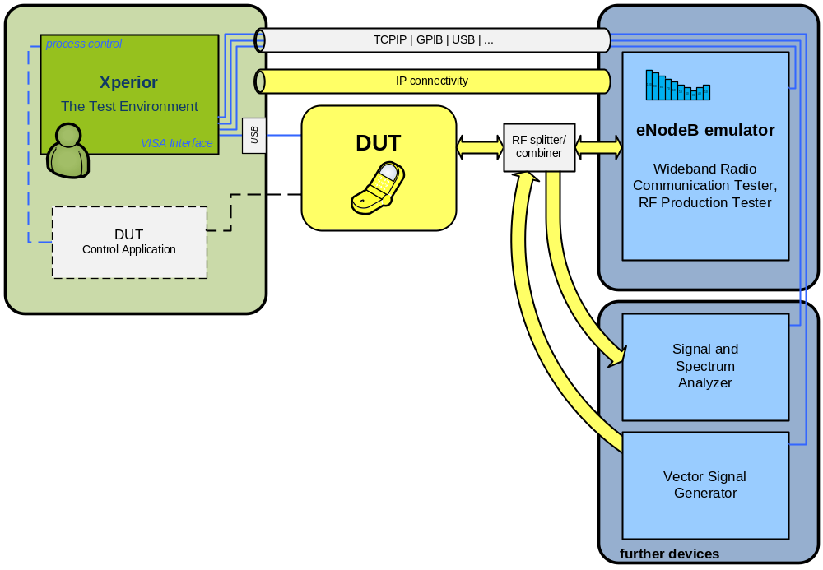

Figure 1: Usecase example

Xperior Features

Script Engine and Interactive Shell
Python scripts are written in Editor’s notebook. Selected script can be started in application’s build-in python interpreter, running such code in separated thread. Interactive console shares the same namespace with running script and vice versa. The advantage is that the console can interact with running code synchronised way (reading or changing object values), which is useful especially during test case development phase.
Application’s core consists of GUI Notebook Editor, special libraries (graphs plotting, text frames, SOAP network procedures, instruments communication (ASRL, GPIB, RSNRP, TCPIP_HISLIP, TCPIP_SOCKET, TCPIP_VX_11, TELNET and USB)) and built-in Python interpreter offering wide spectrum of very useful modules. Also enables changes of internal attributes of Xperior application. Defining own functions or modules and importing them on start or store them as Macro, makes the application to suit to almost anybody. Developing phase can be improved by using the Debugger and plot graphs (easier even more if you are familiar with MATLAB syntaxes). Console mode compiled to *.exe file can be used for special non-GUI embedded cases.
Application’s namespace contains VISA object instances which are configured in following GUI:

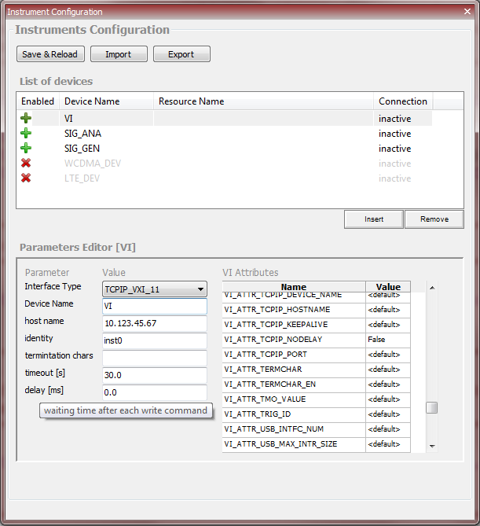
Figure 2: Instruments Configuration

The code auto-completion and object documentation hints is available as shown in figure below. The command completion is also available for SCPI strings.
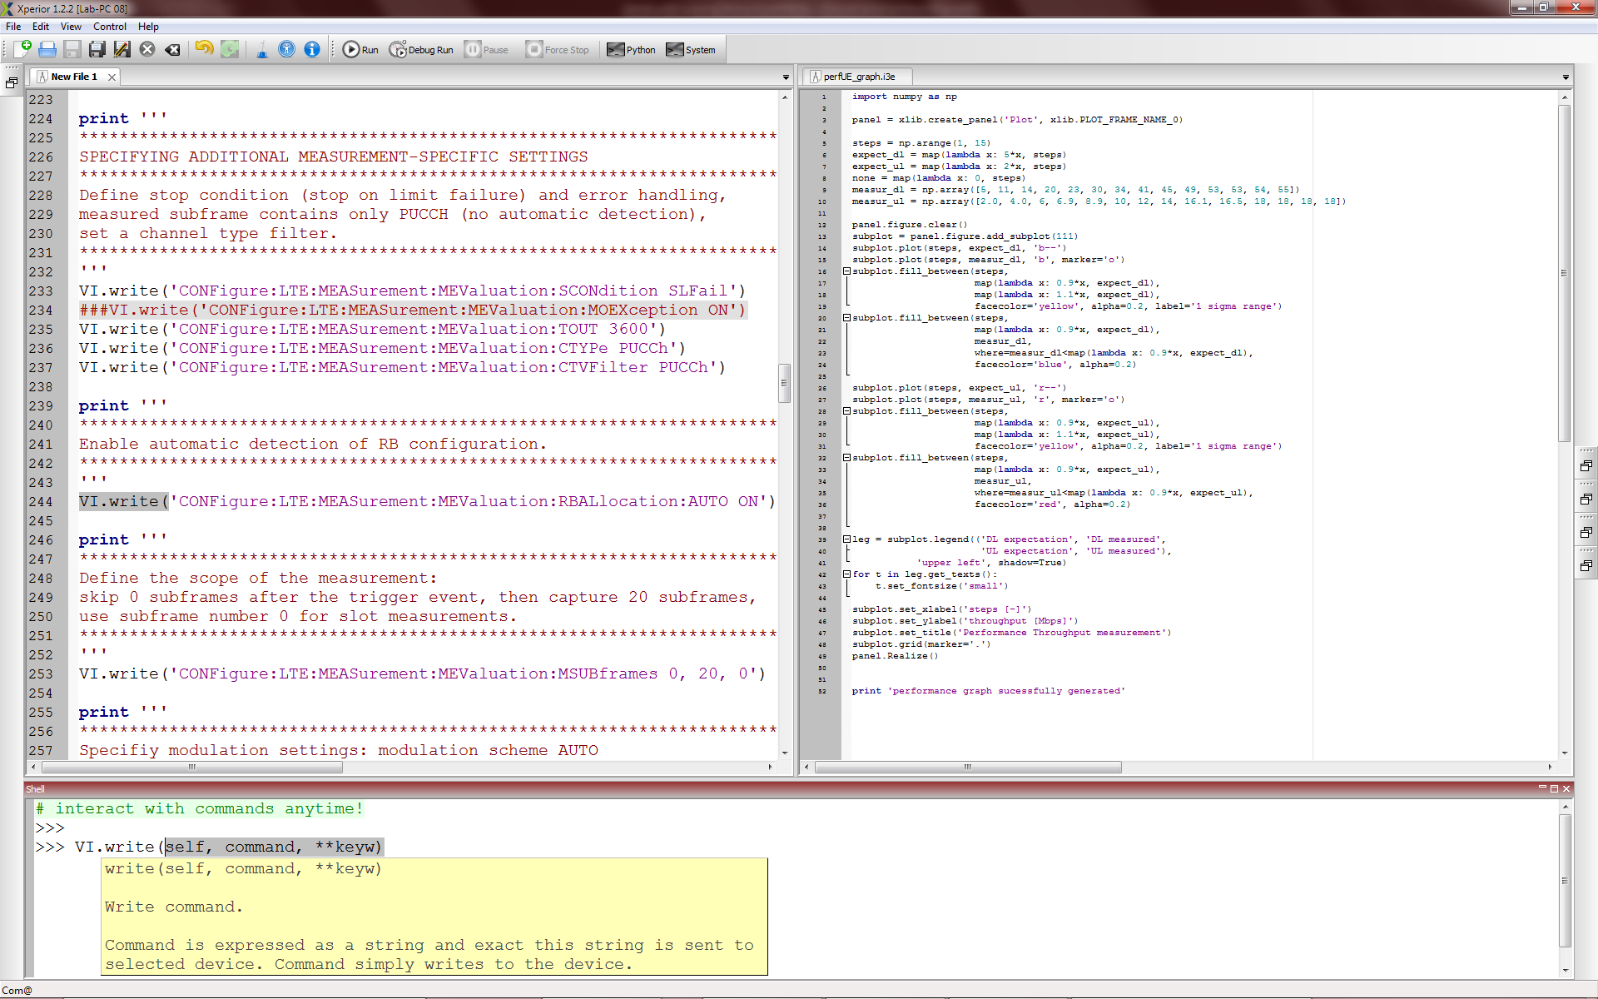
Figure 3: Editor and Shell

Starting a script in a debug mode prepares the script for external debugger (WinPdb) which attaches to the script’s code.
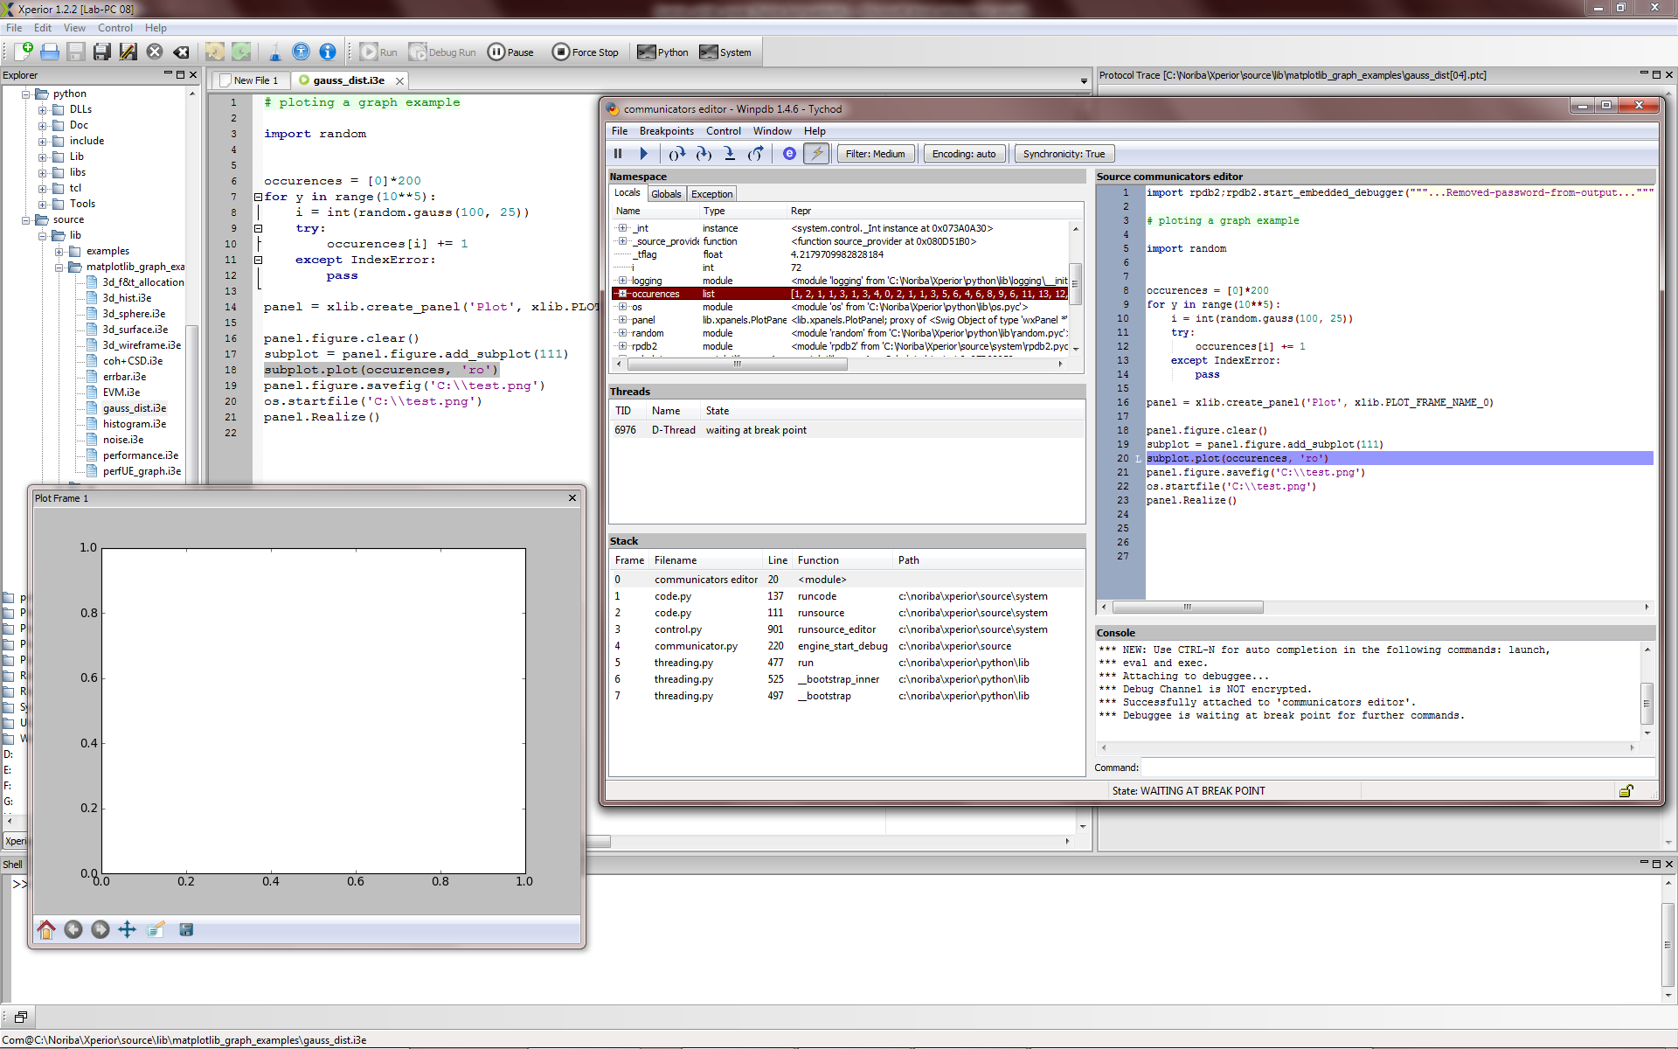
Figure 4: Debugger

Database of Reports
Script’s code contains decision mechanism and ultimately verdict value. All pieces of information about the test results are thoroughly and precisely recorded. The reports are created manually or with automation interface. Let's consider that you have a script controlling and measuring maximal RF power of certain UE. Test results passes for firmware version x.y but fails for x.z. You also know that the results differ for tester A and tester B and that they may use different version of the script. The test logs and UE logs are available on network drive.
To transform a chaos to the order, use Xperior’s Database of Reports.
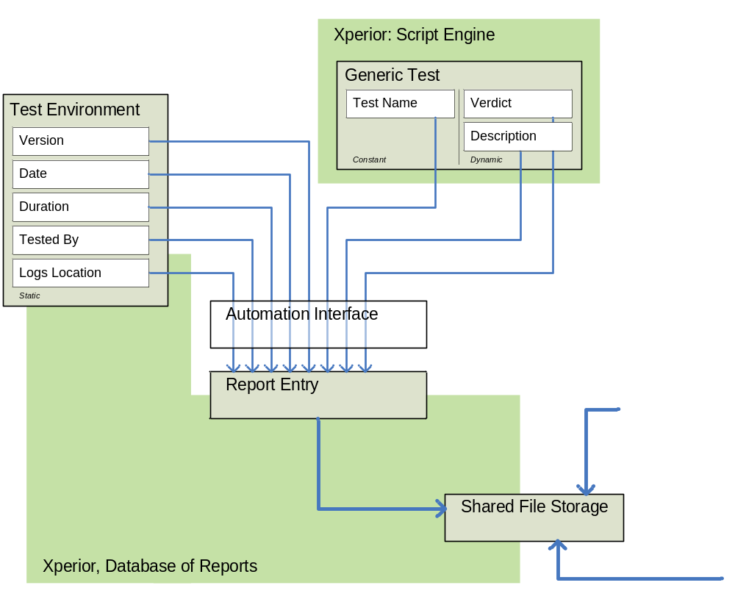
Figure 5: Schematic of Report Entry
By structuring the example in introduction, we get that a generic test is defined by test name and generates a test verdict and test result description. Test environment requires additionally values of version, time and date, duration of the test, reporter name and location of the logs on the file system. Combination of these elements creates a report entry. Graphical interpretation is drawn on figure above.

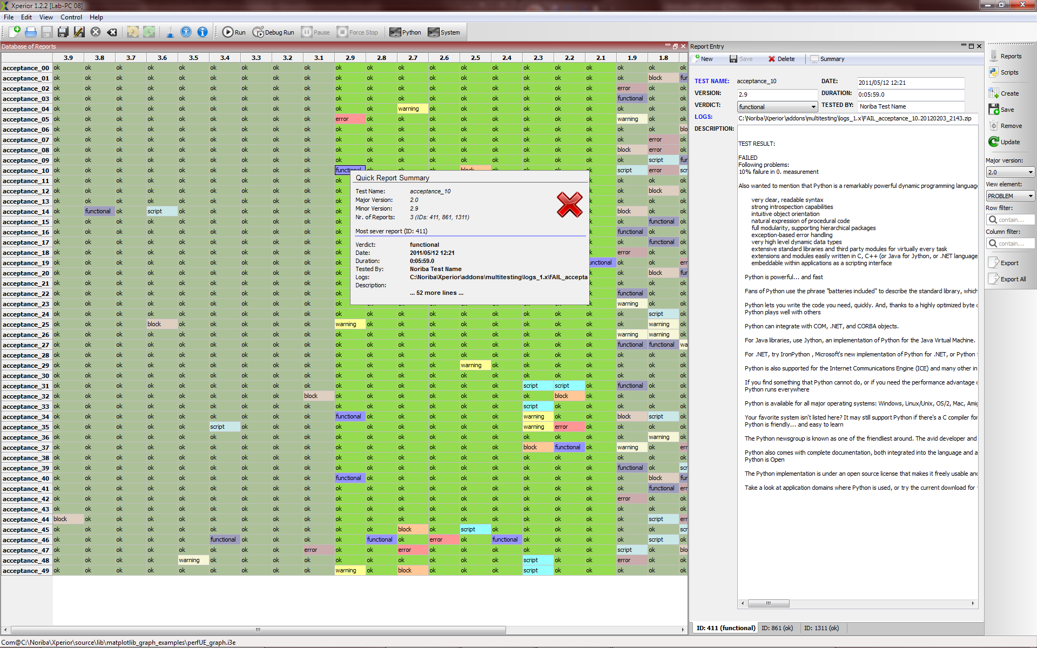
Figure 6: Database of Reports Example

Practical example is above and shows various test cases in the row and evolving software/firmware/hardware version of the DUT in columns. Typical test suite consists of fixed set of scripts and variable count of report entries. Scripts are defined by unique test names. The number of report entries evolves with tested software or firmware development. In Xperior’s Database this evolution is divided to major and minor versions. Logically major version is superordinate and contains one or more minor versions, as highlighted in the figure with saturated colors. It would be possible to define higher level of versions, but it will also add disproportionally more complexity to the application.

Xperior’s Database of Reports additionally supports:

- Multiple-users administration
- Selectable scripts and reports view depth
- Report Entry Editor with hyperlink to pre-selected location
- Quick Report Summary displaying the content of report on mouse rollover
- Export to MS Excel

Multitesting
Multitesting allows you to start selected quantity of scripts in semi-automated mode (without further interacting, with explicit exceptions handling). Test result for every single script run is written to Database of Reports.

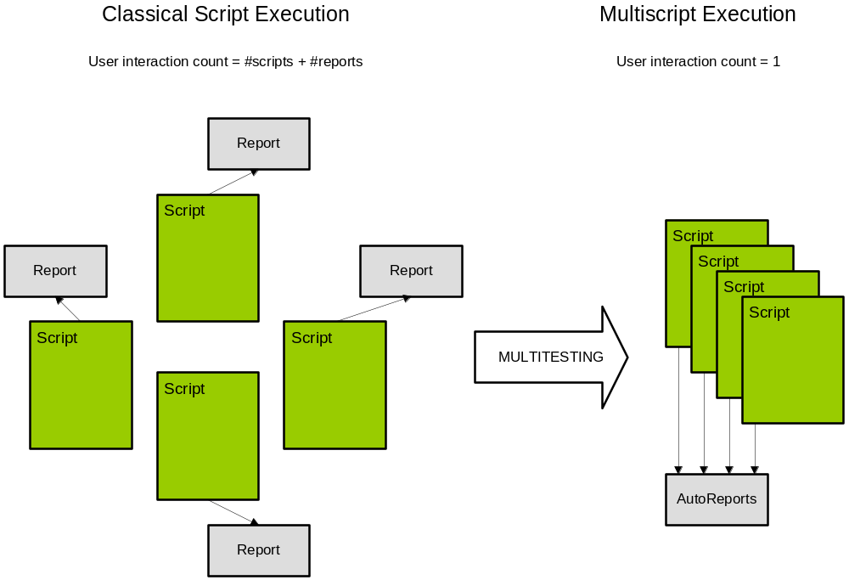
Figure 7: Multitesting principle

Automation
After the test process is well established, repetitive actions identified and the number of test cases and test setups high enough, the process automation has to be considered. It is important to mention the challenging factor of automation in R&D environment, where the robustness and ability to reset to an initial state is one of the priorities, on the one side and the gain for the company which implements such a system on the other. It frees the software developers doing the manual testing for other tasks and gives the development team an important confidence by testing more and on regular time basis.

Noriba created proved automated system based on Xperior for one of its customers. Please refer to http://www.noriba-it.com/products/automated-regression-system/ for more information.

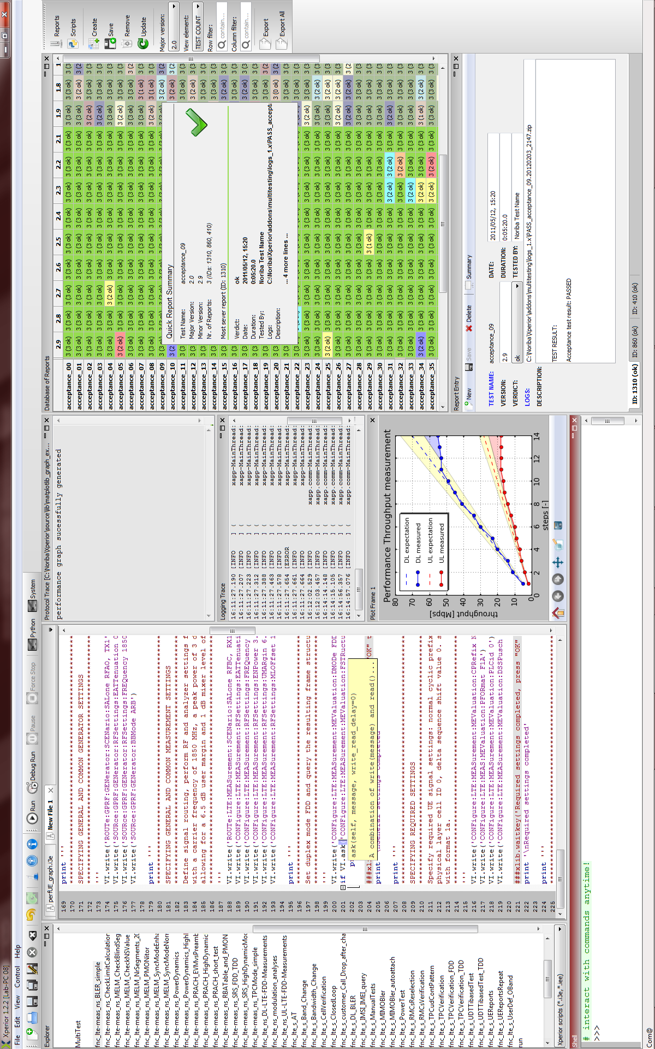
Figure 8: Xperior Application: One of perspectives
Xperior Application
TECHNICAL NOTE

End of Document

About noriba
The company was founded in the year 2010 with the main aim of software development in telecommunication area. We are currently focusing on software and embedded hardware development in UMTS and LTE standards. We have created an innovative software suite called "Xperior". Xperior is designed for verification, validation and stress testing of mobile phone prototypes as well as production models. Described test environment is available as one hardware box solution.
Noriba has developed an "Automated Protocol Stack Regression Test Environment" in cooperation with one the world’s largest test and measurement companies. This proven test environment significantly increases the work efficiency.

Contact

noriba GmbH,
Dingolfinger Str. 6,
81673, Munich, Germany
www.noriba-it.com
info@noriba-it.com
Tel (+49) 176 65024263
Fax (+49) 89 82075723

Radio Access Technology
User Equipment
Radio Frequency
Virtual Instrument Software Architecture (VISA) as host PC software is a well-defined hardware abstraction layer and I/O programming interface for various interfaces, e.g. General Purpose Interface Bus (GPIB, IEEE 488.2) or Ethernet (VXI-11).
Standard Commands for Programmable Instruments (SCPI) is a command set for remote-controlling T&M instruments. Further information is available on http://www.scpiconsortium.org/.

