# Ch0

# Ch1

# Ch2

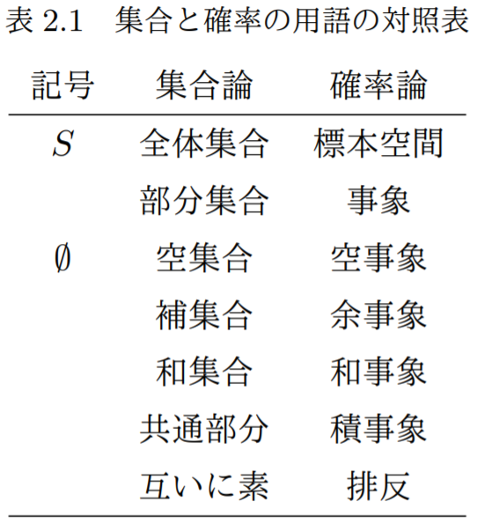

# Ch3

# Ch4

# Ch5

# Ch6

# Ch7

# Ch8

# Ch9

# A

# B

# C

# D

# E