Hackathon Problem Statements
Compiled Set — 6 Problem Statements
Problem Statement — 1
Title | Optimizing Urban Heat Mitigation and Cooling Strategies via Artificial Intelligence and Machine Learning (AI/ML)
Description | Develop a geospatial AI/ML-based system, backed with physics-informed decision making, to identify urban heat stress hotspots, quantify key drivers of urban heating, and generate optimized, scenario-based cooling interventions for mitigating urban heat impacts.
Objective | Participants are expected to develop a framework to:  - Identify Urban Heat Hotspots — Generate heat stress maps using satellite and meteorological data.  - Analyze Drivers of Urban Heating — Quantify the influence of factors such as land use/land cover, urban morphology, vegetation, and atmospheric conditions.  - Model Heat Dynamics using AI/ML — Establish relationships between land surface temperature (LST) and contributing factors using physics-informed ML approaches.  - Generate and Optimize Cooling Scenarios — Simulate interventions (e.g., urban greening, cool roofs, albedo changes, water bodies) and evaluate their effectiveness in reducing heat stress.
Input Datasets | Remote Sensing Data:  - Land Surface Temperature derived from Landsat 8  - Land Surface Temperature from ECOSTRESS  - Land Use/Land Cover from Sentinel-2 / Landsat  Meteorological Data:  - Atmospheric variables (air temperature, humidity, wind speed) from ERA5 & Central Pollution Control Board  Urban Form & Infrastructure:  - Urban morphology from OpenStreetMap, Global Human Settlement Layer & UT-GLOBUS (if available)  Optional Modeling Tools:  - SOLWEIG & InVEST
Outcomes | - Heat stress maps identifying urban hotspots  - Quantitative assessment of key drivers contributing to urban heat  - Validated AI/ML model capturing urban heat dynamics  - Scenario-based evaluation of cooling interventions  - Optimal intervention strategy, including: type of intervention (e.g., green roofs, tree cover), spatial placement, and estimated temperature reduction (°C).

Problem Statement — 2
Title | AI-Driven Automated Crop Type & Moisture Stress Detection, and Irrigation Advisory Across Growth Stages Using Moderate Resolution Spectral Signatures (Optical & Microwave Satellite Data)
Overview | Accurate and timely identification of crop types, detection of moisture stress across phenological stages, and translation of crop water deficit into practical irrigation advisories are critical for precision agriculture, drought monitoring, yield forecasting, climate-resilient farm management, and canal command-area water management.  Satellite remote sensing — combining optical observations such as LISS-IV, LISS-III, AWiFS, Sentinel-2, Landsat and MODIS with microwave SAR observations such as EOS-04, Sentinel-1 and upcoming NISAR-SAR data — provides continuous and scalable monitoring support. Optical data capture vegetation vigour and biochemical condition, while SAR observations support all-weather monitoring during cloudy monsoon periods and are sensitive to crop structure and surface moisture.  The proposed methodology is intended as an operational and nationally relevant extension of satellite-based agricultural monitoring. By integrating crop-type mapping, phenology-aware moisture stress assessment, and irrigation advisory generation, the solution strengthens the intelligence required for programmes such as PMKSY, Digital Agriculture Mission, NMSA and PMFBY — adding a near-real-time water-stress layer that can improve crop monitoring, reduce avoidable irrigation losses, support verifiable crop insurance, and prepare users for effective exploitation of indigenous and international optical and microwave satellite fleets.  This proposal focuses on developing an AI-driven automated methodology for crop type classification, stage-wise phenological mapping, moisture stress detection, and crop water deficit estimation using multi-source satellite data fusion, machine learning, and deep learning models.
Objective | - Develop an automated AI/ML methodology for crop type identification for the current cropped season using multi-temporal spectral signatures from the previous cropped season.  - Detect moisture stress dynamics across crop growth stages (integrating phenology-aware modelling) using optical and/or microwave indicators for stage-wise stress interpretation.  - Develop a satellite-based system to estimate 8-day crop water deficit and generate irrigation advisory maps for canal command areas.
Expected Outcomes | - Within a 30-hour hackathon, a team can demonstrate a functioning pipeline using a defined pilot area, pre-identified crop labels, cloud-hosted satellite collections, and simplified irrigation-advisory logic.  - A methodology and user interface for generating automated high-resolution crop type maps, stage-wise moisture stress, and irrigation advisory maps.  - A dashboard-ready output package consisting of colour-coded stress maps, crop growth-stage interpretation, field- or pixel-level irrigation advisory layers, and time-series visualization.  - A scalable model design that can be extended from a pilot irrigation command area to larger agricultural regions and multiple crop seasons.
Datasets Required | - Optical satellite data: LISS-III / AWiFS / Sentinel-2 / Landsat / MODIS for vegetation vigour, phenology, and spectral-index generation.  - Microwave SAR data: EOS-04 / Sentinel-1 for all-weather monitoring, backscatter analysis, and support during cloud-contaminated kharif periods.  - Ancillary and meteorological data: Rainfall, reference evapotranspiration or weather-grid data, command-area boundary, canal command layers, soil and crop coefficient information.  - Ground information: Existing ground truth points on crop type from the study area, for model training and validation.  The availability of most satellite sources through national and international portals makes the proposed workflow suitable for rapid prototyping as well as later operational scaling.  - Data access and readiness: LISS-III/AWiFS and related ISRO datasets can be sourced from Bhuvan or Bhoonidhi as applicable; Sentinel-1/Sentinel-2, Landsat, and MODIS support open-access cloud or portal-based processing.  - Existing crop ground information and available software resources reduce start-up time for a 30-hour prototype.
Suggested Tools / Technologies | - Programming & geospatial processing: Python, Google Earth Engine, MATLAB, R, GDAL, Rasterio, and related geospatial libraries.  - Machine learning models: Random Forest and XGBoost for tabular and multi-temporal feature classification.  - Deep learning models: LSTM or Temporal CNN for time-series dynamics; U-Net or related architectures for spatial classification where data volume permits.  - Libraries & frameworks: TensorFlow, PyTorch, Scikit-learn, NumPy, Pandas, and geospatial visualization libraries.  - Cloud & deployment: Google Earth Engine, Google Colab, AWS, or ISRO Bhuvan-oriented resources for scalable processing and output hosting.  Cloud platforms such as Google Earth Engine and Google Colab support fast data ingestion, compositing, and model execution, while Python, R, MATLAB, or similar tools support advanced analysis, modelling, and visualisation.
Expected Workflow | Designed on a pilot command area for a 30-hour hackathon; the same architecture can later be expanded to additional regions, seasons, crops, and benchmark datasets.  - Data Pre-processing: Atmospheric correction (optical), speckle filtering (SAR — e.g., Refined Lee filter), temporal compositing (weekly/fortnightly/monthly).  - Feature Extraction: Vegetation indices (NDVI, EVI, NDWI); SAR features (VV, VH polarization, VH/VV ratio); texture features (GLCM); phenological metrics (start of season, peak growth, length of growing period).  - Crop Type Classification: Train supervised ML models using labelled data, apply a multi-temporal classification approach, and generate seasonal crop maps.  - Moisture Stress Detection: Integrate NDVI anomalies, NDWI, and SAR backscatter sensitivity; develop stress indices (Vegetation Condition Index, Soil Moisture Index); perform stage-wise stress classification.  - Water Deficit & Irrigation Advisory Maps: Adopt any methodology (physical crop water balance, crop coefficient / empirical equations) to estimate weekly (8-day) crop water demand (ETc), quantify deficit against actual evapotranspiration and rainfall, and translate this into an irrigation status map.  - AI/ML Model Development: Combine satellite features; train Random Forest / LSTM models for temporal dynamics and generate predictive outputs.  - Validation: Compare against ground truth crop data using accuracy metrics — Overall Accuracy and Kappa coefficient.  - Output: Crop classification map, moisture stress maps (stage-wise), and time-series dashboards.
Evaluation Parameters | - Crop classification accuracy target: greater than 85%, where representative training and validation samples are available.  - Moisture stress classification should be growth-stage aware and show logical correspondence with satellite-based indices.  - The prototype should not only classify crops but also demonstrate that the derived water-deficit and irrigation advisory layers are credible for command-area planning and consistent with available reference information.
Reference Figure | 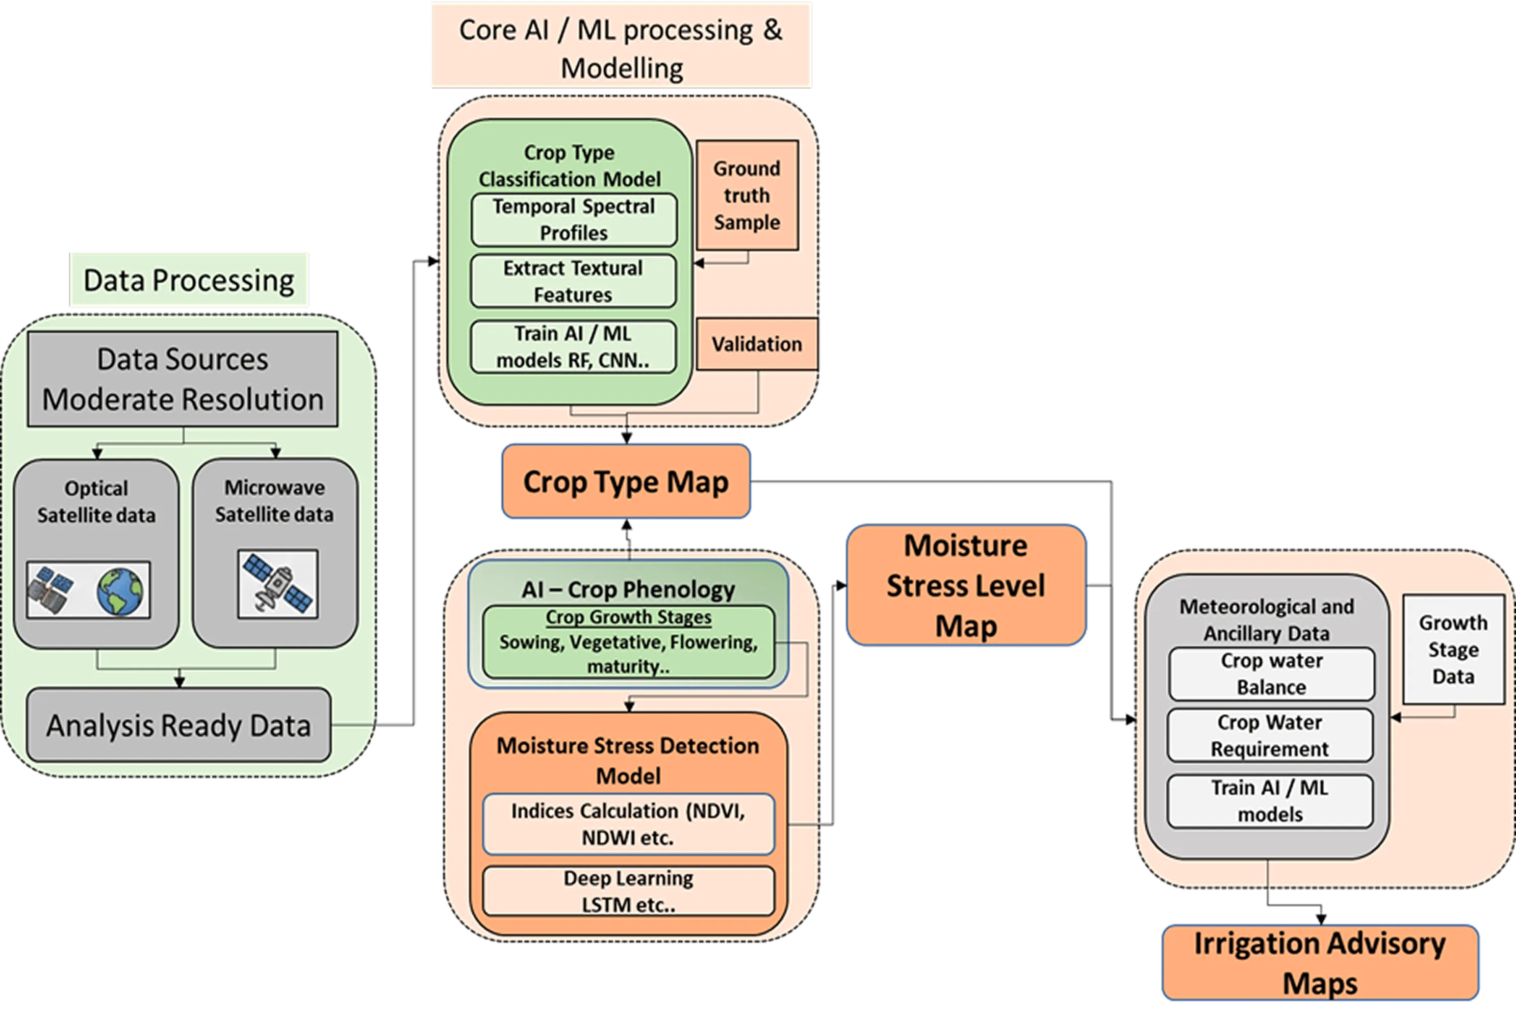

Problem Statement — 3
Title | SDGs in the Classroom
Challenge | Develop a lesson plan that educates high school students about a Sustainable Development Goal (SDG), designed so it can be integrated into a science unit already part of the curriculum (e.g., weather, geology, soil health).
Objectives | - Create a lesson plan that teaches high schoolers about one SDG in a way that naturally fits into an existing science curriculum topic.  - Find new, engaging methods to teach the SDGs rather than presenting them as a standalone topic.  - Include material explaining the tools available to help realize the SDG and measure progress toward it.  - Mandatory requirement: incorporate at least one NASA data source to highlight the role of Earth observation and remote sensing in achieving the SDGs.  - Format is open-ended: a video, an interactive game, an online tool, a website, or another creative medium — whatever best engages and motivates high schoolers to learn.  - Strong submissions could potentially be shared with educators and EO4SDG partners (e.g., via their website or a webinar).
Potential Considerations | - If you're a current high school student, think about which classroom unit would blend naturally with an SDG, and how to teach it interactively.  - If you've graduated high school, consider focusing on the SDG you know or care about most.  - Prefer integrating the SDG into an existing curriculum topic over building a lesson solely about the SDG in isolation.  - Hands-on activities tend to work well for engaging and motivating this age group.

Problem Statement — 4
Focused Area | Digital Farming
Problem Statement (incl. use of ICT) | Develop an affordable app-based solution for soil health monitoring that also suggests which crop to sow based on the detected soil condition.  (Technology Bucket: IoT, AI, ML, etc.)
Expected Output | An app-based solution that detects key soil parameters — moisture content, temperature, relative humidity, nutrient levels, pH, CEC (Cation Exchange Capacity), NPK (Nitrogen, Phosphorus, Potassium), etc. — using IoT sensors, and uses this data (along with environmental values) to recommend the most suitable crop to be produced.  Bonus Objective: Provide remedies and alerts for soil deficiencies — e.g., watering recommendations for low moisture, fertilizer suggestions for nutrient deficiencies, and similar corrective actions.
How Does It Help | Currently, farmers largely follow traditional crop-yielding patterns, sowing routine crops regardless of actual soil condition. Fertilizers are often applied in a blanket, one-size-fits-all manner rather than being matched to the soil's actual nutrient requirements. This mismatch between soil condition and farming practice leads to reduced crop yield and long-term degradation of soil health.  With this solution, farmers can:  - Make informed decisions on which crop to plant based on real, measured soil conditions rather than habit or guesswork.  - Identify soil deficiencies early and apply targeted, timely remedies (e.g., appropriate fertilizer type/quantity, watering schedule) instead of blanket treatments.  - Reduce crop loss and preserve soil health over time through data-driven, precision farming practices.

Problem Statement — 5
Focused Area | Eco-Shield & Disaster Intelligence
Problem Statement (incl. use of ICT) | Develop an integrated environmental monitoring and disaster intelligence solution that combines flood monitoring, early warning systems, landslide risk assessment, wildfire detection, and environmental sensor networks into a unified platform for proactive disaster management.  (Technology Bucket: IoT, AI/ML, Remote Sensing, GIS, Satellite Data)
Expected Output | A system that:  - Flood monitoring — tracks real-time water levels in rivers/reservoirs using IoT sensors and satellite/remote-sensing data, predicting flood likelihood based on rainfall, terrain, and historical patterns.  - Early warning systems — issues automated, location-specific alerts (SMS, app notifications, sirens) to at-risk communities and local authorities when danger thresholds are crossed.  - Landslide risk assessment — uses soil moisture, slope stability, rainfall intensity, and seismic data to generate risk scores for landslide-prone zones.  - Wildfire detection — leverages thermal/satellite imagery and ground sensor networks (temperature, humidity, smoke) to detect fire outbreaks early and estimate spread direction.  - Environmental sensor networks — a distributed IoT mesh continuously collecting environmental data (temperature, humidity, air quality, soil condition, water levels) feeding all the above modules and a central dashboard.  Bonus Objective: A unified dashboard for disaster management authorities showing live risk maps across all five hazard types, with AI-driven severity prediction and automated resource-allocation suggestions.
How Does It Help | Currently, disaster response in many regions is largely reactive — floods, landslides, and wildfires are often detected only after significant damage has occurred, due to the lack of continuous, localized environmental monitoring. Fragmented, hazard-specific systems (if they exist at all) don't share data, delaying coordinated response.  With this solution:  - Authorities and communities get early, actionable warnings instead of after-the-fact damage assessment, reducing loss of life and property.  - Data-driven risk zoning allows better urban planning and evacuation preparedness in landslide/flood-prone areas.  - Faster wildfire containment through earlier detection reduces spread and ecological damage.  - A unified sensor network cuts costs and improves accuracy compared to running separate, siloed monitoring systems for each hazard.

Problem Statement — 6
Focused Area | Sustainability / Climate Action (Personal Carbon Management)
Problem Statement (incl. use of ICT) | Develop a carbon footprint tracking application that goes beyond passive measurement by using behavioral design — personalized nudges, streaks, and goal-setting — to actively influence users toward lower-carbon habits.  (Technology Bucket: Web/App Development, Rules Engine, Gamification, Basic Data Analytics)
Expected Output | An app/web-based solution that:  - Log daily activities (commute mode, meals, electricity usage, shopping, etc.) through a simple activity-logging form.  - Calculate estimated carbon footprint from logged activities using standard emission-factor data.  - Run a rules engine that analyzes logged patterns and triggers timely, personalized behavioral nudges — e.g., “You've driven 4 days this week — try cycling tomorrow to save ~2kg CO₂.”  - Gamification elements: streaks for sustained low-carbon behavior, weekly/monthly goals, and progress visualization to keep users engaged over time.  - Dashboard showing footprint trends, category-wise breakdown (transport, food, energy, etc.), and impact of nudges followed vs. ignored.  Bonus Objective: Social/community layer — leaderboards, shared challenges, or comparison with peer groups to add social accountability as an additional behavioral lever.
How Does It Help | Most existing carbon trackers stop at measurement — they show users a number, but numbers alone rarely change behavior. This creates a “so what?” gap: users see their footprint but have no clear, immediate prompt to act on it, so tracking becomes a one-time novelty rather than a habit-forming tool.  By embedding the nudge as the core feature (not an add-on):  - Users receive actionable, specific suggestions at the moment they're relevant, rather than generic tips.  - Gamification (streaks, goals) taps into habit-formation psychology, increasing sustained engagement compared to plain dashboards.  - Over time, small consistent behavior shifts (commute choices, energy use, diet) compound into measurable reductions in personal carbon footprint.  - The solution demonstrates real behavioral impact, not just data visualization — which is what differentiates it from the many “plain carbon trackers” judges typically see.
Build Notes | Difficulty: Low–Medium  Estimated Build Time: 14–18 hours  Common Pitfall to Avoid: Spending the bulk of build time polishing the tracking dashboard while treating the nudge/rules engine as an afterthought — the nudge logic is the differentiator and should be scoped and built first, not last.

