


University of Wollongong
Bachelor of Computer Science
CSIT321 - Final Year Project
Chatbot for Customer Support

Supervisor : Group Number :  Project Website: | Dr Poh Kok Loo FYP-26-S2-12  https://aeris-chatbot-website.vercel.app/

Group Members:

Name | UOW ID | SIM ID | SIM E-Mail Address
Poon Ka Weng | 8496596 | 10255697 | kwpoon003@mymail.sim.edu.sg
Wang QinXue | 9098045 | 10254202 | qwang037@mymail.sim.edu.sg
Richelle Tang Li Xin | 7910265 | 10230263 | rlxtang001@mymail.sim.edu.sg
Robson Goh Zhu Heng | 9097697 | 10267572 | rzhgoh001@mymail.sim.edu.sg
Wee Jun Yuan Mervin | 8497011 | 10253388 | jymwee001@mymail.sim.edu.sg

Chatbot for Customer Support

Revision History

Revision Number | Revision Date | Revised by | Remarks

Table of contents
1. Introduction 5
1.1. Overview 5
1.2. Project Scope 5
1.3. Project Description 7
1.4. Business Model 8
Value Propositions 9
Individual User (Consumers) 10
Business Users 12
Channels 12
Revenue Stream 12
Freemium Access 13
Premium Access 13
Cost Structure 13
Customer Segments 14
2. Research Finding Analysis 15
2.1 AI Chat agent in the market 15
2.2 Research summary 16
Assembled 16
Sierra 17
Wonderchat 18
SiteGPT 19
Fin 20
Ada 21
2.2 Product comparison 22
3. Project Motivation 23
4. Functional Requirements 24
4.1 Functional Hierarchy 24
4.2 Preliminary Use Case Diagram 26
System Admin 26
User Admin 27
User 28
4.3 Preliminary Use Case Description 29
System Admin Use Case Description 29
User Admin Use Case Description 37
User Use Case Description 50
5. Proposed Plan 68
5.1 Execution Strategy 68
5.2 Software Development Methodology 68
5.3 Risk Analysis 70
5.4 Proposed Duration and Schedule 74
5.5 Roles and Responsibility 76
6. Development Tools 77
7. Expected Results 79
8. Regulations 80
9. Conclusion 81
10. References 82

Introduction

Overview
The market for conversational artificial intelligence (AI) is estimated to be valued at USD 16.09 Bn in 2026 and is expected to reach USD 68.52 Bn by 2033 (Rai, 2026). This is encouraged by the increase of usage for industries such as retail, banking, financial services and insurance, and hospitality. In addition, there has been a focal shift to automated and personalized customer engagement in applications such as virtual assistants, chatbots and voice assistants.
Aeris’ focal point is to contribute to this demand by engineering an intelligent virtual representative. Aeris is designed to combine extensive organizational data and answer to user queries in real-time. Unlike traditional chatbots, this system functions as a dynamic logic engine and context-aware insights. By combining high-speed response generation with a user-friendly navigational interface, Aeris empowers users to achieve comprehensive solutions autonomously, streamlining operational workflows and changing the standard for modern customer engagement.

Project Scope
The primary objective of this project is to engineer a scalable, AI-driven conversational architecture that automates the resolution of high-frequency customer inquiries. Utilizing a Retrieval-Augmented Generation (RAG) framework, the system will ingest and vectorize multi-format organizational data, creating a quality knowledge base.

The project scope consists of:

Backend Engineering: Development of an automated ingestion pipeline for web crawling and document processing.

Model Tuning: Implementation of hyperparameter optimization to ensure context-aware and safe responses.

Front-end Personalization: A customizable UI that allows for brand-specific personal configuration and source-link which acts as citation for transparency.

The final deliverable is an autonomous virtual representative that reduces operational overhead and that fulfills the minimum requirements that were stated at the start of the project with room for further improvement in the subsequent phases.

Project Description
Aeris is a chatbot that is focused on the development of an advanced, AI-driven conversational agent designed to provide autonomous, real-time assistance for frequently asked customer inquiries. This project develops a Retrieval-Augmented Generation (RAG) system that functions as a highly capable logic engine.
By integrating the Large Language Model (LLM) with a knowledge base, the system bridges the gap between raw organisational data and actionable user support. It is engineered to not only interpret natural language but to infer new facts from existing data based inference rules, allowing it to resolve complex, multi-step inquiries that would normally require a human support agent.

Business Model

Key Activities
The key activities in the development of Aeris focuses on integrating advanced functional features while maintaining a clean and professional user interface. Aeris aims to deliver a highly responsive virtual agent that assists customers in real-time, providing immediate resolutions to common inquiries and complex issues alike.
To ensure a seamless user experience, the chatbot is designed with four core capabilities:
Persistent Memory: The system maintains conversation context over time, allowing for personalized interactions where the user never has to repeat information.
Document Integration: Users can upload documents directly within the chat for real-time analysis, enabling faster troubleshooting and more accurate support.
Human Escalation: To guarantee comprehensive service, the bot will intelligently recognize when a query exceeds its scope and will perform a seamless transfer to a live agent.
Intuitive Interaction: The focus on natural, helpful responses that use respectful and humanlike language to guide users through their support they seek.
Examples of industries we want to target to adopt our chatbot:
- Healthcare
- School portals (Education / moodle)
- E-Commerce
Key Partners
The key partners in our model are:

        - Healthcare staff
        - School IT Support
        - Independent Sellers
.

Value Propositions
Aeris adopts a user focused, flexible architecture designed to deliver autonomous, data-driven resolutions for complex inquiries. By prioritizing the need for self-service, the system significantly reduces reliance on traditional human customer support. The core of our idea for the chatbot is the concept of adaptive support; a persistent memory framework that analyzes the history of the users’ interactions to curate a personalized and context-aware service journey.
The system’s engineering balances high-level automation with robust connectivity. Through the integration of an intelligent response engine capable of reading and understanding user-uploaded documentation, the chatbot provides an advanced type of support. To ensure maximum reliability, the architecture is supported by an escalation protocol. This allows for ticket creation which would allow the chatbot to create a ticket for the human agent to attend to at their earliest possible convenience for high-complexity scenarios. This is to ensure that every customer interaction concludes with a comprehensive and verified resolution.

Individual User (Consumers)
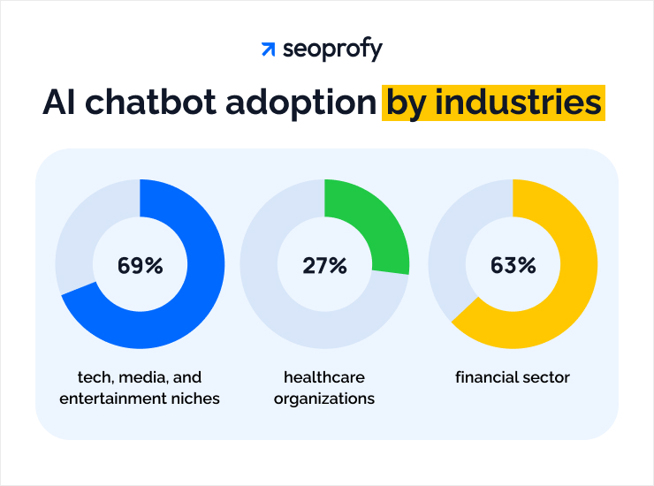
Table 1 Source: https://seoprofy.com/blog/ai-chatbot-statistics/ (2026)

The proposed AI-powered chatbot, Aeris is engineered for broad cross-sector applicability, targeting a diverse demographic of digital users who encounter navigation difficulties within complex web systems. By providing a versatile support layer, the chatbot addresses some known issues in industries such as:

Healthcare Services: Aeris is able to help healthcare staff by allowing the staff to free up time spent on administrative tasks to serve patients better. Patients and caregivers who require immediate responses are able to access the chatbot which is available 24/7. The chatbot is also able to assist patients in accessing information about nearby medical facilities, hours of operation and nearby pharmacies in case of medication refills. Appointment scheduling is also more streamlined due to the use of integrating an online calendar to reflect the appointment date and follow up with appointment reminders. By offering a reliable first point of contact, the system ensures that critical health-related inquiries are addressed with precision, fostering patient safety and adherence.

Academic and Educational Institutions: Aeris is tailored to assist students, faculty, and administrative staff who may face challenges navigating Learning Management Systems (LMS) or institutional portals interface. By simplifying the digital interface through conversational guidance, the chabot is able to reduce frustration due to the confusing interface for users and minimizes the volume of technical inquiries directed at university IT helpdesks.

E-Commerce and Retail Enterprises: Within the competitive retail landscape, the chatbot targets consumers seeking real-time product specifications, inventory availability, and post-transactional support. This level of instantaneous responsiveness is essential for increasing sales, reducing cart abandonment, and encouraging long-term brand loyalty through superior customer service.

Ultimately, the chatbot serves as an all in one solution for any organization looking to bridge the gap between complex digital architecture and the user’s need for an intuitive, self-service resolution path.

Business Users
In each industry the chatbot can be deployed to, the business users are:
          - Support agents
          - Customer service agents
          - IT teams
          - Operations

Channels
          - Mobile App stores (iOS, Android)
          - Websites

Revenue Stream
A hybrid, multi-tired business model is adopted by Aeris. This is designed to match organizational revenue with the actual value delivered to the end-user. Rather than relying on a singular income stream, the chatbot utilizes a diversified monetization framework to ensure long-term scalability, operational sustainability, and high market penetration. This is based on the three pillars, tiered subscription architecture (SaaS), performance based “success credits” and strategic integration and premium add ons.

- Tiered Subscription Architecture (SaaS): The foundation of the model is a scalable "Software-as-a-Service" structure, offering tiered access levels: ranging from support for small-medium enterprises to full fledged features for large enterprises. This would ensure the platform to remain accessible to a broad user demographic.

- Performance-Based "Success" Credits: A usage-based payment component is used to take advantage of the chatbot’s high efficiency. By utilizing an "outcome-based" pricing logic where high volume or high complexity resolutions trigger incremental service credits. This ensures that revenue scales are proportional to the volume and complexity of support queries successfully directed away from human agents.

- Strategic Integration & Premium Add-ons: This concept allows for the extension that go beyond core chat functionality, such as advanced document processing capabilities like for video extraction. These features allow us to target specific needs for specialized sectors ensuring the platform can adapt to their needs.
By utilizing the use of multiple revenue streams, Aeris is engineered to maintain a competitive market position while providing the financial flexibility required to continuously refine its underlying natural language processing (NLP) and machine learning (ML) infrastructures.

Freemium Access
Users can access a core set of features for free, such as being able to upload their pdf documents to it and being able to have access to a real-time agent should the need arises

Premium Access
The Premium Access would only kick in should the user require more features such as unlimited number of uploads for their pdf’s, having a longer chat duration with the chatbot or even the ability to have access to a “smarter” version of the chatbot. Subscriptions are available monthly, quarterly, or annually, priced competitively to appeal to both casual users and users that frequent the particular platform more often.

Cost Structure
A general overview of the spending and expenditure for this project are broken down as followed:
          - Development Cost
            - Consist of Research and Developement
            - Software Development (IDEs, SDKs, Emulator, cloudtools (e.g., firebase, github, taiga))
            - Cross-platform framework (flutter)
            - APIs
            - Backend Services (Cloud based chat models)

          - Operation Cost
            - Marketing and Promotion (social media campaigns)
            - Domain and Web Hosting (for website)
            - Project presentation tools (Video editing tools)

          - Human Resources Cost
            - Student Dev Time
            - Supervisor Consultation

Customer Segments

Our customer segments will mainly be the people who will be using our chatbot. This comprises all users and business users of different categories.

          - Freemium User: The targeted users are members of the public who have a simple question that they want an answer to, hence they would only need the free version for the basic features of the chatbot.

          - Premium User: For users, who are more frequent users of the platform that wish to have additional extra features that they want to use such as unlimited uploads of the PDFs or having a longer connection time within their chat.

Research Finding Analysis

AI Chat agent in the market
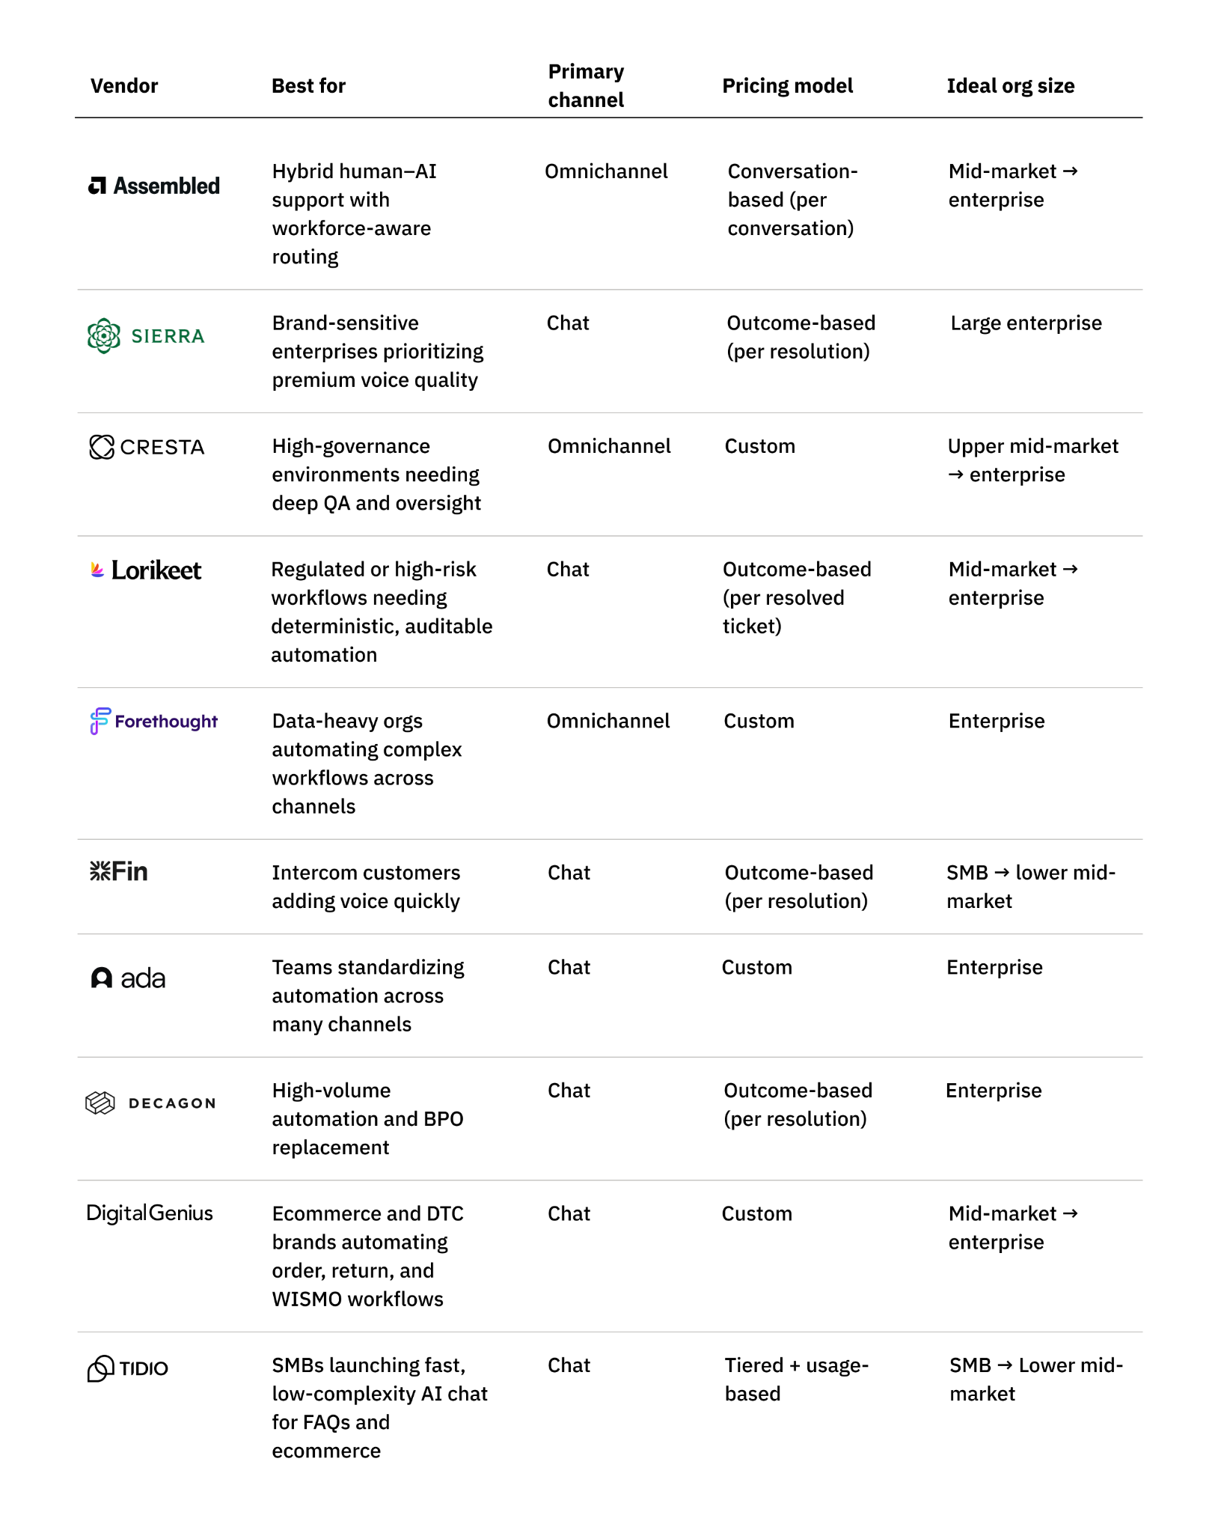
Table 2 Source: https://www.assembled.com/blog/ai-chat-agents-customer-support (2026)

Research summary

Assembled
Smart Features:
- AI chatbot platform that can handle customer support tasks
- Follow multi-step processes to complete actions
- Automate workflows without coding
- Intelligently route and escalate requests
- keep full context when passing to humans
- Works across multiple channels such as chat, email, and voice using a shared AI system.

Chat Interactions:
- Human handover / live chat and email-fallback escalation
- Multilingual responses
- AI response generation logic

Extensions :
- Auto ticket creation
- Context-rich handoffs with full transcript, summaries, and metadata

Monetization Model:
- Subscription-based
  - AI Copilot at $35/month
  - Workforce Management at $25/month.
- Usage-based
  - AI Agents at $0.65/per conversation

Sierra
Smart Features:
- Action-Oriented AI
- Sierra can handle multi-step processes
- Persistent Context Across Channels such as chat, SMS, email, and voice
- AI chat agents sound and behave like a real human that matches their brand identity
- Human handoff with smart summaries

Chat Interactions:
- Built-in human handoff with automatic summaries and routing
- Multilingual responses

Extensions:
- Ticket auto-creation
- Email Summary
- Chat Summary & Handoff
- Multilingual responses

Monetization Model:
- Total cost varies by volume, channels, enabled modules
- Specific price points are not publicly disclosed

Wonderchat
Features:
Training & Customization
- Website crawling, upload of documents, audio/video extraction
- Multiple AI models support
Chat Interactions
- Human handover / live chat and email-fallback escalation
- Suggested replies, lead capture/qualification forms, instant source links
- Multilingual responses
Extensions
- Ticket auto-creation
- AI phone & voice agent
- Chat history retention, transcript export, analytics
Monetization Model:
- Subscription-based
  - Starter - $29: 1,000 messages, 100 webpages/agent, 1 agent, basic file uploads.
  - Basic - $99: 6,000 messages, 1,000 webpages, 2 agents, live chat (3 seats).
  - Turbo - $299: 15,000 messages, 2,500 webpages, 4 agents, live chat (10 seats),
media uploads.
  - Enterprise - custom: unlimited quotas, advanced compliance and integrations.

SiteGPT
Features:
Training & Customization
- Website crawling, upload of documents
- Q&A Training
  - Uses real chat history to refine and improve chatbot
Chat Interactions
- Multilingual responses
- Human handover
Extensions
- Email Summaries
  - Daily summary of chatbot interactions, allows tracking of chatbot performance
- Chat history
  - Review of chatbot conversation
Monetization Model:
- Subscription-based (Monthly)
  - Starter - $39: 4,000 messages, 1000 webpages/agent, 1 chatbot
  - Growth - $79: 10,000 messages, 10,000 webpages, 2 chatbots, multi platform, auto webscrape to ensure up-to-date information
  - Scale - $259: 40,000 messages, 50,000 webpages, 3 chatbots, multi platform, auto webscrape to ensure up-to-date information

Fin
Features:
- AI-powered customer support chatbot
- Designed for FAQ / knowledge-based inquiries
- Focus on fast deployment with minimal setup workload
Interaction：
- Supports natural language conversations
- Mainly deals with short-term, information-oriented communication.
- Provide suggested responses and guided prompts
- Conversations that cannot be handled are passed to human agents
Intelligence & Response Mechanism:
- Use Large Language model (LLMs)
- Employing Retrieval-Augmented Generation (RAG) to retrieve relevant company information and generate responses that are humanized or context-aware for customers.
Extensions：
- Conversation history tracking
- Integration with customer support tools
- Knowledge base ingestion
Monetization Model:
- Subscription-based
- Enterprise plans available with customization and scaling options
- Pricing depending on number of conversations/messages and complexity which enterprise systems requires

Ada
Features:
- Support the implementation of automated customer service through structured workflows.
- Enable the automation of business processes (order tracking, refunds, account support)
- Control conversation logic using flow builder and decision-based routing
- Provide the process builder functionality for dialogue control.
Interaction：
- Support data-driven interactions
- Provides structured, goal-oriented and multi-turn conversations
- Produces clear and controlled responses based on defined logic
Intelligence & Response Mechanism:
- Uses Natural Language Processing (NLP) to detect user intent
- Routes queries into predefined conversation flows
- Combines rule-based logic and AI assistance
- Executes conditional logic and step by step interactions
- Constantly improving performance through learning
- Retrieves real-time data through API integration with backend systems
Extensions:
- Conversation analytics and performance tracking
- Ticket creation and support system integration
- Integration with enterprise systems. (Database, order management)
Monetization Model:
- Provide customized pricing plans based on the size and requirements of the enterprise.
- Pricing based on usage volume, features and integrations.

Product comparison

Features | Wonder Chat | SiteGPT | Assembled | Sierra | Ada | Fin | Our Product
Training & Customization
Web Crawling | Y | Y | Y | N | N | Y | Y
Upload of documents | Y | Y | Y | Y | Y | Y | Y
Video extraction | Y | N | N | N | N | N | N
Q&A Training | N | Y | Y | Y | Y | Y | Y
Chat Interactions
Multilingual responses | Y | Y | Y | Y | Y | Y | Y
Human Handover | Y | Y | Y | Y | Y | Y | N
Source Links | Y | N | Y | N | N | Y | Y
Extensions
Review of Chat History | Y | Y | Y | Y | Y | Y | Y
Email Summaries | N | Y | Y | Y | Y | Y | N
Ticket Creation | Y | N | Y | Y | Y | N | Y
AI phone & Voice Agent | Y | N | N | Y | Y | N | N

Project Motivation
In today’s fast-paced digital world where information is readily available, customers expect instant and effective responses to their queries. However websites without a customer chatbot may lack the ability and the solutions to address such issues. Thereafter, this creates a gap in the market to address such solutions and this would be where our chatbot, Aeris, would come into play to fill and address the market issue.
Aeris is motivated by the need to:
- Provide instant, 24/7 responses to customer inquiries.
- Automate handling of common questions and repetitive tasks.
- Reduce operational costs by minimizing the workload on human agents.
- Ensure consistent and accurate answers based on company knowledge and policies.
- Seamlessly escalate unresolved or complex issues to human support when necessary.
- Continuously learn and improve through user interactions and feedback.

Functional Requirements

Functional Hierarchy
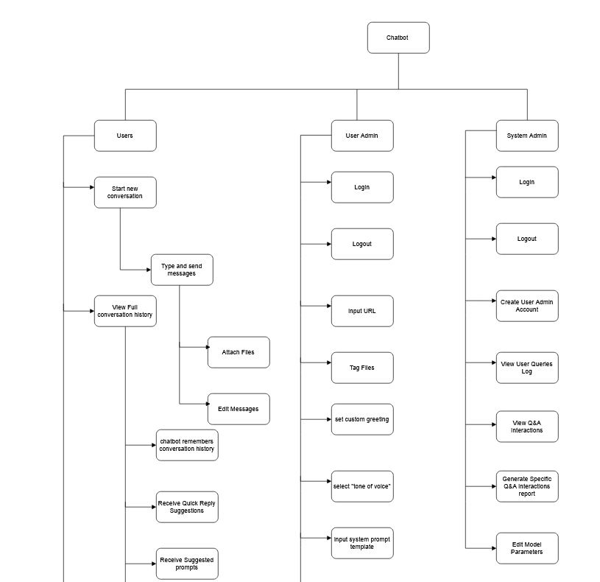

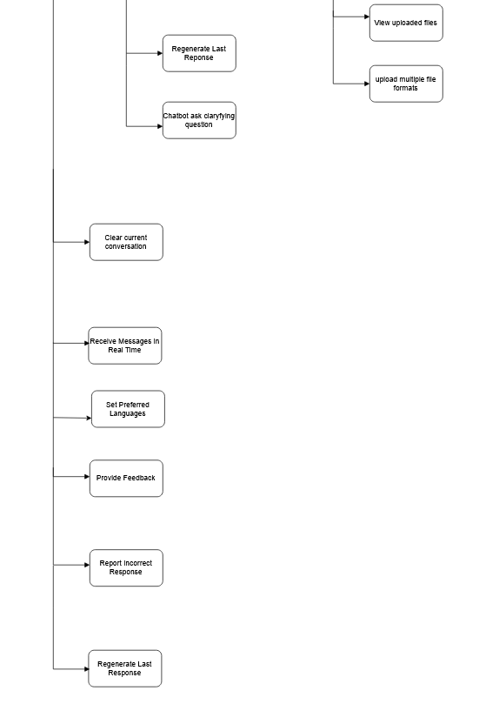

Preliminary Use Case Diagram

System Admin
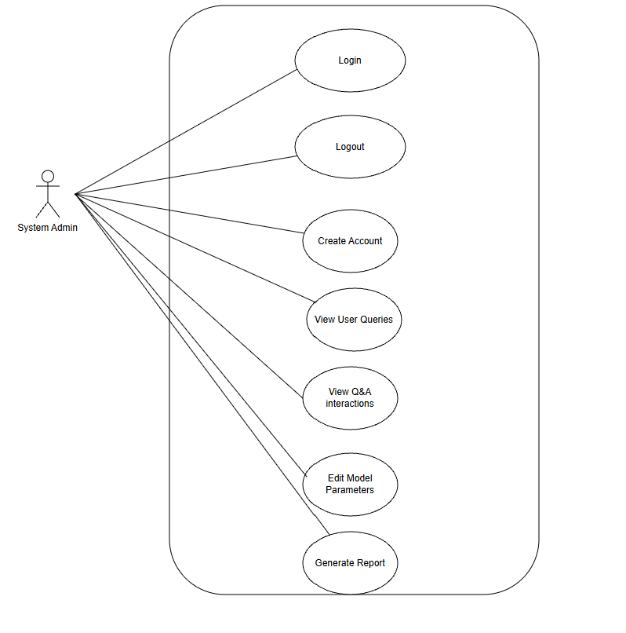

User Admin

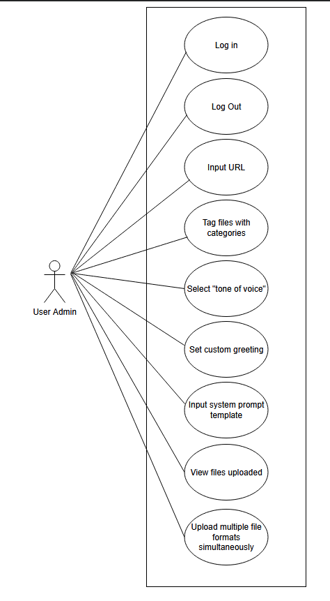

User
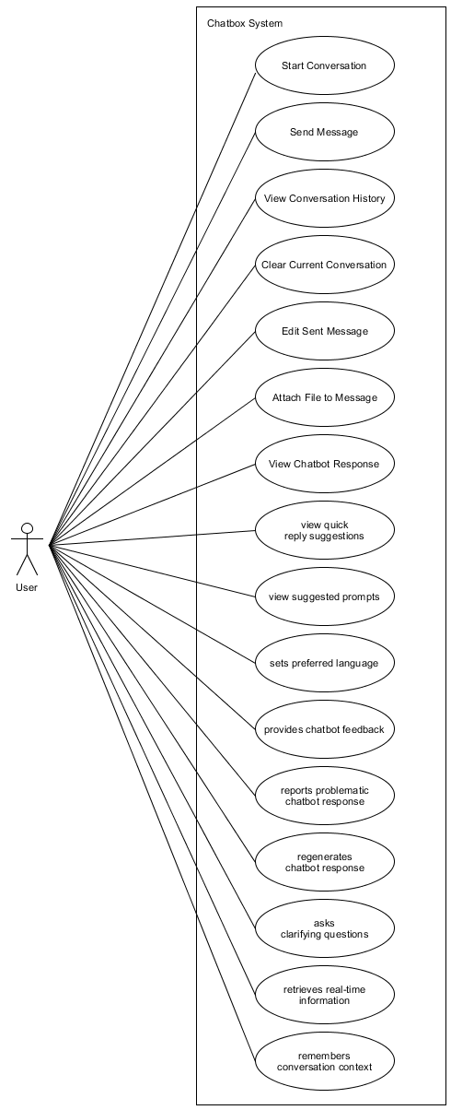

Preliminary Use Case Description

System Admin Use Case Description

Name: Login to System | ID: #01
User Story: As a System Admin, I want to be able to log into the system so that I can access the admin dashboard to control the chatbot back end settings.
Description: The System Admin authenticates their identity to gain access to the administrative features of the system.
Actors: System Admin
Trigger: When the System Admin opens the admin portal login page
Pre-condition: The System Admin has a valid account and internet access
Post-Condition: System Admin – To access the backend dashboard and manage chatbot settings.
Main flow:
- System Admin navigates to the admin login page
- System Admin enters their username/email and password.
- System Admin clicks the “Login” button.
- System validates the credentials.
- System grants access and redirects the user to the Admin Dashboard.
- End.
Alternative/Exceptional flow:
Incorrect credentials
- System displays an "Invalid username or password" error message.
- Return to Step 2.

Name: Admin Logout System | ID: #02
User Story: As a System Admin, I want to be able to log out of the system successfully when I am done with my tasks.
Description: The System Admin logs out to ensure no unauthorised access to the dashboard after their session ends.
Actors: System Admin
Trigger: The System Admin Clicks the logout button
Pre-condition:The System Admin is currently logged into the system
Post-condition:The active session is securely terminated and the System Admin is redirected to the login page.
Main Flow:
1. System Admin clicks on the profile icon.
2. System Admin clicks the Logout button.
3. System terminates the active session.
4. System redirects the user to the Login page.
Alternative/Exceptional flow:
None.

Name: Create User Admin Accounts | ID: #03
User Story: As a System Admin, I want to create accounts so that the User Admins will be able to access the system.
Description: The System Admin creates new login credentials and profiles for users designated as User Admins
Actors: System Admin
Trigger: The System Admin clicks 'Add New User' in the User Management section
Pre-condition:None
Post-condition:A new User Admin account is created and an activation email is dispatched.
Main Flow:
1. System Admin navigates to the User Management section.
2. System Admin clicks the Create Account button.
3. System displays the account creation form.
4. System Admin fills in details (name, email, role, temporary password).
5. System Admin clicks Save.
6. System validates the input and confirms the email is unique.
7. System saves the account to the database.
8. System sends an activation email to the new User Admin.
Alternative/Exceptional flow:
Email already exists: System displays 'Account already exists with this email' and returns to Step 4.

Name: View User Query Logs | ID: #04
User Story: As a System Admin, I want to view a log of user queries so that I can identify which topic requires more data.
Description: The System Admin reviews a list of queries submitted by users to understand user intent and data gaps.
Actors: System Admin
Trigger: When the System Admin selects the “Query Logs” tab.
Pre-condition: The System Admin is logged in and user data exists in the database.
Post-condition: System Admin to be able to identify topics that require more data or training.
Main flow:
- System Admin navigates to the “Analytics” section.
- System Admin selects “User Query Logs.”
- System fetches the list of recent user queries.
- System Admin applies filters (date range, keyword, etc.) if necessary.
- System displays the filtered query list.
- System Admin identifies missing data trends.
- End.

Alternative/Exceptional flow:
No logs found, system displays "No records found for the selected period."

Name: View Q&A Interactions for Fine-Tuning | ID: #05
User Story: As a System Admin, I want to view Q&A interactions from the users so that it can be used to fine tune the chaining process.

Description: .The System Admin views full conversational pairs (user prompt and model response) to evaluate and improve the model's chaining logic.
Actors: System Admin
Trigger: The System Admin accesses the Conversation History section
Pre-condition: The System Admin is logged into the system.
Post-condition: The System Admin is able to analyse model logic and initiate fine-tuning where necessary
Main flow:

1. System Admin navigates to Interaction Logs.
2. System Admin selects a specific interaction or session.
3. System displays the user prompt, retrieved context, and final model response.
4. System Admin reviews the chaining logic used.

Alternative/Exceptional flow: None

Name: Generate Q&A Interaction Report | ID: #06
User Story: As a System Admin, I want to generate a report of specific Q&A interactions so that I can review the previous mistakes of the model.
Description: The System Admin exports specific interaction data into a report format to analyze model errors.
Actors: System Admin
Trigger:When the System Admin clicks the “Generate Report” button.
Pre-condition: The System Admin has identified specific interactions/errors to be reported.
Post-Condition: System Admin to be able to create a document of model mistakes for review and auditing.
Main flow:
- System Admin navigates to the “Reports” section.
- System Admin selects the criteria for the report (e.g., interactions marked as "Incorrect").
- System Admin clicks “Generate Report.”
- System compiles the data into a PDF or CSV file.
- System Admin downloads the file.
- End.
Alternative/Exceptional flow:
Report generation failure.
- System displays "Error generating report. Please try again later."

Name: Edit Model Parameters | ID: #07
User Story: As a System Admin, I want to edit model parameters via the backend dashboard so that I can control the accuracy of the Q&A responses.
Description: The System Admin modifies the technical configuration of the AI model via the dashboard.
Actors: System Admin
Trigger: When the System Admin navigates to the “Model Configuration”
Pre-condition: The System Admin must be logged in
Post-Condition: System Admin able to adjust settings like temperature or top-p to control response accuracy
Main flow:
- System Admin navigates to the “Model Settings” page.
- System displays current parameters (e.g., Temperature, Max Tokens, System Prompt).
- System Admin modifies the values.
- System Admin clicks “Apply Changes.”
- System validates that the values are within the allowed range.
- System updates the model configuration in real-time or upon next restart.
- End.
Alternative/Exceptional flow:
Out-of-range values.
- System displays "Value must be between 0 and 1."
- Return to Step 3.

User Admin Use Case Description

Name: User Admin log into system | ID: #08
User Story: As a User Admin, I want to be able to log into the system so that I can access the admin dashboard to control the chatbot front end settings.
Description: The User Admin modifies the front end of the chatbot via the dashboard.
Actors: User Admin
Trigger: When the User Admin opens the admin portal login page
Pre-condition: System admin must have created an account for the user admin and the user admin must have valid credentials.
Post-condition: User admin would have logged into the system and is able to view the user admin dashboard.
Main flow:
- User Admin navigates to the admin login page
- User Admin enters their username/email and password.
- User Admin clicks the “Login” button.
- System validates the credentials.
- System grants access and redirects the user to the User Admin Dashboard.
- End.
Alternative/Exceptional flow: Incorrect credentials
- System displays an "Invalid username or password" error message.
- Return to Step 2.

Name: User Admin log out of system | ID: #09
User Story: As a User Admin, I want to be able to log out of the system successfully when I am done with my tasks.
Description: User admin to safely terminate current session to ensure security.
Actors: User Admin
Trigger: When the User Admin clicks on the “Log out” button.
Pre-condition: The User Admin is currently logged into the system.
Post-condition: The user admin would have been safely logged out of the system.
Main flow:
- The User Admin clicks on the profile icon.
- User admin clicks on “logout” button.
- System terminates the active session.
- System redirects the user back to the login page.
- End.
Alternative/Exceptional flow: None.

Name: Input URL | ID: #10
User Story: As a User Admin, I want to input a URL, so that the chatbot can automatically ingest information from our company website or documentation portals.
Description: User Admin inputs a URL into the chatbot so that it extracts the information into the knowledge base.
Actors: User Admin
Trigger: The User Admin will have to input the URL into the chatbot and then hit enter.
Pre-condition: User Admin has to be logged into the system and has access to the URL.
Post-condition: The user admin would be able to see the URL that was input in the system under the ‘knowledge sources’ category.
Main flow:
- User Admin navigates to the ‘knowledge sources’ on the dashboard.
- User Admin to click “Add URL”
- User to input the URL in the input field and hit submit.
- System displays a confirmation status which shows the User Admin that it is done.
Alternative/Exceptional flow: Invalid URL
Error message: “Invalid URL. Please enter a valid URL” shown and User Admin to be redirected to step 2.

Name: Tag files with categories when they are uploaded. | ID: #11
User Story: As a User Admin, I want to tag files with categories when they are uploaded so the sources can be tagged when being used to generate answers.
Description: User Admin is able to tag certain categories to the files when it is uploaded to the system.
Actors: User Admin
Trigger: The User Admin will have to input the document into the upload documentation portal and then hit enter.
Pre-condition:
- User Admin has to be logged into the system.
- The categories have to be predefined in the files portal.
- The document has to be in a valid file format.
Post-condition: User admin would be able to see the file in the category they selected in the category they tagged it as.
Main flow:
- User Admin navigates to the ‘knowledge sources’ on the dashboard.
- User Admin to click “Add file”.
- User to upload the file in the input field.
- Beside the input field there is a “choose category” option that the user admin will have to click on.
- The user admin would have to choose the category they want the tag the file as.
- The user admin would also have to include some information like a brief description.
- Once a category is chosen, the user admin will then click on “upload” which will then upload the file to the files portal.
- System displays a confirmation status which shows the User Admin that it is done.
Alternative/Exceptional flow:
- Unsupported file format.
- System displays an error message, “Invalid file format, please upload valid file format.”
- Redirects user admin to step 2.
2. Category not selected.
- System displays an error message, “File category not chosen, please choose a category.”
- Redirects user admin to step 2.
3. Category not found in list.
- The user admin will then be prompted to create a new category using a “+” icon.
- User admin can then create new category.

Name: Select “tone of voice” | ID: #12
User Story: As a User Admin, I want to select a "tone of voice" for the chatbot so that the chatbot remains respectful and friendly towards the users.
Description: User Admin be able to change the “tone of voice” for the chatbot so that it can consistently remain friendly and respectful.
Actors: User Admin
Trigger: User admin selects “chatbot configuration” on the user admin dashboard.
Pre-condition:
- The user admin is logged into the system.
- There are predefined options for tone choices.
Postcondition: A tone that is to the user admin’s requirement has been set.
Main flow:
- User admin to select “chatbot configuration” on the user admin dashboard.
- User admin to select the “tone of voice” option.
- System displays a variety of tone options for the user admin to choose from.
- User admin picks the tone they want and clicks save.
Alternative/Exceptional flow: None.

Name: Select custom greeting for the chatbot. | ID: #13
User Story: As a User Admin, I want to select a "tone of voice" for the chatbot so that the chatbot remains respectful and friendly towards the users.
Description: User Admin be able to set a custom greeting for the chatbot that is in line with their brand identity.
Actors: User Admin
Trigger: User admin selects “chatbot configuration” on the user admin dashboard.
Pre-condition:
- User Admin has to be logged into the system.
- The chatbot has been setup and accessible via the dashboard.
Postcondition:
- The custom greeting has been saved and applied to the chatbot for use.
- The users will be greeted by the updates custom greeting upon starting a new conversation.
Main flow:
- User admin to select “chatbot configuration” on the user admin dashboard.
- User admin to select the “custom greetings” option.
- System to have an input box that says, “Please input your custom greeting here:”
- User admin will then enter the custom greeting in the text box and click on save.
- System displays a confirmation status which shows the User Admin that it is done.
Alternative/Exceptional flow:
User admin leaves the text input box empty.
- System will prompt an error message, “Greeting cannot be empty, please enter a message.”
- System redirects to step 3 where the user admin will be prompted to enter a custom greeting.

Name: Input system prompt template | ID: #14
User Story: As a User Admin, I want to input the system prompt template so that the chatbot doesn't provide unauthorized advice.
Description: User Admin be able to input a prompt template so that the chatbot doesn’t provide unauthorised advice.
Actors: User Admin
Trigger: User admin selects “chatbot configuration” on the user admin dashboard.
Pre-condition:
- User Admin has to be logged into the system.
- The chatbot’s configuration settings are accessible to the user admin on the user dashboard.
Post-condition:
- The prompt template is saved and applied to the chatbot.
- The chatbot will only respond within the boundaries that have been set for the chatbot.
Main flow:
- User admin to select “chatbot configuration” on the user admin dashboard.
- User admin to select, “System prompt template” settings.
- System to display an input box that says, ”Please define the chatbot’s restrictions and boundaries:"
- The user admin will then enter the boundaries and restrictions they want to implement in the text box and click on save.
- System displays a confirmation status which shows the User Admin that it is done.
Alternative/Exceptional flow:
User admin leaves the text input box empty.
- System will prompt an error message, “System prompt cannot be empty, please enter a template.”
- System redirects to step 3 where the user admin will be prompted to enter a custom greeting.

Name: View files that has been uploaded. | ID: #15
User Story: As a User Admin, I want to view the files that I have uploaded so that I can ensure that the data has been properly processed.
Description: User Admin be able to view the files that has been uploaded to the system.
Actors: User Admin
Trigger: User admin selects the “Chatbot knowledge base” portal of the user admin dashboard.

Pre-condition:
- The user admin is logged into the system.
- There is at least 1 file has been uploaded to the system previously.
Postcondition:
- The user admin is able to check the files that have been confirmed to be uploaded to the system’s knowledge base.
- Any failed or missing files to be reuploaded.
Main flow:
- User admin to select the “chatbot knowledge base” section and click on it.
- System displays all the all files that has been uploaded.
- The user admin can then review a list of files that have been uploaded and check the status of it.
- The user admin can then confirm if it has been properly processed or not.
Alternative/Exceptional flow:
- File upload failed.
- System will flag out that the file failed to upload.
- No files uploaded.
- System will prompt an error message, “No files uploaded. Please upload a file.”

Name: Upload a file to the system. | ID: #16
User Story: As a User Admin, I want to upload a file to the system, so that I can extract information from the files for the knowledge base.
Description: User Admin is able to upload a file to the system to extract information for the knowledge base.
Actors: User Admin
Trigger: User admin selects the “Chatbot knowledge base” portal of the user admin dashboard.

Pre-condition:
- The user admin is logged into the system.
- The system has predefined what file formats are accepted.

Post-condition:
- The user admin is logged into the system.
- The file that the user admin has uploaded is saved in the knowledge base with the categories tagged accordingly.
- The knowledge base is now updated and the chatbot can use it to retrieve information.
Main flow:
- User admin to select the “chatbot knowledge base” section and click on it.
- User admin to click on the option “upload file”
- The system will then display an input box with a prompt, “Please upload a file”
- The user admin will then select the file from their device files or will be able to drag and drop the file to upload.
- The user admin to tag the files with their category and add a short description.
- The user admin to click on “Upload”.
- The system will upload the file that the user admin has selected.
- System displays a confirmation status which shows the User Admin that it is done.
Alternative/Exceptional flow:
- File upload failed.
- System will flag out that the file failed to upload.
- File format unsupported.
- System will prompt an error message, “Filename could be uploaded due to unsupported file format.”

Name: Search for a previously uploaded file in the system. | ID: #17
User Story: As a User Admin, I want to be able to search through the uploaded files so that I can look for a file that I have previously uploaded.
Description: User admin can look for a file that they have previously uploaded in the system.
Actors: User Admin
Trigger: Entering a keyword in the search bar.
Pre-condition:
- The user admin is logged into the system.
- The system has predefined what file formats are accepted.
Post-condition:
- The user admin would be able to successfully search up the specific file that they were looking for.
Main flow:
- User admin to select the “chatbot knowledge base” section and click on it.
- There is a search bar for the user admin to enter the file name.
- Once the user admin has entered the keyword into the search bar, enter is clicked.
- The dashboard should now show the list of files with the keyword that they had entered in the search bar.
Alternative/Exceptional flow:
- File with keyword entered does not exist
- System will prompt “File not found” to the user admin.
- Return to step 3.

User Use Case Description
Name: Start Conversation | ID: #18
User Story: As a user, I want to start a new conversation so that I can begin interacting with the chatbot.
Description: The user starts a new conversation with the chatbot so that the user can begin interacting with the system.
Actors: User
Trigger: The user clicks the “Start Conversation” button or opens a new chat session.
Preconditions:
- The user has accessed the chatbot system.
- The chatbot interface is available.
Postconditions:
- A new conversation session is created.
- The chat window is ready for the user to enter messages.
- Any previous conversation context is not carried into the new conversation.
Main Flow:
- The user accesses the chatbot system.
- The system displays the chatbot interface.
- The user selects the option to start a new conversation.
- The system creates a new conversation session.
- The system displays an empty chat window for the new conversation.
Alternative Flows:
- Chat interface fails to load
- The system is unable to load the chatbot interface.
- The system displays an error message to the user.

2. New conversation cannot be created
- The system fails to create a new conversation session.
- The system displays a failure message.

Name: Send Message | ID: #19
User Story: As a user, I want to type and send messages so that I can communicate with the chatbot.
Description: The user can type and send messages to the chatbot so that the user can communicate with the system and receive responses.
Actors: User
Trigger: The user types message and clicks the “Send” button or presses Enter
Preconditions:
- The user has started a conversation.
- The chatbot interface is displayed and ready for input.
Postconditions:
- A new message is sent to the chatbot.
- The message is displayed in the chat window.
- The chatbot generates and displays a response
Main Flow:
- The user types a message in the input field.
- The user sends the message.
- The system receives the message.
- The system displays the user’s message in the chat window.
- The system processes the message.
- The system generates a response.
- The system displays the chatbot’s response

Alternative Flows
No conversation history available
- The user scrolling down the page trying to find historical conversations
- The system finds no previous messages.
- The system displays a message such as “No conversation history available.”

Name: View Conversation History | ID: #20
User Story: As a user, I want to see the full conversation history in the chat window, so that I can review previous messages.
Description: This use case allows the user to view the full conversation history in the chat window so that the user can see previous messages and responses
Actors: User
Trigger: The user open the sidebar or scrolls through to view the pass message
Preconditions:
- At least one conversation between chatbot
- The chatbot interface is available.
Postconditions:
- The conversation history is displayed in the chat window.
- The user can scroll and review previous messages.
Main Flow:
- The user accesses the chatbot interface
- The system retrieves the conversation history.
- The system displays all previous messages in the chat window.
- The user scrolls through the conversation history

Alternative Flows
- User sends an empty message
- The user attempts to send a message without entering any text.
- The system detects the empty input.
- The system displays a warning message

Name: Clear Current Conversation | ID: #21
User Story: As a user, I want to clear the current conversation so that I can start a new conversation afresh.
Description: The user clear the current conversation so that the user can start a new conversation with a clean chat history
Actors: User
Trigger: The user selects “Clear Conversation”option
Preconditions:
- At least one conversation between chatbot
- The chatbot interface is available.
Postconditions:
- All messages in the current conversation are removed.
- The chat window is reset to an empty state.
- A new conversation context is prepared
Main Flow:
- The user selects the option to clear the current conversation.
- The system prompts the user for confirmation.
- The user confirms the action.
- The system deletes all messages in the current conversation.
- The system resets the chat window to an empty state.
- The system prepares a new conversation context.

Alternative Flows
- User cancels the action
- The system prompts for confirmation.
- The user cancels the action.
- The system keeps the current conversation unchanged.

Name: View Chatbot Response | ID: #22
User Story: As a user, I want to receive the message in real-time so that the conversation feels natural and responsive.
Description: The user can view the chatbot’s response after sending a message so that the user can understand the reply and continue the conversation.
Actors: User
Trigger: The system generates a response after the user sends a message.
Preconditions:
- The user has started a conversation.
- The user has sent a message to the chatbot.
- The system is able to process user input.
Postconditions:
- The chatbot’s response is displayed in the chat window.
- The response is added to the conversation history.
- The user can continue interacting with the chatbot.
Main Flow:
- The user sends a message to the chatbot.
- The system processes the user’s message.
- The system generates an appropriate response.
- The system displays the chatbot’s response in the chat window.
- The system stores the response in the conversation history.
Alternative Flows
- No relevant response found
- The system processes the message.
- The system cannot determine an appropriate response.
- The system displays a fallback message
2. Response generation delay
- The system processes the message.
- The response generation takes longer than expected.
- The system displays a loading indicator.
- The system displays the response once ready.

Name: Edit Sent Message | ID: #23
User Story: As a user, I want to edit my messages after sending so that I can correct mistakes.
Description: The user can edit a previously sent message so that the user can correct mistakes or update the content.
Actors: User
Trigger: The user selects the option to edit a previously sent message.
Preconditions:
- At least one conversation between chatbot
- The chatbot interface is available.
Postconditions:
- The selected message is updated with the new content.
- The updated message is displayed in the chat window.
- The conversation history reflects the edited message.
Main Flow:
- The user selects a message to edit.
- The system enables edit mode for the selected message.
- The user modifies the message content.
- The user confirms the update.
- The system updates the message content.
- The system refreshes the chat window to reflect the updated message

Alternative Flows
- User cancels editing
- The user enters edit mode.
- The user cancels the edit operation.
- The system exits edit mode without making any changes.
2. Invalid input during editing
- The user edits the message with invalid or empty content.
- The system detects invalid input.
- The system displays a validation message

Name: Attach File to Message | ID: #24
User Story: As a user, I want to attach files to my message so that I can ask questions about them.
Description: The user can attach a file to a message so that the user can ask questions about the file content.
Actors: User
Trigger: The user selects the option to edit a previously sent message.
Preconditions:
- At least one conversation between chatbot
- The chatbot interface is available.
- The system supports file attachment functionality.
Postconditions:
- The selected file is attached to the message.
- The attached file is displayed in the chat interface.
- The file is ready to be sent together with the message.
Main Flow:
- The user selects the file attachment option.
- The system opens a file selection dialog.
- The user chooses a file from the device.
- The system uploads the selected file.
- The system validates the file type and size.
- The system attaches the file to the message.
- The system displays the attached file in the chat interface.
Alternative Flows
1. User cancels file selection
a. The system opens the file selection dialog.
b. The user cancels the selection.
c. No file is attached.
d. The use case ends.
2. Unsupported file type
a. The user selects a file.
b. The system checks the file type.
c. The system determines that the file type is not supported.
d. The system displays an error message.
3. File exceeds size limit
a. The user selects a file.
b. The system checks the file type.
c. The system determines that the file type is not supported.
d. The system displays an error message.

Name: User view quick reply suggestions. | ID: #25
User Story: As a user, I want to see quick reply suggestions from the chatbot so that I can respond faster.
Description: This allows the chatbot to display suggested quick replies after sending a message so the user can select one without typing manually.
Actors: User
Trigger: Chatbot sends a response message.
Pre-condition: User is interacting with the chatbot.
Post-condition: User submits the selected quick reply that he or she has chosen.
Main flow:
- The user sends a message to the chatbot.
- The chatbot generates a response.
- The system displays quick reply suggestions below the chatbot response.
- The user selects one of the suggested replies.
- The chatbot processes the selected reply.
Alternative/Exceptional flow:
- If no suitable quick replies are available, the system does not display suggestions.
- The user may ignore the suggestions and type a custom reply instead.

Name: User sets preferred language | ID: #26
User Story: As a user, I want to select my preferred language so that the chatbot communicates with me in the selected language.
Name: User sets preferred language
Description:This allows the user to choose a preferred language for chatbot interactions.The chatbot will then respond using the selected language.
Actors: User
Trigger: User clicks “language” button
Pre-condition: user is on the chatbot page
Post-condition: The system saves the user’s selected language preference
Main flow:
- The user click “language” button.
- The system displays a list of available language options.
- The user selects a preferred language.
- The system saves the selected language preference.
Alternative/Exceptional flow:None

Name: User provides chatbot feedback | ID: #27
User Story:As a user, i want to provide feedback on the chatbot’s responses using a thumbs up or thumbs down so that it can improve
Description: This allows the user to give quick feedback on chatbot responses by selecting either thumbs up or thumbs down. The system records the feedback for future analysis and chatbot improvement.
Actors: User
Trigger: User clicks thumbs up or thumbs down button on a chatbot response.
Pre-condition: User is on the chatbot page and a chatbot response has been displayed.
Post-condition: The system saves the user’s feedback on the chatbot response.
Main flow:
- The chatbot displays a response to the user.
- The system shows thumbs up and thumbs down feedback buttons.
- The user clicks either thumbs up or thumbs down.
- The system records the selected feedback.
Alternative/Exceptional flow:
- If the user does not select any feedback, no feedback is recorded.
- If the system fails to save feedback, an error message is shown.

Name: User reports problematic chatbot response | ID: #28
User Story:As a user, i want to report problematic or incorrect responses so that issues can be addressed
Description: This allows the user to submit a report on chatbot responses that are inaccurate, inappropriate, or problematic. The system records the report for review and future improvements.
Actors: User
Trigger: User clicks the report button on a chatbot response.
Pre-condition: User is on the chatbot page and a chatbot response has been displayed.
Post-condition: The system saves the user’s report for review.
Main flow:
- The user clicks the report button.
- The system displays a report form.
- The user enters the details of the issue.
- The user clicks the “Submit” button.
- The system records the report successfully.
Alternative/Exceptional flow:
- If the user cancels the report, no report is submitted.
- If the system fails to save the report, an error message is shown.
- If no reason is selected when required, the system asks the user to complete the report form.

Name: User regenerates chatbot response | ID: #29
User Story: As a user, I want to regenerate the chatbot’s last response so that I can get a different response if I am not satisfied with it
Description: This allows the user to ask the chatbot to generate a new response. The system creates another reply based on the same question or conversation.
Actors: User
Trigger: User clicks “Regenerate” button
Pre-condition: User is on the chatbot page and a chatbot response has been displayed.
Post-condition: The system generates and displays a new chatbot response.
Main flow:
- The chatbot displays a response to the user.
- The user clicks the “Regenerate” button.
- The system processes the request.
- The system generates a different response based on the same input.
- The system displays the new response to the user.
Alternative/Exceptional flow:
- If the system fails to generate a new response, an error message is shown.
- If no previous chatbot response exists, an error message is shown.

Name: Chatbot asks clarifying questions | ID: #30
User Story: As a user, I want the chatbot to ask clarifying questions when my request is ambiguous so that the chat bot can better understand my needs and provide more accurate and helpful responses
Description: This allows the chatbot to ask additional questions when the user’s request is unclear or incomplete. The system gathers more information before providing a final response.
Actors: User
Trigger: User enters an unclear or ambiguous request in the chatbox.
Pre-condition: User is on the chatbot page and has entered a request.
Post-condition: The system receives additional details and provides a clearer, more accurate response.
Main flow:
- The chatbot displays a response to the user.
- The system detects that the request is unclear or ambiguous.
- The chatbot asks a clarifying question.
- The user provides additional details.
- The system processes the new information.
- The chatbot provides a more accurate and helpful response.
Alternative/Exceptional flow:
- If the request becomes clear without clarification, the chatbot responds normally.
- If the system cannot understand the request after clarification, an error message or fallback response is shown.
- If the user does not respond, the conversation remains pending.

Name: Chatbot retrieves real-time information | ID: #31
User Story:As a user, I want the chatbot to retrieve real-time information from external systems so that I can get up-to-date answers
Description: This allows the chatbot to fetch real-time data from external sources such as Website or databases.The system processes the user’s query and retrieves the latest available information before generating a response.
Actors: User
Trigger: User asks a question that requires up-to-date or real-time information.
Pre-condition: User is on the chatbot page and the chatbot system has access to external systems
Post-condition: The system retrieves real-time data and generates a response to displays to the user.
Main flow:
- The user submits a query to the chatbot.
- The system identifies that the query requires real-time information.
- The system sends a request to an external system
- The external system returns the latest data.
- The chatbot processes the retrieved data.
- The chatbot generates a response using the real-time information.
- The system displays the response to the user.

Alternative/Exceptional flow:
- If the external system is unavailable, an error message is shown.
- If no relevant data is found, the chatbot provides a fallback response or asks the user for clarification.

Name: Chatbot remembers conversation context | ID: #32
User Story: As a user, I want the chatbot to remember previous context so that I don’t need to repeat information
Description: This feature allows the chatbot to store and use context from earlier messages within the conversation. The system references past interactions to generate more accurate and context-aware responses.
Actors: User
Trigger: After the user starts a conversation, they can scroll up within the chat to view previous messages.
Pre-condition:The user has an existing conversation with the chatbot.
Post-condition: The system displays the full conversation history, and the user can continue interacting with the chatbot from that point.
Main flow:
- The user starts a conversation with the chatbot.
- The system automatically saves and retains the conversation context.
- The user can scroll up at any time during the conversation to view all previous messages.
- The system continues to display new messages and updates the conversation as the user interacts with the chatbot..
Alternative/Exceptional flow:None

Proposed Plan

Execution Strategy
We will adopt the Waterfall methodology to manage deliverables through a structured and sequential approach. The Waterfall model allows us to complete each phase before moving to the next, ensuring clear documentation, well-defined requirements, and systematic progress throughout the project. This will allow us to maintain control over the project while reducing uncertainties during development.

Software Development Methodology
Methods
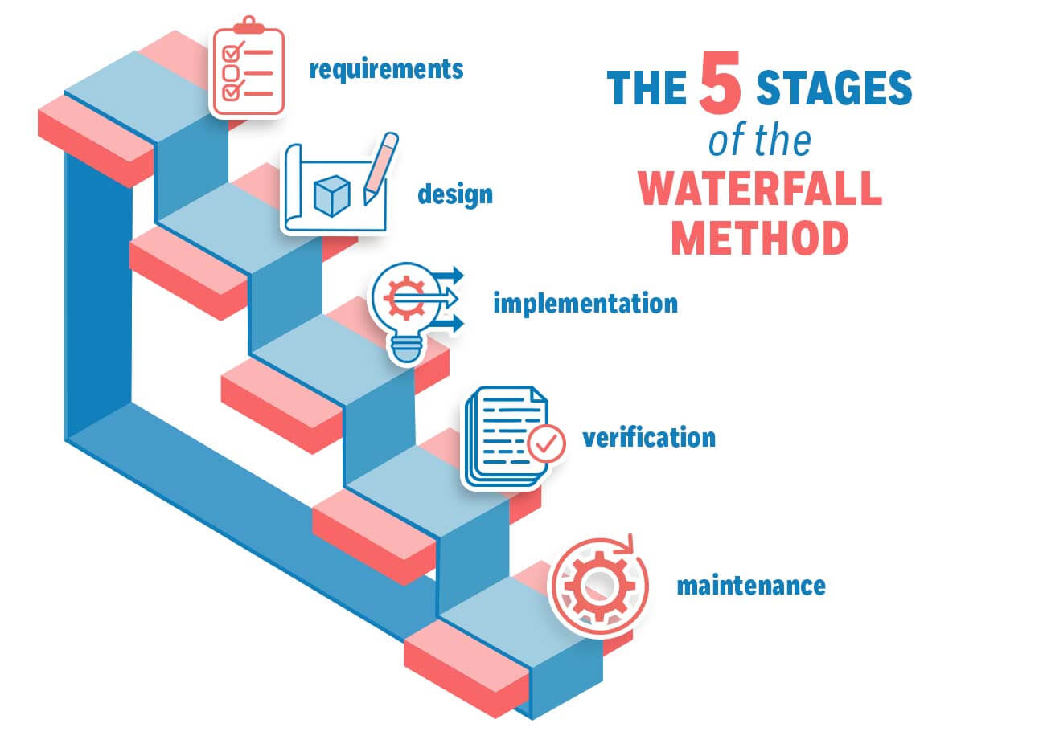

Image taken from (ProjectManagement.org, 2026. Waterfall Methodology: History, Principles, Stages & More. )

Phases of Waterfall Model
- Requirement Analysis
- Collect and define system requirements, including functional requirements and non-functional requirements.
- The output is the User Requirement Specification (URS) report.
- System Design
- Design the system architecture based on the requirements defined, include:
- System architecture
- Database design
- Unified Modeling Language (UML) Diagrams(Use Case Diagrams (UCD), Sequence Diagrams)
- Implementation
- Developers code according to the design documents to implement system functions.
- Testing
- Unit Testing
- System Testing
- Integration Testing
- Ensure that the system meets the specified requirements and has no major defects.
- Deployment
- Deploy the system to the actual environment (such as web platform）for user use.
- Maintenance
- Maintenance after the system is production, including:
- Bug fixes
- Feature optimization
- System update
The waterfall model was chosen for this project because the system requirements are well defined and stable in the early stages.
In addition, the project contains clear documentation and structured deliverables that are in good agreement and aligns with the sequential nature of the waterfall model.
The model also allows for better planning, easier progress tracking, and clearer milestone evaluation, suitable for academic project development.

Risk Analysis

 |  | Risk Elements
Risk Category | Identified Risk | Impact | Probability | Risk Rating
Resources | 1.Limited budget for premium features | M | L | L
 | 2. Inadequate number of developers or testers | M | M | M
 | 3. Hardware limitations? | M | M | M
Technical | - Hallucinations where the model might still provide incorrect advice | H | M | M

 | 2. Bugs affecting performance | M | H | H
User | 1. The "clarifying questions" feature might become repetitive or annoying to the user | L | L | L
 | 2. Privacy concerns discourage registration | H | M | H
Maintenance | 1. Frequent updates required due to device API changes | M | M | M
 | 2. Technical debt from rushed releases | M | M | M

Security | 1. Data leaks of user conversation | H | L | M
 | 2. Insecure storage of premium customers details | H | M | H
 | 3. Unauthorized access might have weak credentials leading to backend breaches | H | H | H
 | 4. Users might attach files that inadvertently contain PII (Personally identifiable information) | H | M | M
Scalability | 1. Backend fails under high traffic (e.g., competitions) | H | M | M
 | 2. Limitations in expanding to other avenues (e.g, mobile apps) | L | L | L
 | 3. Inability to be able to include extra features due to the lack or resources | L | L | L
Reliability | 1. Aeris not being able to provide the accurate response | H | L | M
 | 2. Inconsistent response (hallucinations) | M | M | M

Proposed Duration and Schedule
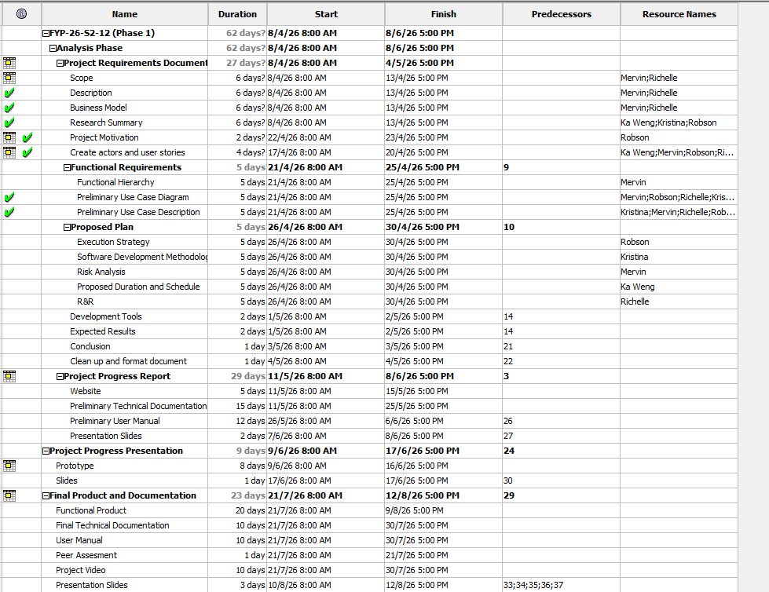

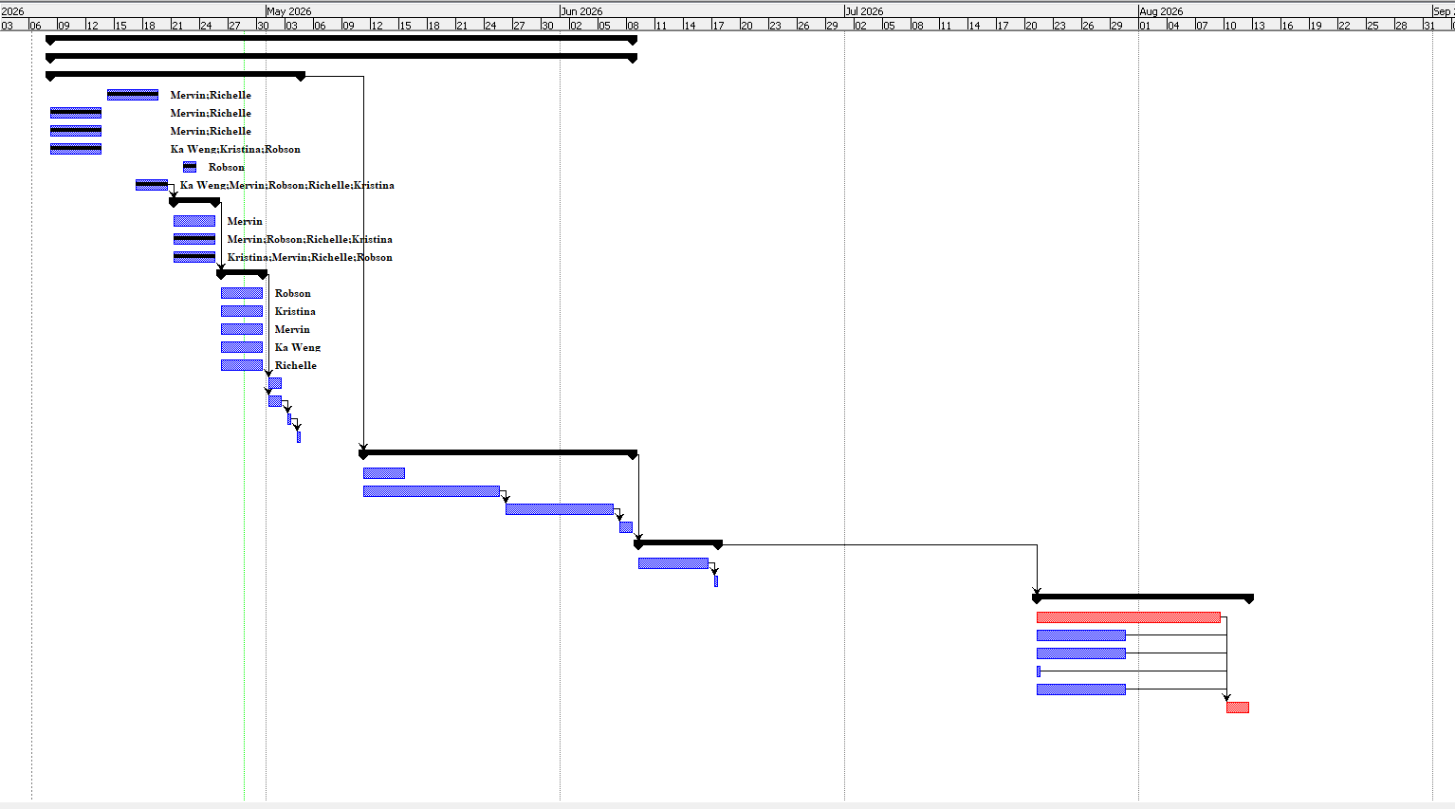

Roles and Responsibility

Name | Roles | Responsibilities
Poon Ka Weng | Group leader, Documentation, Back end developer, | Delegates the tasks to the members, oversees the quality of the project, main coordinator with the supervisor.  Develop schedules and timelines for the project.  Designs and code the main system with according to the documentation
Wang QinXue | Documentation, UI/UX designer. | Draws the various diagrams in the document and writes all other project related contents.  Creates the wireframe and prototype for the system.
Richelle Tang Li Xin | Lead Documentation, Software tester | Draws the various diagrams in the document and writes all other project related contents.  Oversees and manages the document, records meeting minutes.  Prepare and run test cases for the system.
Robson Goh Zhu Heng | Documentation,  Front end developer | Draws the various diagrams in the document and writes all other project related contents.  Codes the UI/UX of the system, ensures accessibility for the users.
Wee Jun Yuan Mervin | Documentation, Software tester | Draws the various diagrams in the document and writes all other project related contents.  Prepare and run test cases for the system.

Development Tools

Front-end
Development Tools | Visual Studio Code
Language | Python/JavaScript/TypeScript
Framework | Streamlit/React
Description
Streamlit is an open source Python library for building interactive web apps only using python.
React is an open source JavaScript library for building user interfaces. It allows the user to easily build and reuse Javascript components with ease. The components are whatever that is displayed to the user.
Back-end
Development Tools | Visual Studio Code
Language | Python
Description

Chatbot will be developed using LangChain, LangGraph framework to build and manage agents for execution, agents deciding which tools to use, streaming etc. LangChain also provides integration with chat models, embedding models to streamline LLM applications. (LangChain, n.d.)
Database
Development tools | MySQL workbench, ChromaDB
Language | MySQL, Python
Description
MySQL is a Relational Database Management System (RDBMS). The database will be used to store user admin, platform management information and also storing of documents that are uploaded by the user admins. (Oracle Corporation, n.d.)
Why MySQL?
- Open Source

- Fast, reliable, scalable
- MySQL can be integrated with MySQL Workbench to provide data modeling, admin tools for server configuration this would allow greater control over the database (Oracle Corporation, n.d.)
ChromaDB is an open-source search infrastructure for artificial intelligence.
ChromaDB allows us to store embeddings with metadata, use vector search to search through dense, sparse databases, and query by similarity search. This would allow us to retrieve the relevant chunks in our knowledge base with ease. (Chroma, n.d.)

Expected Results

Goal | Expected Result
Real-time support | Users receive immediate responses to their questions and issues through Aeris.
24/7 availability | Aeris provides support services anytime without depending on working hours.
Faster issue resolution | Common problems and FAQs are solved quickly without waiting for human support.
Reduced admin workload | Aeris handles repetitive inquiries, reducing the workload of support staff.
Accurate information retrieval | Aeris retrieves correct and updated information according to the user’s request.
Conversation history | Users can view and continue previous conversations from the chat history.
Human escalation support | Complex or unresolved issues are forwarded to human administrators for further assistance.

Regulations

As the use of AI chatbots in customer support and e-commerce rises, there is a need for new laws to be put in place to regulate how platforms are to collect data, generate responses and to protect users from privacy violations and the spread of misinformation.
LLM, user data and automated decision-making are the main components for an AI chatbot. This can raise some legal concerns which includes, data and privacy consent, misleading or biased AI-generated responses, unauthorized data scraping and data collection by chatbots without explicit disclosure.
In the case of Singapore, the Singapore’s AI Governance Frame and Personal Data Protection (PDPA) regulates customer data used in AI chatbots (Chatbotq, 2026). Businesses must ensure to explicitly indicate transparency of what the user’s data is being used for, need their consent, notify the user and have accountability in all the stages of the AI system implementation. (PDPC, 2024)

Conclusion

In conclusion, the Aeris that we have proposed represents our strategic answer to the demand for generic chatbots. By introducing the features that we have suggested such as web crawling, multilingual responses, ticket creation, across the spectrums of training & customization, chat interactions and extensions, the chatbot enables companies to be able to reduce the workload of the human agents. With the conversational AI market projected to surpass $60 billion by 2033, the need for intelligent, scalable automation has never been more pressing. Moving forward, with access to customer’s conversation, it would allow us to be able to further train and improve on the chatbot itself.

References
Assembled. (2024). AI chat agents for customer support. Assembled. Retrieved from https://www.assembled.com/blog/ai-chat-agents-customer-support
Chatboq. (2025). AI Chatbot Regulations & Compliance Risks 2025. Retrieved from: https://chatboq.com/blogs/ai-chatbot-regulations
Chroma. (n.d.). Introduction - Chroma Docs. https://docs.trychroma.com/docs/
Coherent Market Insights. (2024). Conversational AI market size, share, and analysis — industry forecast to 2033. Coherent Market Insights. Retrieved from https://www.coherentmarketinsights.com/industry-reports/conversational-ai-market
Grand View Research. (2024). Chatbot market size, share & trends analysis report by application, by type, by region, and segment forecasts. Grand View Research. Retrieved from https://www.grandviewresearch.com/industry-analysis/chatbot-market
Clark, M. and Bailey, S. (2024) Chatbots in Health Care: Connecting Patients to Information. Ottawa: Canadian Agency for Drugs and Technologies in Health (CADTH Horizon Scans). Retrieved from: https://www.ncbi.nlm.nih.gov/books/NBK602381/
LangChain. (n.d.). LangChain: Observe, evaluate, and deploy reliable AI agents. https://www.langchain.com/
Oracle Corporation. (n.d.). MySQL 9.7 reference manual. https://dev.mysql.com/doc/refman/9.7/en/
ProjectManagement.org. (2024). Waterfall methodology: History, principles, stages, and more. ProjectManagement.org. Retrieved from https://www.projectmanagement.org
Personal Data Protection Commission (PDPC) (2024) Advisory Guidelines on Use of Personal Data in AI Recommendation and Decision Systems. Singapore: PDPC. Retrieved from: https://www.pdpc.gov.sg/-/media/files/pdpc/pdf-files/advisory-guidelines/advisory-guidelines-on-the-use-of-personal-data-in-ai-recommendation-and-decision-systems.pdf
Rai, A. (2026) 'Conversational AI market size and share analysis – growth trends and forecasts (2026–2033)', Coherent Market Insights, 27 March. Retrieved from: https://www.coherentmarketinsights.com/industry-reports/conversational-ai-market

Seoprofy. (2024). AI chatbot statistics: Key data, trends, and insights. Seoprofy. Retrieved from https://seoprofy.com/blog/ai-chatbot-statistics/

