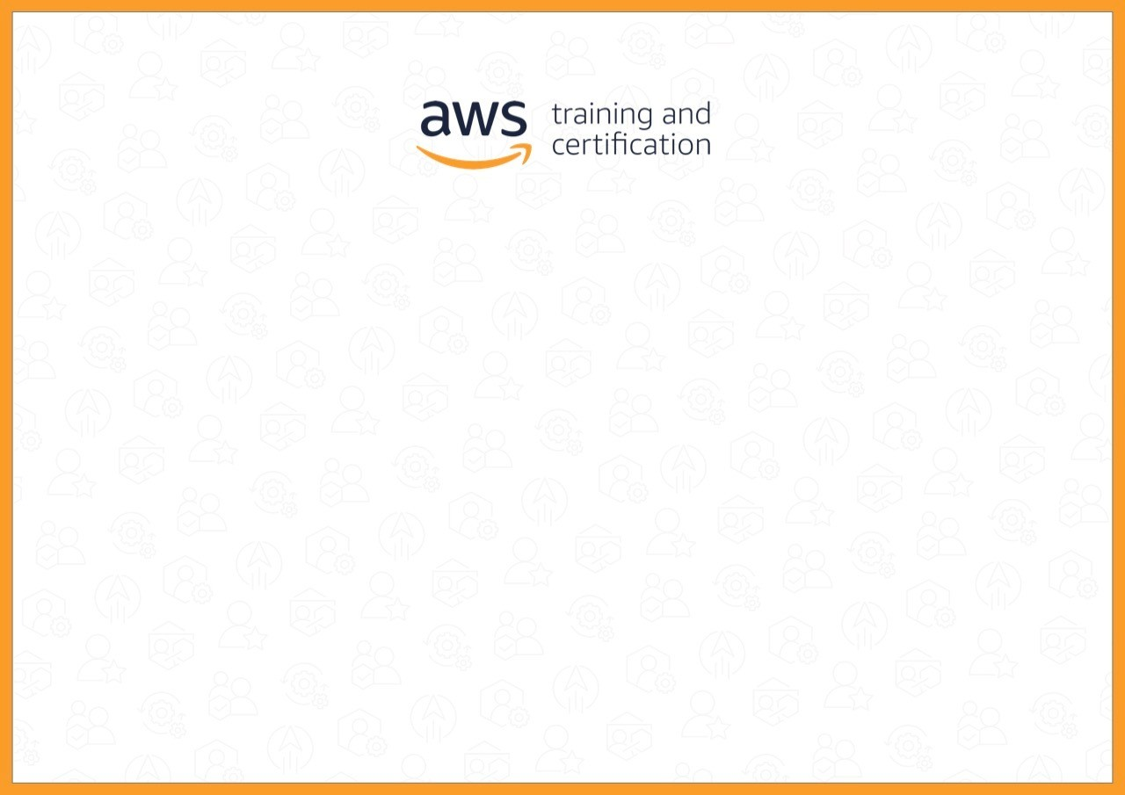

Certificate of Completion

Jorge Batista dos Santos

*successfully completed*

AWS Cloud Practitioner Essentials (Portuguese)

*on*

*1/26/2022*