Le Pham Minh Duc

Un-polarizing news in social media platform

Master’s thesis of mathematical information technology

March 18, 2019

Author:Le Pham Minh Duc (Lê Phạm Minh Đức)

Contact information: [miduleph@student.jyu.fi](mailto:miduleph@student.jyu.fi), minhduc1993@yahoo.com

Supervisors: Oleksiy Khriyenko (oleksiy.o.khriyenko@jyu.fi)

Title: Un-polarizing news in social media platform

Työn nimi:

Project: Master’s thesis

Study line: Web Intelligence and Service Engineering

Page count: x+y (x = page count without appendices; y = page count of appendices)

Abstract: Abstract…

Keywords: Keywords…

Suomenkielinen tiivistelmä: Abstract in Finnish…

Avainsanat: Keywords in Finnish…

Preface

This is where you can write a preface for your thesis. The preface is optional so you don’t have to write it if you don’t want. Also, the glossary on the next page is optional. List of figures and tables are required if there is at least one figure or table in the thesis.

**The most important guideline** for the use of this template: look from the title list which style has been used to which section of the document and use similar styles also in the future when modifying the document. Use always styles, never do formatting outside styles.

If you notice bugs or mistakes in the template, please inform them to Antti Ekonoja ([antti.j.ekonoja@jyu.fi](mailto:antti.j.ekonoja@jyu.fi)).

Jyväskylä, March 18, 2019

Le Pham Minh Duc (Lê Phạm Minh Đức)

Glossary

NLP Natural language processing

DCOM Distributed Component Object Model  
More explanation…

C++ Shouldn’t need any explanation…

List of Figures

Figure 1. Service architecture **Error! Bookmark not defined.**

Figure 2. Test figure 25

List of Tables

Table 1. Example of the table 26

Contents

1 INTRODUCTION 1

1.1 Problems overview 1

1.2 Proposed solution and research questions 1

1.3 Research method 3

1.4 Thesis structure 3

2 HYPOTHESIS AND TECHNOLOGIES 4

2.1 Original hypothesis 4

2.2 Evaluation criteria 4

2.3 Required technologies 5

2.3.1 Natural language processing and its sub-domains 5

2.3.2 Open Information Extractor / Semantic triple 6

2.4 Technologies used in this work 6

2.4.1 Stanford CoreNLP 6

2.4.2 Node.js 8

2.4.3 Version control system, Git and GitHub 9

3 UN-POLARIZING ALGORITHM 11

3.1 Overall solution/algorithm architecture 11

3.1.1 Article annotation pipeline 11

3.1.2 Article matching pipeline 13

3.2 The first algorithm using Sentiment Analysis and Name Entity Recognition 13

3.2.1 Web content processor 13

3.2.2 Stanford Core NLP Annotator 14

3.2.3 Sentiment analysis 15

3.2.4 Named entity recognizer 16

3.2.5 Articles similarity calculation using only Named Entity Recognition 19

3.3 Un-polarizing algorithm using Semantic triples 20

3.3.1 Open information extraction 20

3.3.2 Triplet pairs, common entities and common statement counts 23

3.3.3 Providing the information to the user 24

3.3.4 Limitation of the current system. 26

4 RESULTS EVALUATION 27

5 FUTURE WORKS 28

5.1 Ontologies based entity relevance 28

5.2 Word-net verb contradiction 28

5.3 Cloud service design 29

5.4 User interface and user experience design 29

6 CONCLUSION 30

Bibliography 31

Appendices 32

A Title of the first appendix 32

B Title of the second appendix 32

# INTRODUCTION

## Problems overview

(*Should write like a lot more, with more references as well*) Ideological polarization has been a problem in our society for quite a long time. (that reference from 1986). With the rise of social media (citation here or not), it’s estimated that 66% of US citizen use social media as one source of news (citation from that web page), the amplification of ideological polarization has been increasing much faster than previously due to social endorsement, and other social media techniques that is used to keeps its user engaged (Sporh. 2017). This creates the echo-chamber effects that, by the design of social networks that only show what the users want to see, make the user even furthermore polarized into his own belief and makes him see the world wrongly, which may turn the user into some extremists that might be harmful for the society.

Scholars have been researching about this problem and solutions are proposed (many citations needed) but these solutions are either too impractical (e.g: needing the giant media companies to change their entire business models) or just way out of reach of the scholar scope (e.g: needing of the government’s intervention on the issue or people to stop using the services).

https://en.wikipedia.org/wiki/Echo_chamber_(media)

*References:*

*Boczkowski, P., Mitchelstein, E., & Matassi, M. (2017, January). Incidental news: How young people consume news on social media. In Proceedings of the 50th Hawaii international conference on system sciences.*

[*https://scholarspace.manoa.hawaii.edu/handle/10125/41371*](https://scholarspace.manoa.hawaii.edu/handle/10125/41371)

*Beam, M. A., Hutchens, M. J., & Hmielowski, J. D. (2016). Clicking vs. sharing: The relationship between online news behaviors and political knowledge. Computers in Human Behavior, 59, 215-220.*

*https://www.sciencedirect.com/science/article/pii/S0747563216300656*

## Proposed solution and research questions

The main goal of this thesis is to find the way to break the people’s echo chamber that is mostly caused by the effect of social medias only show the user what he/she wants to see. To combat this, we need to show the user the news from the other side of view. If he/she reads about the opening of a new coal mines help creating a few hundreds of new jobs for the area, he should also know that the new coal mines will cause a great damage to the environment and might cause some local wild-life to disappear.

On top of that, the service must be accessible and easy to use, as the reason of many people using social media as their main source of news as it’s so convenience to have one place to go to and can see both your friend’s status as well as news.

With that goal in mind, the main research question of the thesis is:

* **How to find articles with alternative (different) points of view to a given article?**

We will only attempt to find the news that is relevant to the article but also provide oversight from different point of view that the first article misses. We will not check if the news is credible (but we will try to only provide news from credible sources) or if it is true, we simply provide the user different articles from many points of views about the relevant topic so that he/she can choose to interpret it whatever way he/she wants to.

With the first question answered, we will address two additional support questions on deploying the news un-polarizing service for the mass to use:

* **What is the most convenience way to deliver the service for the user?**

If the service is too complicated to use, or requires too many unnecessary steps, the user will rarely use the service, if at all, which reduces the effectiveness of the system. We need a method that can deliver the alternative points of view to the user that is most convenience for him, for example: a fully automatic system that whenever the user reads a news about a topic, he also has a snippet information of other relevant articles about the topic.

* **How to engineer the service so that it is autonomous, up-to-date and scalable?**

As a news service, it must always catch up with the latest news to be relevant to use. The service needs to read and analyze articles to from various news source all the time so it can serve the user with the latest and most relevant news. Also, as a cloud service, we need to prepare ahead of the service, so that when there are more users, the service will be able to handle that.

## Research method

(*Some good part from the book*) Abc, test text.

## Thesis structure

(*I should write this part last, because there is still more things to change*) – Including this introduction and the problem overview, this thesis will contain five parts. The next part contains our hypothesis based on theoretical research, as well as the state of the current technology and the tools we choose to go forward with the practical prototype.

The third and biggest part, named Un-polarizing algorithm will describe our step to step practical implementation, the problems we faced along the way and the reasons for our implementation decision.

The next part will test the result of our prototype using real world articles with cross human check/validation to see the effectiveness of the solution.

Finally, conclusions for the thesis as well as possible future work and extension are given in the last chapter.

# HYPOTHESIS AND TECHNOLOGIES

## Our hypothesis

Our hypothesis for finding articles with different point of view is simple:

* Given two articles talking about a similar topic, if one article has a positive view on the situation and the other has a negative view regarding the same situation, they are considered to have different point of views.

An example different point of view is:

* Topic: The US’s war in Iraq.
* First article main point: The US’s war in Iraq is good and justified because Saddam Hussein is a dictator and the people living under his reign are suffering.
* Other article main point: The US’s war in Iraq is bad because it furthermore destabilizes the region and the main intention of waging war was because of oil, not for humanitarian purpose.

We think that: if someone read an article, it would be interesting and beneficial for him to also see other articles about the same topic but from a different point of view, as having multiple view angles on a subject make the reader more informed about a problem and less likely to be affected by propaganda as well as reducing the effect of echo-chamber of social media platform, which is the news source of many people nowadays.

However, terms like “similar subject” or “positive/negative views” are quite abstract and, as there is no universally defined rule for finding these characteristics in different articles, we need to define our own rule for finding “Article similarity” and “Positive/negative views”. This leads to our secondary and third hypothesis:

* Two articles are considered to have similar topic if they both contains a good number of similar named entities. A named entity is defined as: a person, location, organization or a numerical expression (Grishman & Sundheim, 1996). For example, given three articles: A, B and C. Article B will be considered “more similar” to A than C to A if the number of similar named entities between B and A is bigger than the number between C and A, and vice versa. (more on chapter **3.2.4** and **3.2.5**).
* An article is considered to have a positive or negative view on a subject can be determined by the sentiment value of such article. (more on chapter **3.2.3**)

However, after the implementation of our first prototype based on these hypotheses, we were not happy with the results (more on chapter **2.3.2** and **2.3.5**). With insights from the previous prototype, we came up with the second set of hypotheses that utilize new technologies and more complex algorithms that we hoped to answer our research question better:

* If two articles state different facts, they are providing contradiction information and the reader should know about both of them.
* If there is no contradiction information between the comparing article and our knowledge corpus, we should suggest the most similar articles to our user. “Article similarity” now is calculated by the number of similar named entity in the two articles, as well as the context the named entity appears in (more on chapter **3.3.1** and **3.3.2**).

Due to the limitation of current technologies (more on chapter **3.3.4**) and our time constraint, we were not able to fully develop and evaluate the second set of hypotheses as much as the first sets. Still, the later prototype provided a lot of interesting information for our evaluation and we believed that we proceeding to the correct direction with these hypotheses and with more resource poured into this work, it could contribute a huge role for the society.

*Grishman, R., & Sundheim, B. (1996). Message understanding conference-6: A brief history. In COLING 1996 Volume 1: The 16th International Conference on Computational Linguistics (Vol. 1).*

## Evaluation criteria

As we discussed in the previous chapter, term like “subject similarity” or “different point of views” are abstract term, so, there is no concrete way to evaluate these characters. We could not find any statistic or equation to evaluate the results of our algorithm. We could only judge the output by using our common sense and opinion’s survey.

To test the rigidity of our algorithm, we gathered a dataset of 78 articles (+ 8 non-readable by the web content parser), consist of three main themes:

* Muslim in Europe: 24 articles
* Muslim in Asia: 39 articles
* Asians in Europe: 17 articles

We then went through each of them and decided which set of articles are more relevant to each other and which pair of articles that contain opinion from different point of view. Once we finished annotating the database, we do the evaluation by comparing our annotation to the results from the algorithm.

With articles spanning in three different main categories that are also related to each other, for each them, there will be some positive hits (related articles) as well as false negatives: news/documents that share similar set of entity and keyword but convey different fields and are not related at all (for example: sports and politics). With these “traps”, we want to test if our algorithm can truly return the relevant information and how close the suggestion is to our annotation.

Finally, since our algorithm can read through the whole article thoroughly, it might discover interesting information that we missed as we only skimmed quickly through our database. Skimming is a realistic behavior though, since most people only read the title or consume through each news source quickly (Gabielkov, Ramachandran, Chaintreau & Legout, 2016).

*Ref:*

*Maksym Gabielkov, Arthi Ramachandran, Augustin Chaintreau, Arnaud Legout. Social Clicks: What and Who Gets Read on Twitter?. ACM SIGMETRICS / IFIP Performance 2016, Jun 2016, Antibes Juan-les-Pins, France. 2016*

## Natural language processing

**Need extra works!!!**

Peer (Liddy, 2001): “Natural Language Processing (NLP) is a theoretically motivated range of computational techniques for analyzing and representing naturally occurring texts at one or more levels of linguistic analysis for the purpose of achieving human-like language processing for a range of tasks or applications”.

Based on our hypotheses from the previous chapter, for this thesis, we will focus on three main sub-tasks covered by NLP:

* Named entity recognition (NER): is a task in Information Extraction consisting in identifying and classifying just some types of information elements, called Named Entities (Marrero et al, 2013). We use NER to identify the similarity between two articles, and then decide if we want to compare their difference in point of view or not. NER is generally considered as a solved problem as the best system entering MUC-7 scored 93.39%, compare to human 97.6% (Marsh & Perzanowski, 1998).
* Sentiment analysis:
* Open Information Extraction (OpenIE):

Making a computer fully able to understand human language have always been an interesting topic, with researches and application started as early as 1968 with SHRDLU (Terry Winograd, 1971). With are many tools, services, applications and researches for NLP that is fully available today, ranging from free open source platform to cloud service, … there are many options for us to consider. We will discuss these options and our choice in the next chapter: Technologies used for this work.

*Ref:*

*Liddy, E. D. (2001). Natural language processing.*

*Marrero, M., Urbano, J., Sánchez-Cuadrado, S., Morato, J., & Gómez-Berbís, J. M. (2013). Named entity recognition: fallacies, challenges and opportunities. Computer Standards & Interfaces, 35(5), 482-489.*

*Marsh, E., & Perzanowski, D. (1998). MUC-7 evaluation of IE technology: Overview of results. In Seventh Message Understanding Conference (MUC-7): Proceedings of a Conference Held in Fairfax, Virginia, April 29-May 1, 1998.*

*Terry Winograd, Procedures as a Representation for Data in a Computer Program for Understanding Natural Language. MIT AI Technical Report 235, February 1971*

## Technologies used in this work

### Stanford CoreNLP

Developed by the researchers at Stanford University from 2006, released as a free and open source software in 2010, with updates still being developed and released nowadays (Manning, Surdeanu, Bauer, Finkel, Bethard, & McClosky, 2014), Stanford CoreNLP is a Java (or JVM based) annotation pipeline framework for most of the common Natural Language Processing (NLP) steps like Named Entity Recognition (NER) (Finkel, Grenager & Manning. 2005), Sentiment Analysis (Socher, Perelygin, Wu, Chuang, Manning, Ng & Potts, 2013) and Open Information Extraction (OpenIE) (Angeli, Premkumar & Manning, 2015). We used Stanford CoreNLP to process raw web-based article text into annotated data and properties, ready for our “un-polarizing” algorithm. Detailed information on the role and usage of Stanford CoreNLP in our work will be presented in later chapters (chapter 3.1 and chapter 3.2.2) where we go in depth with our solution.

We chose Stanford CoreNLP as the foundation technology for our thesis because of two main reasons:

* It has all the services we needed integrated into one big package that will work well together. There are many tools that provide the necessary services (especially NER and sentiment analysis) for us, but each of them has different requirement for the input data as well as different output format. Using separated tools instead of just one require us to put time and effort into making them work together instead of focus on the main research question, which is the “un-polarizing” algorithm. We could argue that using a specialized tool for each of the task might provide better quality output, but our testing results does not show any significant different in the results outputted by these tools compared to Stanford NLP anyway (more on chapter 3.2.3, chapter 3.2.4 chapter 3.3.1).
* It is free and open-source, with full access to source code that can be installed and run locally. Having every cog in our machine (or solution) fully available is important, as the private and close-source service are subjected to changes or shut down at any moment, which, is problematic. Having our algorithm run well and not depending on services we do not control is important not only us, now, but also for when other researchers want to try or test or improve our solution, now, for 10 years from now.

*Ref:*

*Manning, Christopher D., Mihai Surdeanu, John Bauer, Jenny Finkel, Steven J. Bethard, and David McClosky. 2014. The Stanford CoreNLP Natural Language Processing Toolkit In Proceedings of the 52nd Annual Meeting of the Association for Computational Linguistics: System Demonstrations, pp. 55-60.*

*Jenny Rose Finkel, Trond Grenager, and Christopher Manning. 2005. Incorporating Non-local Information into Information Extraction Systems by Gibbs Sampling. Proceedings of the 43nd Annual Meeting of the Association for Computational Linguistics (ACL 2005), pp. 363-370*

*Richard Socher, Alex Perelygin, Jean Wu, Jason Chuang, Christopher Manning, Andrew Ng and Christopher Potts. Recursive Deep Models for Semantic Compositionality Over a Sentiment Treebank. Conference on Empirical Methods in Natural Language Processing (EMNLP 2013)*

*Gabor Angeli, Melvin Johnson Premkumar, and Christopher D. Manning. Leveraging Linguistic Structure For Open Domain Information Extraction. In Proceedings of the Association of Computational Linguistics (ACL), 2015.*

### Node.js

Even though most of the works done in this report are prototype code to demonstrate and test our hypothesis, we want to continue working on our “Un-polarizing algorithm” after this thesis work is completed. We our final goal is to produce a product for people all around the world to use and thus, help creating a better society. With that in mind, we want to choose a programming language that is capable producing quality and stable code base for longevity, performant and highly scalable, but also flexible enough for changes in our prototype development.

Node.js comes to mind as the perfect candidate for our requirements as its multi-paradigm nature and its giant ecosystem of libraries (Tilkov & Vinoski, 2010) allows quickly creation, testing and modification of our prototype with little overhead cost. Several benchmarks also prove the superior performance of a Nodejs web system when compare to other popular technologies like PHP and Python (Lei, Ma & Tan, 2014), which shows the potential of node.js for longevity and development of industrial application.

*Ref:*

*S. Tilkov and S. Vinoski, "Node.js: Using JavaScript to Build High-Performance Network Programs," in IEEE Internet Computing, vol. 14, no. 6, pp. 80-83, Nov.-Dec. 2010.*

*http://ieeexplore.ieee.org/stamp/stamp.jsp?tp=&arnumber=5617064&isnumber=5617049*

*K. Lei, Y. Ma and Z. Tan, "Performance Comparison and Evaluation of Web Development Technologies in PHP, Python, and Node.js," 2014 IEEE 17th International Conference on Computational Science and Engineering, Chengdu, 2014, pp. 661-668.*

*http://ieeexplore.ieee.org/stamp/stamp.jsp?tp=&arnumber=7023652&isnumber=7023510*

### Version control system, Git and GitHub

A version control system (VCS) is “a tool that tracks different versions of software or other content” (Loeliger, Jon, & McCullough, 2012). Using VCS is considered as one of software development best practices, even just for a personal project (Spinellis, 2005). As we are creating a software prototype to evaluate our hypothesis and algorithm, it is best to follow these principles and to use a VCS for our project. These principles are later on, proved to be quite helpful as, throughout the course of our prototype development, we found ourselves utilizing many features of VCS such as source-code backup, code synchronization between different computers, progression roll-back and, finally, through the commit messages: a diary/documentation system.

“Git” is a free “Decentralized version control system” that has a clean internal design, performs quickly and efficiently, enforces accountability (Loeliger, Jon, & McCullough, 2012), and is the VCS we chose to use for this thesis. “Git” was created in 2005 by Linus to help developing the Linux kernel as other VCSs system at that time had limitations and flaws that would make them not a viable solution. These reasons make “Git” not only a good solution to applied to our works, but also make it one of the mostly used VCS nowadays in both public and private sectors.

GitHub was chosen as our hosting service for the project as it was one of the biggest Git supporting services (hence, the name) and is free. All our software prototype, coding history, instructions and documentations are kept on GitHub and are freely available to view, access and execute at any moment from any computer anywhere in the world. An “url” to the project are provided at the end of this report.

*Ref:*

*D. Spinellis, "Version control systems," in IEEE Software, vol. 22, no. 5, pp. 108-109, Sept.-Oct. 2005,*

[*http://ieeexplore.ieee.org/stamp/stamp.jsp?tp=&arnumber=1504674&isnumber=32260*](http://ieeexplore.ieee.org/stamp/stamp.jsp?tp=&arnumber=1504674&isnumber=32260)

*Loeliger, Jon, and Matthew McCullough. Version Control with Git: Powerful tools and techniques for collaborative software development. " O'Reilly Media, Inc.", 2012.*

# UN-POLARIZING ALGORITHM

## Overall solution architecture overview

To answer the main research question of: **“How to find articles with alternative (different) points of view to a given article?”**, we developed a prototype called the “Un-polarizing algorithm”, containing two main parts:

* Article annotation pipeline: to process the natural language text from the article to machine readable format and save them to a local database for comparing later.
* Article matching pipeline: compare a given article to all the annotated articles in our database and find the most appropriate articles with relevant information with different point of views.

### Article annotation pipeline

Here is the overall architecture of the Article annotation pipeline.

Local

database

Web

content

processor

Stanford

Core

NLP

Sentiment

Value

Article

url

Semantic

Triples

Named

Entities

Sentiment analysis

NER

filtering

Semantic

triples

Filtering

Annotated

article

Article annotation pipeline

Figure 1. Test figure

Boxes and lines with different colors represent different parts of process:

* Cyan **box and line**: open information, freely available on the internet
* Red **box and line**: Stanford Core NLP service.
* Green **box and line**: our own custom logic, implemented for this works
* Blue **box**: the article annotation process.
* Black **box**: the database to store the annotated articles
* Dashed box and line: process and algorithm implemented in the second phase prototype, things that we didn’t plan to implement initially.

To annotate an article, we first read its content using the url, and then pre-process the website’s data so that it can be parsed for the NLP task (more on 3.2.1). We then push the news text into the Stanford Core NLP (more on part 3.2.2). From the information received from the Core NLP engine, we use 3 sets of data annotation: the sentiment analysis (more on part 3.2.3), the named entity recognition (more on part 3.2.4) and the semantic triples (more on part 3.3.1). Each dataset then will be furthermore analyzed/filtered using various equation to make it ready for the articles matching solution. Finally, the results will be recombined into one annotated object and saved into our local database

The Semantic triples and other processes related to it like semantic triples filtering are only utilized in the second prototype, where we need to go in-depth with the article and find the contradicting information.

### Article matching pipeline

Figure 1. Test figure

Local

database

Web

content

processor

Article

Annotation

pipeline

Articles scoring

and ranking based

on comparing article

Comparing

url

Most relevance articles

from different point of views

Articles matching pipeline

To find articles with different point of view to a given article, first, we need to run the article’s url through our annotation pipeline to extract the necessary information for the scoring and comparing tasks. After that, we calculate a relevant score for every article stored in our database and rank them based on this score (more on 3.3.2). Finally, we display the highest scored articles to the users as they are the most relevant. We weren’t able to implement the different point of view check in our prototype, but we have some good theoretical claims to do it.

## The first algorithm using Sentiment Analysis and Name Entity Recognition

### Web content processor

**TODO: FORMAT**

Articles on the internet are usually presented inside a web-page, with just not only the news itself, but with many related information for the web-page like html tag, images and captions, links to other news on their website and advertisement. As Stanford CoreNLP’s requirement for input is text paragraph only, we must pre-process the news content to remove the unnecessary information.

We divided the article pre-process into two steps:

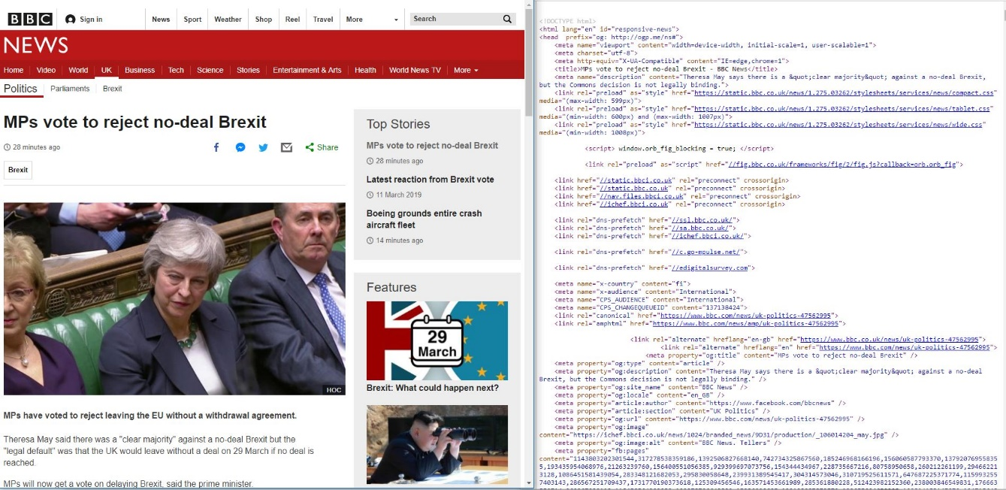

Figure 1. Left: Example news web page – Right: the web source code we received

* Strip away all other un-related content like advertisements, contact information, other stories from their network, etc. From the example above, we could see that the actual news content we want to see is presented in just half of the page (less if we also exclude the image). For this, we implemented a “web content parser” module which utilize a similar technique to reader mode on Firefox[1] which can automatically strip away all the non-article part in the web content, using a NodeJS library called node-readability[2]. However, as this feature is intended for the user to read the news easier without all the bloated content, the html formatting tags, images and captions are still present, and this result will not work with the Stanford CoreNLP.
* Remove the HTML formatting tags and image captions. For this we wrote a small rule-based module to automatically remove the html tags, the image captions by removing any text appear inside a “< >” block, which is the standard for html tag. However, this approach will return a few faulty sentences for every article because each website will have a different layout and method to present their content, making our rule-based filtering ineffective.

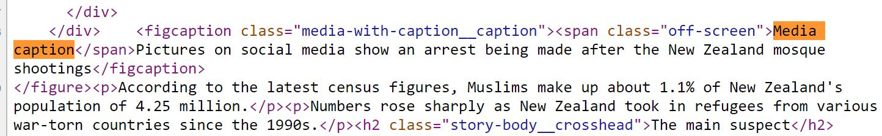

Figure 1. Example with the html filtering. In this case, the word Media caption will not be filtered, but added to the next sentence. The result we have is an incorrect sentence: “Media captionPictures ….” parsed into the annotator

However, we found one other effective way of ensuring that the sentences forwarded into the CoreNLP annotator are correct is to use a cloud service called SMMRY[3]: an article summarization tools, which can read through the article and return the sentences that it thinks contains the most important information of the article. SMMRY works by going through the whole documents, score each word based on their semantic roles and their appearance frequency in the text. It then returns the sentences that has the highest sum of all containing word’s scores.

This tool is quite effective for our case as it strip away all the unnecessary content as well as the html tags, which provides the suitable data for the annotation pipeline. SMMRY also has a parameter to control how many percent of the news document should be reduce, so, we set this value to 0 percent and get the full article pre-processed.

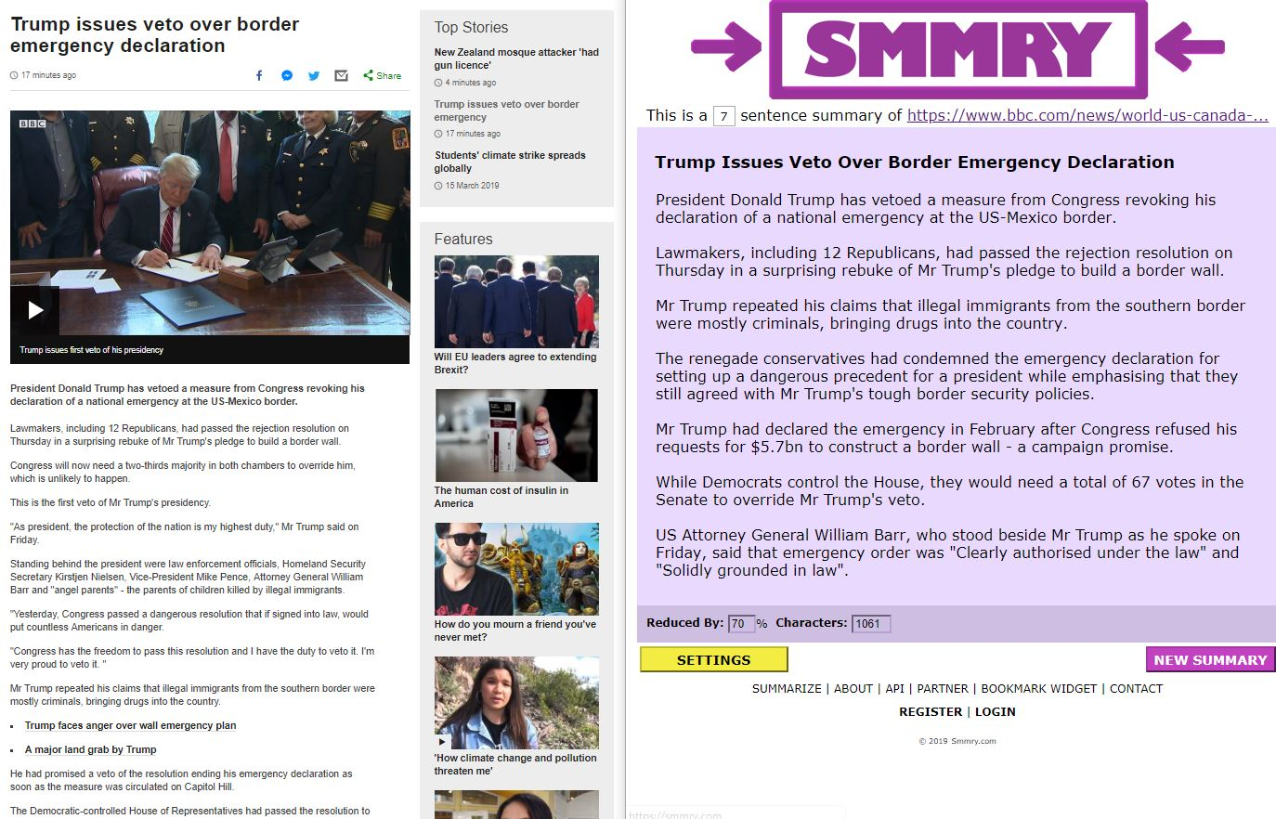

Figure 1. SMMRY example

There are, however, two downsides of using SMMRY:

* The sentences order in the paragraph is incorrect. This is not a problem as Stanford CoreNLP works on a sentence basis only, and our features also do not rely on sentences index in the paragraph.
* This is a service from a private company, which, using it is against our arguments in chapter 2.4 for using open-source technologies only. However, as there is no good and easy to use open source alternative available, we decided to use this tool, but kept our “web content processor” module present in the code base, easily interchangeable with SMMRY for any future reference, in case SMMRY goes out of business.

### Stanford Core NLP Annotator

Glossary: API, Wrapper.

There are multiple ways to use the Stanford Core NLP as listed on their main website (citation needed), but it all boil down to two main methods:

* Directly by the Java API: As Stanford Core NLP is created in Java (citation needed), we can import the whole CoreNLP as a Java library and call all the NLP function through their Java APIs.
* Indirectly through a wrapper: There are many wrappers for CoreNLP available for many common usages: command line wrapper, web-server wrapper, or many programming language wrapper libraries like C#, Python, Pearl, NodeJS …

As we are using NodeJS, here are the best two methods applicable to our usage:

* Using the webserver: this method creates a web service on a local host. This is quite useful as not only it provides all the annotating features, it also has a web interface for quick debugging and visualizing the results of the CoreNLP tool.
* Using the NodeJS wrapper: the NodeJS wrapper also has all the annotation features of the CoreNLP. However, it does not have the web interface for debugging.

We chose to use the Stanford CoreNLP as a webserver as it provides more feature but no significant there is no downside for our use case.

Continue from the previous step: pre-processing; after extracting the text document from the web article, we parse the text into the Stanford Core NLP local server to get the annotations from the article. Since Core NLP have support for many common NLP tasks, each with its own annotators (citation above), we can control which annotators to use, instead of all of them to save some processing power. Hence, for our needs, we only need three annotators: “sentiment”, “ner” and “openie”. However, as there are dependencies for our required annotators to work, here is the list of all annotators we use and theirs usages:

|  |  |
| --- | --- |
| tokenize | Split the text into a list token. A token could be a word, or a special character (dot “.”, comma “.”, etc). “tokenize” is required for all annotators below. |
| ssplit | Split sequence of tokens into sentences. First, the tokenize split the whole document into many smaller tokens, then, it will be combined back to sentences in this step. “ssplit” is required for all annotators below. |
| pos | Part-of-Speech (POS) tagger. This annotator assigns POS to each word in the text, such as noun, verb, adjective, etc. “pos” is required for all annotators below except “parse” |
| lemma | Generates the word lemmas (base form in dictionary) for all token in the document. “lemma” is required for “ner” and “natlog” |
| parse | Create a dependency tree for the sentence. “parse” is required for “sentiment” and “natlog” |
| natlog | Natural logic annotator: create a natural logic dependency between tokens in the texts, required for “openie” |
| ner | Named entity recognizer: recognize named entities. One of our main use cases for this thesis. |
| sentiment | Sentiment analysis: determine the sentiment value of each sentence. One of our main use cases for this thesis. |
| openie | Open information extraction: generate semantic triples from the texts. Used for the second prototype. |

With the Stanford CoreNLP running as a web server locally at port 9000 (or on the cloud), we request the annotations in json format by calling a GET request with this uri:

* *http://localhost:9000/?properties%3D%7B%22annotators%22%3A%22tokenize%2Cssplit%2Clemma%2Cner%2Copenie%2Csentiment%2Cnatlog%2Cparse%2Cpos%22%2C%22outputFormat%22%3A%22json%22%7D*

After receiving the results from the NLP engine, we apply our customized filter for all the annotations to remove all unnecessary information and reformat the result to fit with our un-polarize algorithm (more on next chapters). The filtered and reformatted results (let’s call them core feature) will be saved into the local database for future comparison calculation of the un-polarizing algorithm.

The use of the local database to store core-results is necessary, because when we try to un-polarize an article, we annotated it, then compare its core feature to every other documents’ core-feature in our knowledge corpus. Since the processing time for each article is quite long, around 10 seconds each[4], so, it is not feasible to do all the annotation on the fly without the database.

### Sentiment analysis

Research on how Stanford do their sentiment analysis, some tree or something

(*Introduction, maybe remove this???*) – This is our very first idea upon figuring out a solution to this problem. Our initial hypothesis was simple, if two articles talking about one problem, for example: The U.S President, Donald Trump, if one article talk about him with a positive sentiment, and the other with a negative sentiment, then they are from the different point of view and we should suggest the other article to our user.

(*Example of what other people do, properly write this in a formal way*) – Sentiment analysis services are offered by many big companies like IBM, Google, Microsoft, to some other smaller startups and a lot of open-source library exists as well. However, this method proves to be completely useless for our use-case (at least using the Stanford’s NLP lib). Because practically, sentiment analysis is only good for single sentences only, without taking into account the paragraph or the article. It is mostly used for analyzing customer reviews for products or customer feedbacks.

(*Stanford NLP bad*) – Furthermore, the Stanford NLP sentiment analysis result are quite limited, only 5 values, from very negative to normal to very positive, and work on the context of a single sentence only. Google’s service proves to be a bit more useful with sentiment scale from 0 to 100, but still work on a single sentence context. IBM’s service is the fanciest with scale of 100 for sentiment but also some other adjectives like “Anger”, “Nice”, “Happiness”, … which seems to be the most suitable for our case if we decided to go with this.

(*We use it anyway*) – However, as this is a public research with source code fully available for people to use on their own, we don’t want to tie ourselves to private services that might either be unavailable someday, or restrict our access because of reasons, we decided to go with Stanford NLP, the open-sourced solution from other academia.

(*Our own algorithm*) – We calculate the sentiment value for article using Stanford NLP using the weighted average sentiment value of each sentence in the article. In which, we calculate the average value for the whole thing, but longer sentence (by characters count) will have a bigger weight than short sentence.

$$V= \frac{\sum{(S_{i}* L_{i})}}{\sum{L_{i}}}$$

* **V** is the sentiment value of the article.
* $S_{i}$ is the sentiment value of sentence *i*
* $L_{i}$ is the length in number characters of sentence *i*

(*Why it’s bad and why we don’t use it*) – The sentiment analysis hypothesis later on proves to be almost useless, as the sentiment value of the sentence/paragraph have very little correlation to the content in the articles. Which mean, even if the paragraph talks about the killing of Yemen people, it might still have a normal or positive sentiment (*TODO: find example*), because journalism is usually supposed to give provide information in the most neutral way, so it’s hard to find any correlation between them. Furthermore, it’s kind of easy to fool the system, using word like nice, good, or similar to that, to make it have a higher sentiment value.

In short, sentiment analysis proves to be almost useless.

This is flaw since it can’t detect sarcasm and is flawed.

*References*

*http://blog.conceptnet.io/posts/2017/how-to-make-a-racist-ai-without-really-trying/*

*Sentiment from text analysis are bias.*

*https://researchportal.bath.ac.uk/en/publications/semantics-derived-automatically-from-language-corpora-necessarily*

### Named entity recognizer

(*How do we use the NER, the initial solution/algorithm use NER. Briefly the result of the one using only NER*) – Named entity recognizer (NER) is also presented in our original idea. With the sentiment value used to judge the \**difference in point of view*\* between two articles, we use named entity recognizer (NER) to find the relevance articles to the one the user is reading and then, compare the sentiment result to suggest it to him.

The default NER of Stanford NLP contains a lot of unnecessary information that bloat the return result for our algorithm so much. Many information (named entities) detected are quite un-relevance to our case, for example, he/she, year, number and some proposition text like Mister, Miss … We have to write a filter for the NER results to get the relevance information only. For the user convenience, we also split the result into two categories: abstract entities and discrete entities.

The two groups contain:

|  |  |
| --- | --- |
| Discrete entities | Abstract entities |
| PERSON | RELIGION |
| LOCATION | NATIONALITY |
| ORGANIZATION | TITLE (job title) |
| MISC | IDEOLOGY |
| CITY | CAUSE_OF_DEATH |
| STATE_OR_PROVINCE |  |
| COUNTRY |  |

Stanford Core NLP work on a single sentence basis only, which mean the meaning of the next or previous sentence in the paragraph doesn’t affect the annotation of one sentence in anyway, which is a bad thing for us since we want to work on a rather macro way, instead of micro based way like this. Thus, after filtering out the un-needed result, we perform the entities counting, in which we count the number of each time an entity has appeared in the article, as well as calculate the sentiment value or the average sentiment value of that entity, and finally, save all the result to the local database.

|  |  |
| --- | --- |
| (*Remove the table border later*) – Initially, the annotated value stored for one article in our database look like the part on the right:  All article will be stored as a JavaScript object, in one big single database.json file.  Each annotation object contains:   * Meta data about the articles: url, title * Annotated title, which contains sentiment value, length, and entities appearance * Annotated contents of the article, which contains information on all the entities, their appearance and their average sentiment value.   With these annotations’ information stored, we implemented a matching algorithm to suggest relevance articles to the one the use is viewing (more information on part **3.3.1 Articles similarity calculation using only NER**). However, this approach is not good enough since the sentiment analysis doesn’t work as well as expected, so this in effect just return bunch of articles talking about the same thing. | Figure n: Example of an annotated article stored in our database |

With the article annotations stored in our database, we can now suggest news with different point of view to any given article with our un-polarizing algorithm.

### Articles similarity calculation using only Named Entity Recognition

(*What a crap result we got with NER – something to cite here, I don’t know, some people must have probably researched about this*) – Our initial idea was really simple, find articles that talk about similar topic, and then sort them by the different in sentiment value, so that if two articles talk about similar topic but with vastly different sentiment value, they will have different point of view and it worth showing to the users. This approach however, as pointed out in part 3.2.2-Sentiment Analysis, is not effective since the Sentiment analysis results are all over the place and have no meaningful contribution to the algorithm at all. However, after finish writing the Similarity calculation, we found that even just suggesting the articles with relevance topics can provide lots of interesting information from many different points of view already, without considering the sentiment value.

The goal here is to not find the most similar articles, but the most relevance one, in which, we defined the relevance <*do some research here!*> as articles sharing both similar and different contents (entities). Two articles, if deemed relevance, should have half of their contents talking about similar things, and the other half talk about different things. We calculate the relevance score between two articles using this equation:

In which:

* X is the relevance score
* is the number of unique similar entities. Unique means that each entity entrance is only count once, even if they appear multiple times in both articles.
* is the number of unique different entities, summed from both articles.

As shown in the equation, when the two articles are absolute relevance (by our definition above), X should be 0, and the less relevance the two articles are, the bigger the X value will be. So, to find the list of the most relevant articles, we find the article with the smallest X value (because X is the absolute value so 0 will be smallest).

In the code, we call the -<*similarityModule.findSimilarArticles*> - this is the function we called. The input is one single “url” and the output is the list of relevance articles with their annotated information displayed so that the user know why we suggest these.

(*End and hook for the next part*) - This equation provides good results, but however, we weren’t happy with the result, or more exactly, what we get from the solution. The result did give us some other articles to the solution, but what we have is just article’s titles, and some mentioned keywords. We felt that we could do better by analyzing the article furthermore and find different opinions/facts on a sentence basis, not just by keyword counting/sentiment analyzing.

## Un-polarizing algorithm using Semantic triples

### Open information extraction

(*How openie improve our result, how do we use it and store it information*) – To furthermore improve the matching algorithm as to find even more relevance information for the user, we use Semantic Triples. The idea now is not only just match article that talks about the same things, but to read the sentences of the article and then see if there are any other articles that is also mention the same thing: ie: Trump hates brown people and Trump push brown people. This can in turn provide much more relevance information as two articles, at one point, talk about the same thing, so the user can not only see what each article says, but they can also have the power to see the content which the subject is talked about. To do such marvelous task, we use OpenIE from Core NLP.

Open information extraction from Core NLP works pretty good out of the box. Inputting one sentence into it and it gives you a lot of statements constructed from that sentence to work on. These statement however are too many and too noisy as some of the statement are quite useless information (he is president) or some are shortened version of other statement (USA hates muslim people vs USA hates muslim people all over the world).

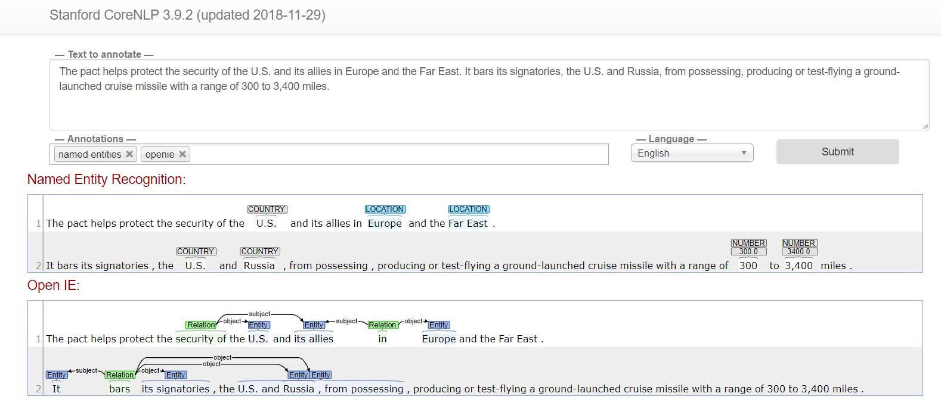

Picture n: example of result from Core NLP

*TODO: Need example of this*

To make use of the OpenIE data, we do a three-step filtering.

First, triplets with the relation word that is not a verb and not the verb “be” is also removed. This make sure that all the non-meaningful statement (example needed!) will be removed from our result <*tripletMeaningfulProcessor.filterOpenieResult*>

Second, we remove all the triplets that are just shortened version of others, this remove quite a bit of them (needs some number value, to see the effect) *<tripletTrimmer.trimShorterTriplets>*

Last, combined with the named entities analyzed from 3.2.4, all the statement that doesn’t have an entity mentioned will also be removed, since the triplets without any meaningful entities mentioned will be useless in term of information for us anyway <*coreFeatureExtractor_getContainingEntities*>

* Find example for each of these cases to see which result is removed and which is saved to see the impact, also, maybe some number on how much is removed for example.

After these three-step filtering, the annotated data of the article is saved to our local database as a JavaScript object in json format, same process as part 3.2.4, only with different data.

|  |  |
| --- | --- |
| This is a snippet of the annotation data stored in our database. Each entry contains:   * Meta data about the article: url and title * Array of annotated information about the content of the article, split down to a sentence level.   Each data-sentence contains:   * Full text content of the sentence * Triplets exists in the sentences and their information.   Each triplet in the sentence annotation contains:   * Subject, relation and object text. * Full text content of the triplet (combine subject, relation and object) * Containing entities.   We made the decision to store as much information as possible like the full sentence text as well as the triplet’s text so that when we return the un-polarized result to the user, they can see all the reason that leads to the decision to show them the results and can judge the comparisons for themselves. | Figure n: Example of an annotated article stored in our database (current version) |

### Triplet pairs, common entities and common statement counts

(*What are these 3 above stuffs and our sorting equation*) – With the semantic triples annotation implemented, we hoped to find some common or opposite statements from different articles that we normally could not normally find if we just read through the titles and skim through the contents. We use this equation to calculate the relevance of any given article to the source article:

In which:

* is the relevance score, the higher X is, the more relevant the article is to the comparing one.
* is the number of triplet pairs appear in both articles. Two triplets are considered a triplet pair when they share two common entities, on both the subject and object part. For example, if one statement says <*United Kingdom negotiates deal with the European Union*> and the other statement says <*European Union rejects the deals from United Kingdom*> they are considered a pair because they both talk about <*European Union*> and <*United Kingdom*> in theirs subject and object part.
* is the number common unique entities appear in both articles. If two news piece talk about an entity, it is count (but only once, even if it appears multiple times)
* is the number of common statements appear in two articles. If two statements (semantic triples) talk about a similar entity, this number goes up.
* are the constant weight value for each of these variables. In our prototype, we set =1. We use these values because entity pairs are quite rare, as most of the articles in our database, when compared to the rest of the other articles, doesn’t exist a pair at all. Maybe test with a bigger database?

General rating of the information here? I don’t know, maybe we add more data or stuffs like that?

### Providing the information to the user

Since the main purpose of our solution is to provide the user more information so that they can make a better judgement of themselves, we feel that it is important that the we should also provide as much information as possible. So, for our un-polarizing result, we will give the user the list of the most relevance articles to the one he wants to check, as well as other information that we use to come up with the conclusion, so that he can see the full picture himself, knows the reason we come up with the result, and now, being informed, can fully know the news about the situation or subjects.

|  |  |
| --- | --- |
| The return result for the user is a list of relevant articles and their annotated data, each contains:   * Meta data: general information about the two articles, containing their urls, titles and the number of entity pairs, common entities count and common statement count. * Entities pair data: we feel like this is the most interesting information so if is exist, it’s should be shown. * Entities data: all the rest information of the entities, which contains what the entity is as well as in what context it appears in, in both the source and target articles. | Figure n: Example of an annotated article stored in our database (current version) |

### Limitation of the current system.

* No verb processing in the Semantic Triple: Our current implementation only utilizes the “subject” and the “object” part of the semantic triples. The relation part, which, based on our filters, will always contains at least one action word. This information could be important as it can help us to find contradiction between different statement, thus, gives the user an even better view of the topic.
* No negation checking: current Stanford Core NLP system doesn’t detect negation in their Open Information Extraction yet, so we might miss some semantic triples from the articles. Especially, when the verb processing is implemented, missing the negative triples could lead to missing some of the contradict information. This is weird since they do have negation checking (in POS annotator), but I guess they can’t make it to work in “natlog” annotator.
* Computational drawback: processing an article on my computer (i5-6700HQ) took around 10 second to process one article. It’s not a big problem because 10 seconds isn’t too long but should be noted since it’s not instant.
* Needs huge database, to works. A single topic (ie immigrant) should have around 50 articles to be able to generate good ground truth of information, and the bigger the database is, the longer the computational time it takes. We can build the database to be bigger by automatically fetch news articles from source like Google news, but to solve the computational problem for big database, we need more research on how big companies like Google, Amazon or IBM deal with it.

# RESULTS EVALUATION

(*Detailed information from our article base, how many is close to the point, how many useful information can we get from that*) –

# FUTURE WORKS

## Ontologies based entity relevance

(*How using ontologies, can help finding similar words/entities, similar to the ontologies relevance in Chinh’s thesis*) – The current system finds entities pair base totally on their word-to-word similarity. Using ontologies, we could find and link together entities that are relevant to each other (ie, Muslim and Christian, as both are religion), thus, making the system smarter and able to find more information.

## Word-net verb contradiction

(*With the triplet pairs implemented, we could find contradiction between the triplets. Using word-net to find verb that have similar meaning/or opposite meaning*) – For processing the relation verbs, using wordnet (<https://wordnet.princeton.edu/>) or similar tool, so we can find words that have similar meaning, close meaning or opposite of each other, thus, making the system able to find more connection/contradiction between different statements within different articles.

## AI based un-polarized algorithm

It’s not that easy, you just can’t say AI and all the problem is solved. But traditionally, as NLP evolve, all the programming/method driven method for NLP has been changed for a better machine learning model for almost everything like sentiment, openie and more tasks (tons of reference needed here). We could try to apply the same for our stuffs. However, we realize that as there are so many possible inputs data (which is all of the Stanford NLP annotation stuffs), and the outcome is so limited, same POV, different POV ???, training these data would be really hard. Training these models would be an interesting task as well. But we think AI is the future, and we should aim for it.

## Cloud service design

Local

database

Web

content

processor

Article

annotator

Requested URL

News gatherer

News

suggestions

module

Suggested

articles

Figure 1. Test figure

With the algorithm ready, we need to automatically get our data somehow. Fortunately, there are a lot of news APIs available, for example, Google News or many other things, just one simple APIs and it can give you all the thing you want. It’s also good for evaluation later, because these APIs allow you to search for query by word, date and time, which will be useful to compare the results between our stuffs and theirs.

## User interface and user experience design

# CONCLUSION

Hope you enjoyed the text...

In the bibliography the recommendable style is Chicago. You can also use other styles: the main thing is that the styles of the bibliography and referring technique are **consistent** in the whole thesis.

|  |  |  |  |
| --- | --- | --- | --- |
| Word | Year | Magnitude | Example |
| example | [1700,2000] | [1,10] | example |
| example | [1950,2000] | [1,106] | example |
| example | [1995,2000] | [10–6,106] | example 1, example 2 |

Table 1. Example of the table

Bibliography

Spohr, Dominic. "Fake News and Ideological Polarization: Filter Bubbles and Selective Exposure On Social Media." *Business Information Review* 34.3 (2017): 150-160.

Meikäläinen, Matti. *Tietotekniikan perusteet.* Helsinki: WSOY, 2000.

Santanen, Jukka-Pekka. "Opinnäytteiden kirjoittaminen, lyhyt oppimäärä." 2000. http://users.jyu.fi/~santanen/info/kirjoittamisesta.html (accessed 5.10.2012).

Writer, John. "Name of the article." *Computer*, no. 2/2000 (2000): 31-32.

Appendices

1. Title of the first appendix
2. Title of the second appendix

1. https://support.mozilla.org/en-US/kb/firefox-reader-view-clutter-free-web-pages
2. <https://www.npmjs.com/package/node-readability>
3. https://smmry.com/
4. Tested on average of 100 article annotations, using author’s computer: Dell inspiron 7559 with i5-6300HQ and 8GB of RAM