Projekt č. 1

Logické obvody

1. ročník – kombinovaná forma,
Informační a komunikační technologie, LB1IKT01K

Jan Šmíd
SMID051

Zadání č. 965

- K(0,1,2,6,9,14,(3,11,12,13))
- D(1,7,9,10,12,13,15,(6,8))
- D(1,2,5,10,13,14,15,(4,6,12))
- K(5,6,8,12,14,15,(0,2,11,13))
- D(0,2,4,6,11,15,(5,7,14))
- K(2,4,10,11,12,13,(1,3,5,9))

Pro každou booleovskou funkci sestavte Karnaughovu mapu a z ní vyjádřete minimální součtovou formu, kterou upravíte pro realizaci hradel NAND.
Pro každou booleovskou funkci nakreslete síť pomocí hradel NAND, kde počet vstupů není omezen.
a) funkce: K(0,1,2,6,9,14,(3,11,12,13))

a.1) tabulka | a.2) Karnaughova mapa  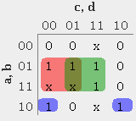  a.3) Minimální součtová forma  bc + bd + abd
  dec | hex | a | b | c | d | f
  0 | 0 | 0 | 0 | 0 | 0 | 0
  1 | 1 | 0 | 0 | 0 | 1 | 0
  2 | 2 | 0 | 0 | 1 | 0 | 0
  3 | 3 | 0 | 0 | 1 | 1 | x
  4 | 4 | 0 | 1 | 0 | 0 | 1
  5 | 5 | 0 | 1 | 0 | 1 | 1
  6 | 6 | 0 | 1 | 1 | 0 | 0
  7 | 7 | 0 | 1 | 1 | 1 | 1
  8 | 8 | 1 | 0 | 0 | 0 | 1
  9 | 9 | 1 | 0 | 0 | 1 | 0
  10 | A | 1 | 0 | 1 | 0 | 1
  11 | B | 1 | 0 | 1 | 1 | x
  12 | C | 1 | 1 | 0 | 0 | x
  13 | D | 1 | 1 | 0 | 1 | x
  14 | E | 1 | 1 | 1 | 0 | 0
  15 | F | 1 | 1 | 1 | 1 | 1

a.4) Návrh pomocí hradel NAND

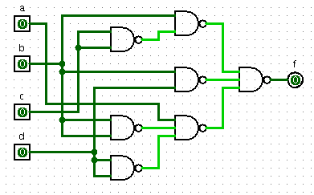
b) funkce: D(1,7,9,10,12,13,15,(6,8))

b.1) tabulka | b.2) Karnaughova mapa  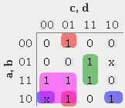  b.3) Minimální součtová forma  bcd + bcd + abd + ac
  dec | hex | a | b | c | d | f
  0 | 0 | 0 | 0 | 0 | 0 | 0
  1 | 1 | 0 | 0 | 0 | 1 | 1
  2 | 2 | 0 | 0 | 1 | 0 | 0
  3 | 3 | 0 | 0 | 1 | 1 | 0
  4 | 4 | 0 | 1 | 0 | 0 | 0
  5 | 5 | 0 | 1 | 0 | 1 | 0
  6 | 6 | 0 | 1 | 1 | 0 | x
  7 | 7 | 0 | 1 | 1 | 1 | 1
  8 | 8 | 1 | 0 | 0 | 0 | x
  9 | 9 | 1 | 0 | 0 | 1 | 1
  10 | A | 1 | 0 | 1 | 0 | 1
  11 | B | 1 | 0 | 1 | 1 | 0
  12 | C | 1 | 1 | 0 | 0 | 1
  13 | D | 1 | 1 | 0 | 1 | 1
  14 | E | 1 | 1 | 1 | 0 | 0
  15 | F | 1 | 1 | 1 | 1 | 1

b.4) Návrh pomocí hradel NAND

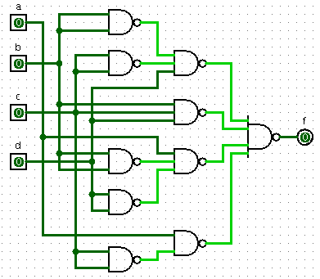
c) funkce: D(1,2,5,10,13,14,15,(4,6,12))

c.1) tabulka | c.2) Karnaughova mapa  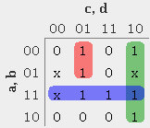  c.3) Minimální součtová forma  acd + cd + ab
  dec | hex | a | b | c | d | f
  0 | 0 | 0 | 0 | 0 | 0 | 0
  1 | 1 | 0 | 0 | 0 | 1 | 1
  2 | 2 | 0 | 0 | 1 | 0 | 1
  3 | 3 | 0 | 0 | 1 | 1 | 0
  4 | 4 | 0 | 1 | 0 | 0 | x
  5 | 5 | 0 | 1 | 0 | 1 | 1
  6 | 6 | 0 | 1 | 1 | 0 | x
  7 | 7 | 0 | 1 | 1 | 1 | 0
  8 | 8 | 1 | 0 | 0 | 0 | 0
  9 | 9 | 1 | 0 | 0 | 1 | 0
  10 | A | 1 | 0 | 1 | 0 | 1
  11 | B | 1 | 0 | 1 | 1 | 0
  12 | C | 1 | 1 | 0 | 0 | x
  13 | D | 1 | 1 | 0 | 1 | 1
  14 | E | 1 | 1 | 1 | 0 | 1
  15 | F | 1 | 1 | 1 | 1 | 1

c.4) Návrh pomocí hradel NAND

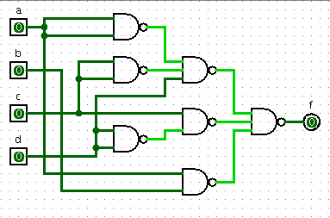
d) funkce: K(5,6,8,12,14,15,(0,2,11,13))

d.1) tabulka | d.2) Karnaughova mapa  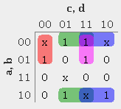  d.3) Minimální součtová forma  acd + bd + bc + acd
  dec | hex | a | b | c | d | f
  0 | 0 | 0 | 0 | 0 | 0 | x
  1 | 1 | 0 | 0 | 0 | 1 | 1
  2 | 2 | 0 | 0 | 1 | 0 | x
  3 | 3 | 0 | 0 | 1 | 1 | 1
  4 | 4 | 0 | 1 | 0 | 0 | 1
  5 | 5 | 0 | 1 | 0 | 1 | 0
  6 | 6 | 0 | 1 | 1 | 0 | 0
  7 | 7 | 0 | 1 | 1 | 1 | 1
  8 | 8 | 1 | 0 | 0 | 0 | 0
  9 | 9 | 1 | 0 | 0 | 1 | 1
  10 | A | 1 | 0 | 1 | 0 | 1
  11 | B | 1 | 0 | 1 | 1 | x
  12 | C | 1 | 1 | 0 | 0 | 0
  13 | D | 1 | 1 | 0 | 1 | x
  14 | E | 1 | 1 | 1 | 0 | 0
  15 | F | 1 | 1 | 1 | 1 | 0

d.4) Návrh pomocí hradel NAND

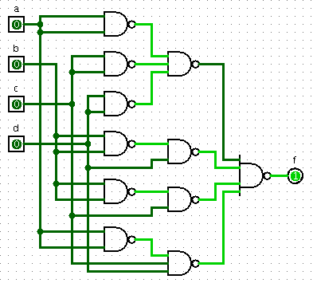
e) funkce: D(0,2,4,6,11,15,(5,7,14))

e.1) tabulka | e.2) Karnaughova mapa  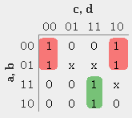  e.3) Minimální součtová forma  ad + acd
  dec | hex | a | b | c | d | f
  0 | 0 | 0 | 0 | 0 | 0 | 1
  1 | 1 | 0 | 0 | 0 | 1 | 0
  2 | 2 | 0 | 0 | 1 | 0 | 1
  3 | 3 | 0 | 0 | 1 | 1 | 0
  4 | 4 | 0 | 1 | 0 | 0 | 1
  5 | 5 | 0 | 1 | 0 | 1 | x
  6 | 6 | 0 | 1 | 1 | 0 | 1
  7 | 7 | 0 | 1 | 1 | 1 | x
  8 | 8 | 1 | 0 | 0 | 0 | 0
  9 | 9 | 1 | 0 | 0 | 1 | 0
  10 | A | 1 | 0 | 1 | 0 | 0
  11 | B | 1 | 0 | 1 | 1 | 1
  12 | C | 1 | 1 | 0 | 0 | 0
  13 | D | 1 | 1 | 0 | 1 | 0
  14 | E | 1 | 1 | 1 | 0 | x
  15 | F | 1 | 1 | 1 | 1 | 1

e.4) Návrh pomocí hradel NAND

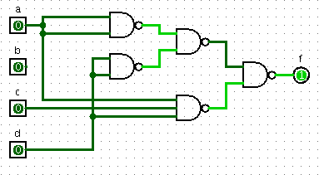
f) funkce: K(2,4,10,11,12,13,(1,3,5,9))

f.1) tabulka | f.2) Karnaughova mapa  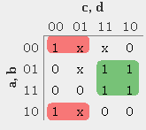  f.3) Minimální součtová forma  bc + bc
  dec | hex | a | b | c | d | f
  0 | 0 | 0 | 0 | 0 | 0 | 1
  1 | 1 | 0 | 0 | 0 | 1 | x
  2 | 2 | 0 | 0 | 1 | 0 | 0
  3 | 3 | 0 | 0 | 1 | 1 | x
  4 | 4 | 0 | 1 | 0 | 0 | 0
  5 | 5 | 0 | 1 | 0 | 1 | x
  6 | 6 | 0 | 1 | 1 | 0 | 1
  7 | 7 | 0 | 1 | 1 | 1 | 1
  8 | 8 | 1 | 0 | 0 | 0 | 1
  9 | 9 | 1 | 0 | 0 | 1 | x
  10 | A | 1 | 0 | 1 | 0 | 0
  11 | B | 1 | 0 | 1 | 1 | 0
  12 | C | 1 | 1 | 0 | 0 | 0
  13 | D | 1 | 1 | 0 | 1 | 0
  14 | E | 1 | 1 | 1 | 0 | 1
  15 | F | 1 | 1 | 1 | 1 | 1

f.4) Návrh pomocí hradel NAND

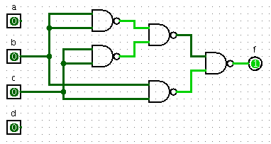
Závěr

na tomto projektu jsem se naučil pracovat s booleovou algebrou, pravdivostní tabulkou a minimalizací pomocí Karnaughovy mapy s následnou realizací návrhu obvodu pomocí hradel NAND.

