Raphael Enyinnaya

Arnel Jerome Adviento

**How to build Document**

GitHub Repository: <https://github.com/j3romey/Seng>

GitHub Commit Log: <https://github.com/j3romey/Seng/commits/master>

How to download the game

1. Download from the repository above
   1. D5Game_Data
   2. D5Game.exe
2. Open D5Game.exe
3. Play the game and Enjoy! :D

How to set up the project to be used

Pre-requisite: make sure Unity 4.6.1 is installed (<http://unity3d.com/get-unity/download/archive>)

Downloaded D5UnityPackage from repository

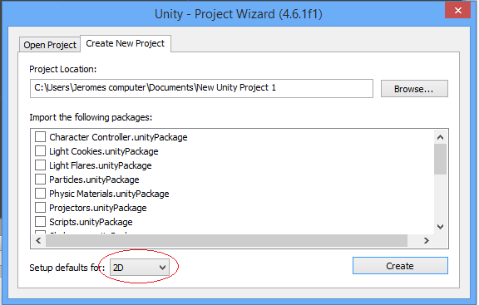

1. Create a new Project in Unity,

and set defaults to 2D

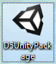

1. Open D5UnityPackage
2. 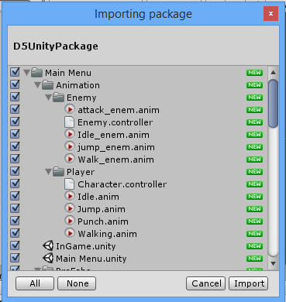Import The Package
3. Loading the In Game Scene:

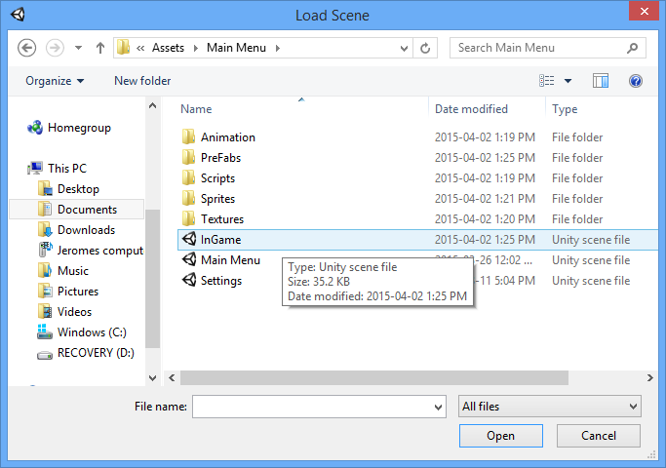File > Open Scene > Main Menu > InGame

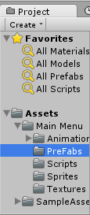

1. Accessing the Prefabs:

Asset > Main Menu > Prefab

* 1. Adding a Layer to a GameObject:

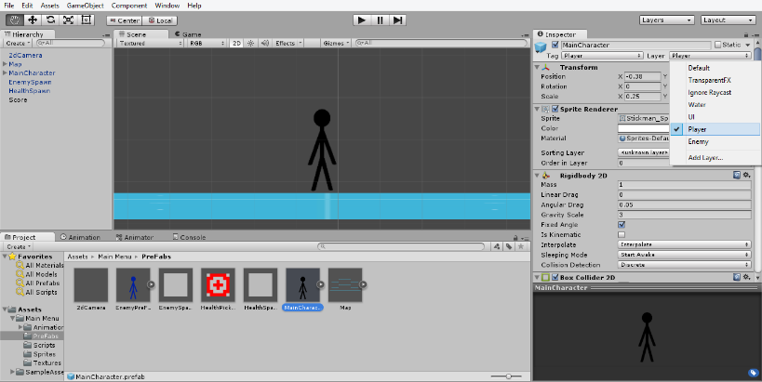Select MainCharacter > Layer > Add Layer > ‘Player’

* 1. Select EnemyPreFab > Layer > Add Layer > ‘Enemy’

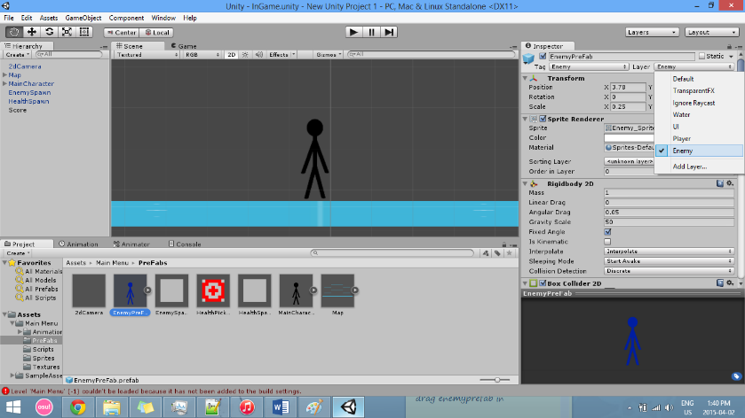

1. Setting up your build settings

File > Build Settings > Drag and Drop the 3 Scenes

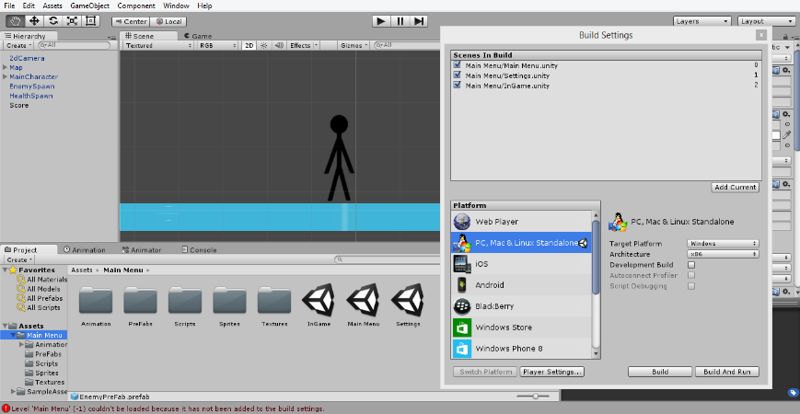

1. Congratulations, you are now ready to use and edit our Project