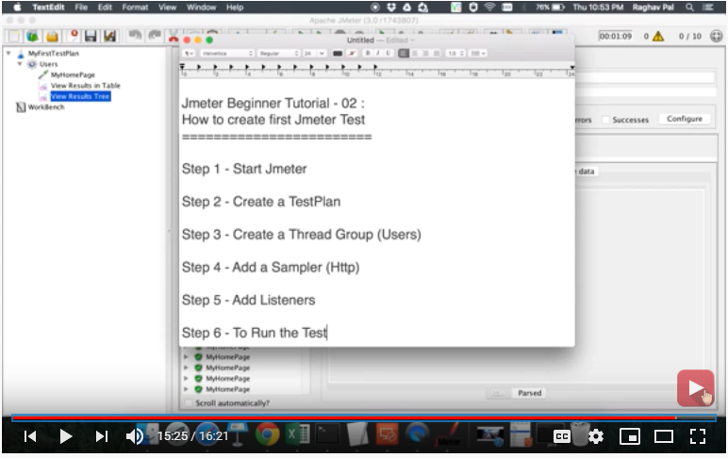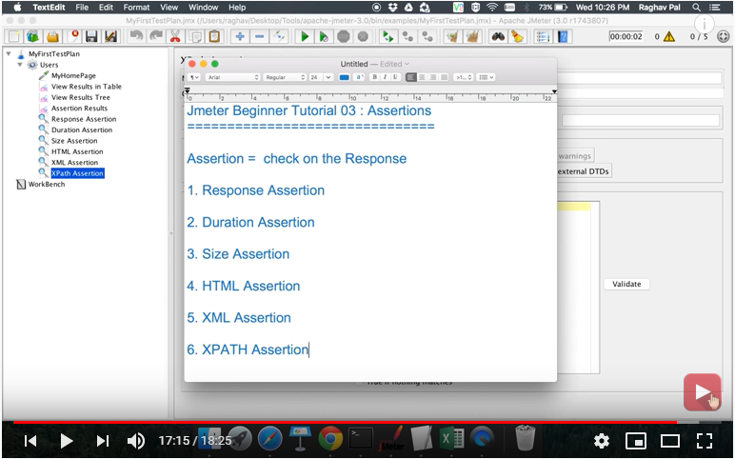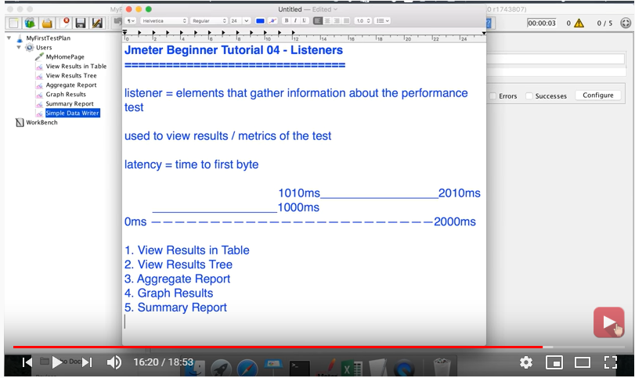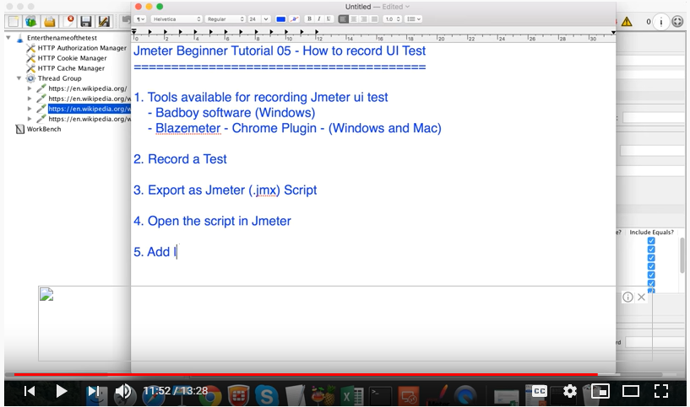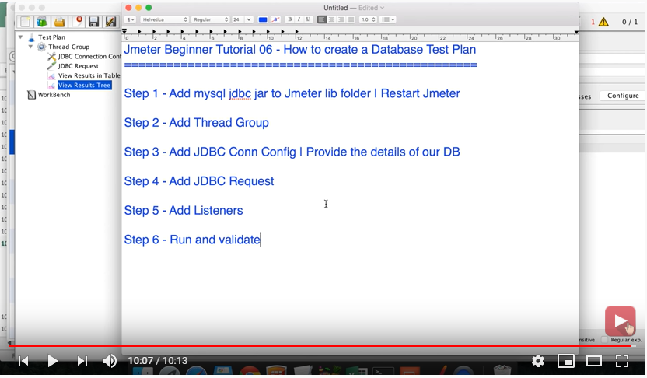

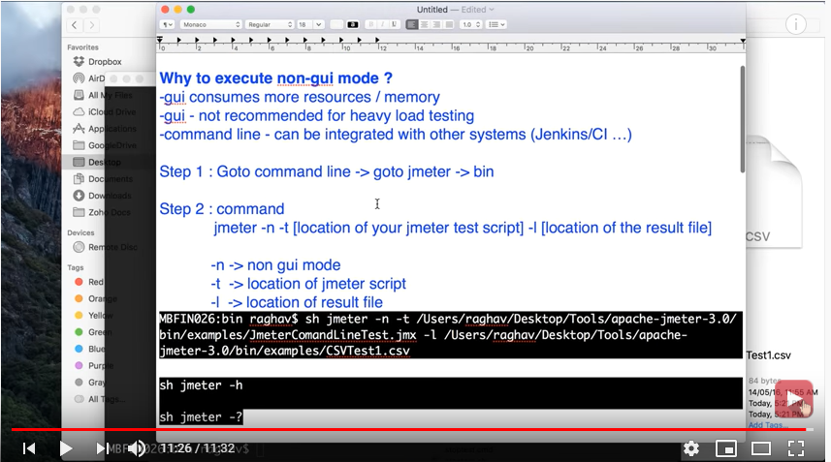

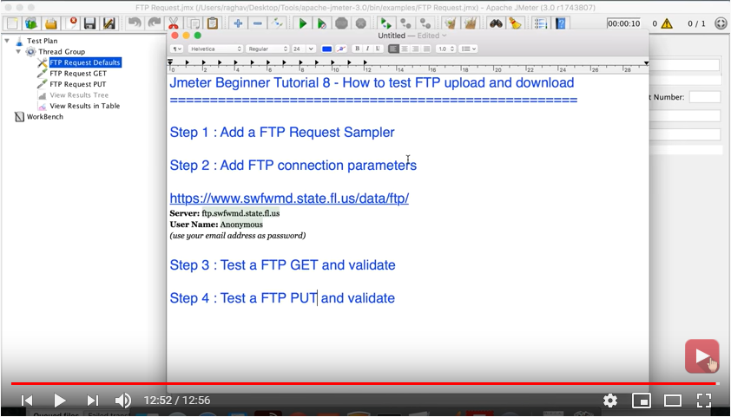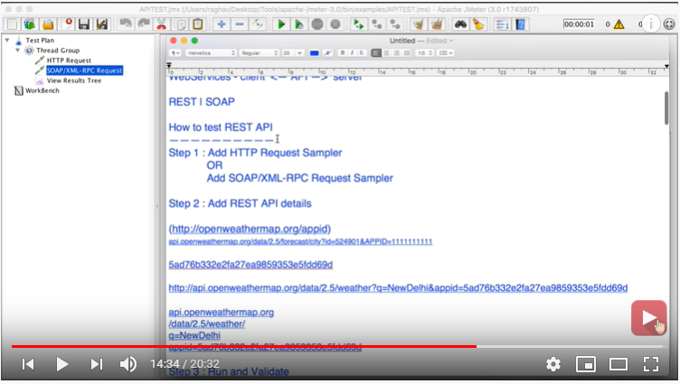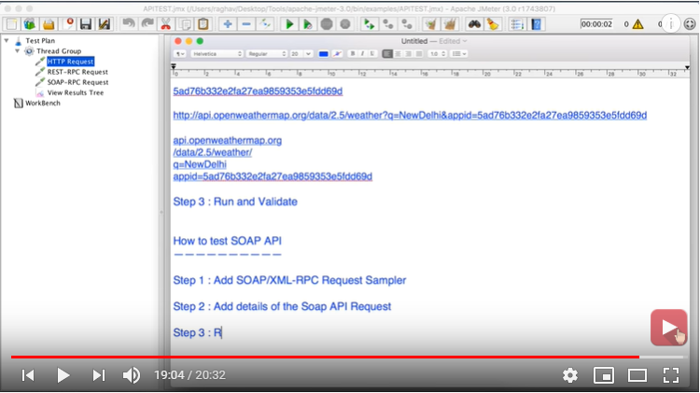

#------------------------------------------------------  
#SAVE SERVICE Configurations  
#---------------------------------------------------------  
jmeter.save.saveservice.bytes = true  
jmeter.save.saveservice.label = true  
jmeter.save.saveservice.latency = true  
jmeter.save.saveservice.response_code = true  
jmeter.save.saveservice.response_message = true  
jmeter.save.saveservice.successful = true  
jmeter.save.saveservice.thread_counts = true  
jmeter.save.saveservice.thread_name = true  
jmeter.save.saveservice.time = true  
jmeter.save.saveservice.print_field_names=true  
# the timestamp format must include the time and should include the date.  
# For example the default, which is milliseconds since the epoch:  
#jmeter.save.saveservice.timestamp_format = ms  
# Or the following would also be suitable  
jmeter.save.saveservice.timestamp_format = dd/MM/yyyy HH:mm  
#save service assertion  
jmeter.save.saveservice.assertion_results_failure_message = true

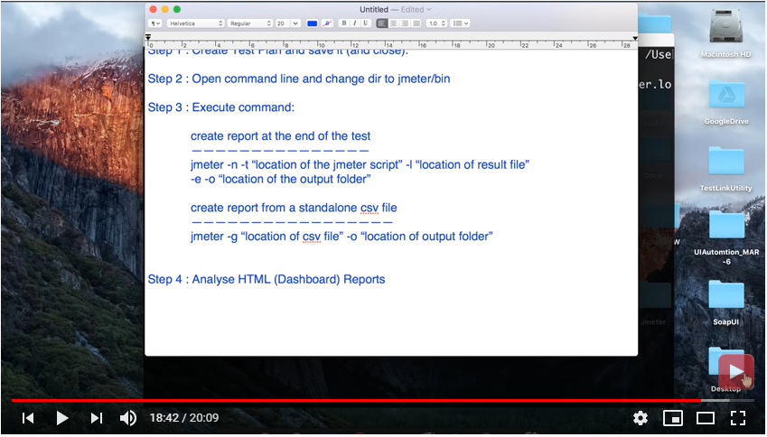

CMD : jmeter -n -t practice\Ui-Test.jmx -l Practice\rec.csv -e -o HTML_reports

Usi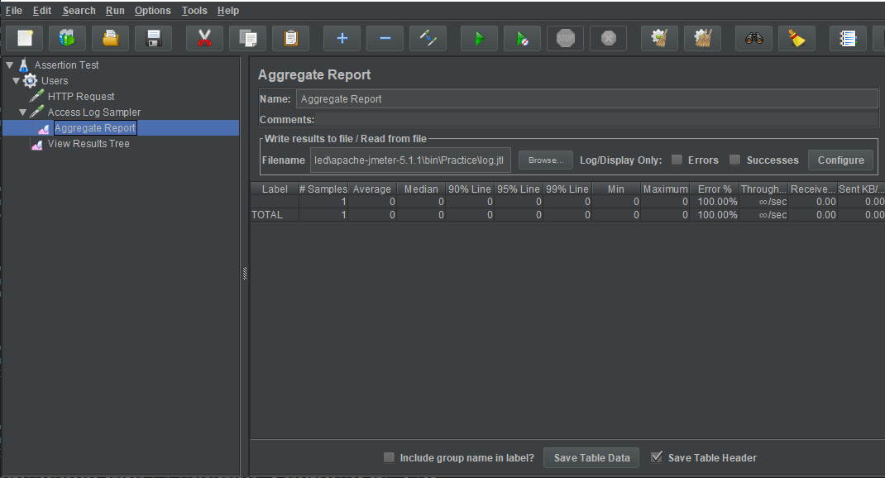

apache-jmeter-5.1.1\bin>jmeter -g practice/rec.jtl -o rep3

however log file will be generated at runtime need to generate only .csv and reports

jmeter -n -t Practice/log_gen.jmx -l reports/log_gen.csv -e -o reports/report1

