# 1. Basic

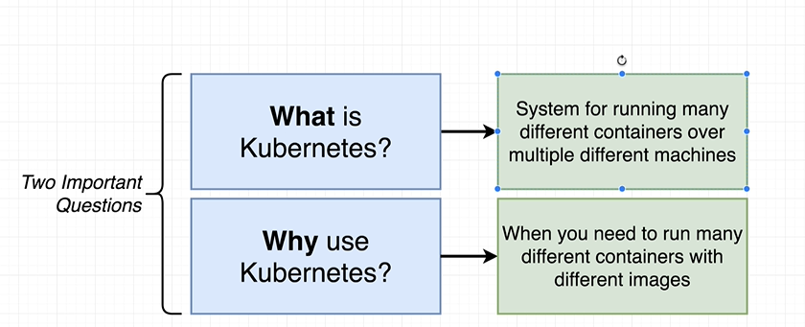

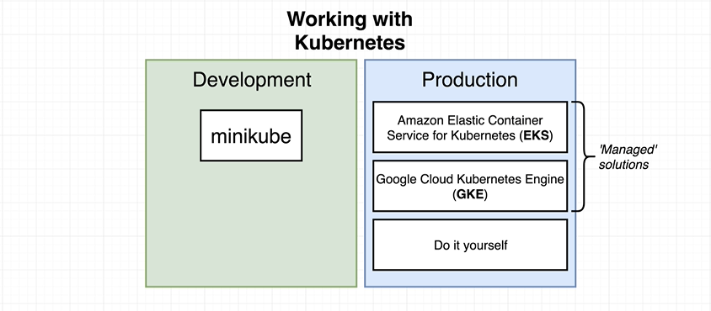

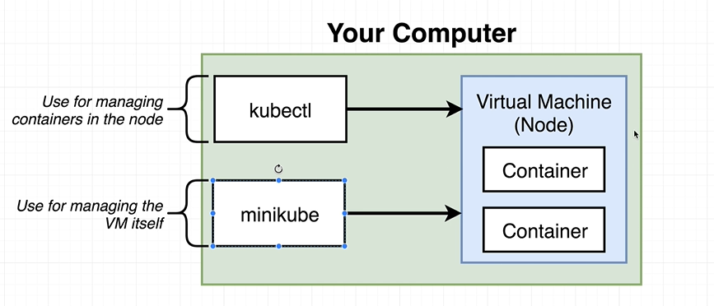

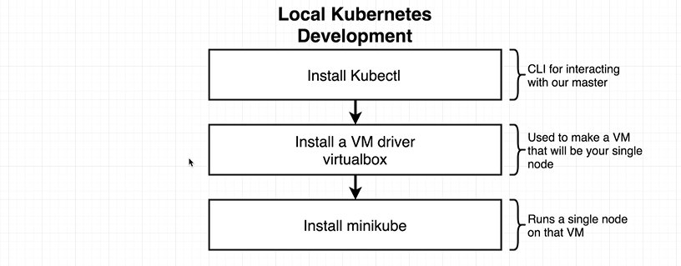

## 1.1 Install Kubernetes - Master on Linux

References: <https://www.devopsschool.com/blog/setting-up-kubernetes-clusters-using-kubeadm-manual-way-in-rhel-7-centos7/>

Pre-requisite – [Installing Docker](https://www.devopsschool.com/tutorial/docker/install-config/) [ This need to be there in Master and Worker Node. Both]

As part of the installation, every node (master and minions) needs:

* kubeadm: the command to bootstrap the cluster.
* kubelet: the component that runs on all of the machines in your cluster and does things like starting pods and containers.
* kubectl: the command line util to talk to your cluster.
* Docker: Container Enginer.
* CNI: Container Network interface.

### 1.1.1 **Change Mac Adress [Optional]**

**Virtual box -> Setting -> Network ->Advance**

### 1.1.2 **Change Host Name**

hostnamectl set-hostname basava.master.com

### 1.1.3 **Stop and Disable Firewall**

1. systemctl stop firewalld
2. systemctl disable firewalld

### 1.1.4 **Disable swap**

* 1. sudo swapoff -a
  2. sudo sed -i '/ swap / s/^/#/' /etc/fstab

# Reboot a machine after that.

### 1.1.5 **Setup yum repo for kubelet kubeadm kubectl**

**Sudo -s**

* cat <<EOF > /etc/yum.repos.d/kubernetes.repo

[kubernetes]

name=Kubernetes

baseurl=https://packages.cloud.google.com/yum/repos/kubernetes-el7-x86_64

enabled=1

gpgcheck=1

repo_gpgcheck=1

gpgkey=https://packages.cloud.google.com/yum/doc/yum-key.gpg <https://packages.cloud.google.com/yum/doc/rpm-package-key.gpg>

exclude=kube*

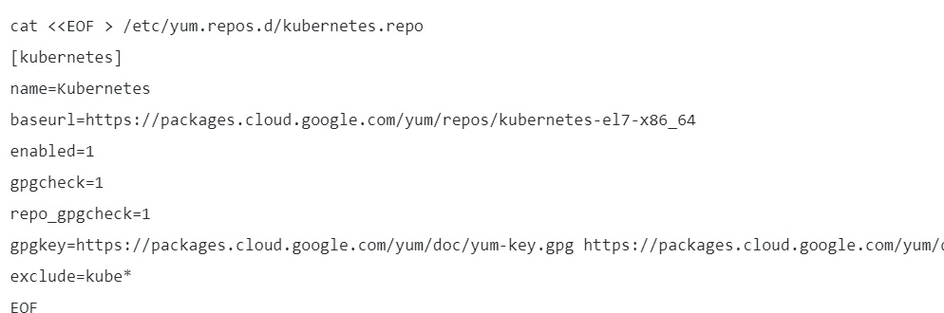

### 1.1.6 **Set SELinux in permissive mode (effectively disabling it)**

* setenforce 0
* sed -i 's/^SELINUX=enforcing$/SELINUX=permissive/' /etc/selinux/config

### 1.1.7 **Install kubelet kubeadm kubectl and enable kubelet**

* yum install -y kubelet kubeadm kubectl --disableexcludes=Kubernetes
* systemctl enable --now kubelet
* # Reboot a machine after that.

### 1.1.8 **Finally, initialize a kubernetes clusters**

* **kubeadm init --ignore-preflight-errors all**

**Copy text : starts with “kubeadm join ……….” 🡪 Master Adress**

### 1.1.9 **Setup Workstation in the Master node only. You can be regular user for it.**

* mkdir -p $HOME/.kube
* sudo cp -i /etc/kubernetes/admin.conf $HOME/.kube/config
* sudo chown $(id -u):$(id -g) $HOME/.kube/config

### 1.1.10 **Verify Clustors**

* + kubectl get nodes
  + kubectl get pods --all-namespaces

## 1.2 Install Kubernetes - Nodes On Linux

### 1.2.1 **Install Kubernetes pod networking**

kubectl apply -f [https://cloud.weave.works/k8s/net?k8s-version=$(kubectl version | base64 | tr -d '\n')](https://cloud.weave.works/k8s/net?k8s-version=$(kubectl%20version%20|%20base64%20|%20tr%20-d%20'\n'))

### 1.2.2 **Setup nodes [ In the node aka worker ]**

#Follow 1.1.1 Change Mac Adress [Optional]

#Follow 1.1.2 Change Host Name

#Follow 1.1.3 Stop and Disable Firewall

#Follow 1.1.4 Disable swap

#Follow 1.1.5 Setup yum repo for kubelet kubeadm kubectl

#Follow 1.1.6 Set SELinux in permissive mode (effectively disabling it)

#Follow 1.1.7 Install kubelet kubeadm kubectl and enable kubelet

**CMD** : kubeadm join 10.50.52.137:6443 --token hnkkcw.w5wqlpyss6uu4wwf

--discovery-token-ca-cert-hash sha256:e27cb08d4dec1e2f74840286491f46f55825a09c818bdba8d0d228c2991e23ed --ignore-preflight-errors all

**IMPORTANT NOTE:**

1. MASTER stores all images.

2. we need atleast one Slave to run . 🡪 join slaves to master

**START NODES :**

kubectl apply -f "https://cloud.weave.works/k8s/net?k8s-version=$(kubectl version | base64 | tr -d '\n')"

**OTHER COMMANDS:**

kubectl get nodes

vi pod_yaml.yaml

kubectl create -f pod_yaml.yaml

kubectl get pods

check image is running or not in slave.

## 1.3 Cluster Info

* kubectl cluster-info
* kubectl cluster-info dump 🡪 resolve cluster related problem.

## 1.4 Node info

<https://kubernetes.io/docs/concepts/architecture/nodes/>

s

# 2. API - Kinds or Types

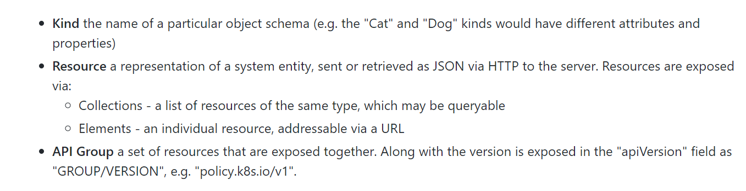

## 2.1 Objects

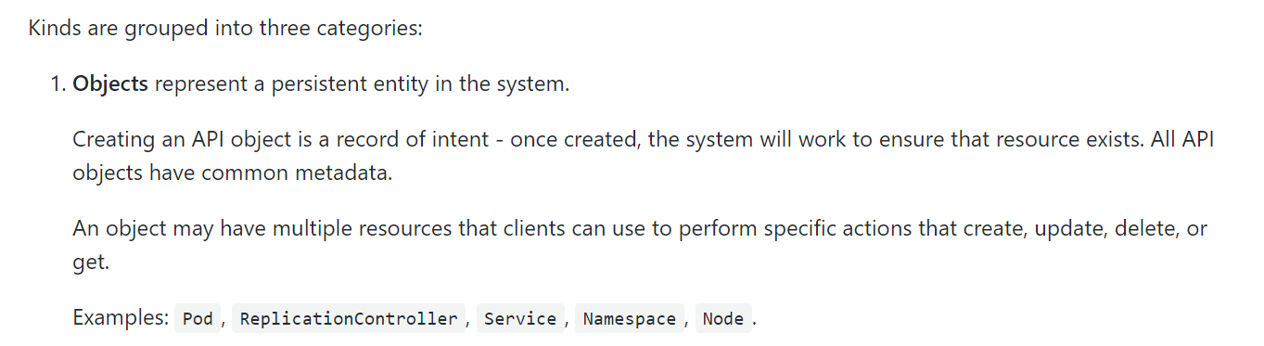

<https://github.com/kubernetes/community/blob/master/contributors/devel/sig-architecture/api-conventions.md#resources>

### 2.1.1 Pod exmaples

==========

apiVersion: v1

kind: Pod

metadata:

  name: test-pd

spec:

  containers:

  - image: scmgalaxy/nginx-devopsschoolv1

    name: test-container

    volumeMounts:

    - mountPath: /cache

      name: cache-volume

  volumes:

  - name: cache-volume

    emptyDir: {}

==========

apiVersion: v1

kind: Pod

metadata:

  name: test-pd

spec:

  containers:

  - image: scmgalaxy/nginx-devopsschoolv1

    name: test-container

    volumeMounts:

    - mountPath: /cache

      name: cache-volume

  volumes:

  - name: cache-volume

    emptyDir: {}

==========

apiVersion: v1

kind: Pod

metadata:

  name: hello-pod

  labels:

    app: webserver

spec:

  containers:

  - name: hello-ctr

    image: nginx

    ports:

    - containerPort: 80

### 2.2.2 working with labels

kubectl get pods --show-labels

kubectl label pods labelex owner=Michael

kubectl get pods -l env=development

kubectl delete pods label

## 2.2 Lists

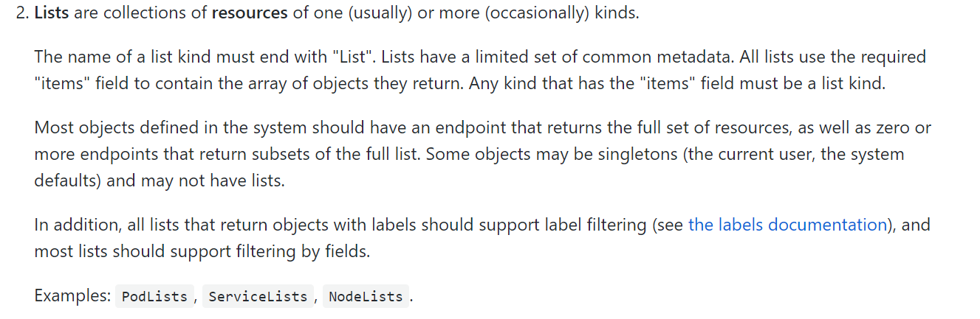

## 2.3 Simple

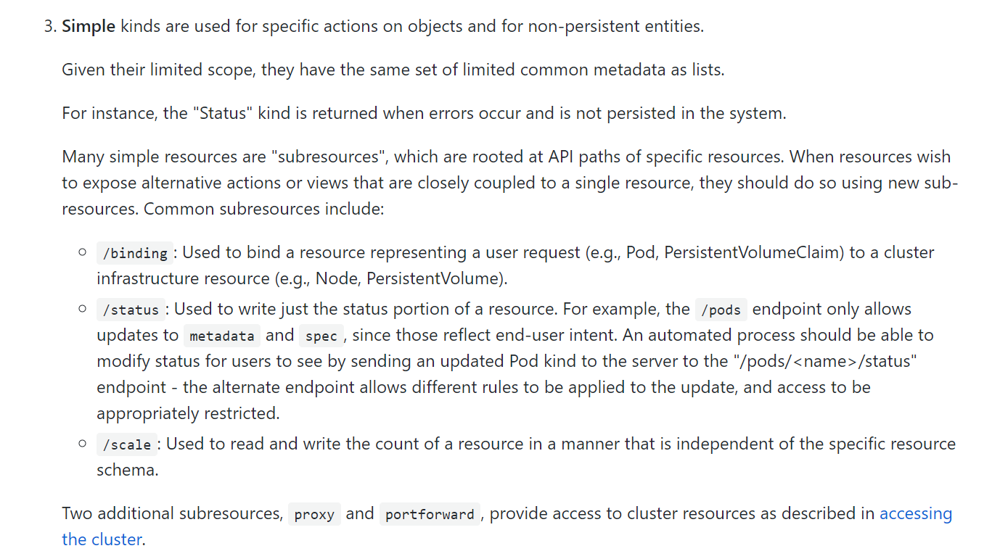

# 3. YAML – keys

* 1. apiVersion
  2. kind
  3. metadata
  4. spec
  5. status

## 3.1 apiVersion and Kind

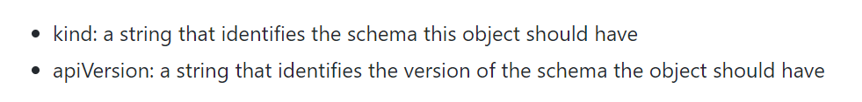

## 3.2 Meatadata

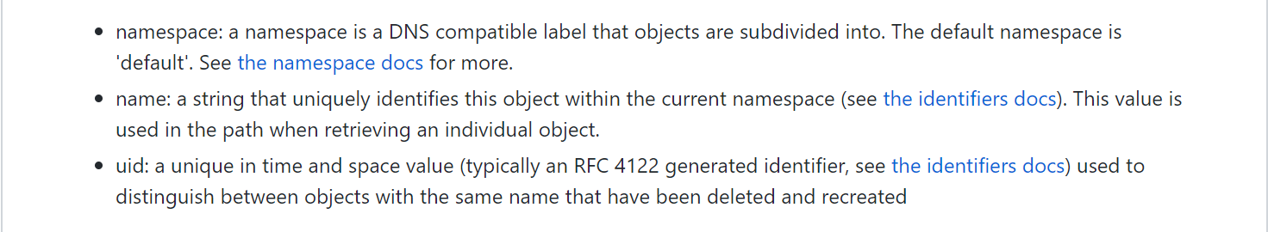

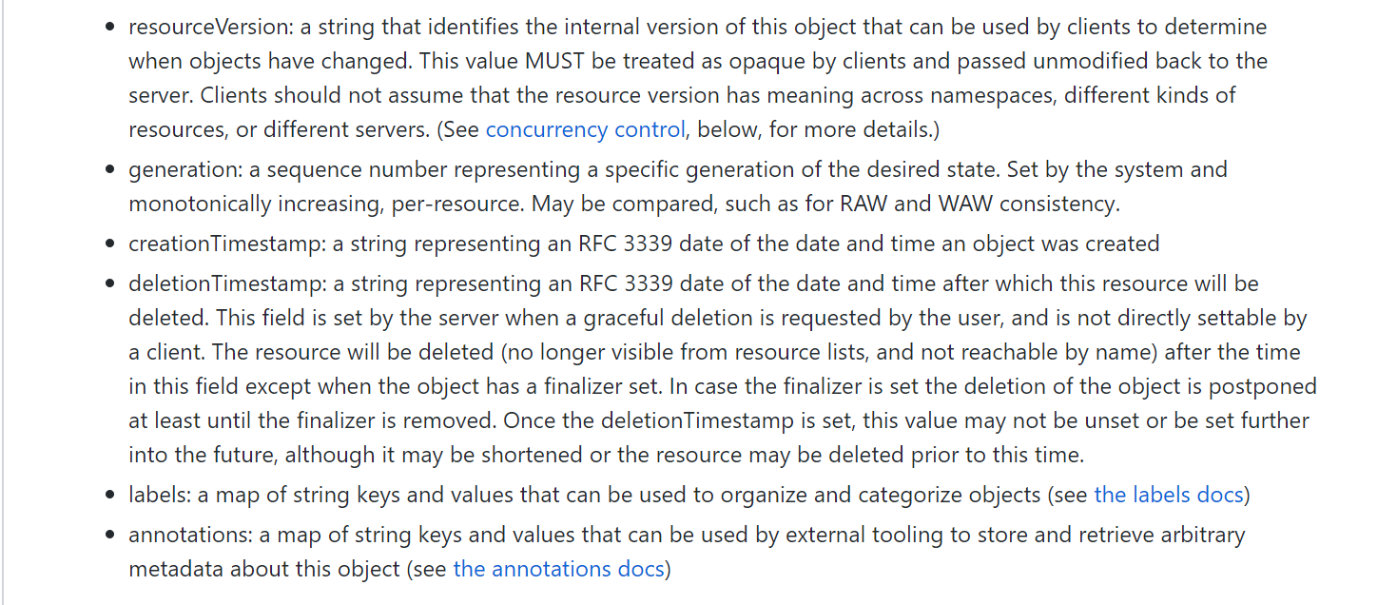

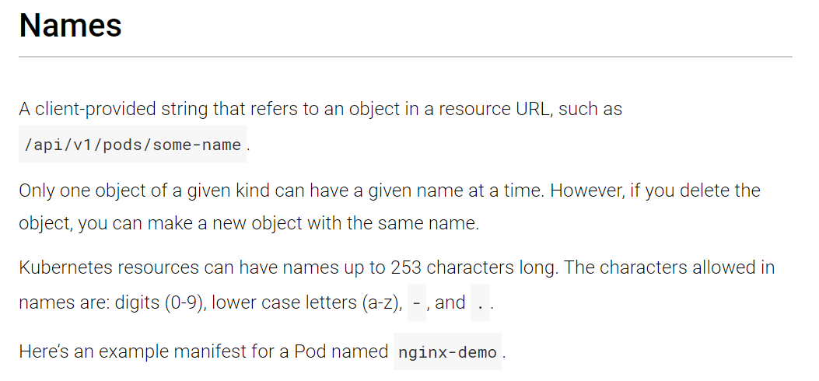

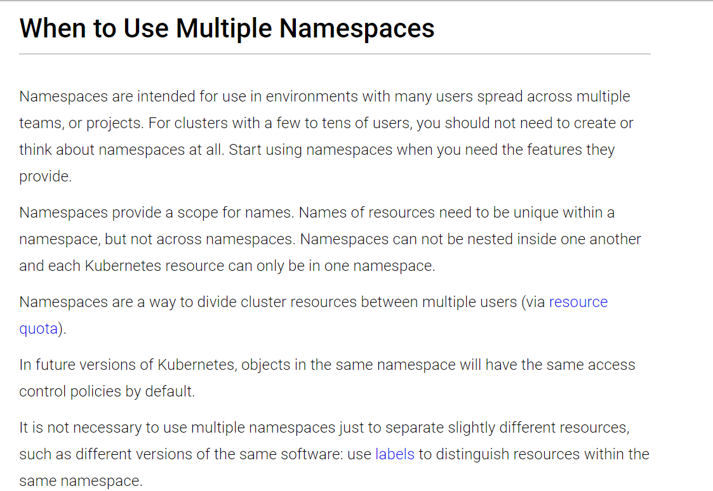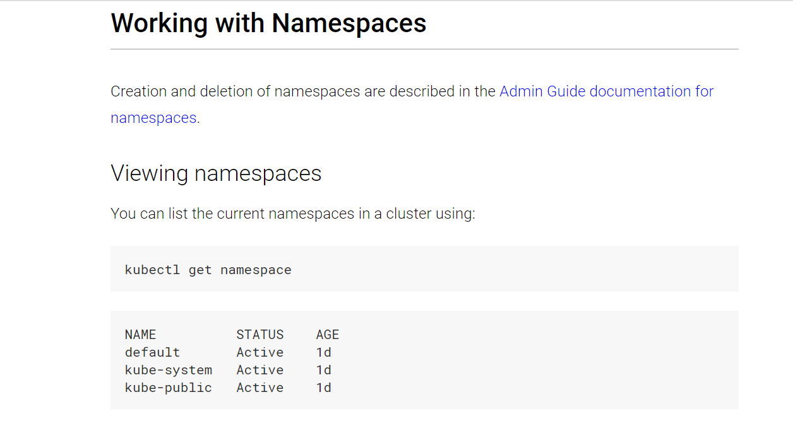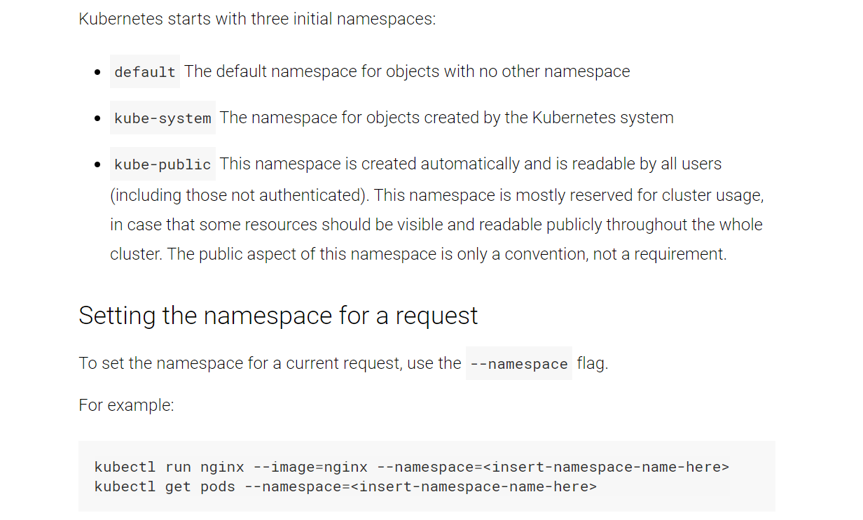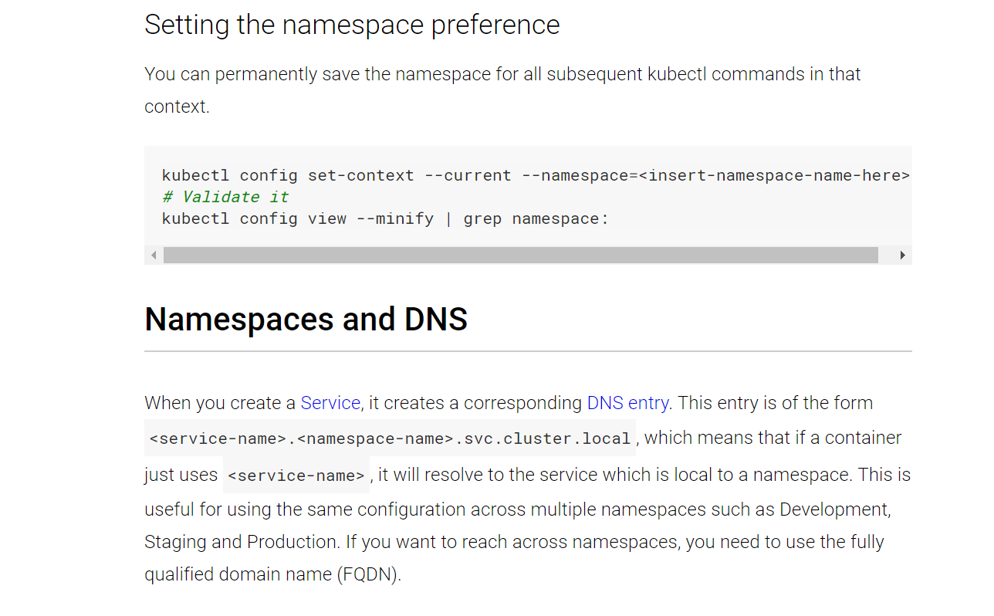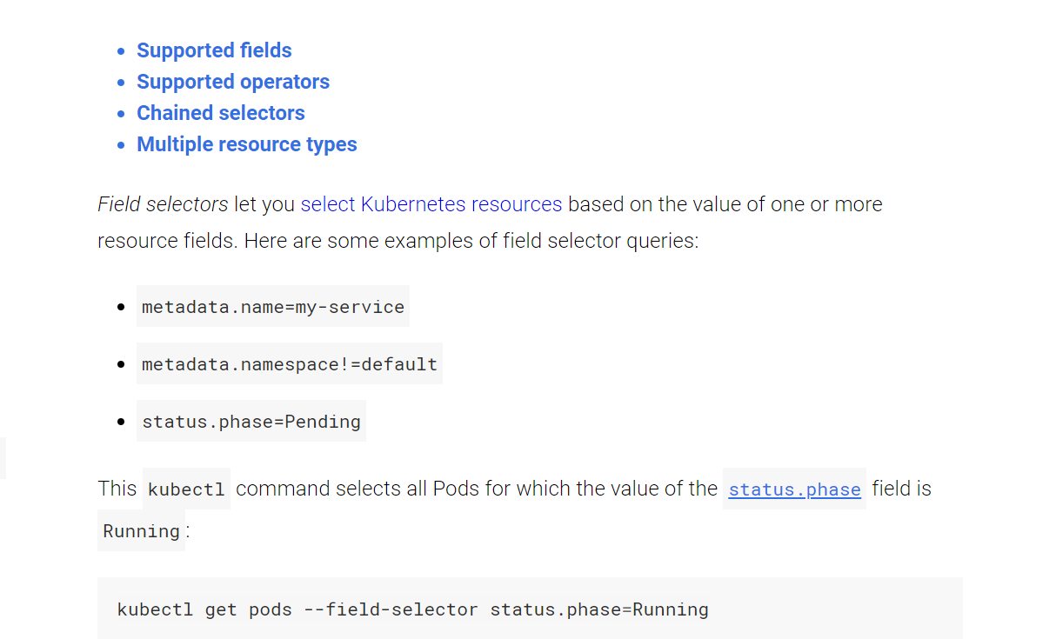

## 3.3 Spec and Status

# References

https://www.devopsschool.com/blog/setting-up-kubernetes-clusters-using-kubeadm-manual-way-in-rhel-7-centos7/

https://www.devopsschool.com/blog/how-to-check-containers-readiness-inside-a-pod-using-readinessprobe/

https://www.devopsschool.com/blog/how-to-check-containers-health-inside-a-kubernetes-pod-using-livenessprobe/

https://www.devopsschool.com/blog/working-with-kubernetes-cluster-using-kubectl-part-1/

https://www.devopsschool.com/blog/understand-docker-volume-from-beginner-to-deep-dive-level/

https://www.devopsschool.com/blog/kubernetes-volume-hostpath-explained-with-examples/

https://www.devopsschool.com/blog/kubernetes-volume-emptydir-explained-with-examples/

https://www.thegeekdiary.com/centos-rhel-7-configuring-an-nfs-server-and-nfs-client/

https://www.devopsschool.com/blog/working-with-kubernetes-cluster-using-kubectl-part-7-labels/